

December 26, 2008

Inside this Issue
1 Administration
2 Operations
2 Training/EMS
3 Did You Know?
3 Birthdays
3 Looking Back
4 Upcoming Events
4 Classifieds

 Administration News

The computer system upgrade has begun. The T1 line will be complete within the week and the process of switching severs and server rooms will begin shortly there after. There will many changes over the next few months until this upgrade is complete so I ask for your patience through the process. The first change is that Firehouse Web is no longer available. Lt. Cassin and I are working on the apparatus laptops so you can access Firehouse from the street. These changes are nearly complete but a couple of the apparatus laptops need a little fine tuning. I will keep you updated as quickly as I can in regards to this process.

Remember that we will be closing out the 2008 accounts next week. Please get all outstanding invoices to headquarters by Tuesday morning, December 30 so we can process bills in the afternoon. Please contact Crystal or myself with any questions.

Be Careful and Enjoy the rest of the Holiday Season

“To effectively and efficiently provide professional services to our community”

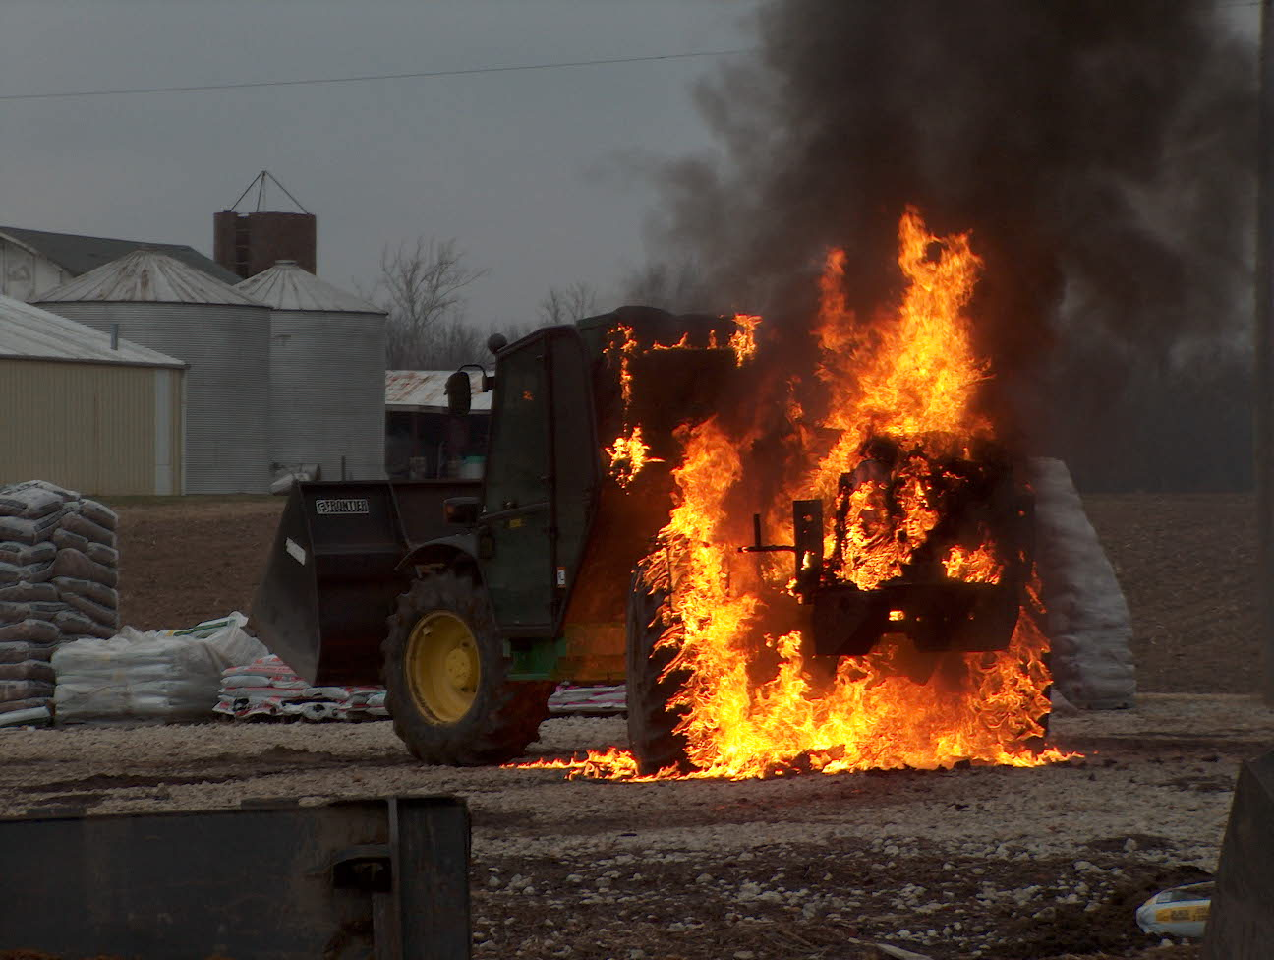 Operations News

Dustin O’Neal has been awarded the B shift Station 53 day position. Congratulations Dustin.

We will be ordering a new Scott TIC to replace the damaged unit after the first of the year pending approval of the FPDB on 1-6-09.

New portable generators with quartz lights have been placed on Engines 51 and 52.

New hose has been ordered and will be here after the first of the year. Station Captains see Scott Wiegle if you need any additional supply.

No new updates on MECA and the ability of Perry, Decatur and Franklin Township to talk on our system. If they assist us, we will try to utilize Ops 94.

Swift water suits have been placed on Engine 52 and 53 for use. These suits are designed to be used for water rescue emergencies prior to the arrival of Station 51 apparatus during extreme life safety events. These suits are not the Ice Commander type, but more general water use. Chief Pell wanted these suits available on the apparatus after the flooding events this summer. These suits can be used in cold water and ice for short periods of time safely. Also, Captain Settles has ordered thermal protection that may be worn under the swift water suit. Please see your Station Captain with any questions.

Be Smart and Stay Safe Have a Blessed Holiday Season.

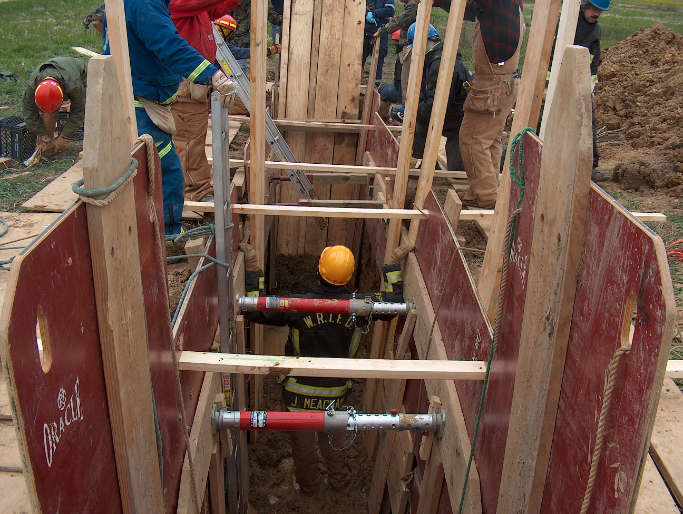 Training/EMS News

Happy Holidays from the Training/EMS Division!!!!!!!!!

Stay Safe and Enjoy the Holidays.

“TRAIN AS IF YOUR LIFE DEPENDS ON IT, BECAUSE IT DOES!!!!!

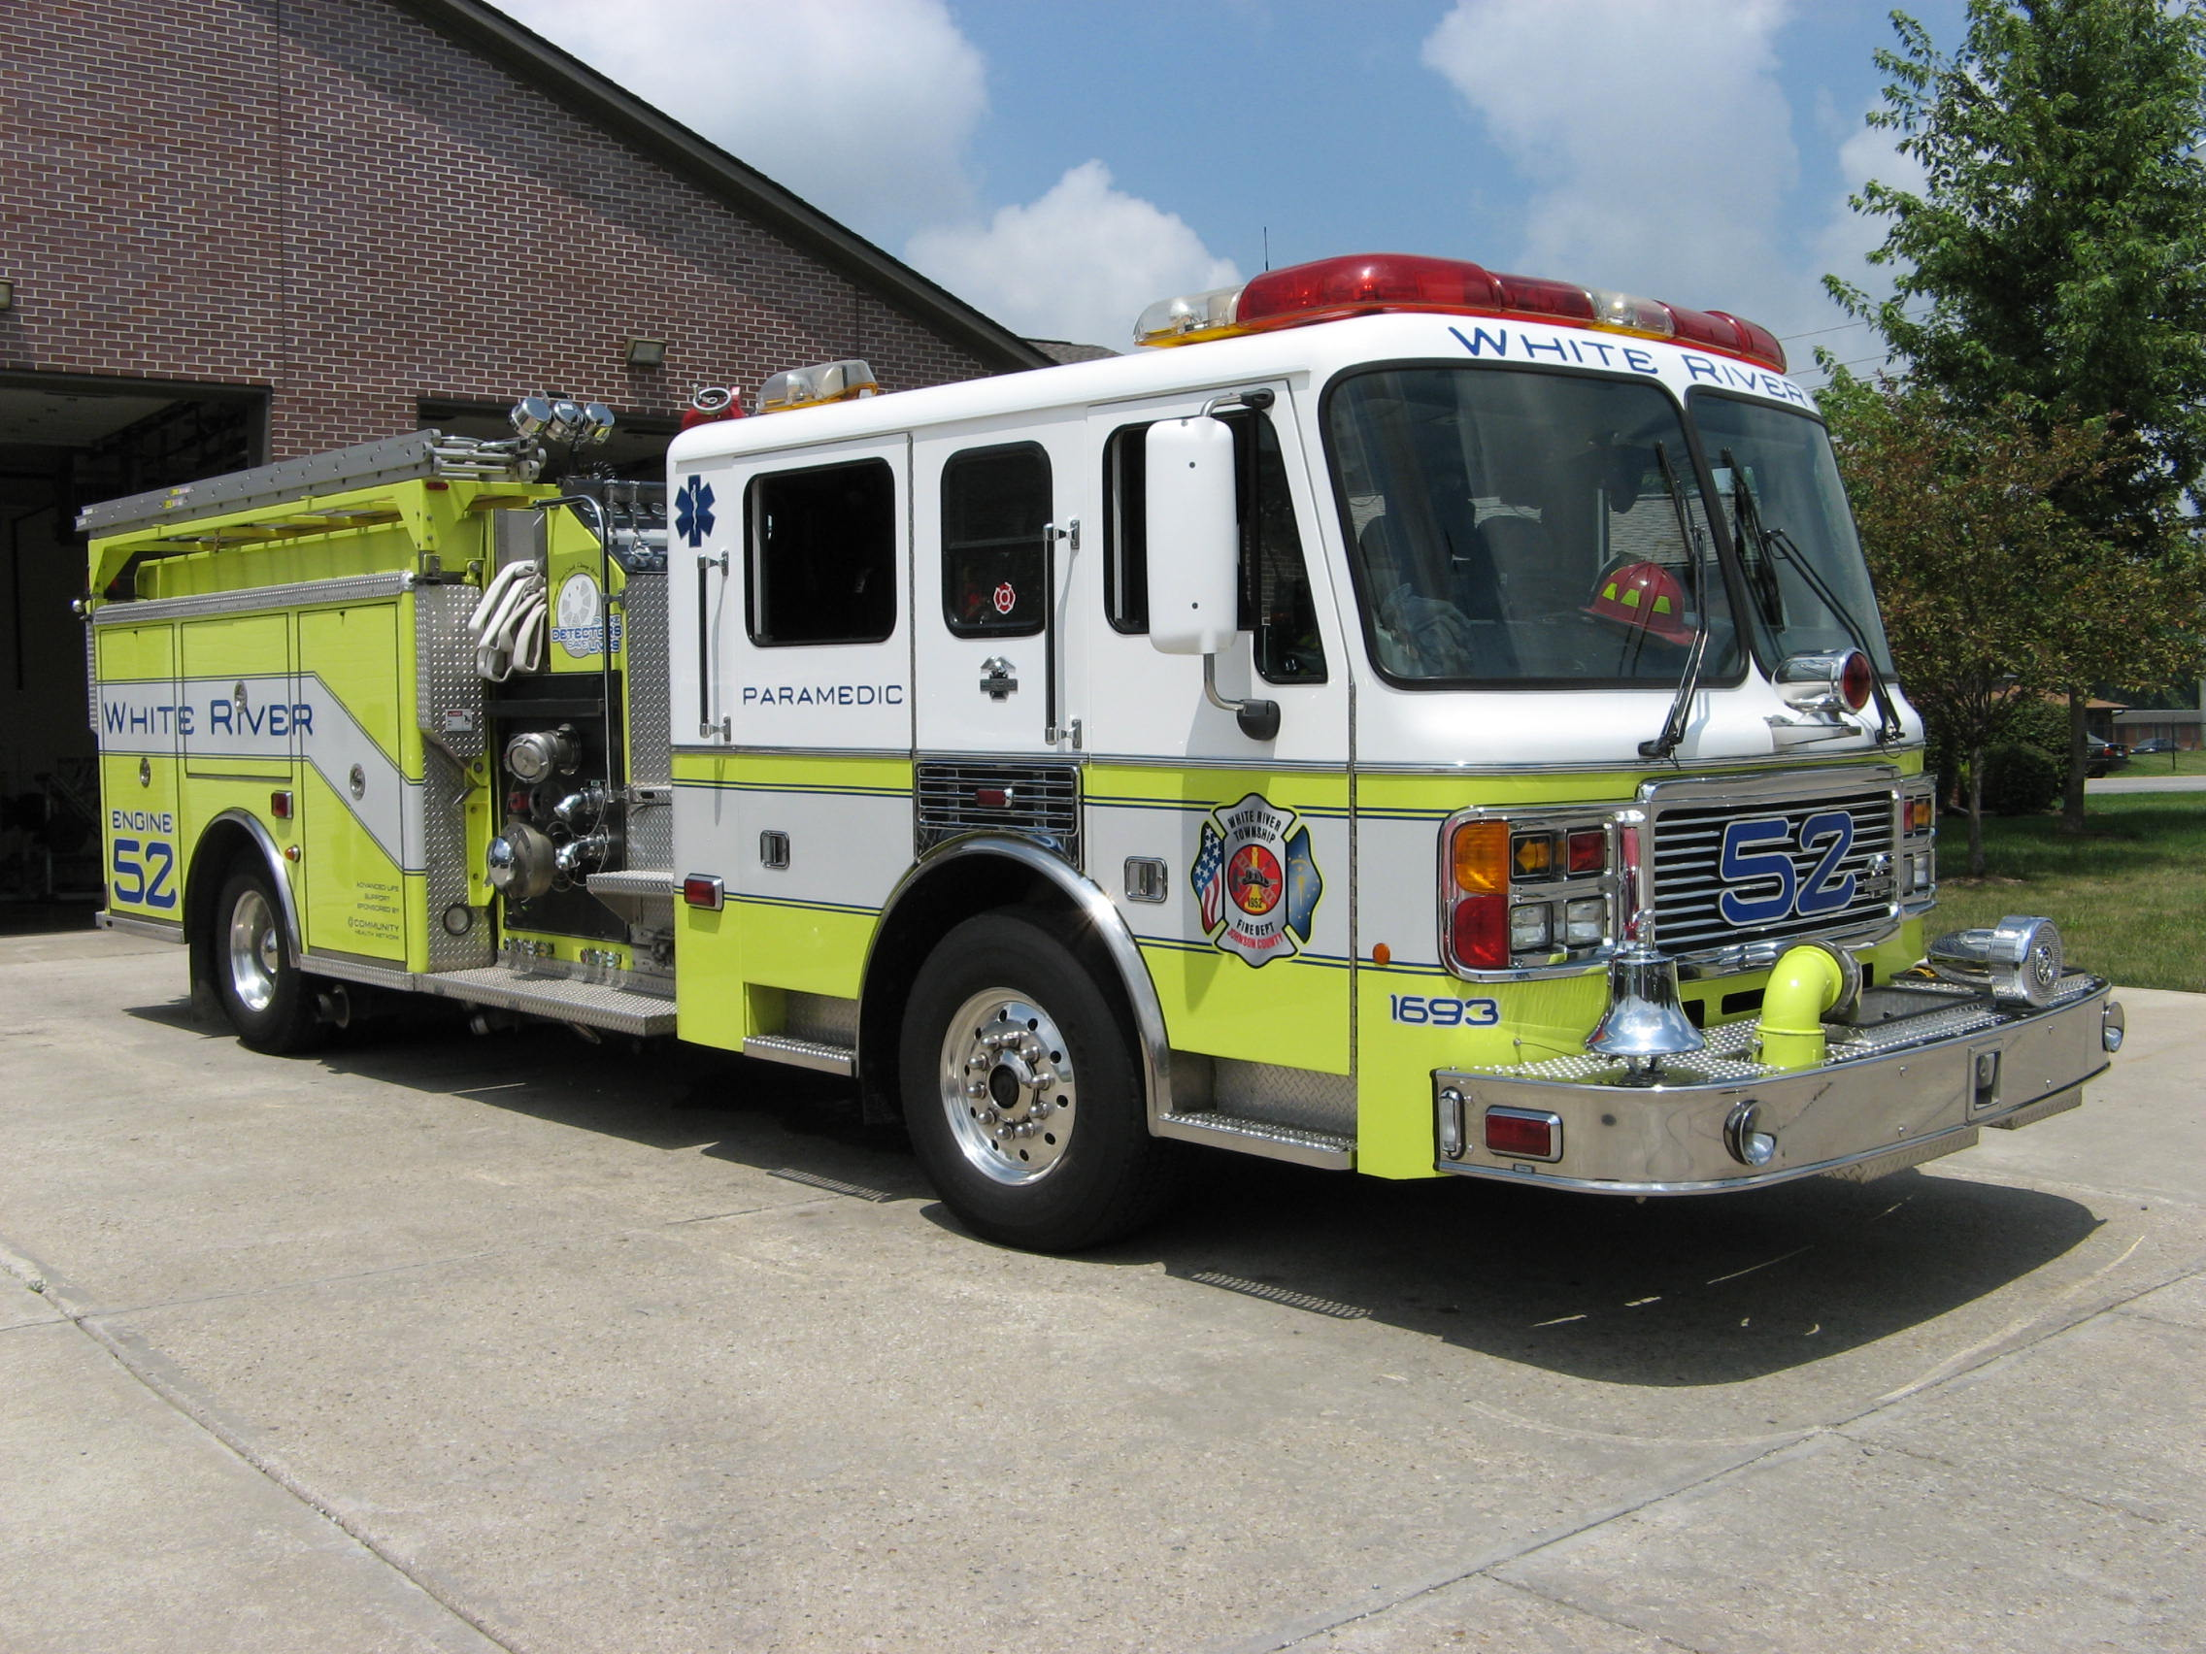 Did you know?

Did you know that the percentage of Africa that is wilderness is 28%?
Did you know that the percentage of North America that is wilderness is 38%?

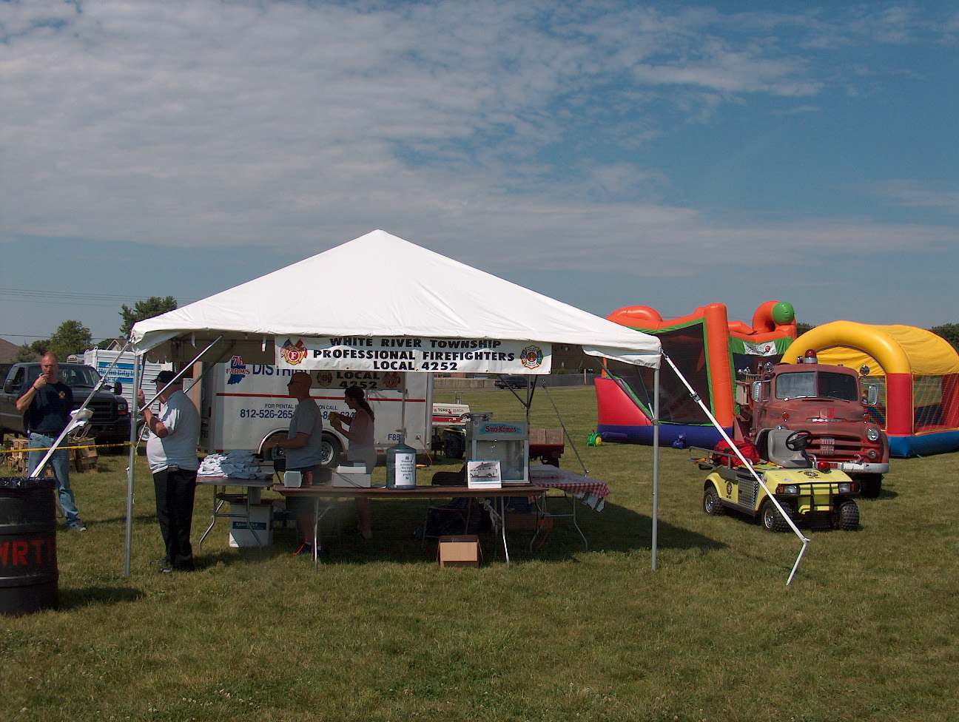 Birthdays (December 26 – January 8)

Ben Williams December 30
Scott Alexander January 6
Mike Shoemaker January 8

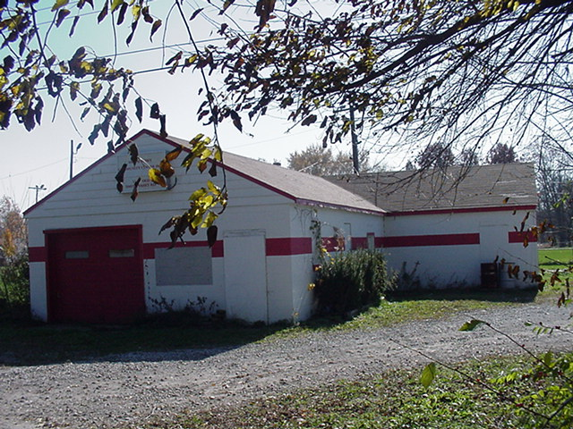 Looking back…..

55 years ago December 29, 1953

Fire equipment expensive

In order to provide the best equipment for the men of the Smith Valley Volunteer Fire Department, members shopped around to find the best deal on fire coats and hats. That deal came from the Indiana Fire Prevention Company where each set of a coat and hat will cost $37.35. Boots will cost an additional $7.50 a pair.

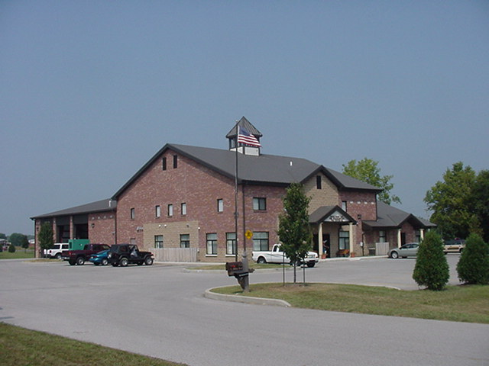 Upcoming events (December 2008 – January 2009)

Fire Protection District Board Meeting January 6, 2009 - 7pm Station 53
December 2008
S | M | T | W | T | F | S
 | 1 | 2 | 3 | 4 | 5 | 6
7 | 8 | 9 | 10 | 11 | 12 | 13
14 | 15 | 16 | 17 | 18 | 19 | 20
21 | 22 | 23 | 24 | 25 | 26 | 27
28 | 29 | 30 | 31
January 2009
S | M | T | W | T | F | S
 |  |  |  | 1 | 2 | 3
4 | 5 | 6 | 7 | 8 | 9 | 10
11 | 12 | 13 | 14 | 15 | 16 | 17
18 | 19 | 20 | 21 | 22 | 23 | 24
25 | 26 | 27 | 28 | 29 | 30 | 31

Classifieds

MLS number 2866095 listing a home for sale on a 9.5 acre lake – 5lb bass, paddle boats, fishing boats, and canoes. Three bedroom, with a master suite, two bath, split floor plan, kitchen, laundry room, great room, fireplace, two car garage, 1495 square feet. Year built 1996, screened in back porch, electrical connection for a hot tub on the patio. The home has a new 30 year roof, the outside and inside has been freshly painted and the home has a new ceramic tile kitchen floor. Please call Judy Hoeping at Tomorrow Realty 881-6407 or log onto the website www.tomorrowrealty.net to see the home.

