

December 12, 2008

Inside this Issue
1 Administration
2 Administration
2 Training/EMS
3 Did You Know?
3 Birthdays
3 Looking Back
4 Upcoming Events
4 Classifieds

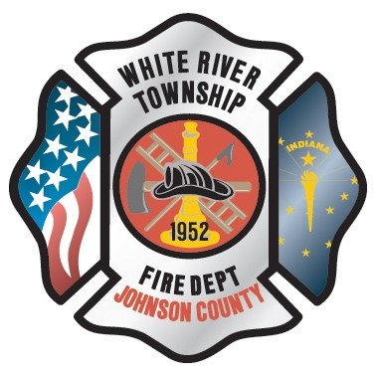 Administration News

The computer upgrades were approved at the December District Board meeting. The upgrades consist of switching from the wireless system we currently use to T1 and Comcast cable lines. We will also be reconfiguring our current server setup at headquarters. The orders have been placed for the installation of the T1 lines to station 51 and 52. This should occur within the next month. We will test the system and work out any bugs before transferring the wireless system to the hard-line system. We will also be replacing a few of the older computers that we have in our department as well as new printers and copiers for the stations. I will keep everyone updated as these changes take place.

“To effectively and efficiently provide professional services to our community”

Over the last few years we have talked about installing a video conferencing system in the department. We have looked at many systems and have tried to put together a package that meets the needs of the department. We had three companies bid on the project and Boyer Networks presented the best package for the dollar amount. This information was presented at the December District Board meeting and was approved. This system will allow companies at the three stations to be linked together via cameras, microphones, and monitors. You may watch a training session live via the internet or view it later as this system has a DVR feature that will allow all session to be recorded and watch later using a secure internet login. This will allow the companies to stay in service on station for a majority of classroom sessions, including Audit and Review, as well as many shift and department meetings. This will also assist the night time personnel in obtaining EMS in service lecture hours as well as keeping up with departmental changes. The order has been placed for this equipment as well and Boyer Networks will provide a timeline as to the completion date for this project. This is an exciting project but will be successful with the correct procedures in place. All members will be properly trained in its use and accessibility.

There will be a lot of technology upgrades in the next several months. I ask that you exercise patience as we work to complete these projects. The goal is to make the system more efficient and effective for the end user, you.

Have a wonderful Holiday Season!

.

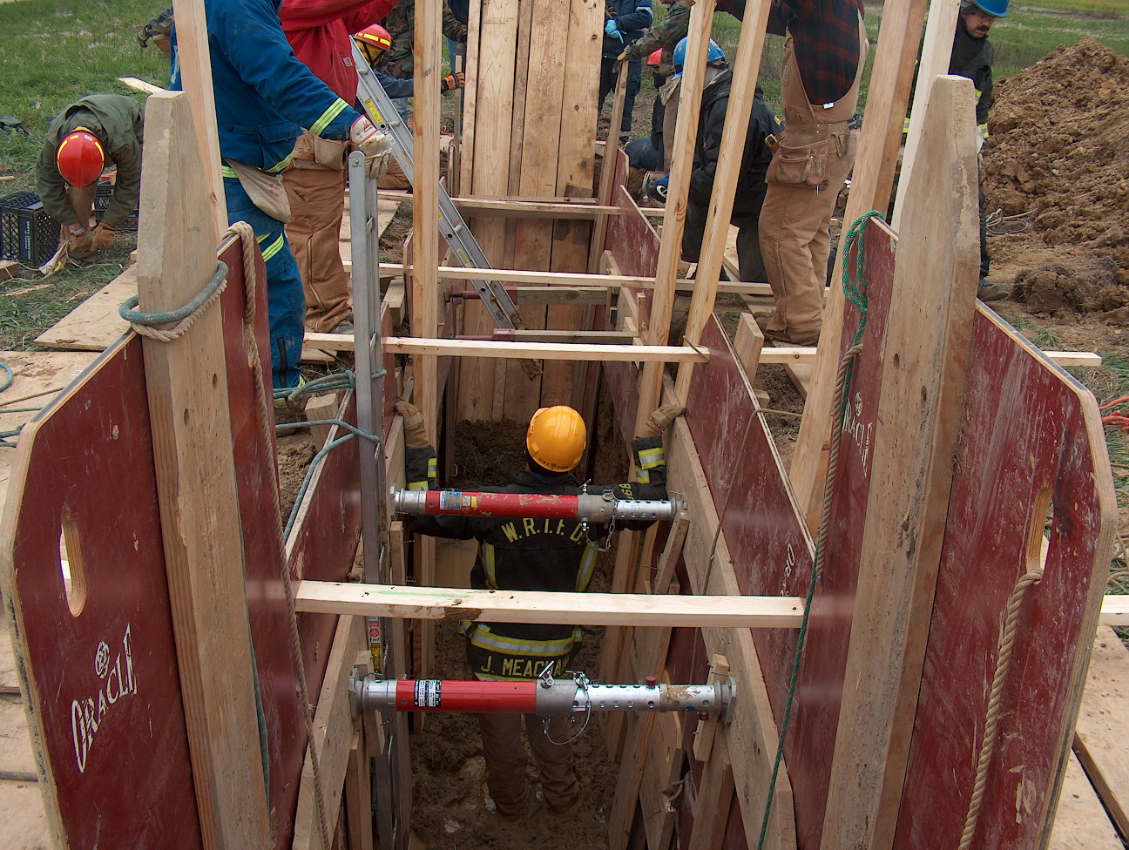 Training/EMS News

Happy Holidays everyone I hope that everyone had a great Thanksgiving. We will be conducting an Engine Company Operations class in January. The dates are January 12th, 13th and 14th. Lt. Alford is teaching the class, however if you are interested in taking this class please email me to let me know. This will be a great class and will conclude on January 14th at ESEC with some live burns in their burn building.

The district board approved us purchasing video conferencing for the department. This will assist us in training tremendously. I will keep everyone up to date on this project and we will be able to teach and train while we keep everyone on station. There will be DVR trainings for anyone to watch at a later date. This will be a big help for EMS training and Audit and Review with Dr. Gansman.

That’s all I have for now. Everyone please be safe this winter and have a very Merry Christmas.

TRAIN AS IF YOUR LIFE DEPENDS ON IT, BECAUSE IT DOES!

Chief Engmark

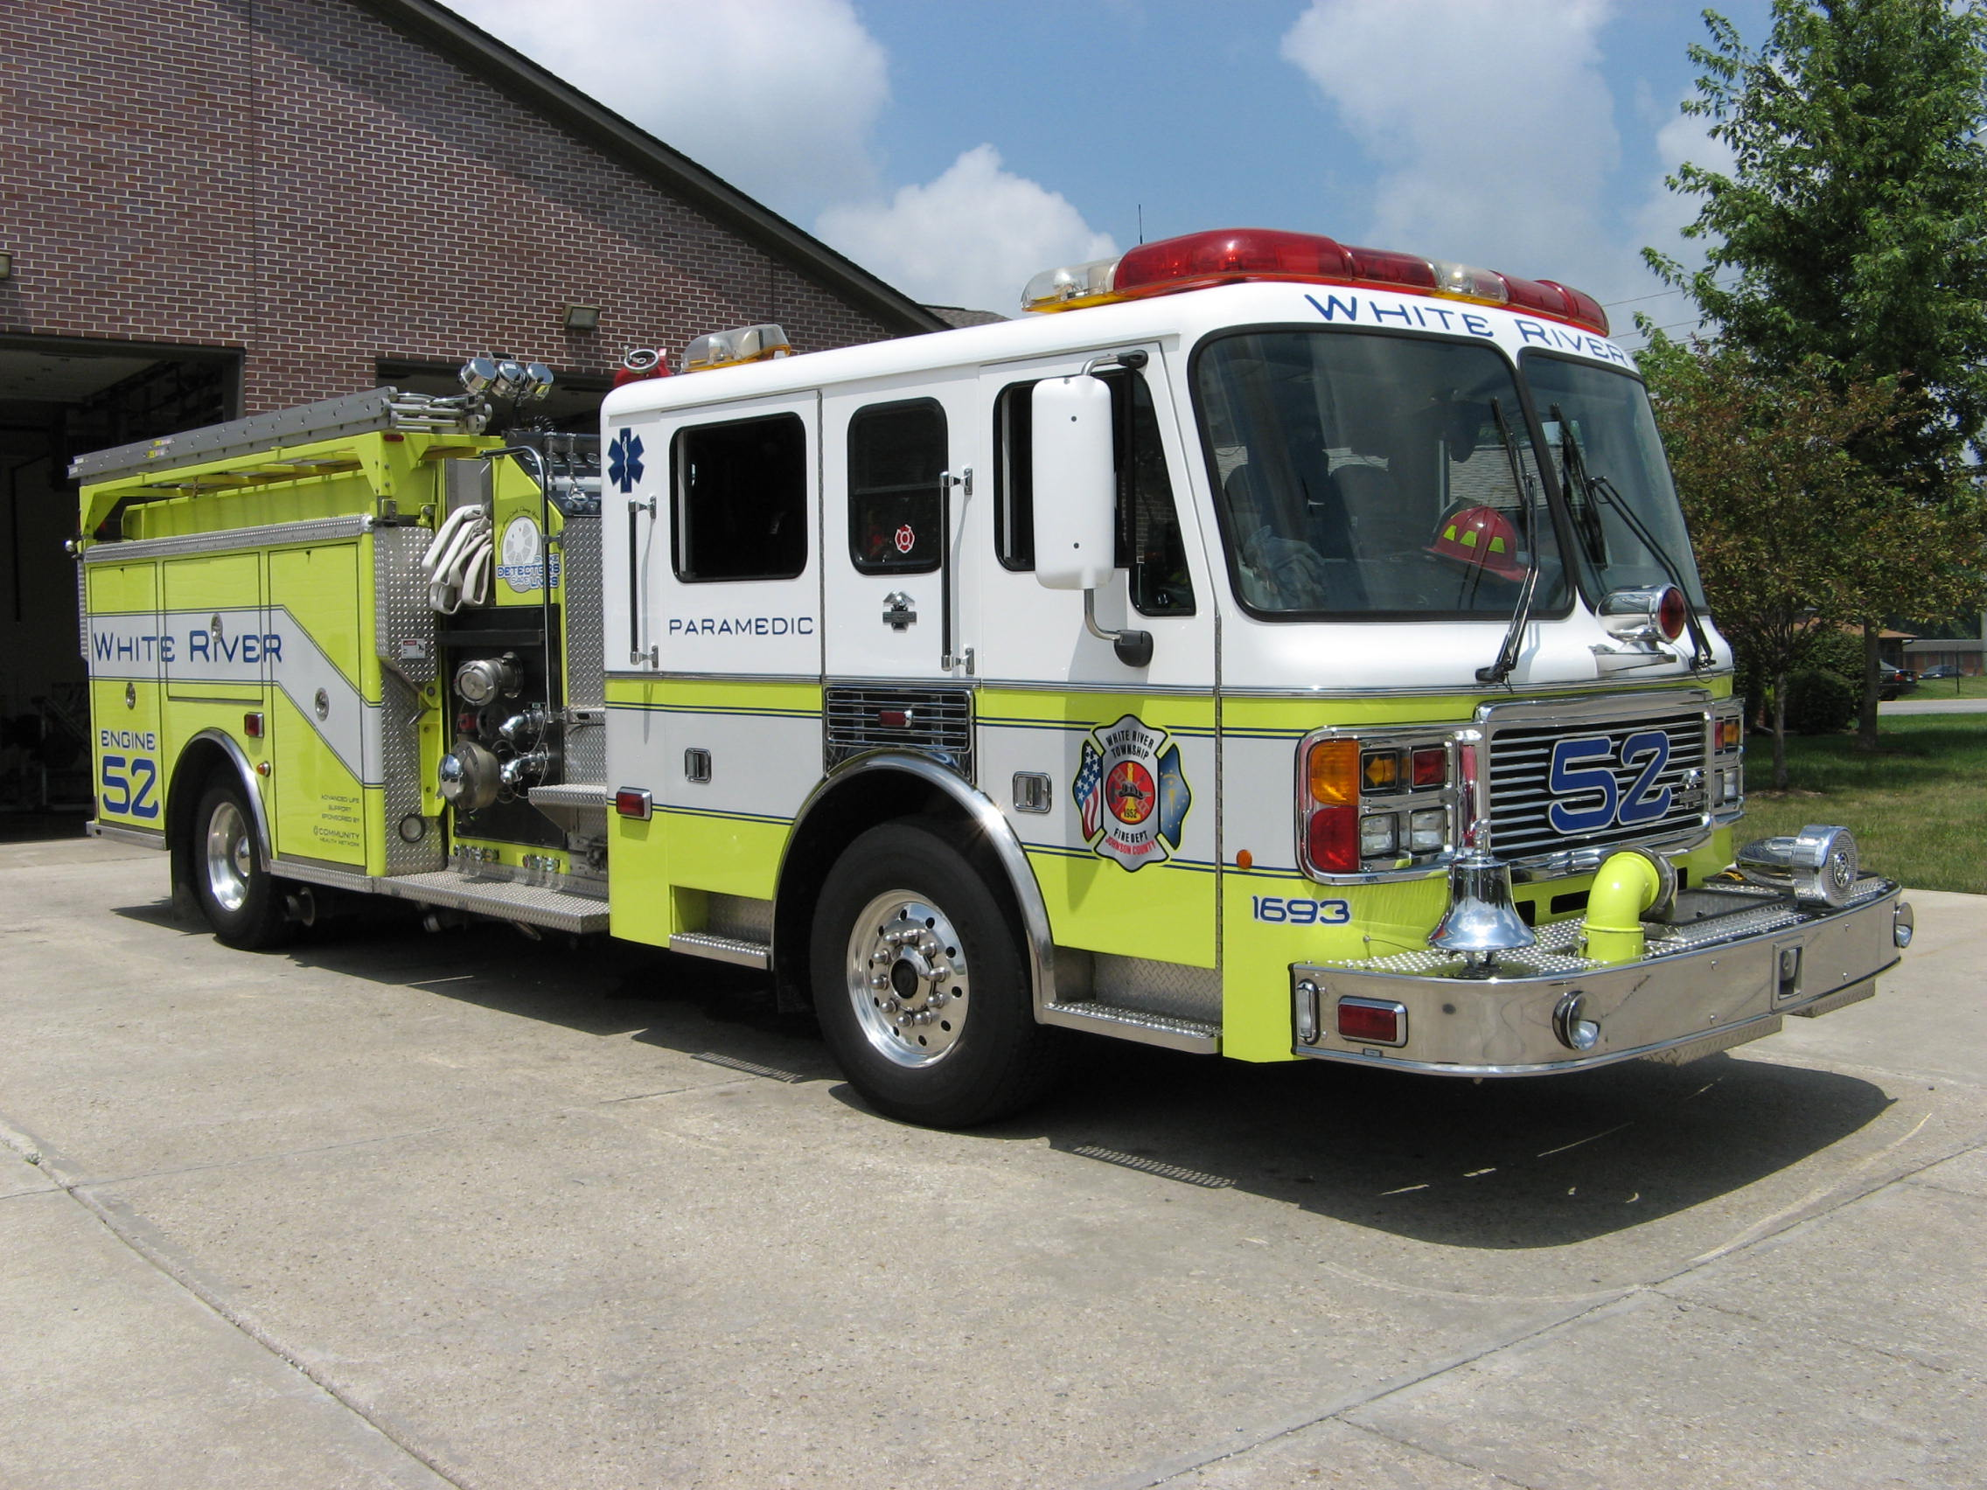 Did you know?

Did you know that the state with the highest percentage of people who walk to work is Alaska?

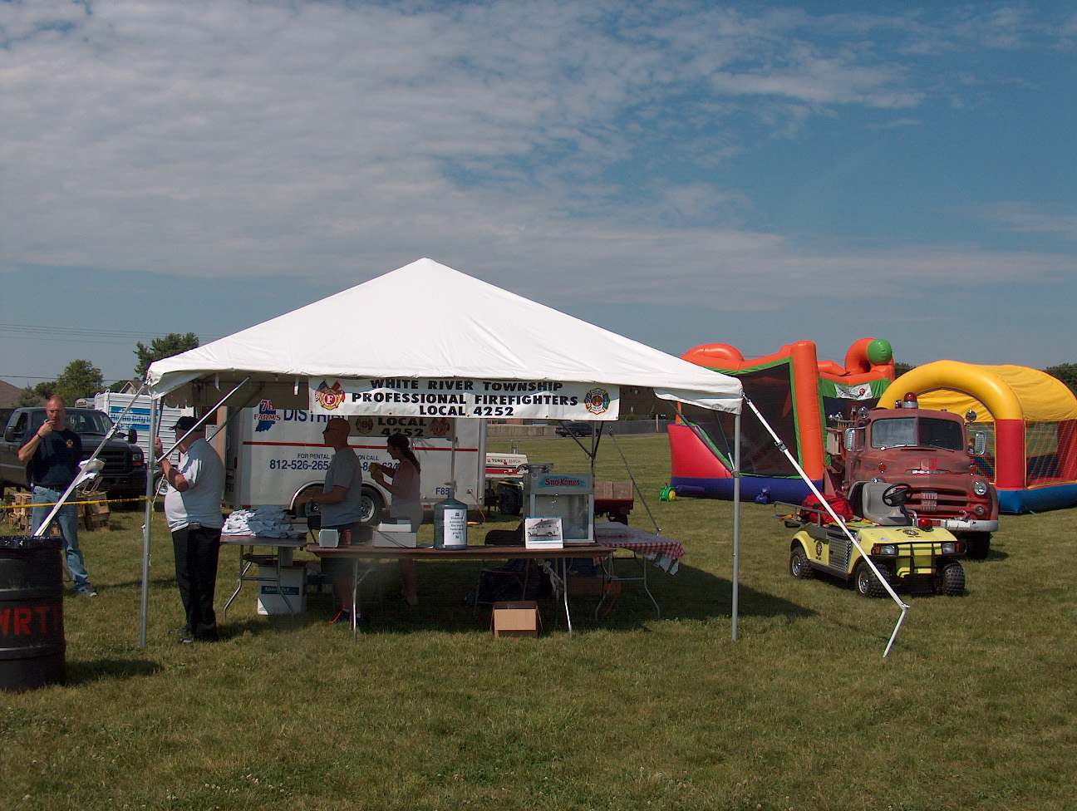 Birthdays (December 12 - 25)

Charles Belden December 14 Shawn Harvey December 15
Jim Engmark December 17 Travis Sichting December 20
Dan Huff December 23 Matthew Oakley December 25

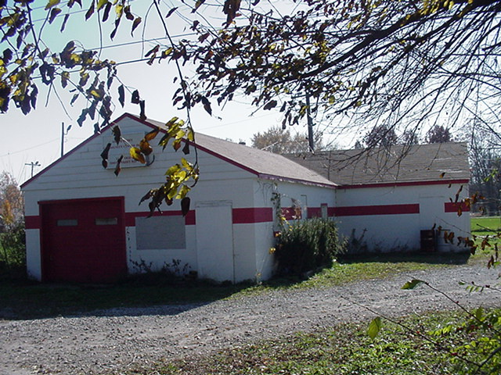 Looking back…..

31 years ago December 18, 1977 All I want for Christmas
For 11-year-old Timmy Rieman, Indiana’s Muscular Dystrophy Poster Child and a resident of White River Township, Christmas came a bit early Sunday. Tim was made an honorary member of the White River Township Volunteer Fire Department during the department’s Christmas party Sunday. He received a fire helmet, firefighter’s insignia and a framed certificate denoting the honor.


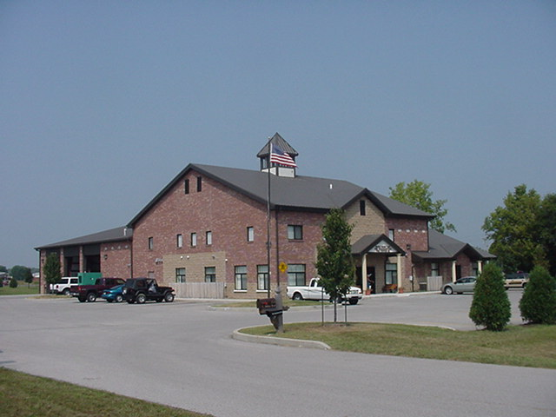 Upcoming events (December 2008 – January 2009)

Fire Protection District Board Meeting January 6, 2009 - 7pm Station 53
December 2008
S | M | T | W | T | F | S
 | 1 | 2 | 3 | 4 | 5 | 6
7 | 8 | 9 | 10 | 11 | 12 | 13
14 | 15 | 16 | 17 | 18 | 19 | 20
21 | 22 | 23 | 24 | 25 | 26 | 27
28 | 29 | 30 | 31
January 2009
S | M | T | W | T | F | S
 |  |  |  | 1 | 2 | 3
4 | 5 | 6 | 7 | 8 | 9 | 10
11 | 12 | 13 | 14 | 15 | 16 | 17
18 | 19 | 20 | 21 | 22 | 23 | 24
25 | 26 | 27 | 28 | 29 | 30 | 31

Classifieds

MLS number 2866095 listing a home for sale on a 9.5 acre lake – 5lb bass, paddle boats, fishing boats, and canoes. Three bedroom, with a master suite, two bath, split floor plan, kitchen, laundry room, great room, fireplace, two car garage, 1495 square feet. Year built 1996, screened in back porch, electrical connection for a hot tub on the patio. The home has a new 30 year roof, the outside and inside has been freshly painted and the home has a new ceramic tile kitchen floor. Please call Judy Hoeping at Tomorrow Realty 881-6407 or log onto the website www.tomorrowrealty.net to see the home.

For sale 2 seater roadster, Cadillac Convertible, 1993, mint condition, red with a black top, leather interior, front wheel drive, to see please call Jackie Emmons. The asking price is $10,000.00.

