

November 28, 2008

Inside this Issue
1 Administration
1 Operations
2 Did You Know?
3 Birthdays
3 Looking Back
4 Upcoming Events
4 Classifieds

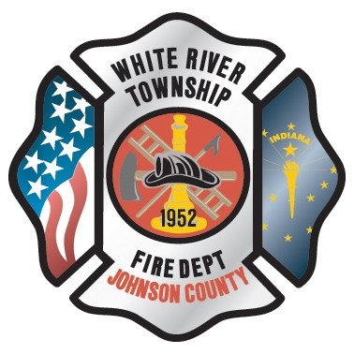 Administration News

Happy Thanksgiving – nothing new to report for the Administration Division

“To effectively and efficiently provide professional services to our community”

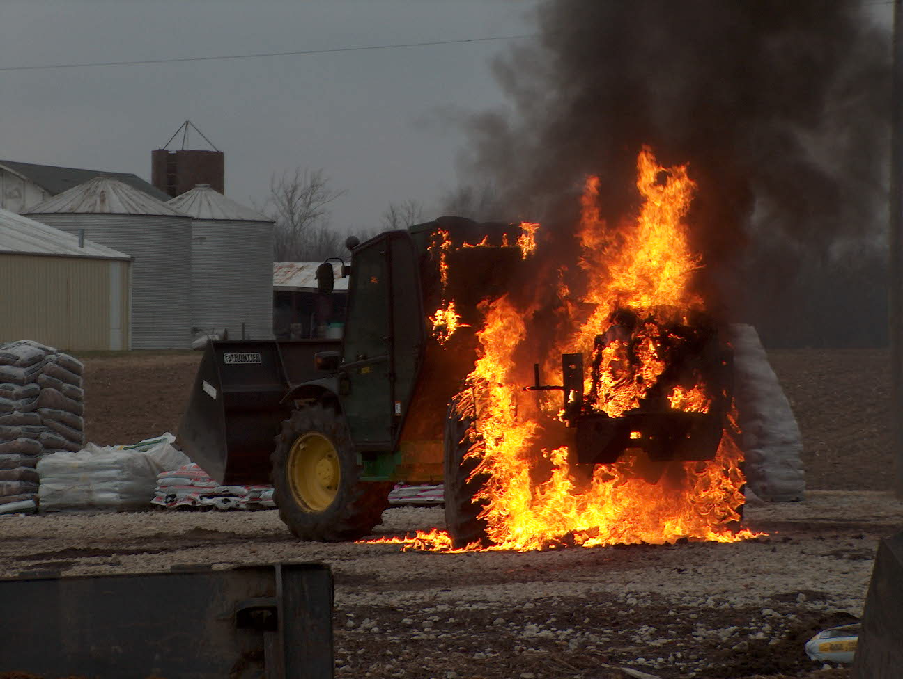 Operations News

We are currently looking at a couple different TICs to replace the damaged unit from Ladder 51. We will have a choice sometime in early December and the order will be placed.

The incident reports are already looking better. If you have any questions about 1710 reporting or any other questions, see your company officer.

A big thank you goes out to Chiefs Engmark, Skipper, Hart, and Thacker, Craig Zollars, Bill Williams, Chris Phillips, Chris Pelley, Kyle Blue, Scott Wiegle, Nathan Poff, Cynthia Bortz, Joe Dietz, and Derrick Norcross for helping with three straight weeks of CPR at CGMSN and CGMSC. You all truly make a difference.

Have a good holiday. Be Smart and Stay Safe

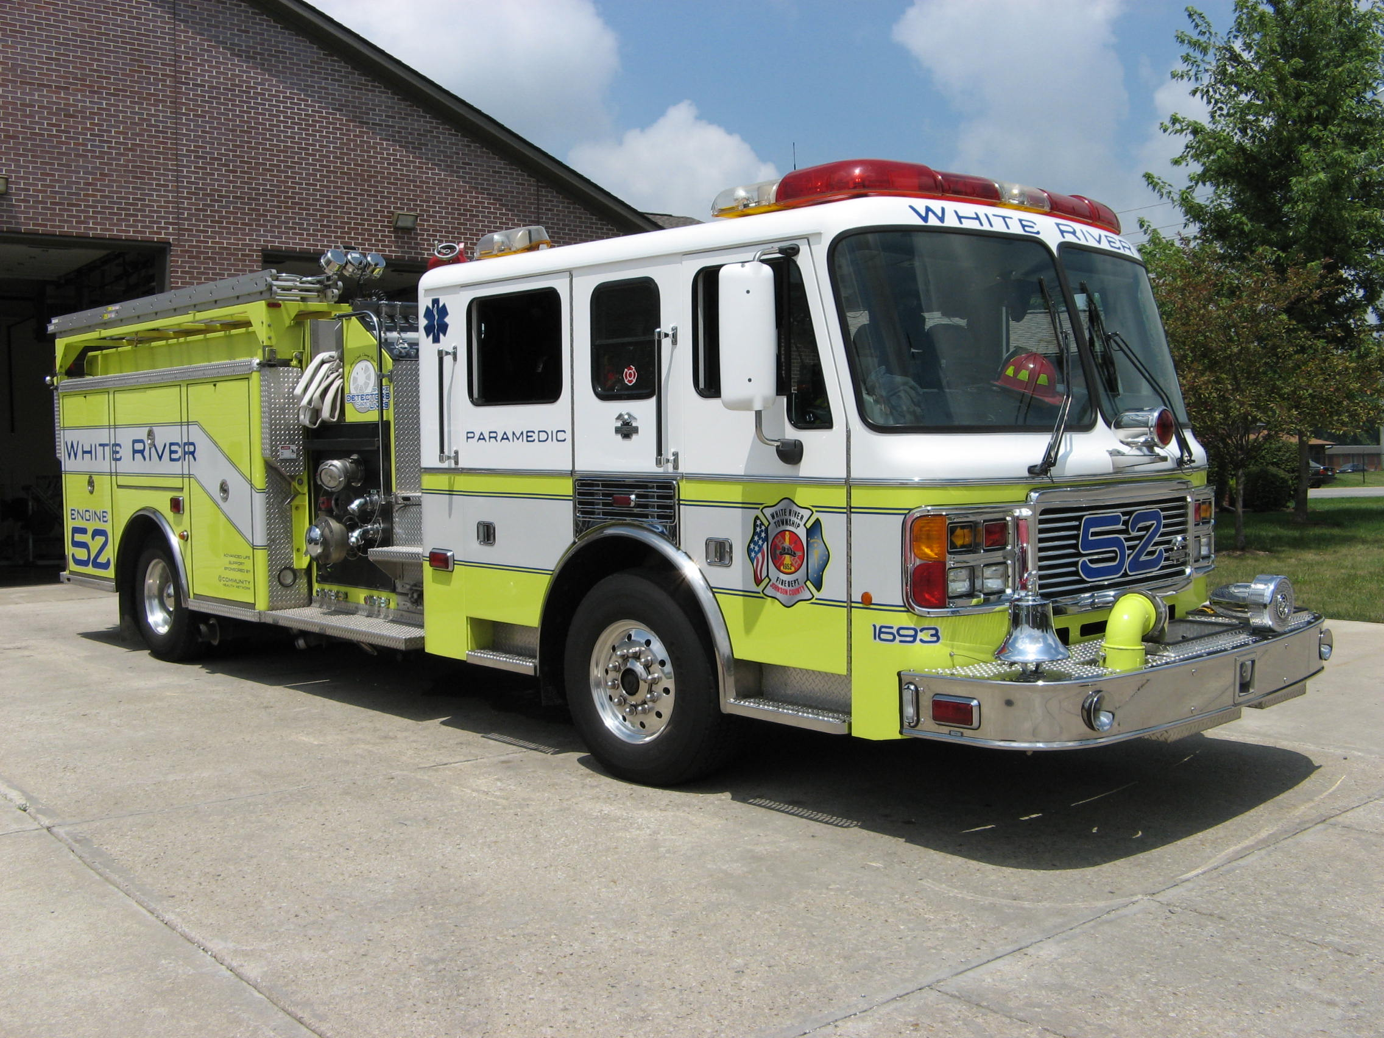 Did you know?

Did you know that Thanksgiving Day is a traditional North American holiday and is a form of harvest festival? The date and whereabouts of the first Thanksgiving celebration is a topic of modest contention, though the earliest attested Thanksgiving celebration was on September 8, 1565 in what is now Saint Augustine, Florida. Despite scholarly research to the contrary, the traditional “first Thanksgiving” is venerated as having occurred at the site of Plymouth Plantation, in 1621. Today, Thanksgiving is celebrated on the second Monday of October in Canada and on the fourth Thursday of November in the United States. Thanksgiving dinner is done in the evening, usually as a gathering of friends and/or family.

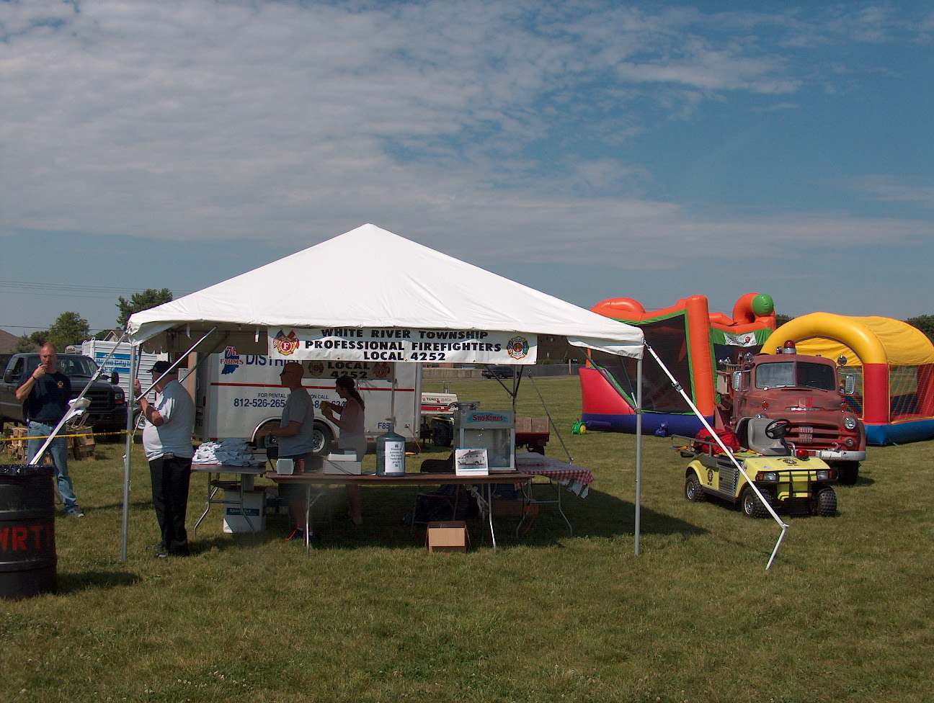 Birthdays (November 28 – December 11)

Joe Green December 1
Mike Combs December 1
Josh Justice December 6
Tim Smith December 10
Ben Roberts December 11
Nick Alford December 11
Greg Maxwell December 11

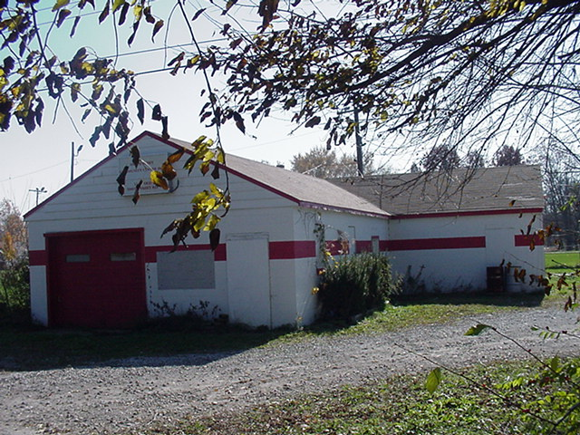 Looking back…..

18 years ago November 30, 1990

Tanker gets new engine, transmission
Fire Chief Howard Bennis and firefighter Ken Deane are seen in the photo below polishing the chrome on Engine 53, a 2,000 gallon pumper-tanker unit that the White River Township Fire Department recently upgraded. "The engine and transmission were both shot and needed to be replaced or have extensive work on them," said Chief Bennis. "Because the transmission was a manual and now over 13 years old, it was decided the best course of action would be to replace both with new equipment," he added. The work was completed last month and the truck was placed back in regular service at the station shortly thereafter.

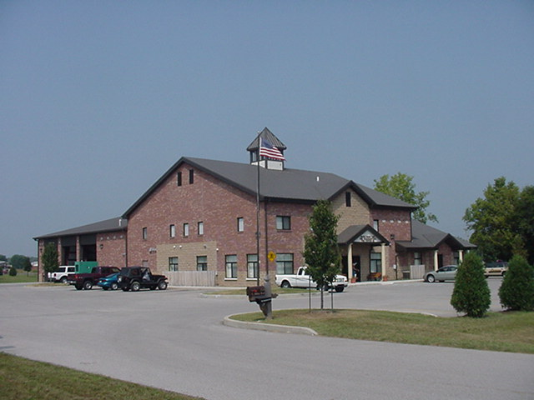 Upcoming events (November – December 2008)

Fire Protection District Board Meeting December 2, 2008 - 7pm Station 53

november 2008
S | M | T | W | T | F | S
 |  |  |  |  |  | 1
2 | 3 | 4 | 5 | 6 | 7 | 8
9 | 10 | 11 | 12 | 13 | 14 | 15
16 | 17 | 18 | 19 | 20 | 21 | 22
23 | 24 | 25 | 26 | 27 | 28 | 29
30
december 2008
S | M | T | W | T | F | S
 | 1 | 2 | 3 | 4 | 5 | 6
7 | 8 | 9 | 10 | 11 | 12 | 13
14 | 15 | 16 | 17 | 18 | 19 | 20
21 | 22 | 23 | 24 | 25 | 26 | 27
28 | 29 | 30 | 31

Classifieds

Please remember if you have an event planned Wedding, Cookout or Church Picnic that you would like to invite everyone to attend please send Jackie Emmons an email. Please let me know that you want it published in the newsletter. Also, remember that we have a large White River Township Fire Department family and an even larger extended Fire Department family because we know a lot of people from other departments. Well brothers and sisters let’s give each other a bit of help in this economy. Please email Jackie Emmons if you are selling a car, motorcycle or if you are looking for an item, such as a special type of car or motorcycle. I will put it in the employee newsletter.

