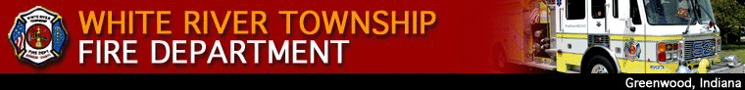

November 14, 2008

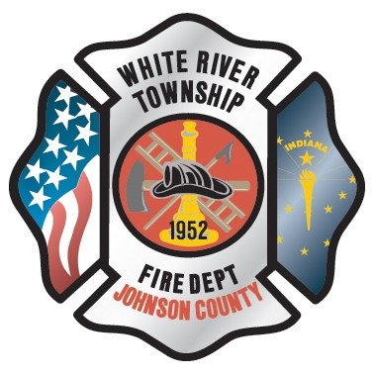 Administration News
Inside this Issue

1 Administration
1 Dec 2008 Schedule
2 Training/EMS
2 Did You Know?
2 Birthdays
3 Looking Back
4 Upcoming Events
4 Classifieds

I have spent the last couple of weeks working on quotes for the computer systems. All quotes will be ready for the December District Board meeting. I have also been working with FH Software on the CAD issues and we believe that there is some interference with the CAD software and the computer backup each evening. FH Software technicians are working on a resolution for this issue. It is hard to believe that we are working on wrapping up 2008. Please make sure you get invoices and reimbursements in to be processed by the 10th of December. This will allow all payments to clear before January 2009. Finally, the 2009 Employee Recognition Dinner is scheduled for January 24, 2009 at Pipers Café (Southport and SR 37). Please make plans to attend. Chief Thacker

“To effectively and efficiently provide professional services to our community”

December 2008 Schedule
So far, 2008 has been an extremely busy year. We have had fires, floods, tornados, and rescues, in addition to training fires, PR events, fundraisers, and personnel changes. With the upcoming holiday season, I am sure you and your families will be busy making holiday plans. The Senior Staff and I have decided to give some breathing room in the usual department schedule. The regularly scheduled training and Officer Development classes have been removed from the schedule for the month of December. Chief Engmark is considering EMS training for anyone that needs in-service hours. There may be some impromptu PR events due to the holidays such as the toy drive. We won’t be event-free, but hopefully this gives some relief to a busy schedule. A job well-done deserves recognition and some relief in the event schedule. Keep up the good work and enjoy the holidays with your crew and families. Chief Pell

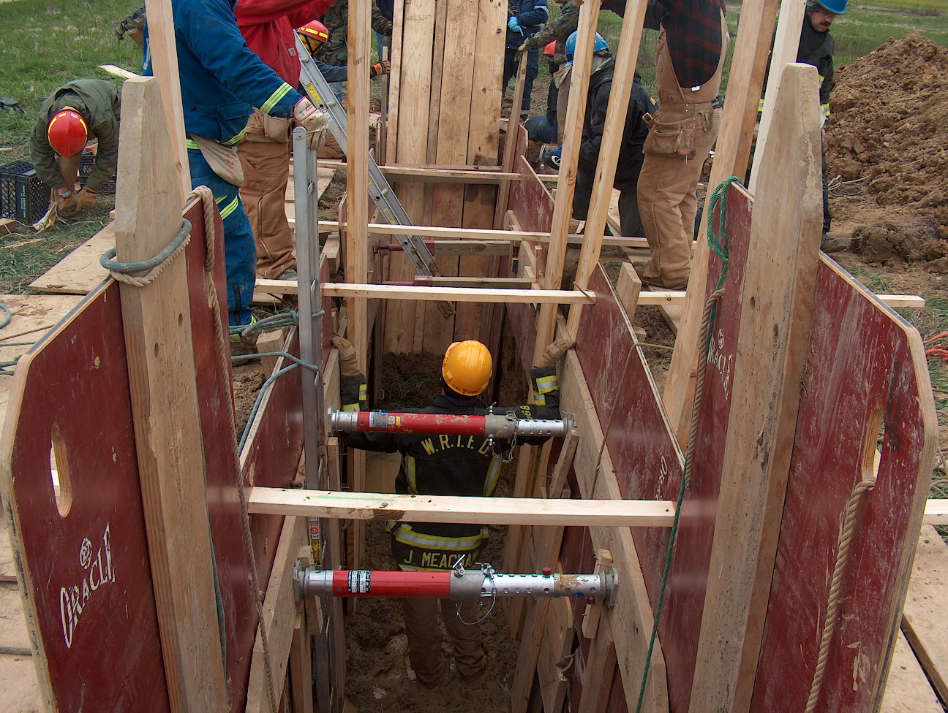 Training/EMS News

Well the NFPA 1403 burns are complete with the exception of burning the house down. Center Grove is filing the demo permit and we should have access to burning the house down soon. I will probably pick a Saturday to do that so that we can possibly do a couple of training burns before burning it down. I know that we had some incidents during the three days but I think we had some very good burns and excellent training. We got approximately 21 burns out of the house, and as small as it was I am very surprised. A big thank you to all the instructors and those that helped prepare the house to burn. I will do a post training report and get that out when it is complete. One thing we do need to remember when doing trainings or actual incidents is that we need pay attention to everything including the small details. We had some equipment damaged that was expensive, and we just can not let that happen. More to come in the training report.

The new ALS combo boxes are in and you will probably see those on your engines soon if you haven’t already.

Run audits are going well and I appreciate everyone’s work on doing EMS run reports. The more detailed that we make our EMS reports the better it is for you in the long run, especially if you end up in court one day and you have to rely on your run report to testify.

Train as if your life depends on it, because it does! Happy Holidays!

Chief Engmark

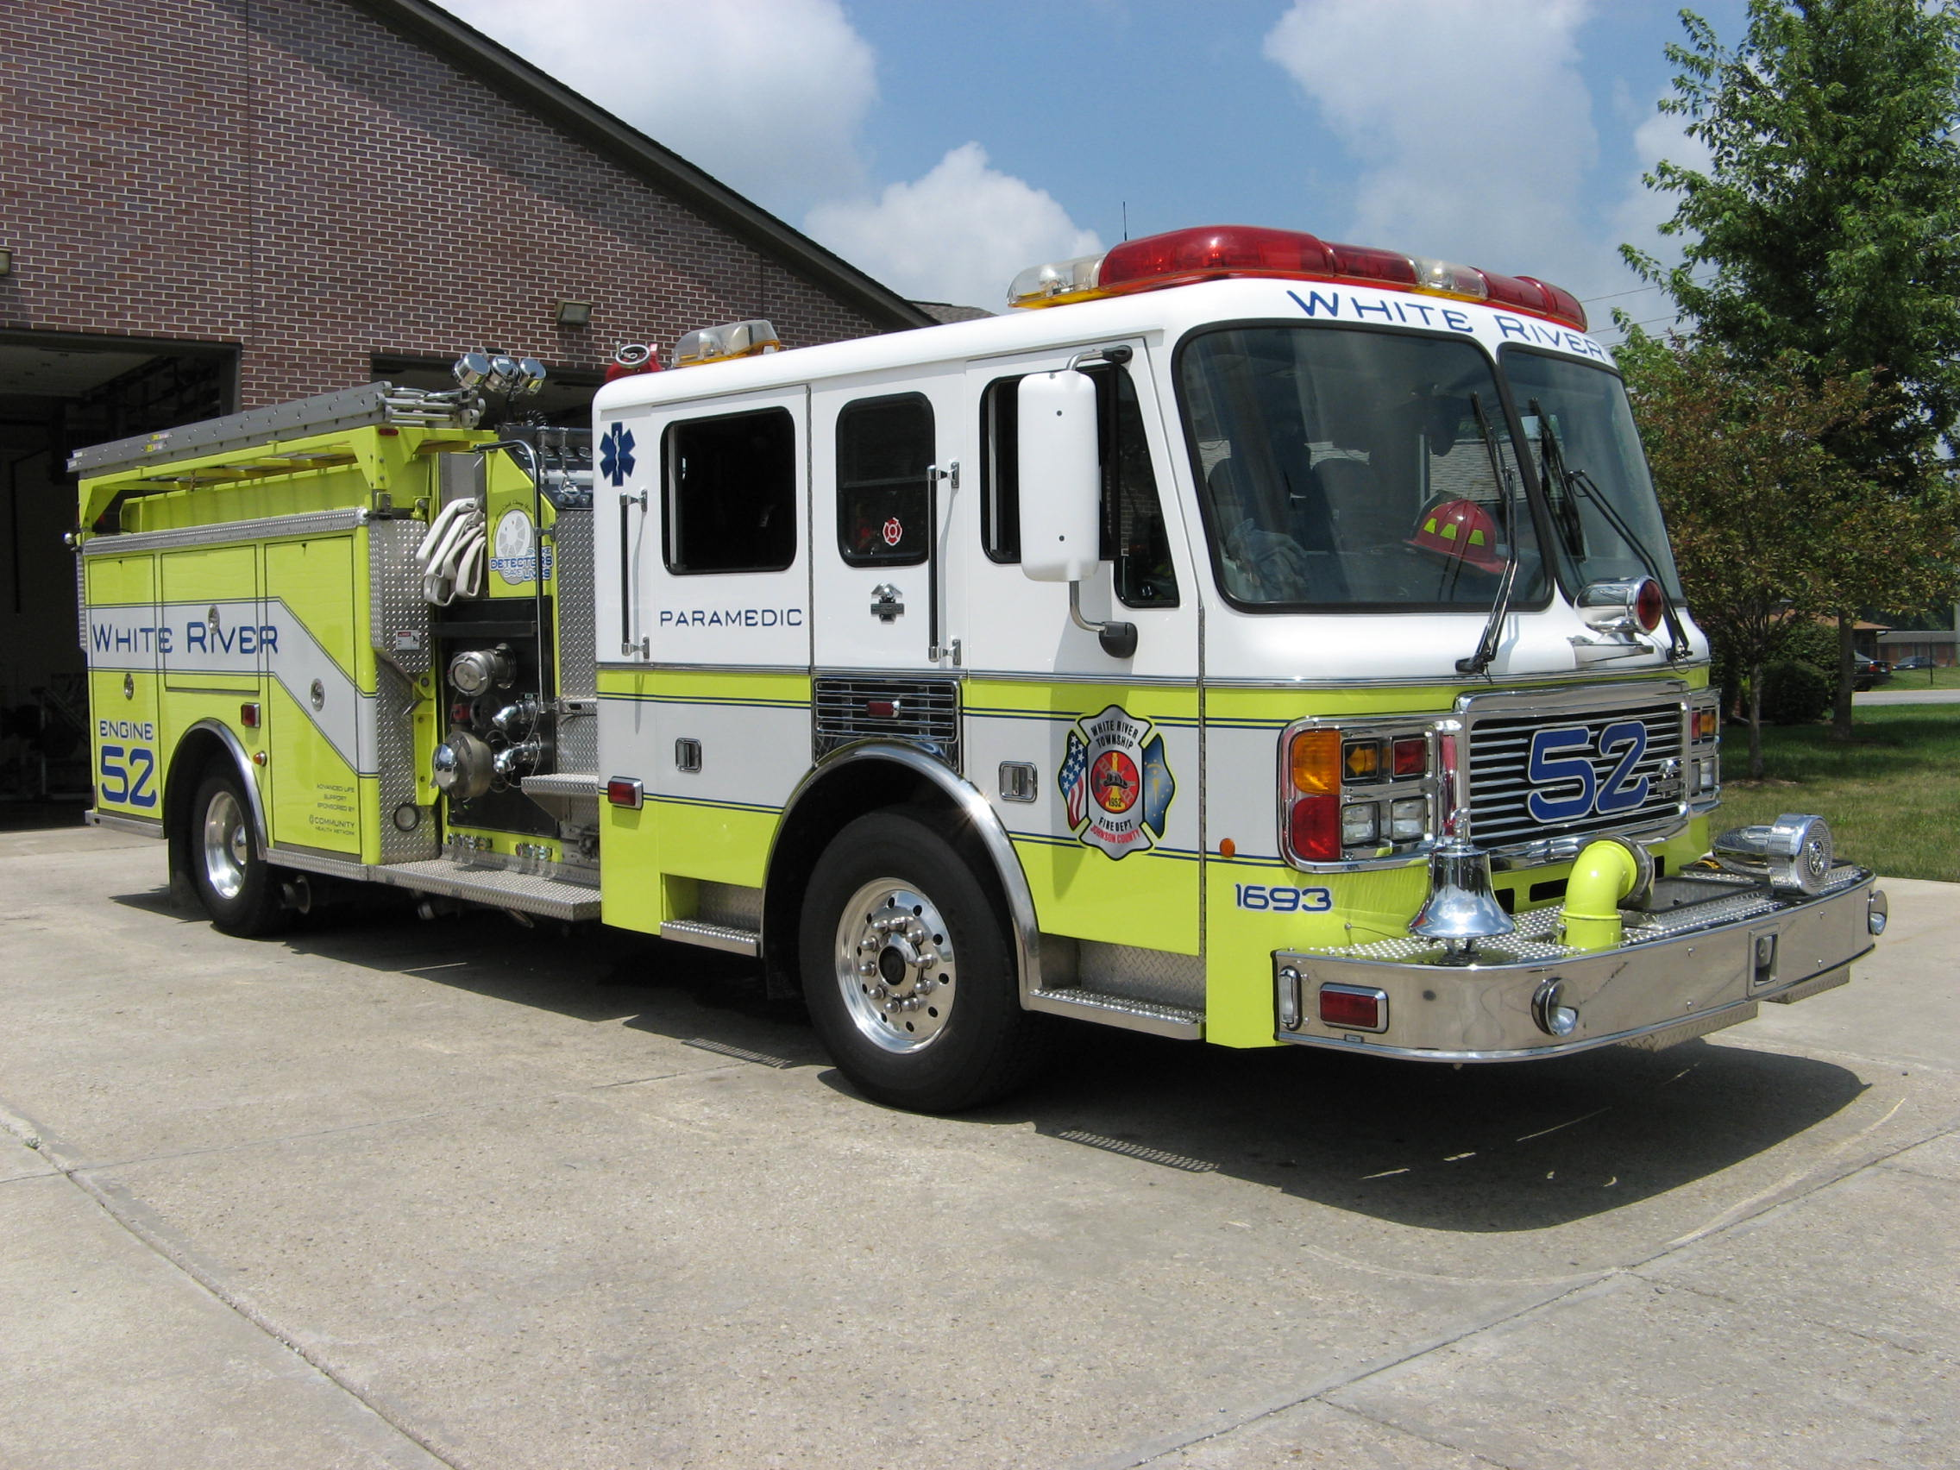 Did you know?

Did you know that the city with the most Rolls Royce’s per capita is Hong Kong?

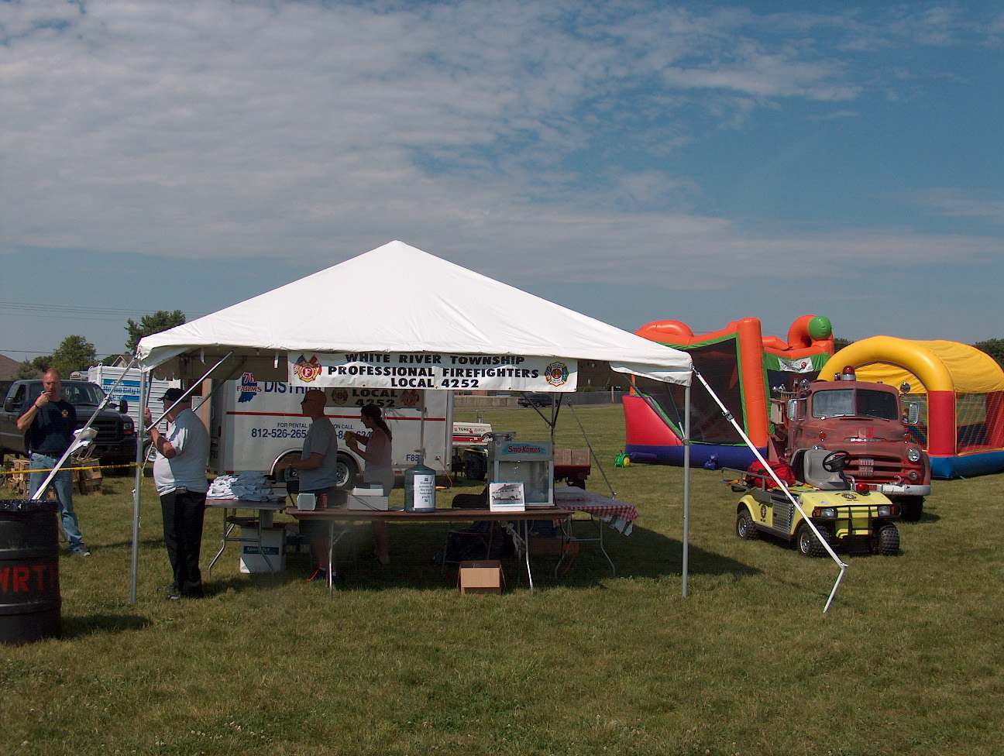 Birthdays (November 14 – November 27)

Tony Slusher November 15
Joshua Flagle November 17
Casey Arkins November 17
Steve Gorman November 20

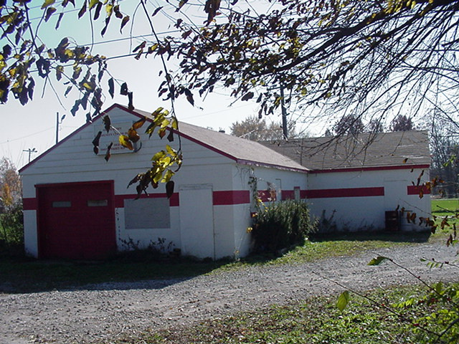 Looking back…..

19 years ago

November 14, 1989

Caring fireman loves saving lives

Sophomore Ryan Ford feels that White River Township Volunteer Fire Department’s cadet program is “really helpful to the community.” Ford became interested through his friend Kevan Crawley, who is currently the chief cadet, and began training last August. The cadets attend classes every Thursday night and one Sunday a month in order to accumulate the 24 hours of training required to actively participate in emergency runs. During training the cadets learn such things as emergency medical procedures, the behavior of fire, and practical use of the equipment. Cadets may also attend additional classes on Saturdays to earn points and learn other duties of fireman such as fire checks in local businesses. Each of the cadets has a scanner in their car that receives all dispatch calls. In response to a dispatch call any available cadets report to the station. They are then transported to the emergency by the station pick-up truck or another emergency vehicle. There must be adults with the cadets at all times and the cadets must remain outside if there is a fire. Ford assures that this is a “big responsibility” and that the cadets are still very helpful. They can hold hoses and do additional things to aid those inside. “I love it!” Ford says of the cadet program. “It’s really neat you know what to do when something (an emergency) happens.” The emergency medical experience is especially valuable to Ford since his father has been the victim of a heart attack. He feels more secure now, since he has some emergency medical training and would know what to do should it happen again. Being a volunteer cadet has definitely had an effect on Ford. He plans to volunteer as a fireman in his spare time after attending college and pursuing his ambition of becoming a pilot.

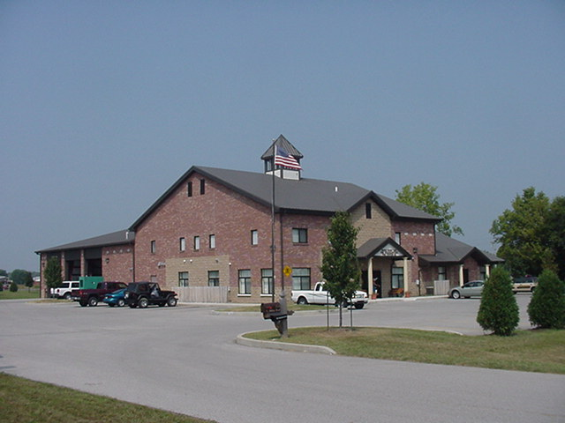 Upcoming events (November – December 2008)

Fire Protection District Board Meeting December 2, 2008 - 7pm Station 53

november 2008
S | M | T | W | T | F | S
 |  |  |  |  |  | 1
2 | 3 | 4 | 5 | 6 | 7 | 8
9 | 10 | 11 | 12 | 13 | 14 | 15
16 | 17 | 18 | 19 | 20 | 21 | 22
23 | 24 | 25 | 26 | 27 | 28 | 29
30
december 2008
S | M | T | W | T | F | S
 | 1 | 2 | 3 | 4 | 5 | 6
7 | 8 | 9 | 10 | 11 | 12 | 13
14 | 15 | 16 | 17 | 18 | 19 | 20
21 | 22 | 23 | 24 | 25 | 26 | 27
28 | 29 | 30 | 31

Classifieds

Please remember if you have an event planned Wedding, Cookout or Church Picnic that you would like to invite everyone to attend please send Jackie Emmons an email. Please let me know that you want it published in the newsletter. Also, remember that we have a large White River Township Fire Department family and an even larger extended Fire Department family because we know a lot of people from other departments. Well brothers and sisters let’s give each other a bit of help in this economy. Please email Jackie Emmons if you are selling a car, motorcycle or if you are looking for an item, such as a special type of car or motorcycle. I will put it in the employee newsletter.

