

October 17, 2008
Inside this Issue
1 Administration
2 Operations
2 Training/EMS
3 Did You Know?
3 Birthdays
4 Looking Back
4 Upcoming Events
4 Classifieds

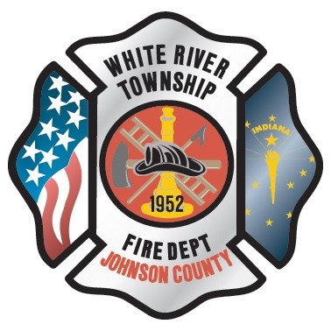 Administration News

As I am penning this article, we are working on getting quotes for the computer and networking upgrades to the current system. I hope to have these in time for the November District Board meeting.

We will be putting a new purchase order program in place at the first of the year. I will conduct training on this system for all of those that have purchase authorization abilities. This software will help us better manage the invoices that come into the office.

Over the last month the Firehouse CAD program has been down at some point every day. I have been in discussion with Firehouse and have updated the program without much change. The problem may lie with the computer backup each day. I am still trying to establish a pattern of trouble. The bottom line is if the run does not appear in Firehouse when you return to complete the information, call Greenwood Dispatch and get the run number and times. Do not delay completing the report because it is not in the computer. Chief Slauter and I check the system often and will try to keep these issues to a minimum. I will provide a better update as I receive more information. Please forward any questions or concerns about the Firehouse Software to me so I can understand the problems and get them worked out.

“To effectively and efficiently provide professional services to our community”

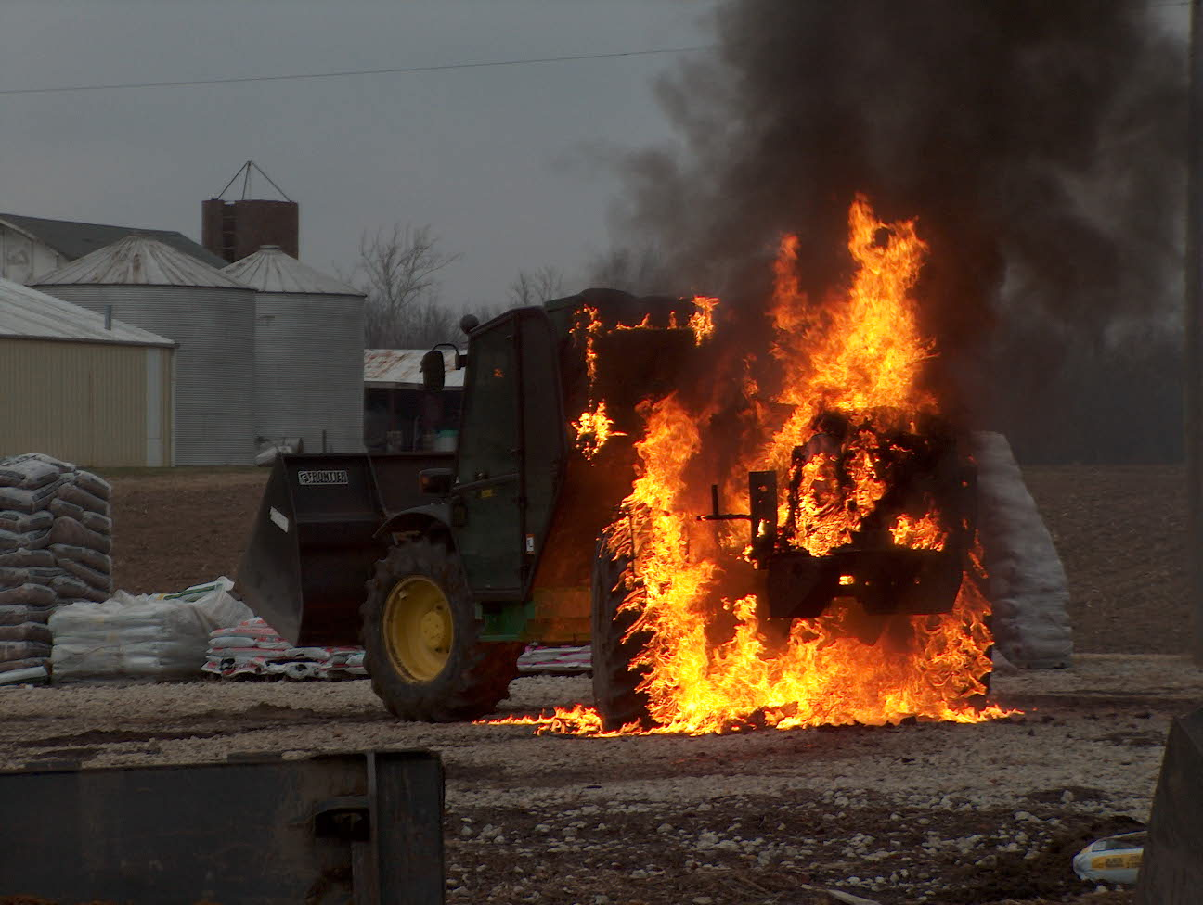 Operations News

We have secured three different SCBA manufacturer models to test during the NFPA 1403 burns in November. MSA, Scott, and ISI will have representatives on the site to answer any questions. My intent is to have an evaluation form created for performance feedback from the three different brands.

This is the last chance for part time employees to bid on any open shift positions. After next week, these open spots will be offered to new employees. See the Battalion Chief of the respective shift if you are interested. I would also encourage any sign up individuals to share a shift with another sign up person.

Please use caution with the apparatus laptops, especially the screens. We have had to repair two damaged screens in the last couple of months.

Now that the Rescue 51 project is complete, the special operations team will begin the project of purchasing the new collapse rescue trailer. Captain Settles will oversee this project. All questions and ideas should be submitted to Captain Settles.

Thanks to all who assisted with the Center Grove Middle School North Football Game EMS Coverage. I have heard many positive comments from parents and staff stating how thankful they are that we are present during the games.

Remember to submit any year end equipment requests to your station captain.

BE SMART AND STAY SAFE

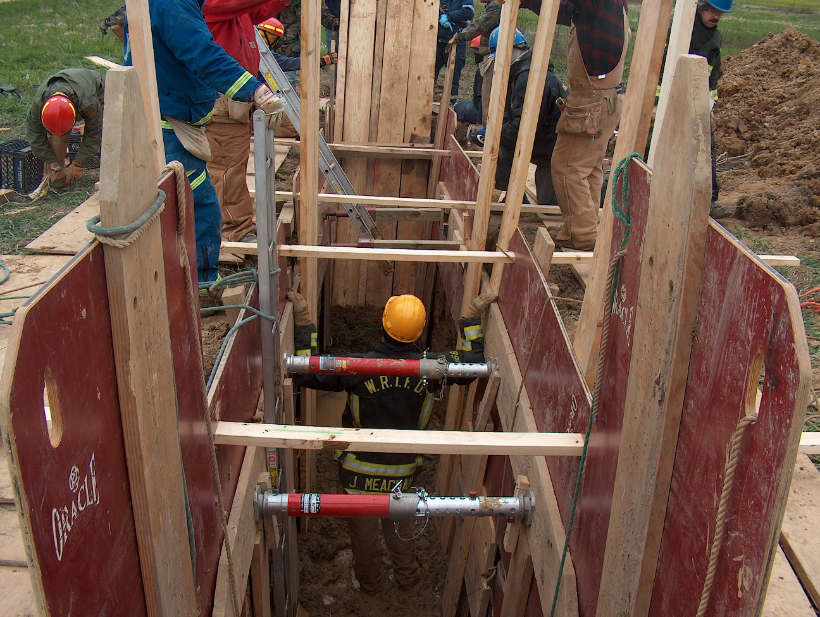 Training/EMS News

We finally have the asbestos report that we needed to do the NFPA 1403 burns at the house on Morgantown Road. We have set the new dates for November 10th, 11th, and 12th. We still have a few things to finish up to get the house ready, but it will not take long to finish those up. We will have some new SCBA’s to use for testing during the burns as well. Chief Slauter has set that up with the different reps and they will be there as well to answer any questions we might have. We will also be doing some digital radio testing during the burns, and along with that we will have some dispatchers there to see how and why we do the things we do on fires so that they might get a better perspective of our job to help them when they are in the communications center. We will do some training on the digital talk groups the week before the burns as well.

October 28th, 29th, and 30th will be the Live Wire demo from Duke Energy, I think I put the wrong dates in last months newsletter. If you have any questions on that just get with Dale Saucier.

The cars were delivered to McCarty’s old mulch farm and training is underway for extrication. Please get as much training as you can on these cars while they are there. Thanks to Dale Saucier for getting that set up. Your shift training officers should have a schedule for you on what to do to the cars. Next weeks training is company level and can be used for the extrication training as well.

The new ALS combo boxes came in however they were the wrong size, so they have been sent back and the new ones should be here in the next week or so. Don’t forget Audit and Review is October 22nd at 2PM at HQ. Also please keep track of your EMS hours and when your book is due. We had a few people wait until crunch time recently and it is hard to get everything completed and up to the state in a short period of time. The last group of Run Audits that I received from Dr. Gansman had a good amount of ATTABOYS so keep up the good work on the EMS reporting.

Train as if your life depends on it, because it does!

Be Smart and Stay Safe! Chief Engmark

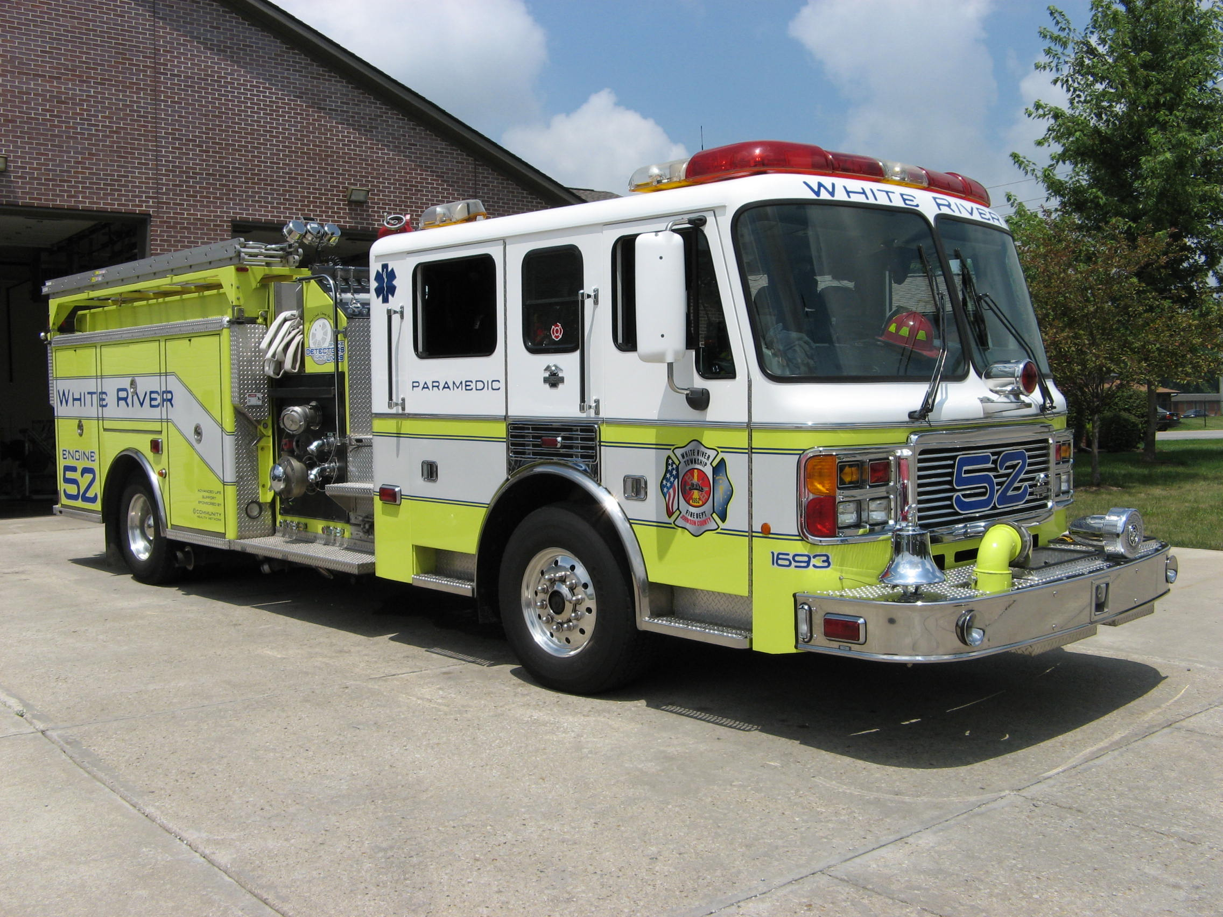 Did you know?

Did you know that the amount of money saved by American Airlines in 1987 by eliminating one olive from each salad served first class was $40,000.00?

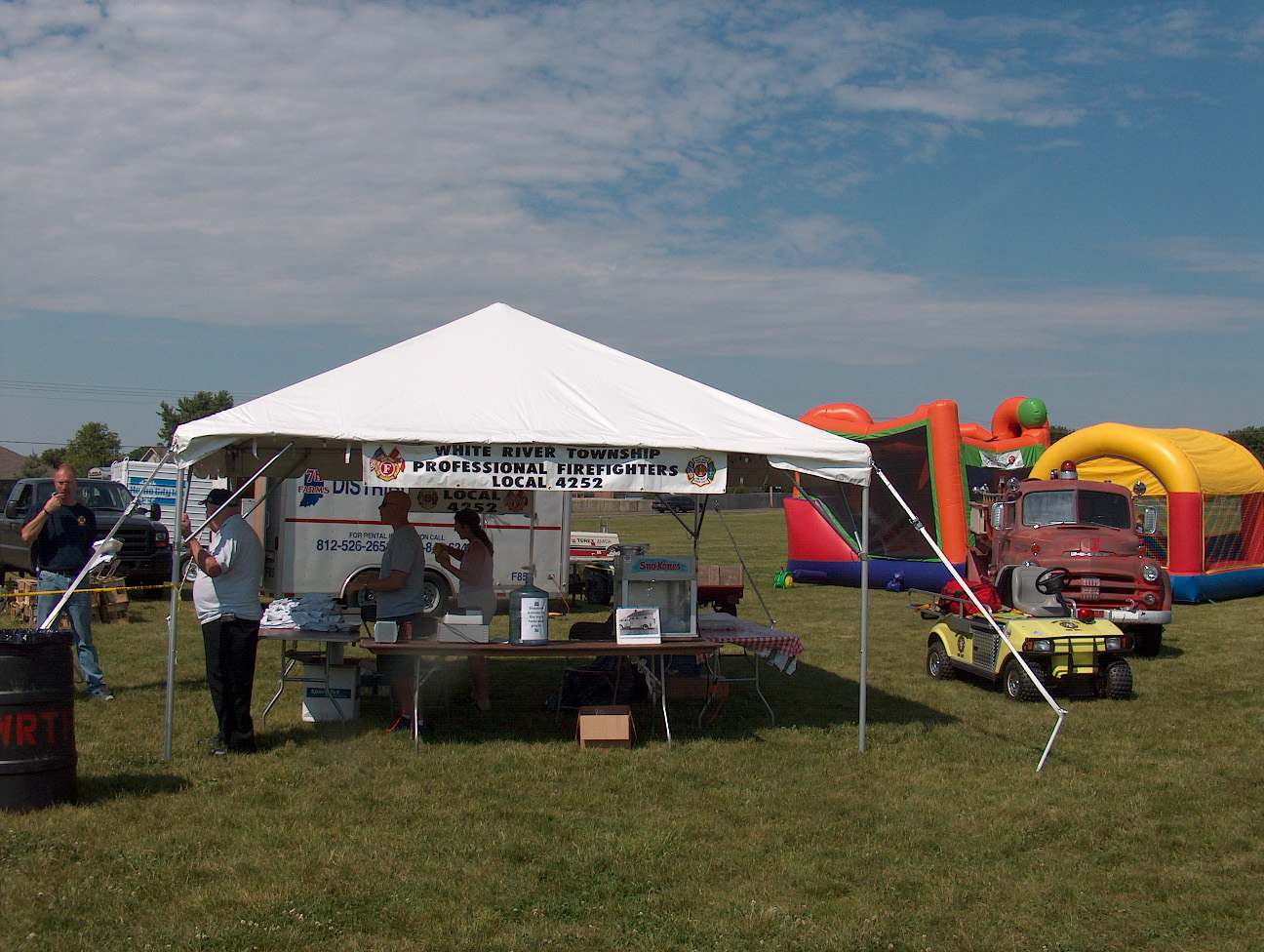 Birthdays (October 17 – October 30)

Corey McGaha October 18
Kyle Brooks October 19
Lorrick McCullum October 20
Steve Ladd October 20
Kyle Blue October 28
Jim Meacham October 28
Carey Slauter October 29

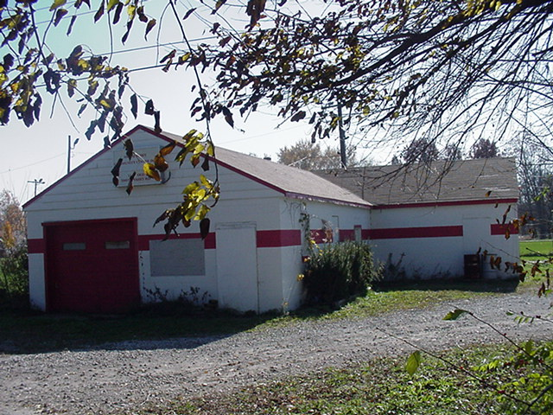 Looking back…..

36 years ago October 20, 1972 New fire truck arrives
White River Township volunteer firemen took delivery today of a new fire truck built by Howe Fire Apparatus, Inc. The truck is valued at $41,000.

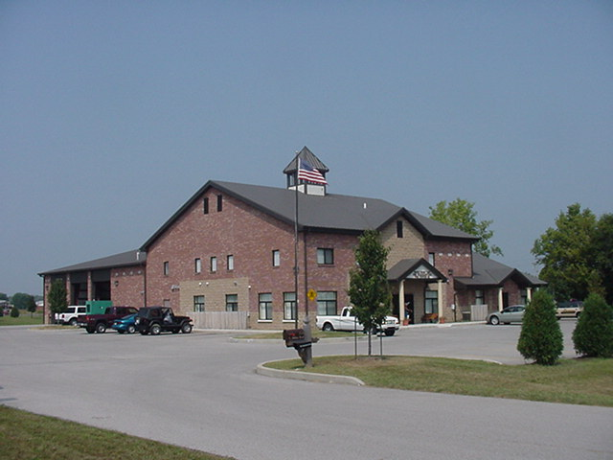 Upcoming events (November – December 2008)

Fire Protection District Board Meeting November 4, 2008 - 7pm Station 53

november 2008
S | M | T | W | T | F | S
 |  |  |  |  |  | 1
2 | 3 | 4 | 5 | 6 | 7 | 8
9 | 10 | 11 | 12 | 13 | 14 | 15
16 | 17 | 18 | 19 | 20 | 21 | 22
23 | 24 | 25 | 26 | 27 | 28 | 29
30
december 2008
S | M | T | W | T | F | S
 | 1 | 2 | 3 | 4 | 5 | 6
7 | 8 | 9 | 10 | 11 | 12 | 13
14 | 15 | 16 | 17 | 18 | 19 | 20
21 | 22 | 23 | 24 | 25 | 26 | 27
28 | 29 | 30 | 31

Classifieds

Please remember is you have an event planned Wedding, Cookout or Church Picnic that you would like to invite everyone to attend please send Jackie Emmons an email. Please let me know that you want it published in the newsletter. Also, remember that we have a large White River Township Fire Department family and an even larger extended Fire Department family because we know a lot of people from other departments. Well brothers and sisters let’s give each other a bit of help in this economy. Please email Jackie Emmons if you are selling a car, motorcycle or if you are looking for an item, such as a special type of car or motorcycle. I will put it in the employee newsletter.

