

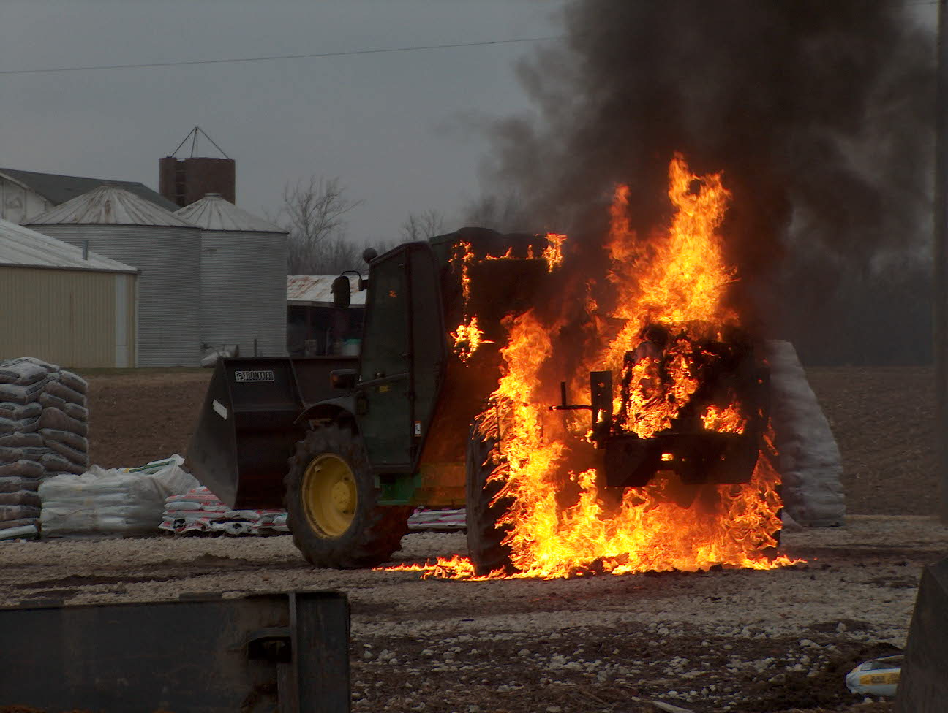 Operations News
October 3, 2008

Inside this Issue
1 Operations
2 Prevention
2 Training/EMS
3 Did You Know?
3 Birthdays
3 Looking Back
4 Upcoming events
4 Classifieds

The cones and road sign are in for the update to the Roadway Safety SOG. Chief Engmark and Engineer Saucier will be working on the SOG and placing the equipment on the apparatus. We are still waiting on the vests to be delivered.

The Rescue 51 project is about 99 percent complete. Once it is completely finished, we will start working on the technical rescue trailer project. Captain Settles will be the lead for this project.

Please remember to make sure someone from your crew is carrying the MECA pager during your entire shift. In order for this system to function effectively and efficiently, we need to be responding to Perry Township quickly, but safely.

On duty crews will be assisting with Fire Prevention next week. Your shift Battalion Chief will be briefing you concerning crew participation. Please make sure that you have your Class B shirt with you next week.

When entering street names on the basic screen tab for Firehouse NFIRS reports, please make sure you select the street name menu using the F2 key. Just because Fire Control enters the street name, that doesn’t mean it is correct. Also, if a room or apartment number is given, please enter that information in the area provided. This may seem trivial, but it is necessary in order to extract the correct data from Firehouse. Please see your Battalion Chief if you have any questions.

Thanks again for the hard work you do everyday to make our department stronger and our community safer. Be Smart and Stay Safe

“To effectively and efficiently provide professional services to our community”

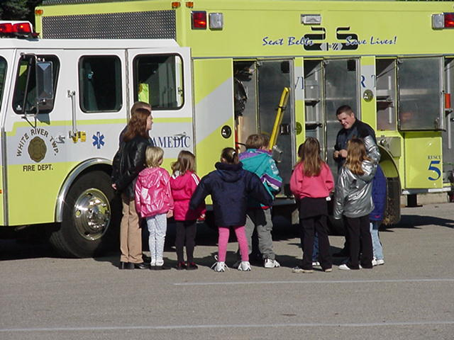 Fire Prevention News

Celebrate Fire Prevention Week with White River Township Fire Department Thursday, October 9th, 2008. Time: 5pm to 8pm. Location: Fire Station 51 - 3016 W. Olive Branch Road. There will be food, safety talks and station tours.

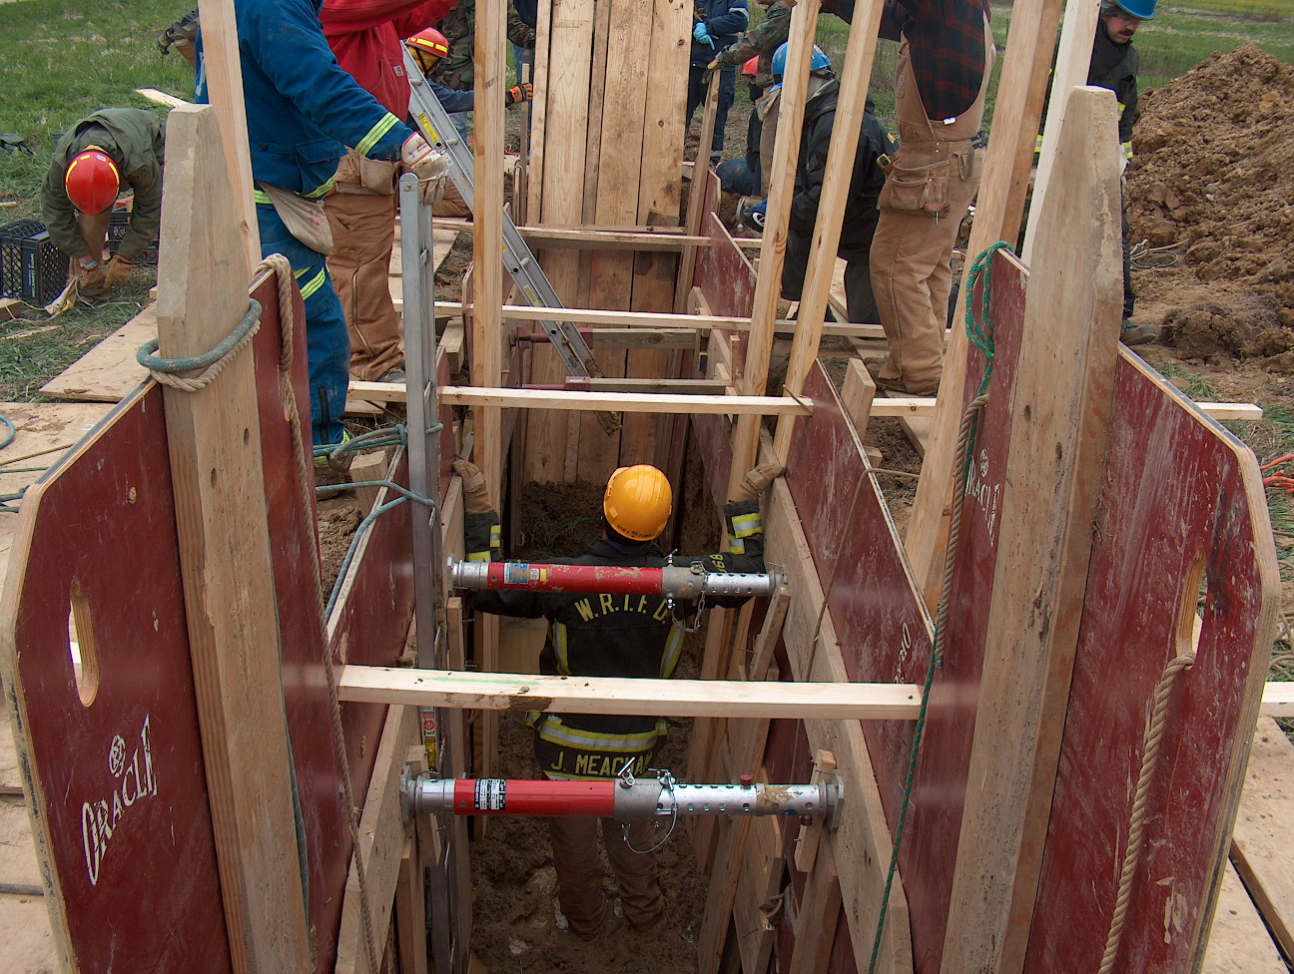 Training/EMS News

I want to thank everyone who came by HQ on September 18th and spoke to the rep from Columbia Southern University. I thought we had a really good turn out. The rep stated that there were several people interested in their program. I think this is a great program and hope that anyone that signs up enjoys it as well.

Autism awareness training went real well and they will be returning in the next couple of months to show us their new video that they are finishing up soon. This is a firefighter based DVD so it should be pretty good. She is going to set up a date and time so that she can visit all three shifts again and show the video and hopefully have some interaction with some of their kids. I think this interaction is important for us, so that we can get familiar with some of these great kids. Thanks to everyone for their input during the trainings.

We will be doing the NFPA 1403 burns at the house on Morgantown Road October 13th, 14th, and 15th. We will start at 0900hrs and try to be finished up by noon. Some crews have already went down and started to prepare the house for burning. The cadets will be going down Thursday night 10/2/08 to do some more work. We will start getting the shingles off the house probably the week before we do the burns. We want to leave them on as long as we can so in case it rains we don’t get the inside of the house too wet. Please get with your shift training officers as they will be scheduling times to go down and finish up that work. Thanks to everyone in advance for preparing this house for the burns. Depending on how things go that week, we might look at burning the rest of the house down on October 17th.

October 28th, 29th and 30th Dale Saucier has set up live wire demo training through Duke Energy. This will be a daytime training only, so if there is any night shift people that would like to see this demo please try and attend one of these days. This is a great demonstration to see if you have never seen it.

Don’t forget Audit and Review coming up in October, the date is the 22nd at 2PM. I am in the process of ordering some new ALS combo boxes made by Pelican, so you should see those coming soon.

Train as if your life depends on it, because it does!
Be Smart and Stay Safe! Chief Engmark

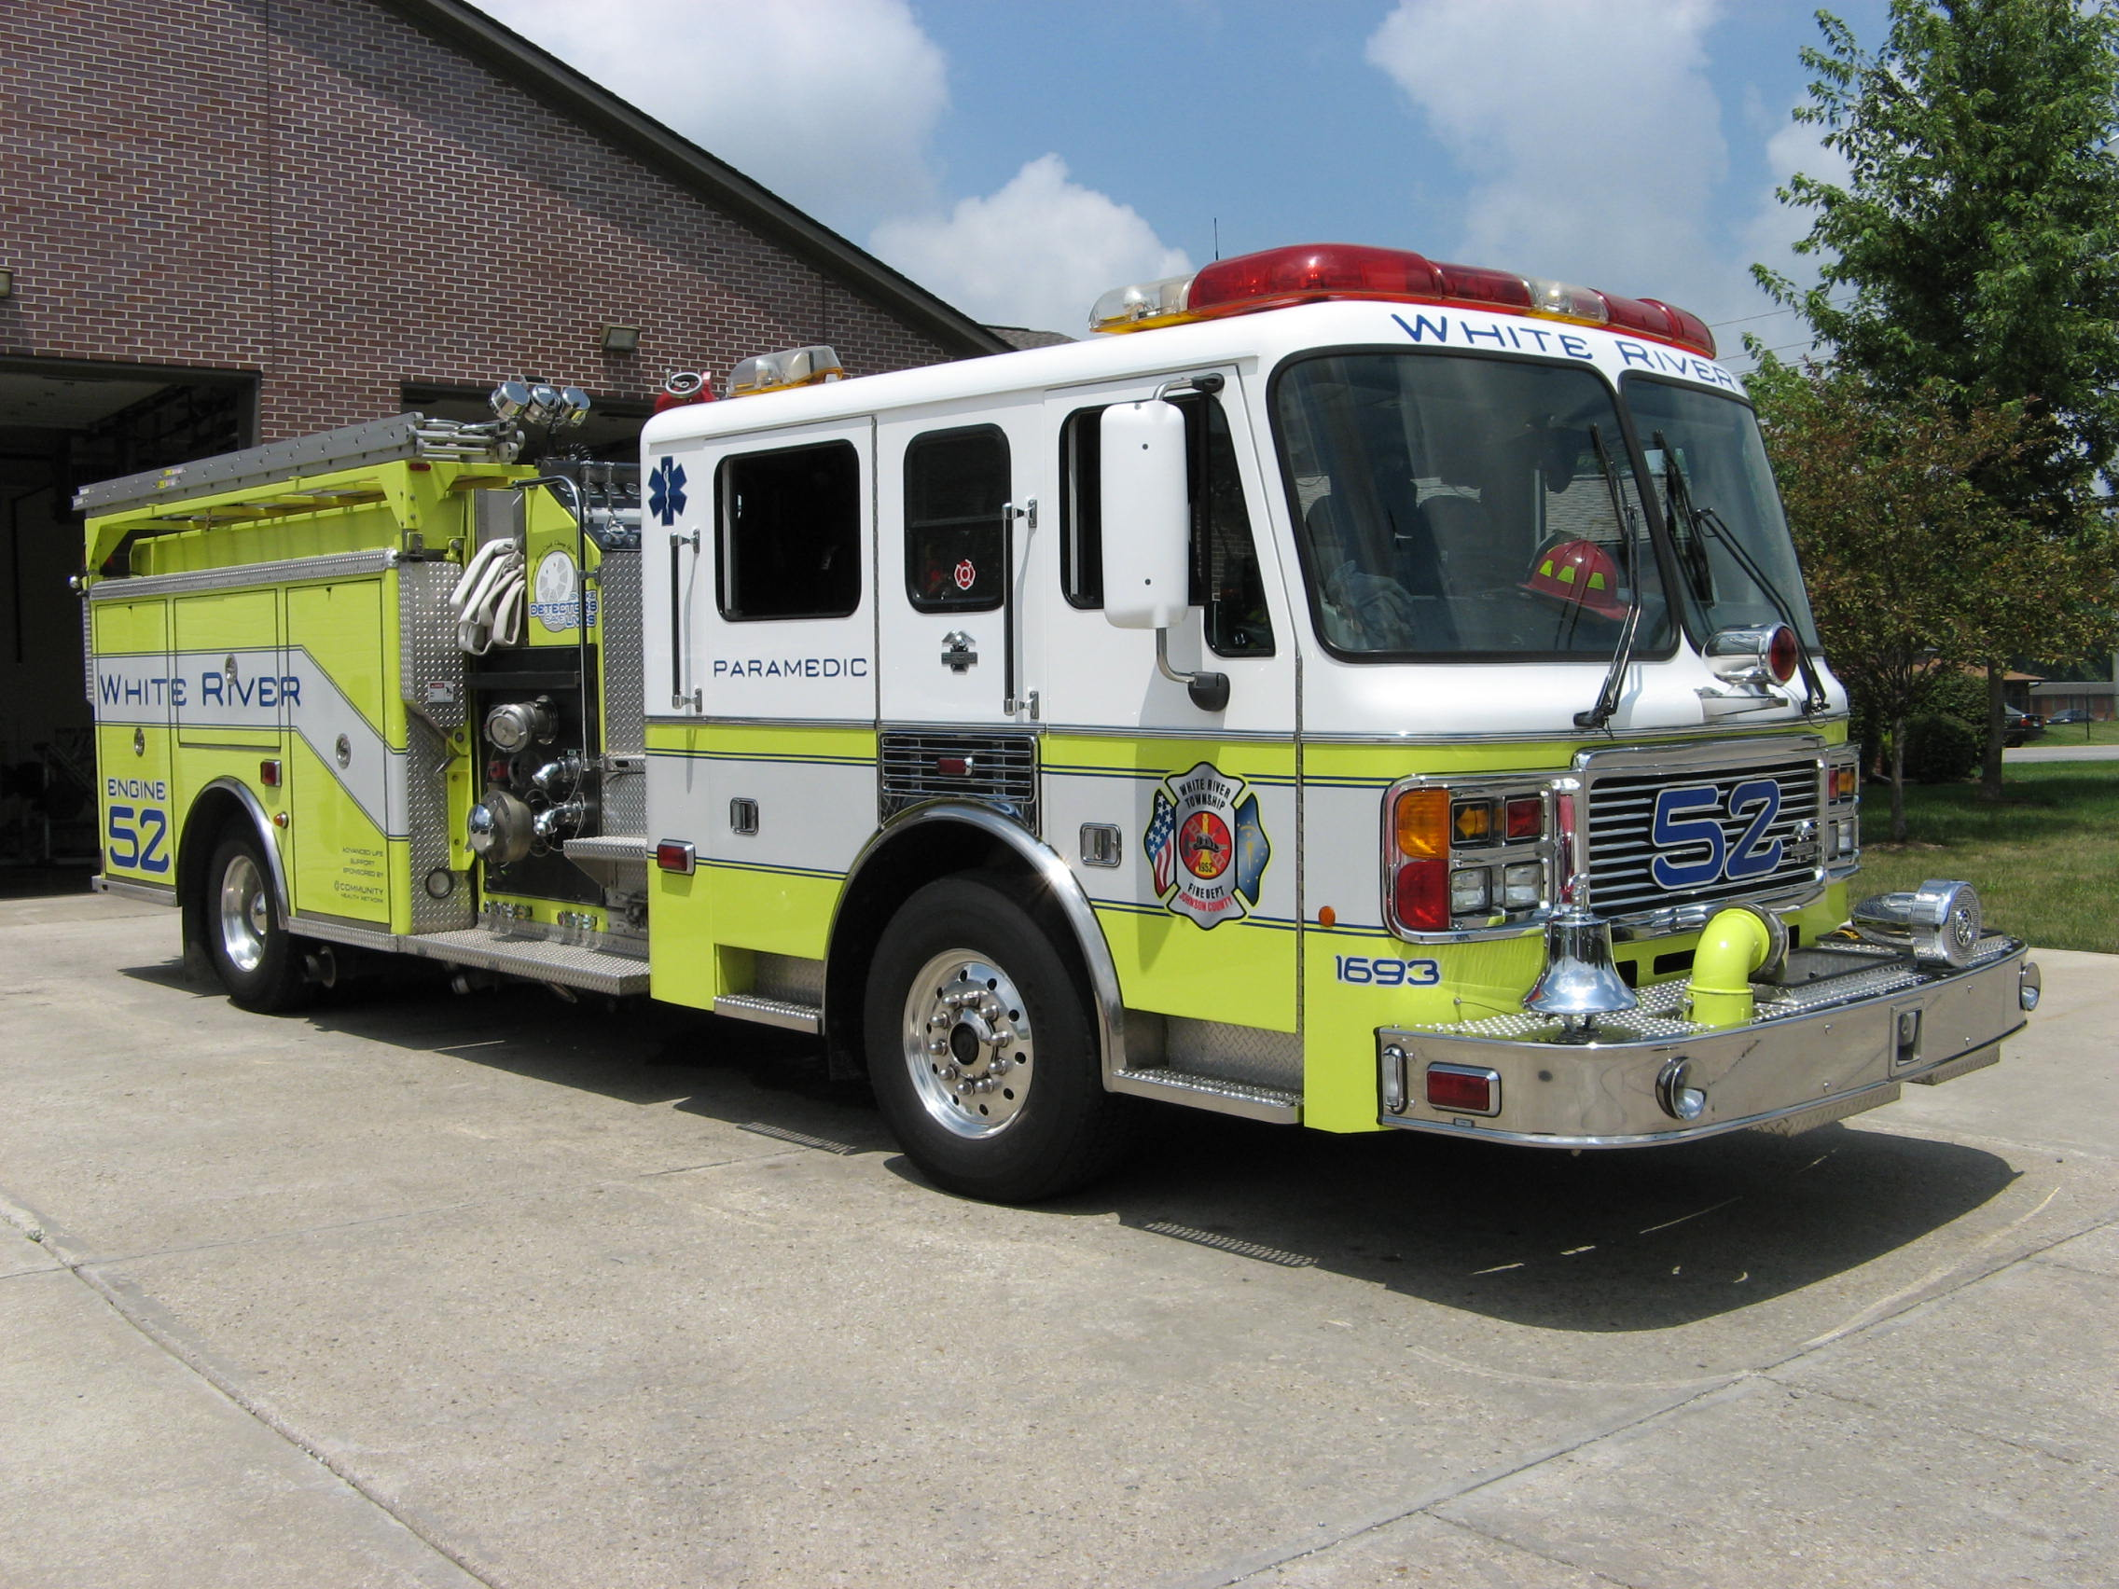 Did you know?

Did you know that the Hawaiian alphabet has 12 letters?


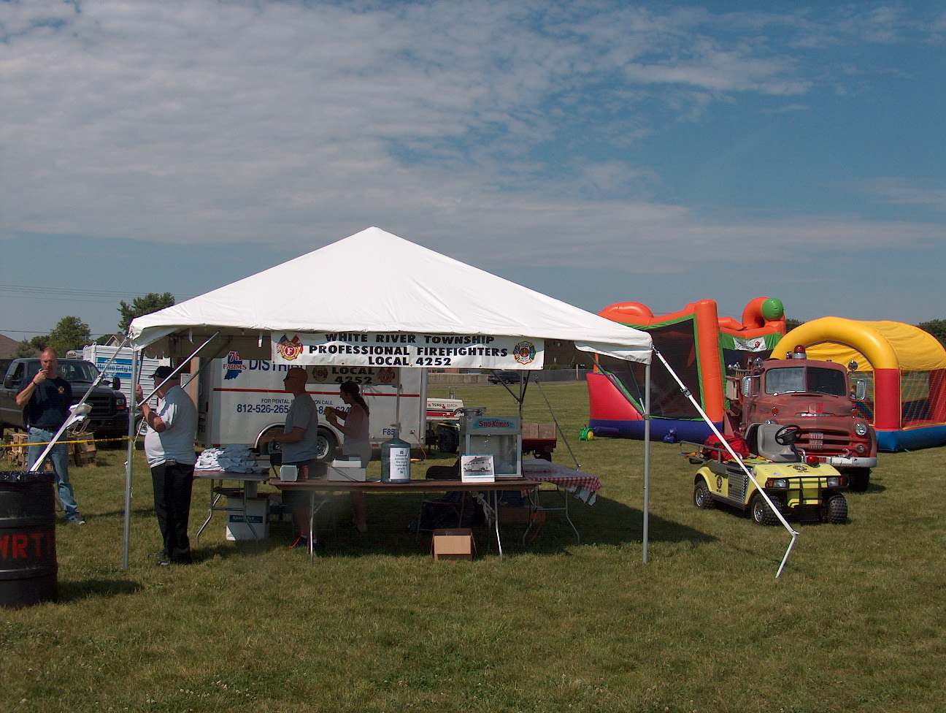 Birthday (October 3 – October 16)

Randy Becker October 9



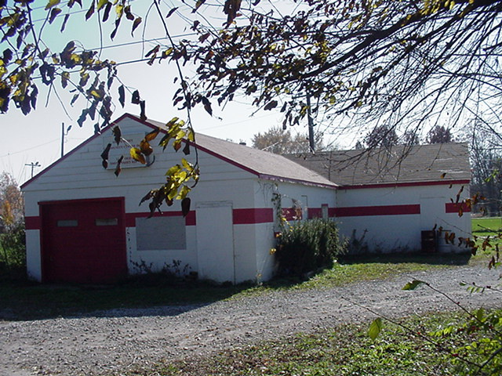 Looking back…..

50 years ago October 3, 1958 Firefighters attend school White River Township Firefighters attended a firefighting school recently to learn the basic principles of fighting fires. Those who attended will return to instruct others.


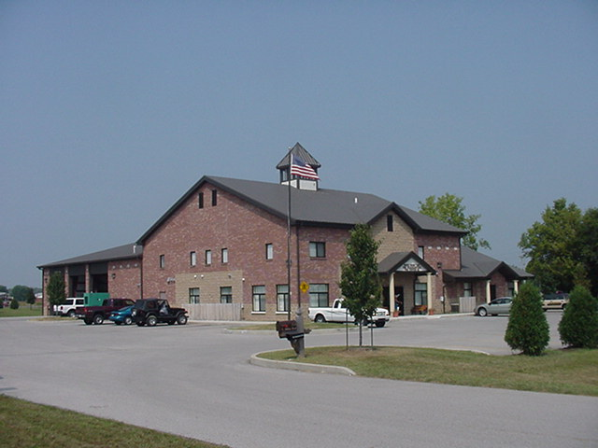 Upcoming events (October 2008)

Fire Protection District Board Meeting October 7, 2008 - 7pm Station 53

Celebrate Fire Prevention Week with White River Township Fire Department Thursday, October 9th, 2008. Time: 5pm to 8pm. Location: Fire Station 51 - 3016 W. Olive Branch Road. There will be food, safety talks and station tours.

october 2008
S | M | T | W | T | F | S
 |  |  | 1 | 2 | 3 | 4
5 | 6 | 7 | 8 | 9 | 10 | 11
12 | 13 | 14 | 15 | 16 | 17 | 18
19 | 20 | 21 | 22 | 23 | 24 | 25
26 | 27 | 28 | 29 | 30 | 31

Classifieds

Rummage Sale at Greenwood Middle School
Saturday, October 4, 2008.
Time: 8am to 12 noon.

