

September 19, 2008

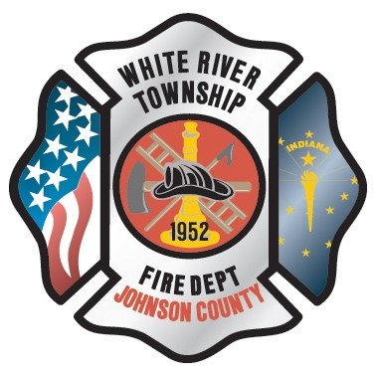 Administration News
Inside this Issue
1 Administration
2 Operations
2 Training/EMS
3 Training/EMS
3 Did You Know?
3 Birthdays
4 Looking Back
4 Upcoming Events

As you may have read in Chief Pell's Grapevine, the Department of Local Government Finance has sent us preliminary approval for our 2008 budget. Yes, Better late than never. With this news we can now move forward with a few capital projects that were planned for 2008. Chief Pell and I will present the information for the computer upgrades at the October District Board Meeting. The plan is to give the board the information and make a decision in November about the purchase. This upgrade will be a major undertaking as we will purchase a new server, desktops and printers. There will be more information to come on the specifics as we update quotes for the project. We will examine all areas of the current system and create short-term and long-terms plans that will keep the department on the cutting edge of technology. The goal of this upgrade is to streamline operations and make things better for the end user, you.

Until next time, keep up the good work

Chief Thacker

“To effectively and efficiently provide professional services to our community”

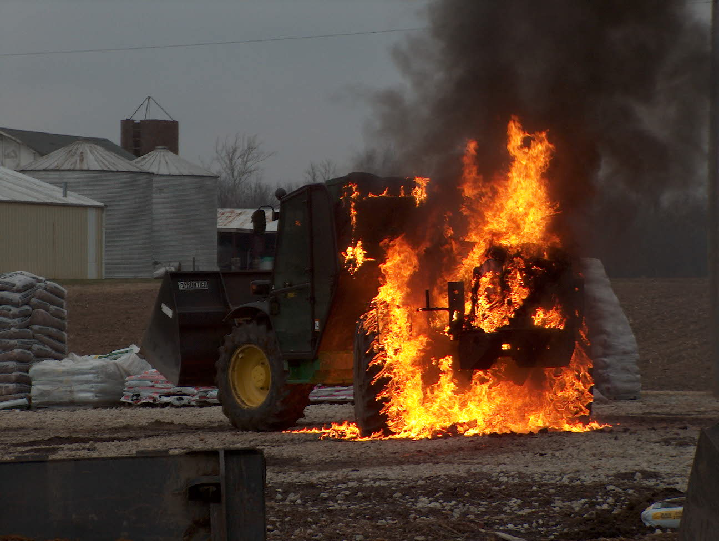 Operations News

The Hurst Maverick Tool and power unit have been moved from Ladder 51 to Engine 52. This move was to give the department an extrication option if both Rescue and Engine 51 were out of service or on another incident. This is a back up to our current system, not to replace our current practice of the Extrication Task Force 51 concept. The Station 52 officers and Battalion Chiefs have been given direction on use and alternate response guidelines.
In the event that Extrication Task Force 51 is unavailable, Engine 52 and Engine 53 will respond with a mutual aid extrication apparatus. See your Battalion Chief with any questions.

Be ready for pump and hose testing over the next couple of months. Lt. Hurrle will coordinate pump testing and Engineer Wiegle will coordinate hose testing.

Please review new SOG 633, Air Monitoring for IDLH Atmospheres at Structure Fires.

Rescue 51 is back in service after returning from the graphics shop. Thanks to all who helped with the project, especially Lt. Alford.

Be Smart and Stay Safe

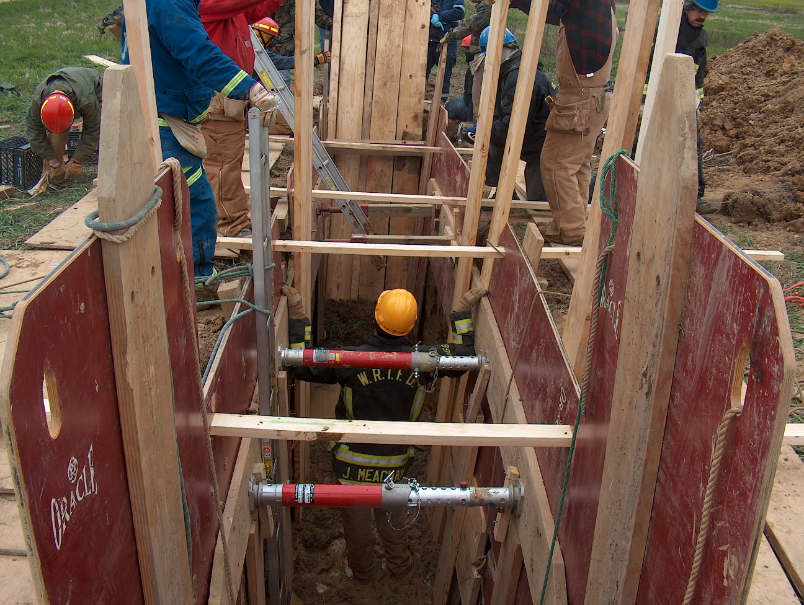 Training/EMS News

I am very excited about my new position and appreciate everyone’s support. I am really looking forward to this new endeavor and chapter of my life. I want nothing more than to continue with the great training program already established and build on it. I want to make sure that I continue to get you all the tools and training to do your job safely.

I am in the process of meeting with the shift training officers and will be utilizing them tremendously for training. We have already started the process of getting the house on Morgantown Road ready to do NFPA 1403 burns. The state has already come down and did an inspection, and the paperwork is complete. We are just waiting on their blessing to continue. In the mean time I would like to start getting some crews down there to prepare it for burning. Since the weather is going to be nice for the next week or so, it might be a good idea to start that part of the process. I will get with the three Battalion Chief’s to get that going. We are looking at the first week in October to burn.

Next week 9/22-9/24 we will be hosting Autism Awareness Training. This is always good training and good information, and the group just loves our department and firefighters as a whole. The training will be at Station 51 in the training room downstairs and we will have both day and night training, 0900hrs and 1930hrs will be the times.

Dale Saucier has obtained some cars for extrication training coming in a week or so. He has sent an email out to all shift training officers on how he would like the training to go. You will see more on this coming soon. If you have any questions please get with Dale or your shift training officer.

As far as EMS goes, I met with Dr. Gansman and we are working hard on run audits. I already sent out some emails on the June and July run audits. There were some good comments from Dr. Gansman, and then there were some things that need a little work. I will be sending those emails out on a regular basis so that we can continue to work on those things. There were a lot of atta boys from Dr. Gansman so good work!

All the Engines should now have new Fentenyl. I picked it up last week and placed it in the Narcotics boxes. We are in the process of replacing our last M Series Zoll monitor with a new E Series. The quote has been received, and we are taking the information to the next District Board Meeting for approval. We will also be receiving two more AED Pros. I will be placing an order for some EMS equipment in the next couple of weeks, so if there is something that you feel we need let me know.

Again, I am very excited to be in this position and I am looking forward to working with everyone. If you have any ideas for Training including EMS please feel free to call or email me.

Train as if your life depends on it, because it does!
Be Smart and Stay Safe! Chief Engmark

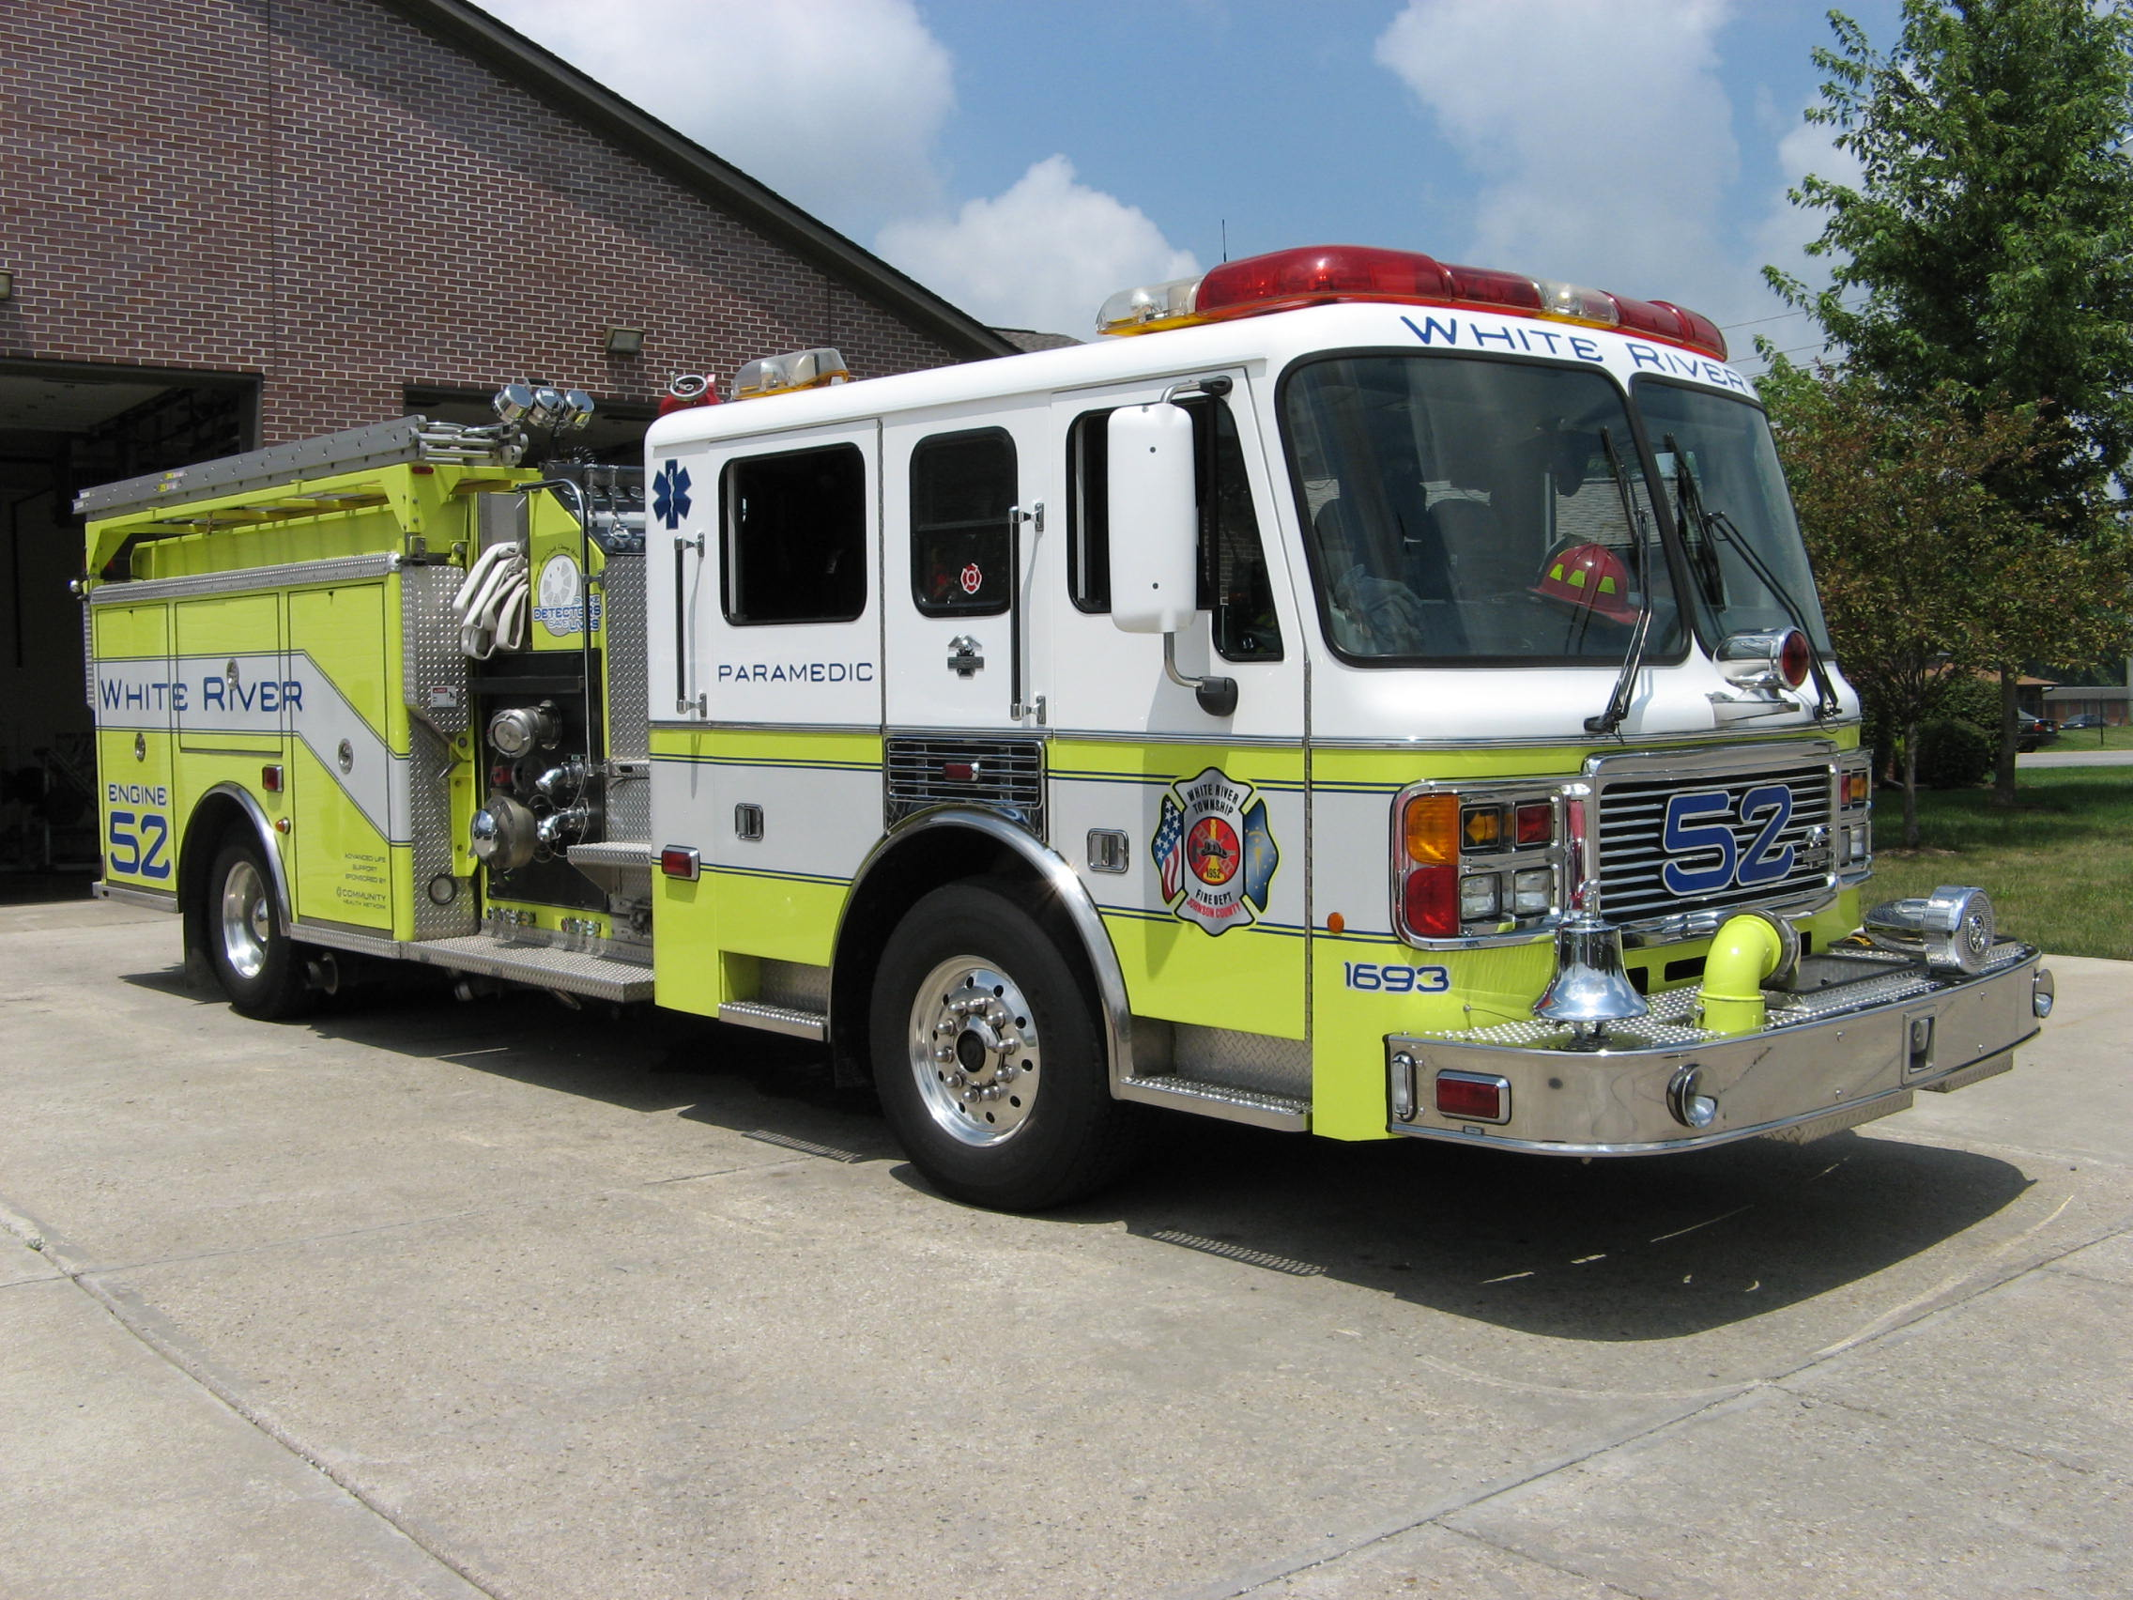 Did you know?

Did you know that the smartest dogs are the Scottish Border Collie, Poodle and the Golden Retriever?

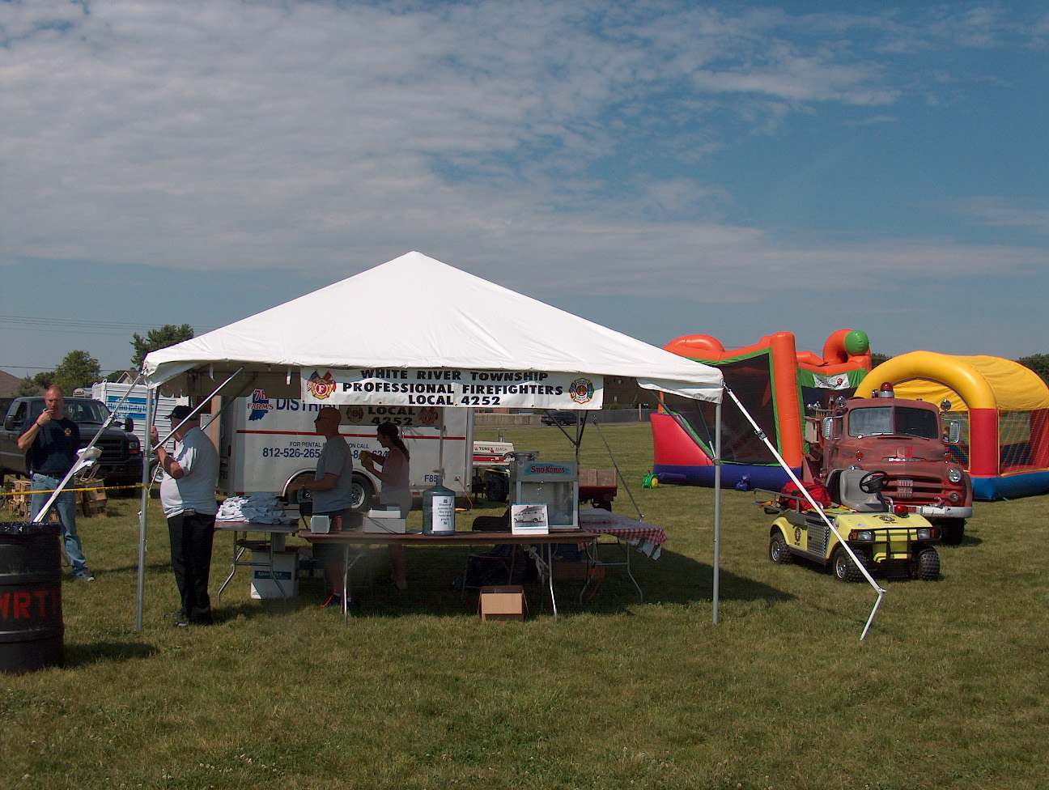 Birthdays (September 19 – October 2)

Jason Bailey September 19

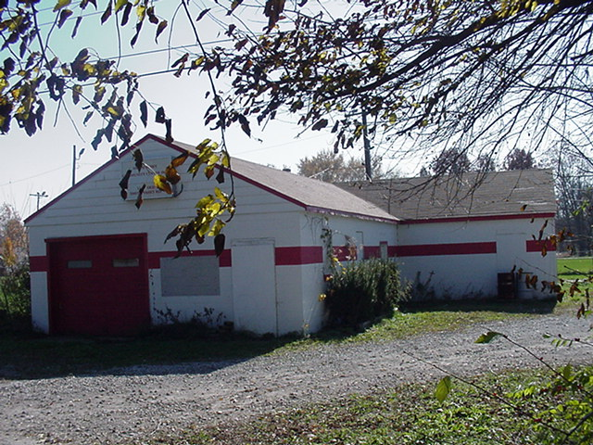 Looking back…..

29 years ago September 19, 1979 Skating party set for Saturday
The White River Township Volunteer Fire Department cadet corps is sponsoring a skating party Saturday at the Big Red Barn in Greenwood. Proceeds from the event will be used to buy firefighting gear for the cadets. The skating party will be from 2 p.m. to 4p.m. Tickets are priced at $1. Anyone interested in purchasing tickets in advance can call Cadet Chief Mark Young, 422-5829. The fire department will hold a fish fry Sept. 28 and 29 just north of the intersection of State Road 135 and Smith Valley Road. The fish fry will begin at 3 p.m. Sept 28 and at 11 a.m. Sept 29, 1979.

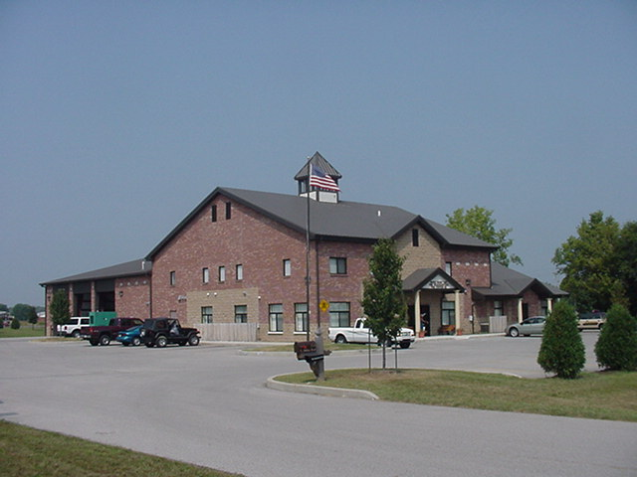 Upcoming events (September – October 2008)

Date Night September 26, 2008 at 7:15pm to see the new movie FIREPROOF Never Leave Your Partner Behind (Kirk Cameron and Erin Bethea) from the creators of “Facing the Giants”. Contact Jeff Pine @ GFD pinej@greenwood.in.gov to reserve a ticket. Child care is being provided by Calvary Baptist Church.

Fire Protection District Board Meeting October 7, 2008 - 7pm Station 53

september 2008
S | M | T | W | T | F | S
 | 1 | 2 | 3 | 4 | 5 | 6
7 | 8 | 9 | 10 | 11 | 12 | 13
14 | 15 | 16 | 17 | 18 | 19 | 20
21 | 22 | 23 | 24 | 25 | 26 | 27
28 | 29 | 30
october 2008
S | M | T | W | T | F | S
 |  |  | 1 | 2 | 3 | 4
5 | 6 | 7 | 8 | 9 | 10 | 11
12 | 13 | 14 | 15 | 16 | 17 | 18
19 | 20 | 21 | 22 | 23 | 24 | 25
26 | 27 | 28 | 29 | 30 | 31

