

September 5, 2008
Inside this Issue
1 Administration
2 Operations
2 Did You Know?
2 Birthdays
3 Looking Back
3 Upcoming Events
4 Upcoming Events

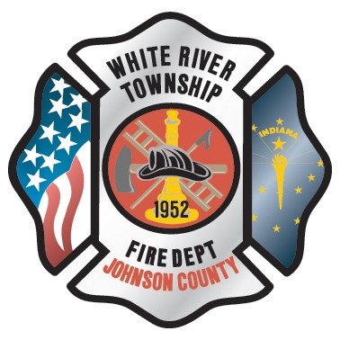 Administration News

These are just a few updates on some of the ongoing projects around the department. The department will be bringing on seven new firefighters towards the end of this month. The new employees have been fitted for uniforms and gear. Once their equipment arrives, orientation will be scheduled. Four of the seven are cadets who have served in good standing and will be filling hours on different shifts. You should expect to see these personnel working shifts by the beginning of October.

I was asked if we are ever going to do suppression training again. The answer is absolutely. I will be working with Chief Engmark and bringing him up to speed with the training division. I would expect to see some suppression evolutions at the training property within the next few weeks. NFPA 1403 burns will take place in October. The weather should be right and the road construction should be near completion.

The Technical Rescue Awareness test has been ordered. Expect to take it the week of September 22.

Finally, I am trying to clear up a couple of credit cards purchases. If you know of these purchases please fill out a purchase authorization and submit to Jackie.

08-11-08 – Meijer – 173.66
08-11-08 – Meijer – 133.73

“To effectively and efficiently provide professional services to our community”

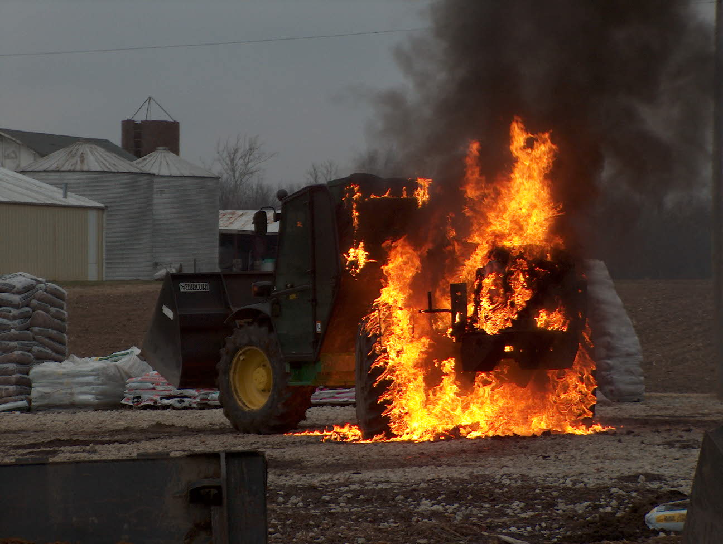 Operations News

The rescue project is near completion. Rescue 51 is in service. Lt Alford states that the only area left to address are some tool mounting and updating the mobile radios. See Lt Alford with any questions. Thanks to all at Station 51 for their hard work. Please enter all maintenance requests for this apparatus under Rescue 51.

I was informed by Mike Watkins that all the MOSCAD issues should be corrected. The next step is to begin the process of selective apparatus dispatching in the next couple of weeks.

As you have seen, the Perry Township responses have increased with their Geozone changes. Please make sure that you keep the MECA pagers with you at all times. If you have pager problems, please let me know.

The new traffic vests and equipment have been ordered; we are still waiting on the equipment to arrive. Engineer Saucier is the point of contact.

Company officers should be contacting their Captains for end of the year equipment requests in the next couple of weeks. Captains should have all requests forwarded to me by September 30.

That is it for now. Be smart and stay safe.

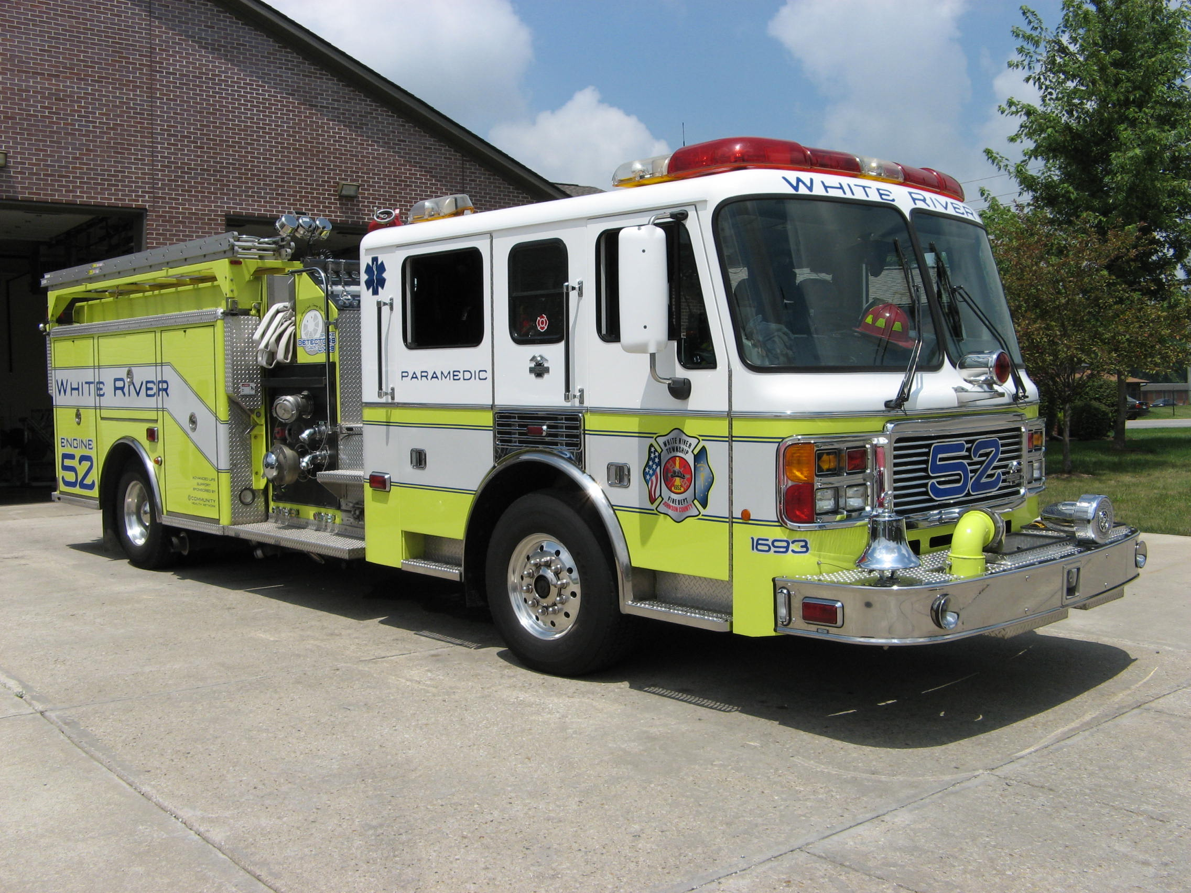 Did you know?

Did you know that it is possible to lead a cow upstairs but not downstairs?

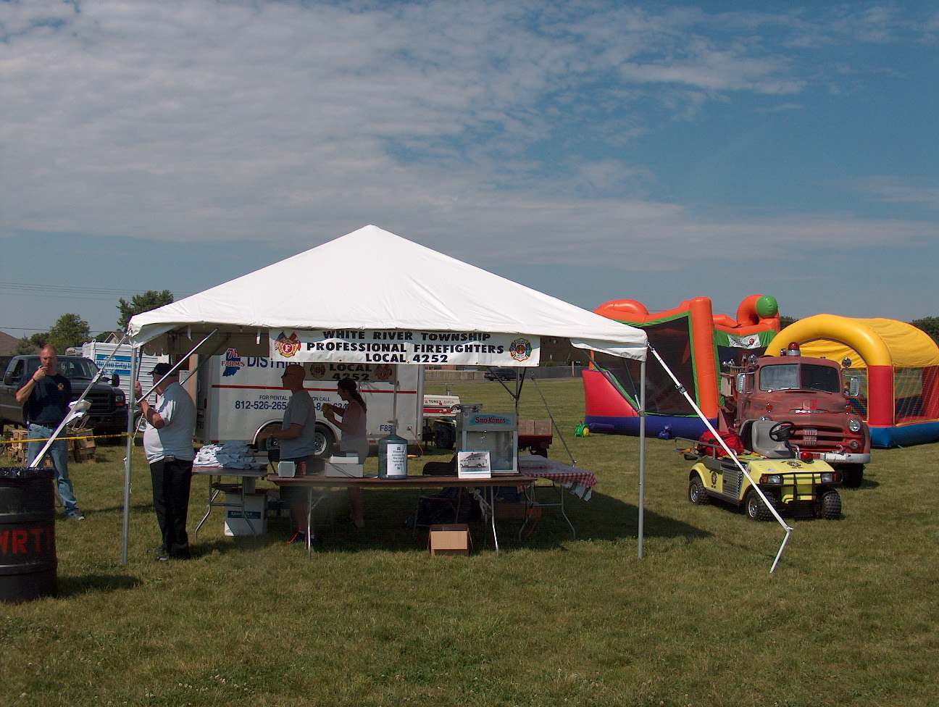 Birthdays (September 5 – September 18)

Derek Norcross September 7
Dan Speer September 12
Joe Marsh September 13
Dustin Harris September 13
Chris Phillips September 14

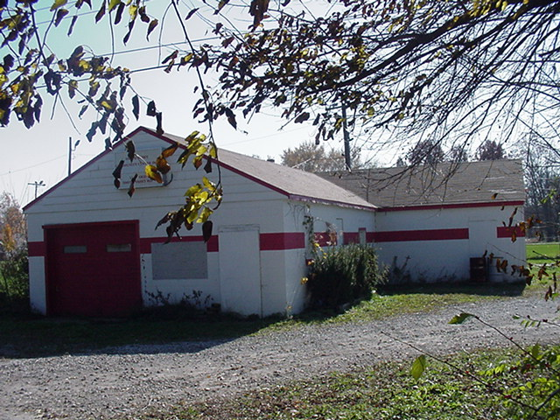 Looking back…..

13 years ago September 6, 1995 Firefighters answer MDA's call
There were more than just firefighters filling firemen’s boots last weekend. Tens of thousands of dollars were stuffed into boots and buckets as county firefighters held their annual collection for the Muscular Dystrophy Association. The firemen are an annual fixture at road intersections; collecting money for the MDA each Labor Day weekend. “We feel like it is so widespread, we don’t even have to put up banners. People just naturally associate Labor Day with Jerry’s Kids,” said Mike Herron, lieutenant training officer for the Franklin Fire Department. On Saturday, eight Franklin firefighters collected about $1,000 at the intersection of Jefferson and Main streets in downtown Franklin. Herron said the department has made the annual collections since the famous telethon began. This year larger donations and less change than usual was collected by the White River Township Fire Department. “We had a lot of big donations this year — a lot of twenties, a lot of $10 bills,” said department Chief Scott Cassin. “Usually people just throw in change they have in their ashtray or can pull out of their pockets real quick,” he said. About 15 White River firefighters worked Saturday through Monday to collect $9,900. As in many fire departments, on-duty firefighters and some volunteer off-duty firefighters stood posted at intersections for donations, while being on call for emergencies. “I think they had a couple calls (while taking donations), but they just threw their stuff on the truck and went, then set everything back up when they got back (to collection sites),” said Cassin. Greenwood firefighter Don Fouts said this year his department collected $13,400. He said about 30 Greenwood firefighters collected money at three different locations in the city from Saturday through Monday. One day a passer-by asked Fouts if he was afraid of getting hit while standing in the street. “I’m not afraid of getting hit, but I just figure I’m out here giving someone else the chance to walk some day,” said Fouts, who didn’t recall firefighters ever getting hurt while taking donations. The purpose behind the MDA collections was driven home for Fouts when he visited an MDA camp in August. “It was really neat. The kids always want to do things everybody else does. They swim, sleep in their cabins, do crafts,” he said. The firefighters always make sure to thank people for their donations and often receive thanks in return.

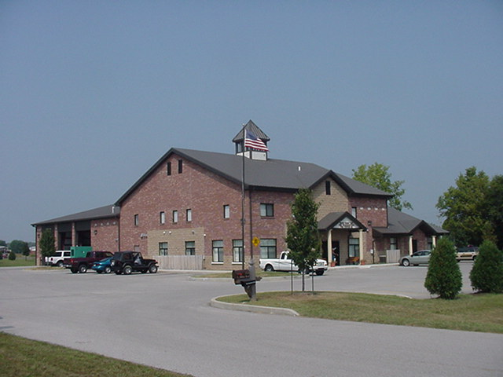 Upcoming events (September – October 2008)

Saturday, September 6, 2008 Chili Cook-Off 4:00 pm to 8 pm at Clark-Pleasant Intermediate Cafeteria (Sheek Rd and Worthsville Rd.) Open to the Public $10.00 entry fee. Raffle for variety of door prizes and Trophies for 1st, 2nd and 3rd place. Chili tasting. Children’s Activities. Fire Trucks on Site. Further information contact Brandon Nicoloff phone #317-331-6533. All proceeds raised will benefit The Hoosier Burn Camp.

Please don’t forget about the employee meetings. They are scheduled for: Sunday, September 7th, 1600 and Tuesday, September 9th, 1930
Items on the agenda include request for input on part-time scheduling, 2009 budget info, and a general question and answer session. All employees are invited.

The 3rd Annual Car Show, Sock Hop and Benefit for the Johnson County Firefighters Association will held on Saturday, September 13, 2008 at The Greenwood Moose Lodge 813 W. Smith Valley Rd. Phone #317-882-6150.
Time: (10:00 – 4:00 Shine & Show set up); (12:00 – 4:00 Free Car Show); (12:00 – 8:00 Kitchen Open); (7:00 – 11:00 pm Sock Hop 50’s & 60’s); (4:00 – 5:00 Awards Presentation); (12:00 – 9:00 Silent Auction). Open to the Public $5.00 donation at the door. Food Baskets $7.00 each Hamburger, Cheeseburger, Tenderloin, Hot Dogs, Chili Dogs, your choice of French Fries or Onion Rings with your basket. Soft Drinks $1.00 each. One 50/50 drawing at 10:00 pm at the dance. Twist contest, best dressed 50’s & 60’s contest and Hula Hoop contest.

The White River Township Professional Firefighters Union Local 4252 will be sponsoring its annual golf outing at the Hickory Stick Golf Course located at 4422 Hickory Stick Boulevard, Greenwood, on Friday, September 19th 2008 with a 10:00 am shotgun start. The cost is $300.00 per team of 4 players. Contact Lt. Dave Scholl (317) 664-1881 or Tim Smith (317) 339-29999.

Fire Protection District Board Meeting October 7, 2008 - 7pm Station 53

september 2008
S | M | T | W | T | F | S
 | 1 | 2 | 3 | 4 | 5 | 6
7 | 8 | 9 | 10 | 11 | 12 | 13
14 | 15 | 16 | 17 | 18 | 19 | 20
21 | 22 | 23 | 24 | 25 | 26 | 27
28 | 29 | 30
october 2008
S | M | T | W | T | F | S
 |  |  | 1 | 2 | 3 | 4
5 | 6 | 7 | 8 | 9 | 10 | 11
12 | 13 | 14 | 15 | 16 | 17 | 18
19 | 20 | 21 | 22 | 23 | 24 | 25
26 | 27 | 28 | 29 | 30 | 31

