

August 8, 2008

Inside this Issue
1 Administration
2 Looking Back
3 Looking Back
3 Did You Know?
3 Birthdays
4 Upcoming Events

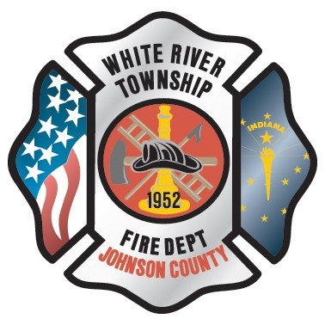 Administration News

Wednesday, August 6th, was Chief Cassin’s last day in the office. I hear that he has arrived safely in Orlando and should be moving into his new apartment as I write this. Hopefully, most of you were able to stop by the open house Tuesday to congratulate Chief Cassin and wish him well. If you didn’t make it, I am sure he would appreciate a phone call or email. His cell phone number will remain the same, and I am sure he will check his email.

We all hope to make a difference when we enter the fire service. You hear nice comments at retirement parties about how much better the department is due to the contribution of the person retiring. I have never seen a case where this is more apparent than with Chief Cassin. He has served White River Township Fire Department faithfully for 22 years. You can see the positive impact throughout the department every day. Some examples are the Strawberry Festival, the strategic plan, our budget, the website, our computer system, the policy manual, multiple building projects, etc. The list could go on and on. The White River Township Fire Department is such a good department today in large part due to Chief Cassin. I am grateful for all of his service. Chief Cassin will still provide us with support in the months and years to come. He is only a phone call or email away. I hate to see him go, but I am excited that he is pursuing something that he has wanted for many years. The future is bright for both the department and Chief Cassin. I know we all appreciate what he has done for the department and wish him good luck with his new restaurant.

“To effectively and efficiently provide professional services to our community”

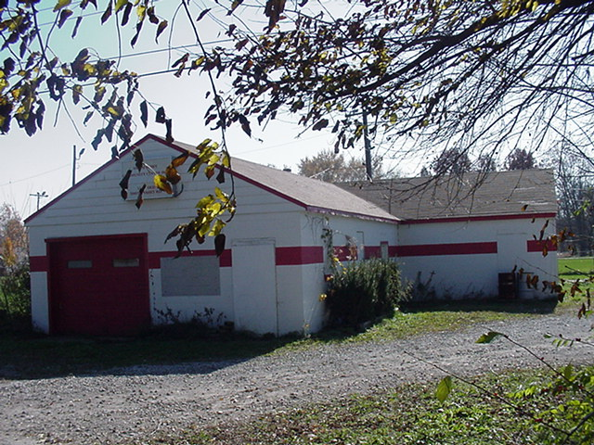 Looking back…..

24 years ago December 15, 1984
Cadet program holds open house
Last evening, the White River Township Volunteer Fire Department Cadet Program held an open house for parents and other individuals wishing to become cadets. The Cadet Program is a sub-group of the fire department consisting of high school students ages 14-18 years who wish to become firefighters after graduation. The open house was intended to raise awareness of the program while at the same time demonstrating some of the skills learned by those already in the program. Cadet Scott Cassin was in attendance.
18 years ago December 17, 1990 Volunteers amazing
The following was printed as a letter to the editor and reprinted with permission from the Daily Journal. To the editor:
I am a parent of a White River Fire Department volunteer. It has been a privilege through the years to know how much time these men and women donate to the community. Their devotion to the White River area goes mostly unnoticed. At their annual Christmas dinner, they read a summary of the past year’s events and I find it amazing that they handle as many as 70 calls in one month. They will respond at any time of day or night and to any type of call whether it is a house fire, car accident, sickness or having a child locked in a closet. These are unpaid professionals who put their life on the line for us. There are so many outstanding people in this organization that trying to name one Individual who excels is really hard. I think Rusty, the Firefighter of the Year, said it best. There isn’t just one person who is more important than the other. We are a team, from the cadets to the chief. How right he is, and it’s this dedication to our area that we all can be proud and thankful for.
John Cassin, Greenwood
16 years ago December 14, 1992
Fire department chooses chief
Scott Cassin has been chosen as chief of the White River Fire Department for 1993. Cassin has been with the department since the mid-’80’s and served as assistant chief for 1992 and one other year, said Chuck Hagedon, public relations person for the district. Cassin was chosen by the district’s seven-member board. His appointment was announced at the district’s annual Christmas party, held Dec. 11, 1992.
15 years ago June 5, 1993 First annual festival hosted
The White River Township Fire Department hosted its first Strawberry Festival this weekend on the recreational field located immediately north of Center Grove Elementary School on Morgantown Road. The Department had previously held an annual fish fry to generate public interest and gain much needed monetary support for equipment and apparatus. However, now that the department has grown considerably, the desperate need for holding a true "fundraiser" was no longer as much of an issue as acquainting the public with their fire department. The event was a huge success, despite daytime high temperatures only reaching the mid 60's and remaining overcast for most of the day. Food choices such as pizza, hot dogs, and of course, strawberry shortcake were plentiful and enjoyed by all. Activities included clown visits, rides in the bucket of Greenwood Fire Department's Snorkel truck, Sheriffs Department drug detection K-9 demonstration, an automobile extrication demonstration complete with "victims", a car fire demonstration, and much more. Fire Chief Scott Cassin stated that he was "extremely pleased with the event turn out and hopes this will become a new fire department annual tradition".

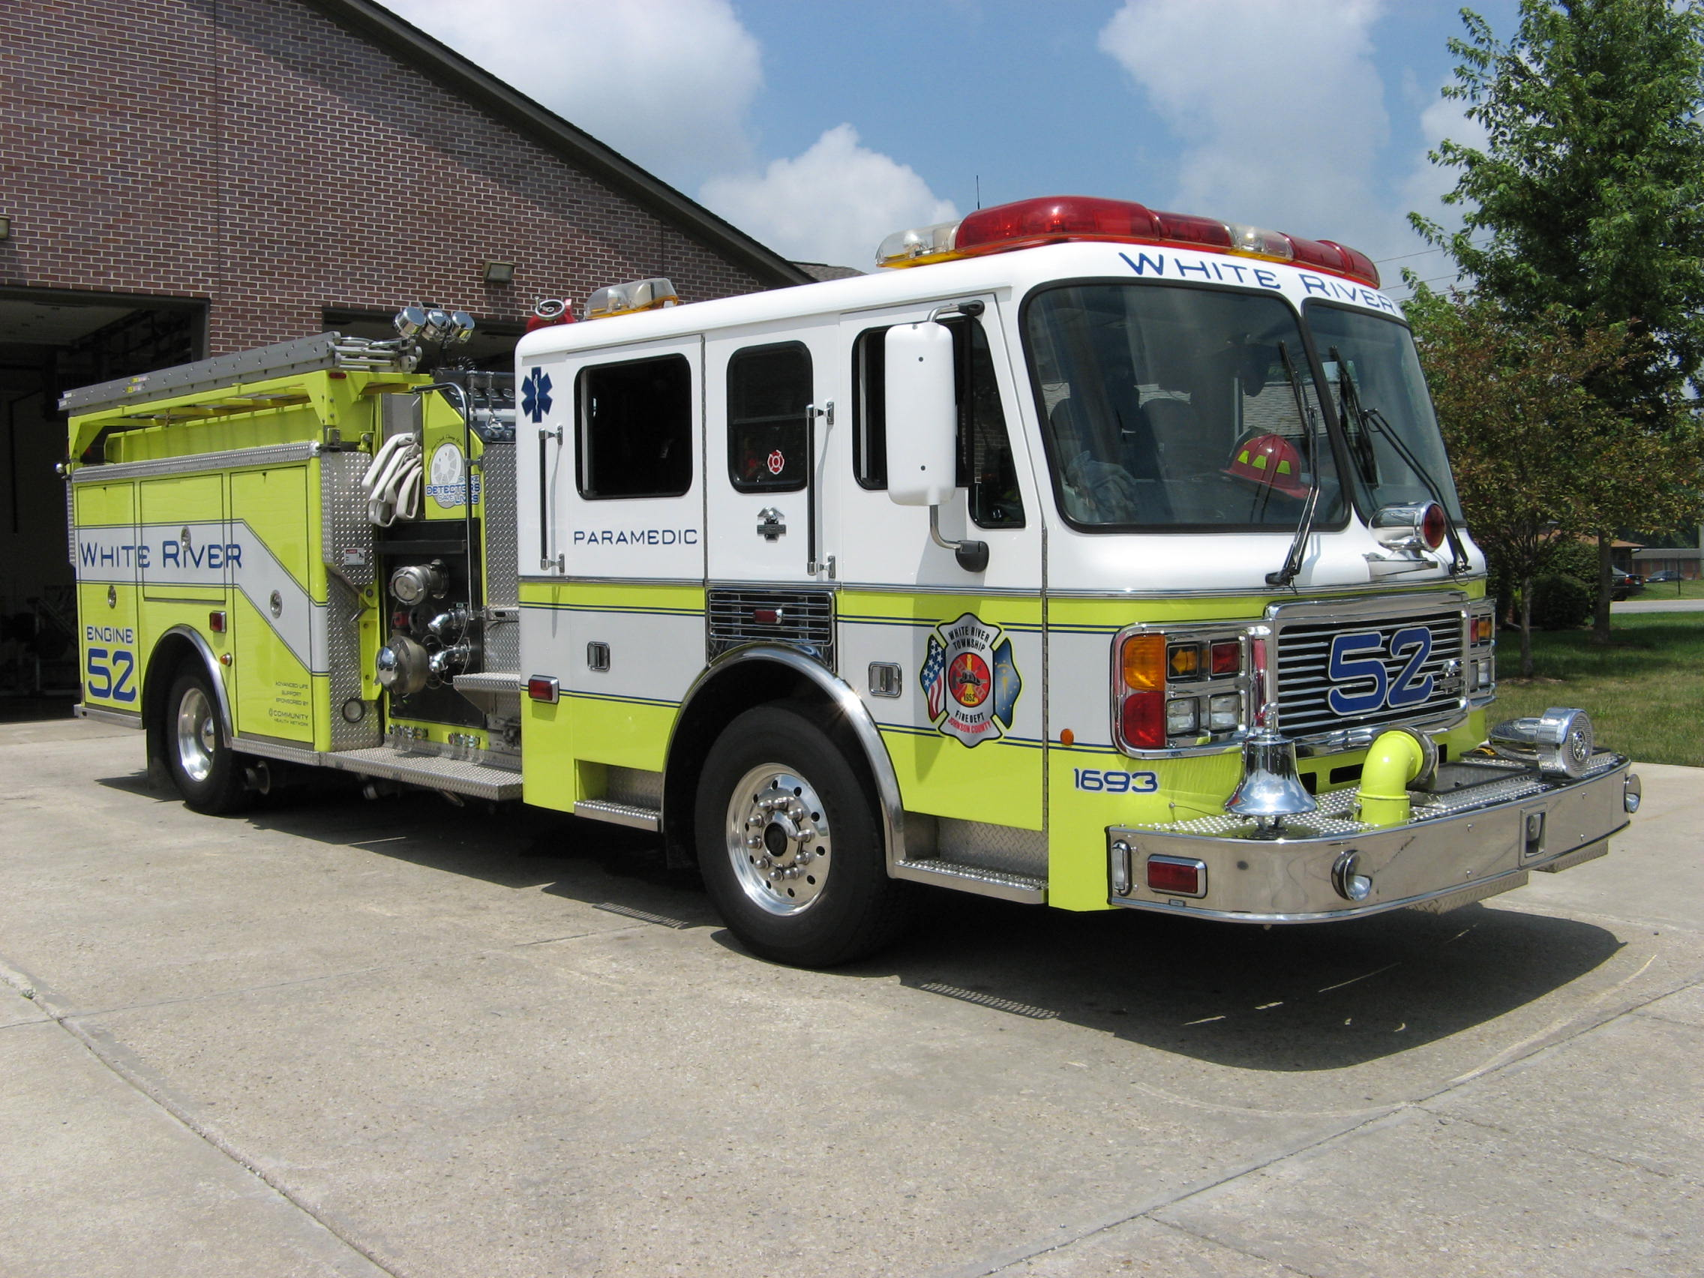 Did you know?

Did you know that Coca-Cola was originally green?

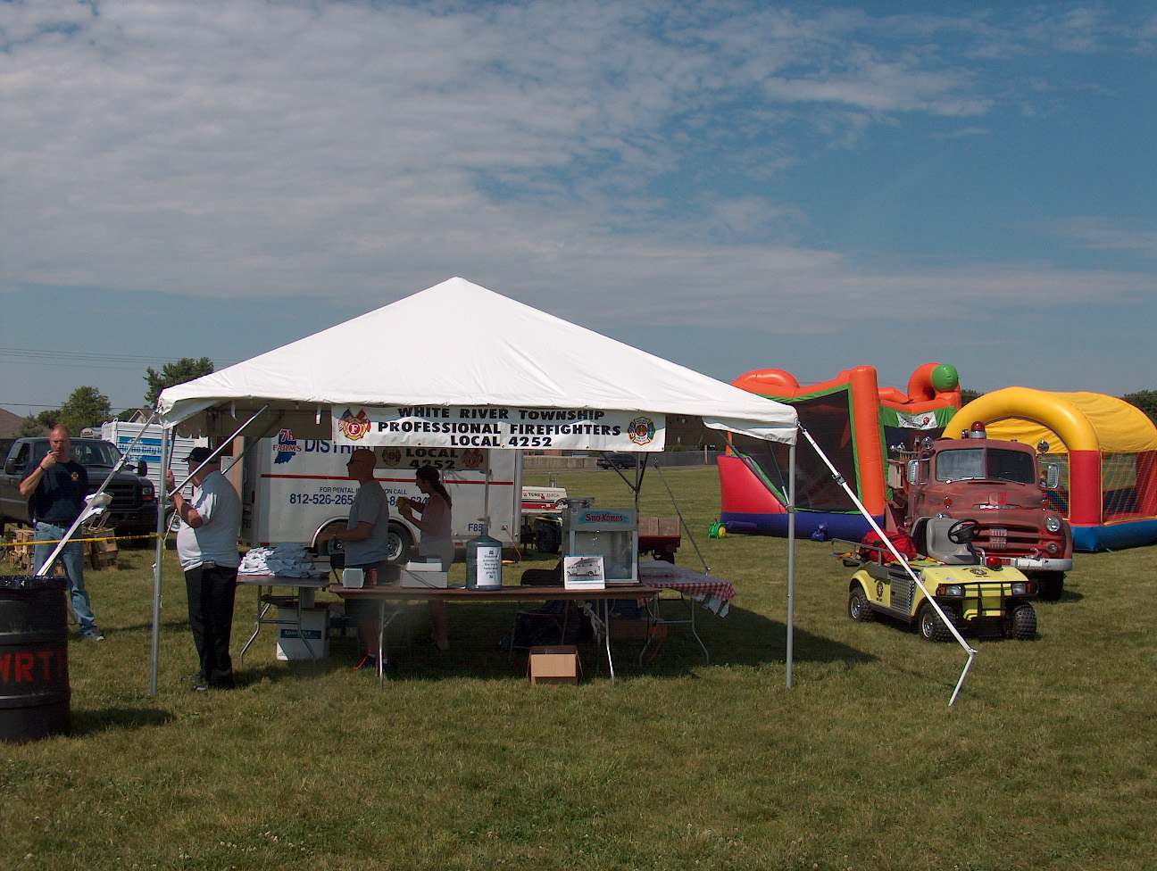 Birthdays (August 8 – August 21)

Steve Snider August 8
Matthew Myers August 9
George Boots August 15
Greg Hedge August 15
Daniel Strong August 19

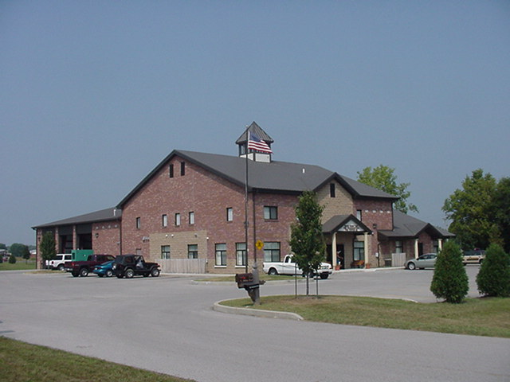 Upcoming events (August – September 2008)

Saturday August 9, 2008 The 7th Annual Charity Softball Tournament in memory of our fallen brother Lt. Dale McKnight hosted by Franklin Fire Local 3433. All Proceeds go to the Cole McKnight Trust Fund. Please call for more information if need the contact person is John Henderson 317-346-3713. Cost of $250.00 per team. The event will be at Franklin American Legion and our Danny Dewitt Field... (Rain date Aug 10th)

august 2008
S | M | T | W | T | F | S
 |  |  |  |  | 1 | 2
3 | 4 | 5 | 6 | 7 | 8 | 9
10 | 11 | 12 | 13 | 14 | 15 | 16
17 | 18 | 19 | 20 | 21 | 22 | 23
24 | 25 | 26 | 27 | 28 | 29 | 30
31
Fire Protection District Board Meeting September 2, 2008 - 7pm Station 53

september 2008
S | M | T | W | T | F | S
 | 1 | 2 | 3 | 4 | 5 | 6
7 | 8 | 9 | 10 | 11 | 12 | 13
14 | 15 | 16 | 17 | 18 | 19 | 20
21 | 22 | 23 | 24 | 25 | 26 | 27
28 | 29 | 30

