

July 25, 2008

Inside this Issue
1 Did You Know?
2 Birthdays
2 Looking Back
3 Upcoming Events
3 Classifieds

“To effectively and efficiently provide professional services to our community”

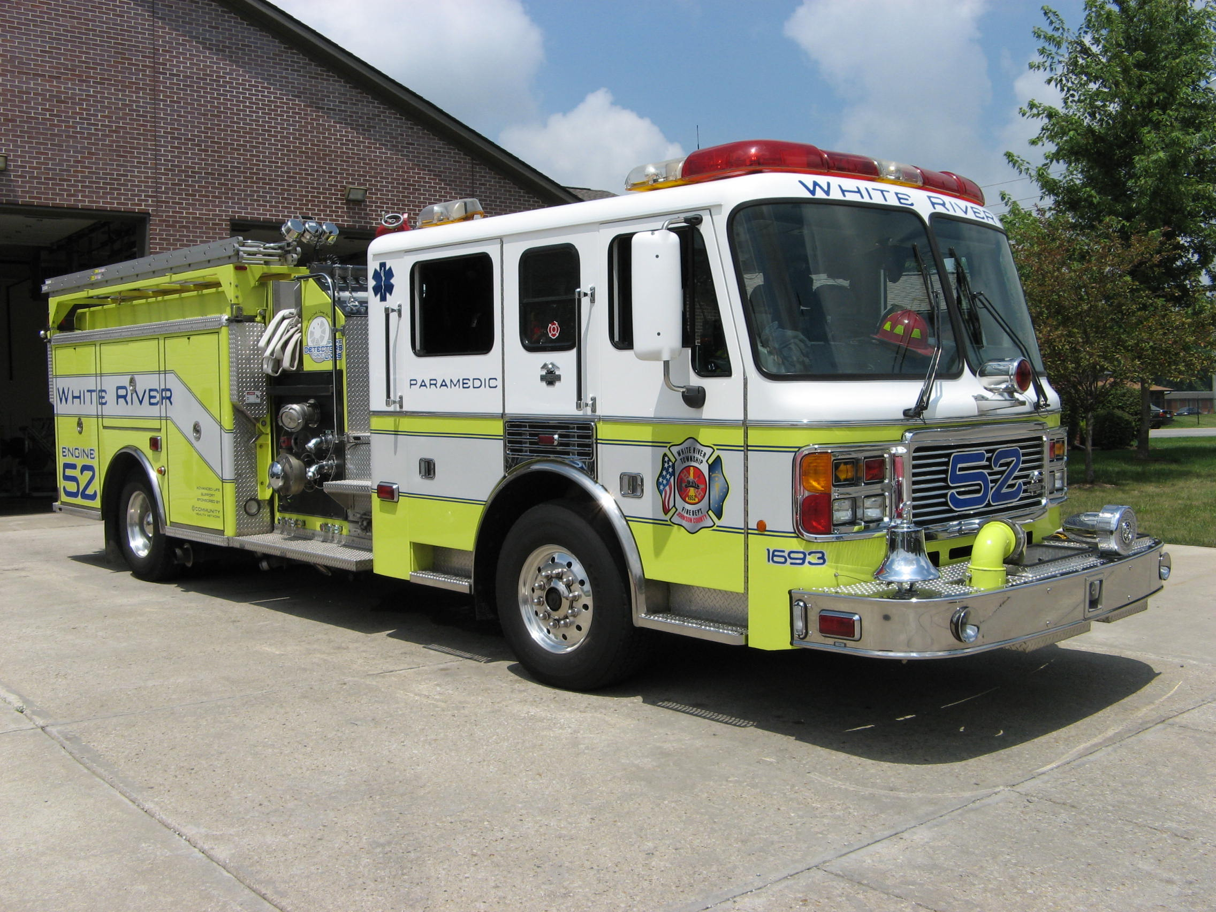 Did you know?

The James Bruce Round Barn is a round barn located near the Stephenson County, Illinois city of Freeport, United States. The barn was constructed in 1914 by the team of Jeremiah Shaffer and the Haas Brothers, who were responsible for at least a dozen round barns in the area. The barn features a single hip roof design which was probably influenced by the Agricultural Experiment Stations at the University of Illinois and the University of Wisconsin. The Bruce Round Barn was the last known round barn designed by the Shaffer–Haas team. The building was listed on the U.S. National Register of Historic Places as part of a multiple property submission in 1984.

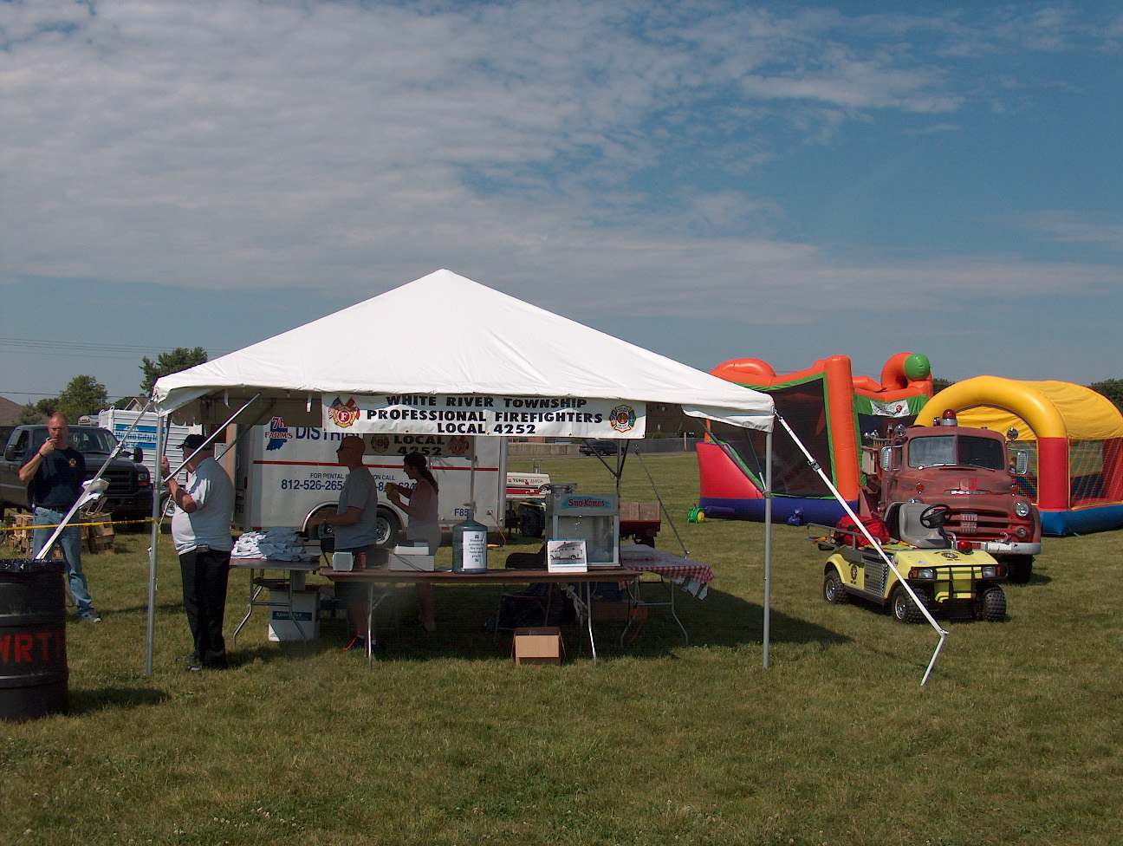 Birthdays (July 25 – August 7)

Mike Ridge July 31
Jon Whitham July 31
Mark Hart August 2

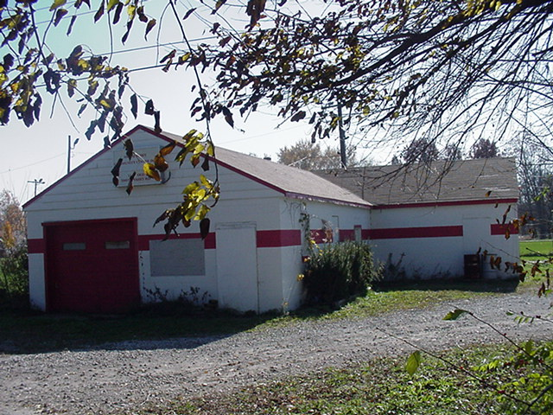 Looking back…..

32 years ago August 3, 1976 Center Grove school fire
No damage was reported to the former Center Grove Junior High School building when fire broke out on the roof of the building shortly before noon Tuesday. White River Township volunteer firefighters said the fire erupted in a pile of construction debris on the roof of the building. The fire was quickly extinguished, causing no damage to the building itself. Workmen are replacing the roof on the building and had taken a lunch break shortly before the fire broke out.

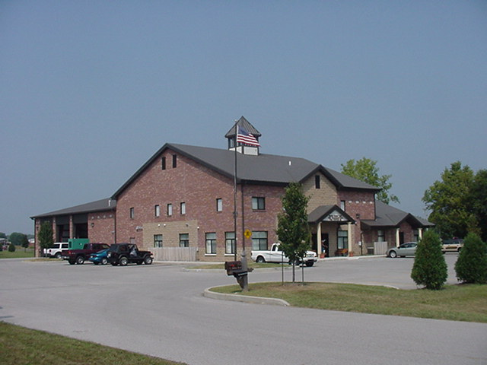 Upcoming events (July – August 2008)

Fire Protection District Board Meeting August 5, 2008 – 7pm. Station 53

Saturday August 9, 2008 The 7th Annual Charity Softball Tournament in memory of our fallen brother Lt. Dale McKnight hosted by Franklin Fire Local 3433. All Proceeds go to the Cole McKnight Trust Fund. Please call for more information if need the contact person is John Henderson 317-346-3713. Cost of $250.00 per team. The event will be at Franklin American Legion and our Danny Dewitt Field... (Rain date Aug 10th)
`
july 2008
S | M | T | W | T | F | S
 |  | 1 | 2 | 3 | 4 | 5
6 | 7 | 8 | 9 | 10 | 11 | 12
13 | 14 | 15 | 16 | 17 | 18 | 19
20 | 21 | 22 | 23 | 24 | 25 | 26
27 | 28 | 29 | 30 | 31
august 2008
S | M | T | W | T | F | S
 |  |  |  |  | 1 | 2
3 | 4 | 5 | 6 | 7 | 8 | 9
10 | 11 | 12 | 13 | 14 | 15 | 16
17 | 18 | 19 | 20 | 21 | 22 | 23
24 | 25 | 26 | 27 | 28 | 29 | 30
31

Classifieds
Please remember is you have an event planned Wedding, Cookout or Church Picnic that you would like to invite everyone to attend please send Jackie Emmons an email. Also, remember that we have a large White River Township Fire Department family and an even larger extended Fire Department family because we know a lot of people from other departments. Well brothers and sisters let’s give each other a bit of help in this economy. Please email Jackie Emmons if you are selling a car, motorcycle or if you are looking for an item, such as a special type of car or motorcycle. I will put it in the employee newsletter.

