

July 11, 2008

Inside this Issue
1 Administration
2 Administration
2 Operations
3 Did You Know?
3 Birthdays
3 Looking Back
4 Upcoming Events
4 Classifieds

 Administration News

For those of you that missed this comment in the Chief’s Grapevine, I think it is worth repeating.

Jim Dodson gave the department a very nice comment at the last District Board meeting. He listened to the flood incident on the radio and visited the station twice during the storm. He said that he was extremely impressed with the entire department and proud of how we handled the incident. He wanted the entire department to know how appreciative he is of our service to the community.

I appreciated his comments and feel the same way. I am very proud to be a member of this Fire Department. It makes me feel good to know that the District Board is appreciative of our performance.

Keep up the good work! I think you will continue to see the benefits to the community and the department.

Chief Pell

“To effectively and efficiently provide professional services to our community”

Administration

The project to transition the TSU to a heavy rescue is well underway. The bid to purchase the old Rescue 51 has been awarded. We received two bids. It was sold for $80,000. One bid asked for more equipment than we were willing to sell, therefore it was sold to the bidder that only included the items listed in the legal advertisement.

We will be able to use the old Rescue 51 until work is completed on the TSU. That work is scheduled to begin next week. Our Maintenance Division will coordinate with Chief Slauter to begin removing equipment from the old Rescue 51. Chief Slauter will notify the companies as those two apparatus are marked in-service and out-of-service. When the project is complete, the current TSU will become “Rescue 51”. It will be available for both tactical rescue responses as well as support functions. Chief Slauter will issue any running order changes once the new rescue is marked in-service.

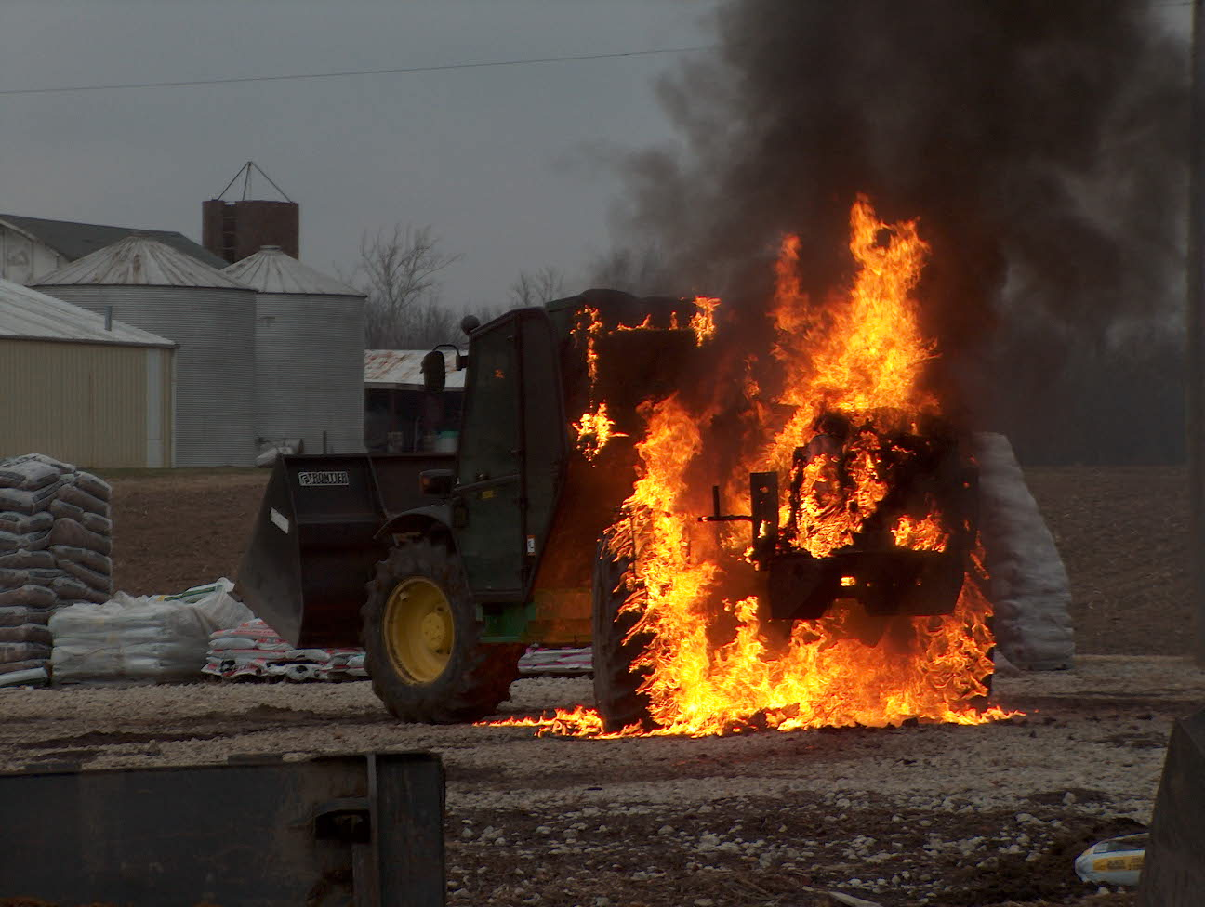 Operations News

All radios have been reprogrammed for digital use on the MECA system. Private Combs installed the templates provided by MECA and the IDHS. We may need to make some adjustments but since MECA changed this past Monday, we had to make the changes immediately. If you have any questions, please contact Private Combs. Please be patient, we aren't finished with all the changes yet. Training for digital communications equipment is currently being developed by Chief Thacker and Private Combs and should be out next week.

We currently have two handheld radios missing from our apparatus. It will cost $7,000.00 to replace both radios. Also, both radios have been turned off by the State. Please contact Battalion Chief Slauter is you have any knowledge of the missing radios.

All flood damaged equipment is currently being replaced. Captain Settles has ordered the water rescue equipment and Lieutenant Cox has ordered PPE. We also have committed to placing two dry suits on all engine companies. See Battalion Chief Slauter with any questions.

The TIC on Rescue 51 has been rebuilt and is back in service.

That is all for now. Be smart and stay safe.

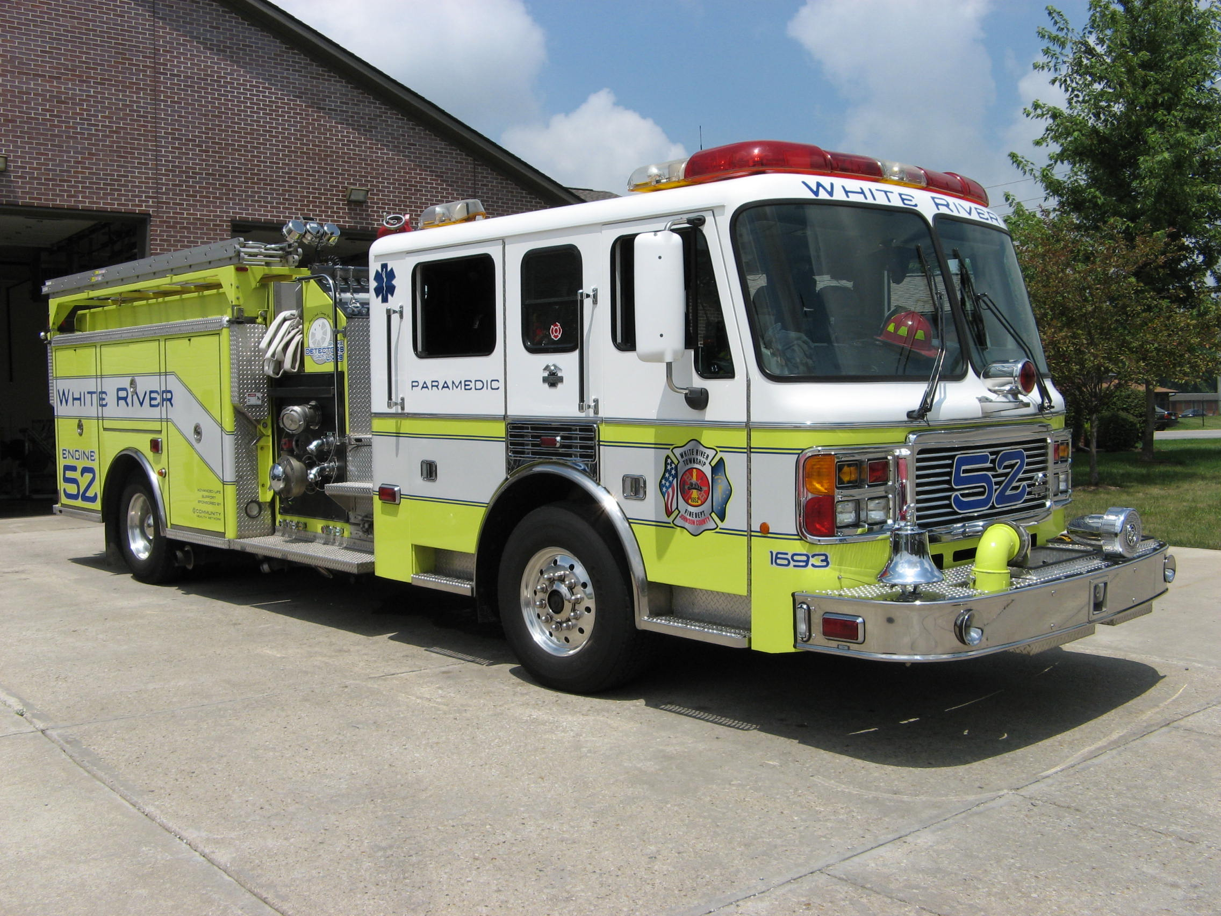 Did you know?

Did you know that on April 22, 1914, Babe Ruth, then a Baltimore pitcher, appeared in his first professional baseball game, shutting out Providence, 6-0.

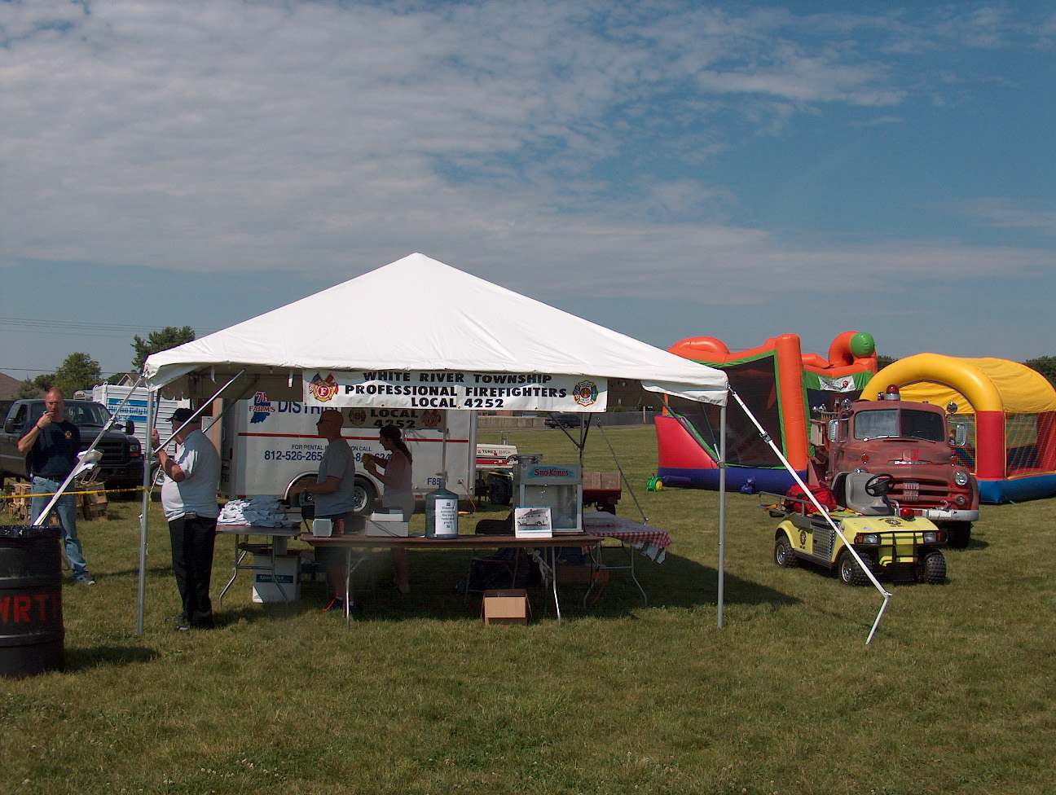 Birthdays (July 11 – July 24)

Joel Heavner July 11
Jory Cox July 13
Mike Winterhalter July 13
Joseph Settles July 18
Jason Ramey July 19

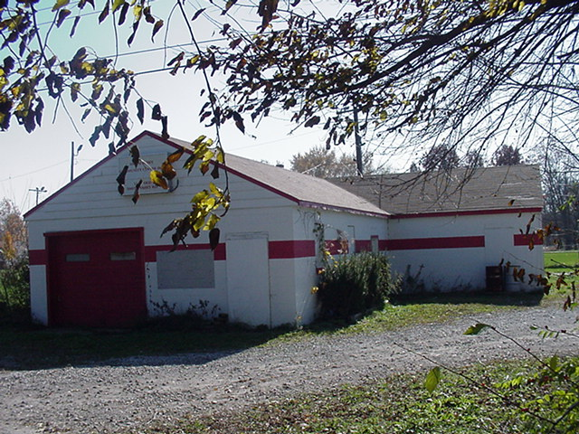 Looking back…..

50 years ago July 20, 1958 Auxiliary donates tables & chairs
The Ladies Auxiliary of the White River Township Fire Department in Smith Valley donated several tables and chairs to the department recently. The tables and chairs will be used for meetings and other gatherings at the station.

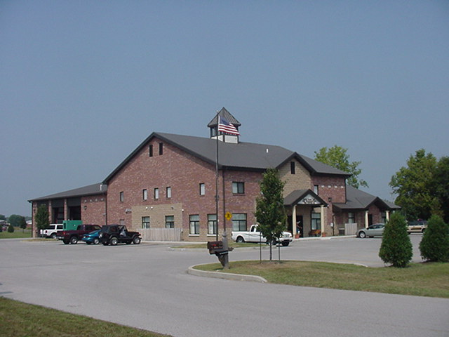 Upcoming events (July – August 2008)

Fire Protection District Board Meeting August 5, 2008 – 7pm. Station 53

Saturday August 9, 2008 The 7th Annual Charity Softball Tournament in memory of our fallen brother Lt. Dale McKnight hosted by Franklin Fire Local 3433. All Proceeds go to the Cole McKnight Trust Fund. Please call for more information if need the contact person is John Henderson 317-346-3713. Cost of $250.00 per team. The event will be at Franklin American Legion and our Danny Dewitt Field... (Rain dateAug 10th)
`
july 2008
S | M | T | W | T | F | S
 |  | 1 | 2 | 3 | 4 | 5
6 | 7 | 8 | 9 | 10 | 11 | 12
13 | 14 | 15 | 16 | 17 | 18 | 19
20 | 21 | 22 | 23 | 24 | 25 | 26
27 | 28 | 29 | 30 | 31
august 2008
S | M | T | W | T | F | S
 |  |  |  |  | 1 | 2
3 | 4 | 5 | 6 | 7 | 8 | 9
10 | 11 | 12 | 13 | 14 | 15 | 16
17 | 18 | 19 | 20 | 21 | 22 | 23
24 | 25 | 26 | 27 | 28 | 29 | 30
31

Classifieds

- Saturday, July 12, 2008 Community Church of Greenwood’s Gathering Place Annual Rummage Sale and Family Fun Day. If you have any items to donate to the sale call Jess Degenhardt 889-7606 ext 6003
- Saturday, July 12, 2008 Clearbrook Lakes Homeowners Association Annual Garage Sale take Smith Valley Road to Averitt Road turn south at Stop 18 Road turn East to Harrison Drive and turn North into Clearbrook Lakes (Clearbrook Lakes is about a block West of Greenwood Fire Station #93)

