

June 13, 2008

Inside this Issue
1 Did You Know
1 Birthdays
2 Looking Back
3 Upcoming Events
4 Classifieds

“To effectively and efficiently provide professional services to our community”

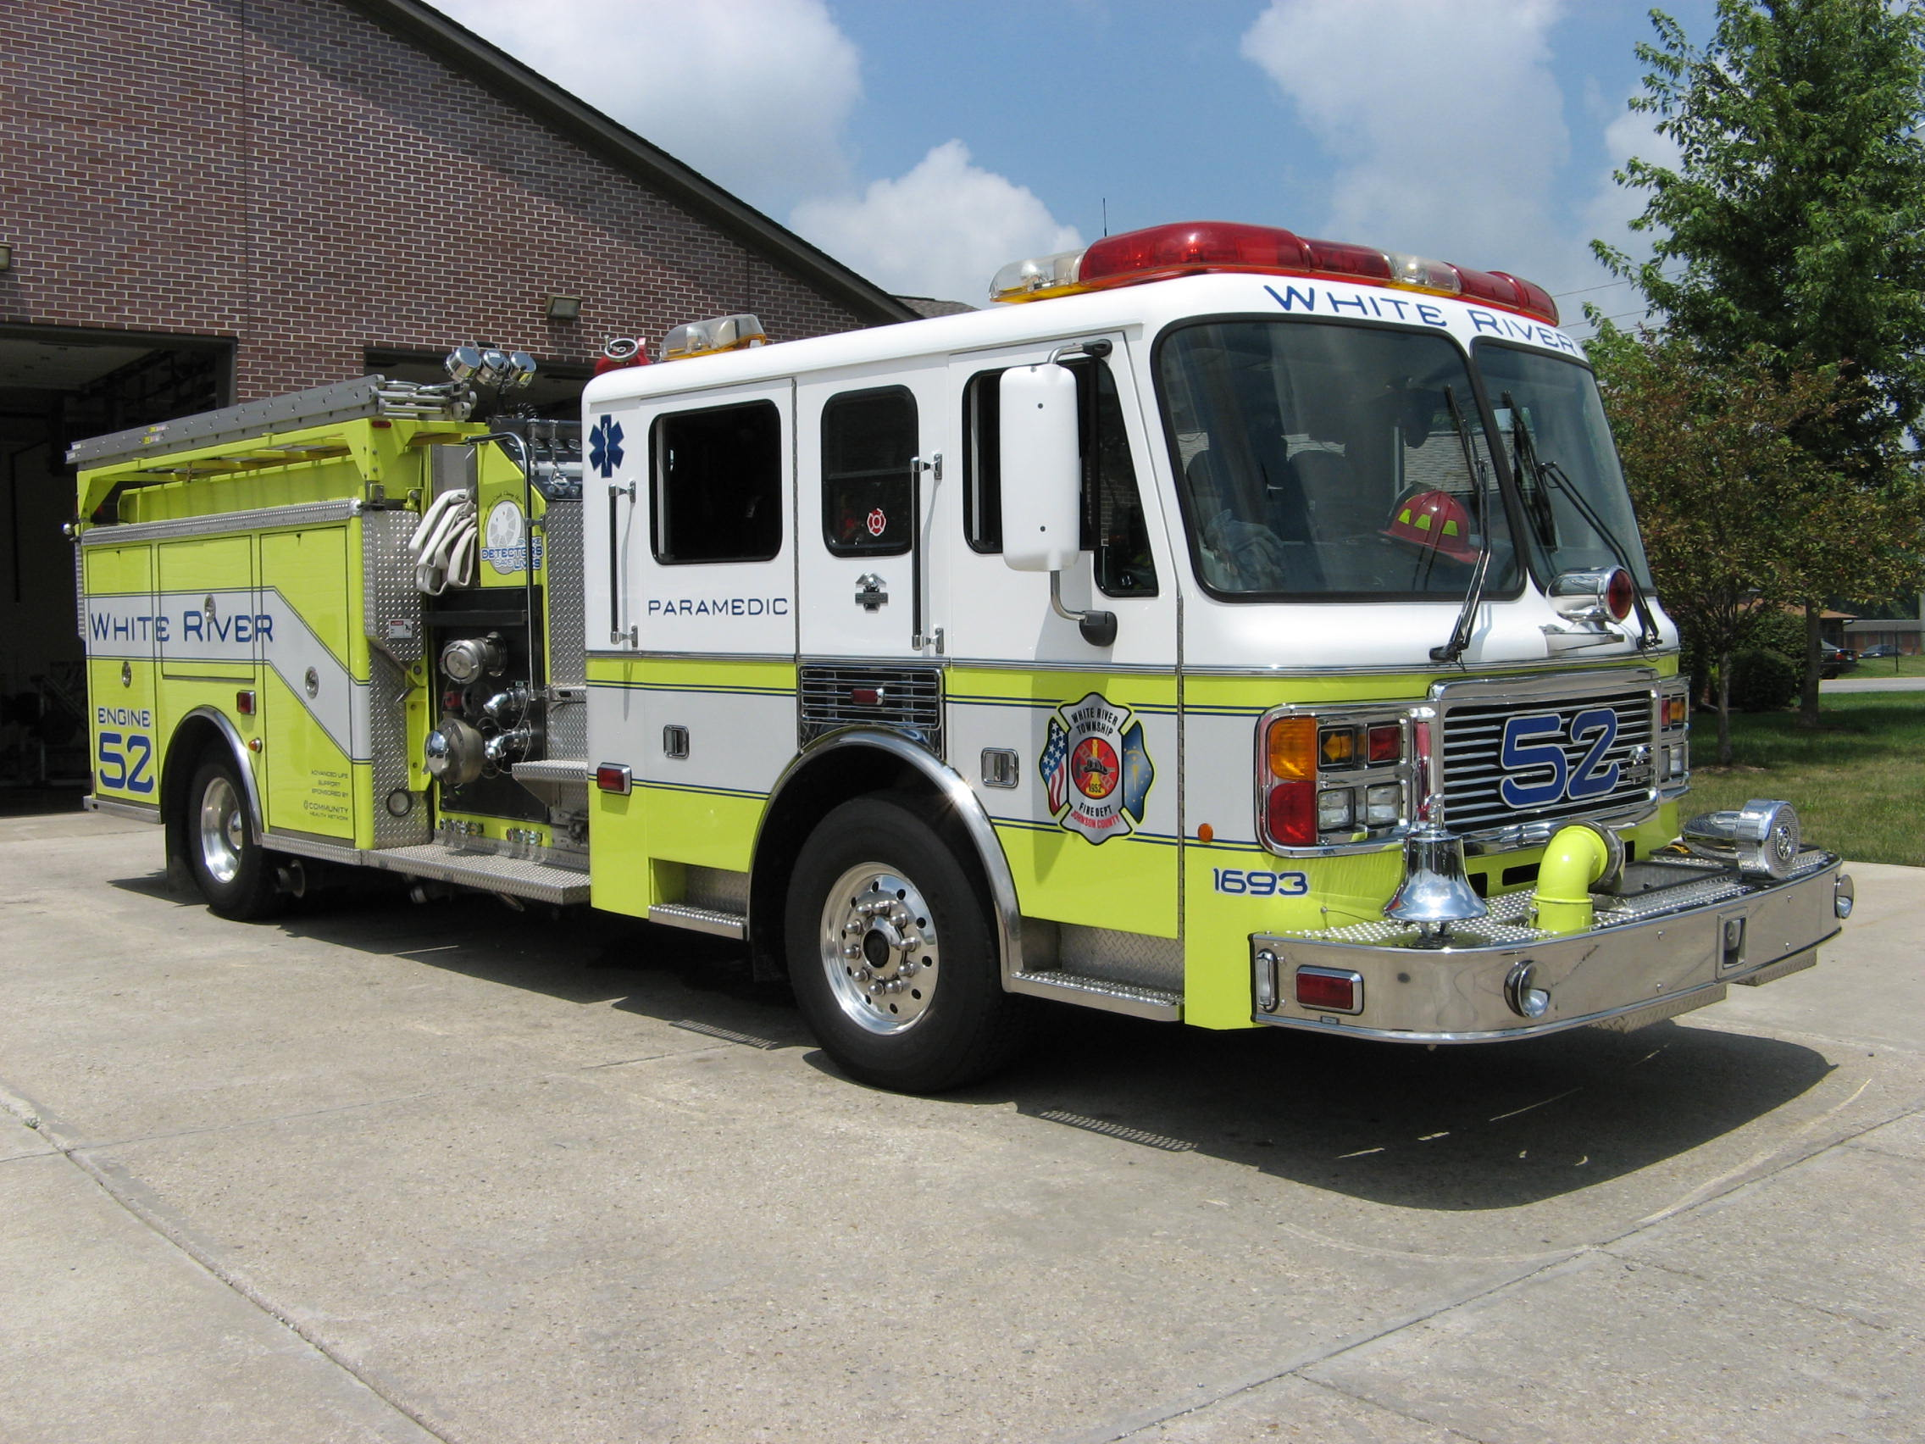 Did you know?

The Earth’s largest ocean is the Pacific Ocean, which has an area of about 60,060,000 square miles, including the portion that may be counted as part of the Southern Ocean. The Pacific covers about one-third of the surface of the Earth, and is larger than the world’s total combined land area.


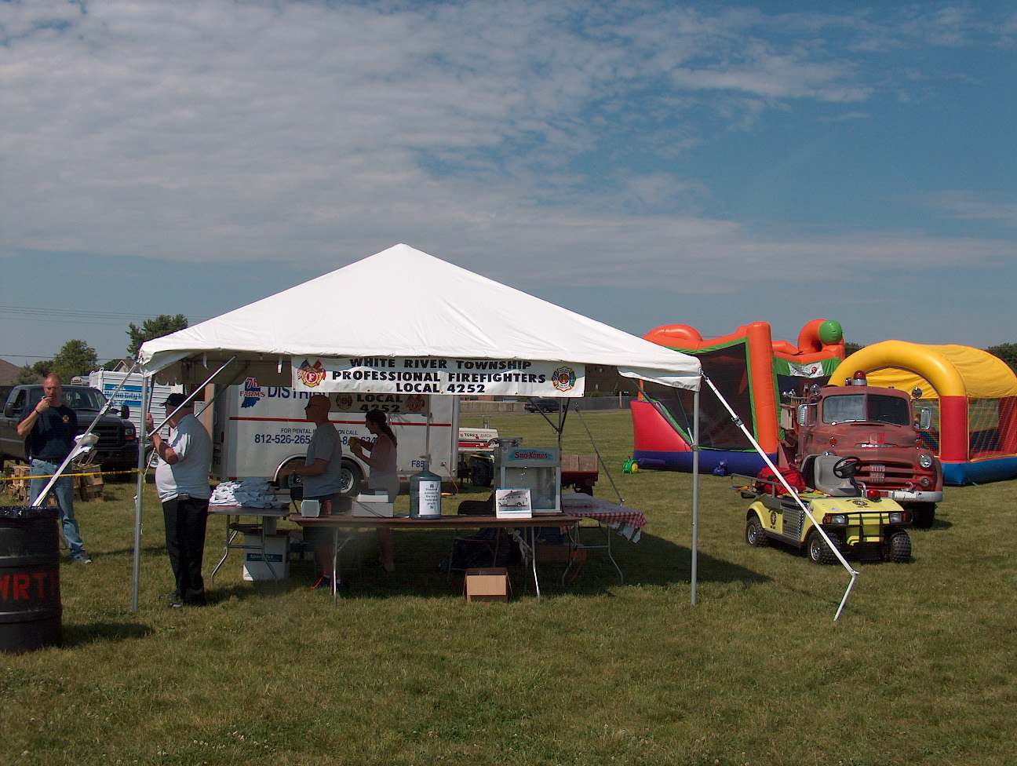 Birthdays (June 13 – June 26)

Chris Pelley June 13 Craig Zollars June 18
Logan Kerr June 19 Bryan Baker June 22

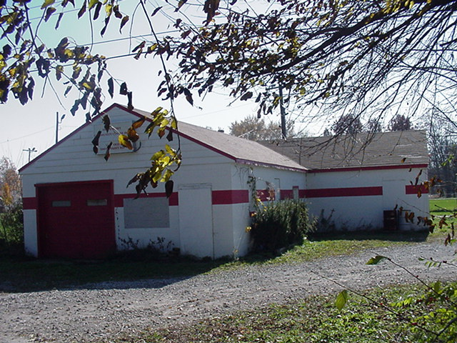 Looking back…..

24 years ago June 21, 1984 Township fire risk rating lowered
White River firemen and community organizations have won a battle to get the township’s fire suppression rating lowered, and that could save residents money on insurance premiums. A non-profit insurance service organization that issues fire suppression ratings recently lowered the rating for the entire township. The rating is a measure of the overall fire suppression capability of the community and is used to determine fire insurance rates. The lowered rating could mean up to a 20 percent savings on fire insurance premiums in the area, a White River Township insurance agent said. Township residents living within 1,000 feet of a fire hydrant now have a fire rating of seven, instead of 10. Residents living more than 1,000 feet from a hydrant have a fire rating of nine instead of 10. White River Township had never been rated before a rating was requested in February of 1983. Because the township had not been rated, it was considered a 10, the worst rating on a scale of one to 10 established by a nationwide insurance organization. The campaign to get a township fire rating was a combined effort of the Bargersville Volunteer Fire Department, Bargersville City Utilities, Indiana Cities Water Corporation, White River Coalition, White River Township Trustee Bob Kelso, and White River Township Volunteer Fire Department.
ISO Commercial Risk Services Inc., a non-profit organization, surveyed the township for its fire protection status and issued the new rating. ISO customer service representative Jerry Sheets said the organization considers such factors as fire department personnel, equipment, training, water supply, the number of fire hydrants in the area, water pumping capabilities, and fire communication systems when rating an area. Greenwood’s rating is six, Sheets said, and Franklin is a seven. Indianapolis carries a two rating with ISO. Sheets said ISO will inspect the township again in 15 years. ISO also issues suggested insurance rates its members may or may not follow. Sheets said the insurance premium for a commercial building with a seven rating could be 36 percent less than for a structure with a ten rating. Larry Finkenbine of Farm Bureau Insurance said White River homeowners could see a 10 to 20 percent difference in their insurance premiums because of the lowered rating. He said most housing developments in the township are now within 1,000 feet of a hydrant, so their rates could already be lower. Farm Bureau charges the same premium for areas with fire ratings of two to eight. He said people living in predominately rural areas will most likely benefit from the change because ratings of nine and ten carry different premiums. Farm Bureau automatically lowers premiums of its customers when fire ratings change, but some companies don’t. White River residents should contact their insurance agents to see how the new fire rating will affect the cost of their new fire insurance.

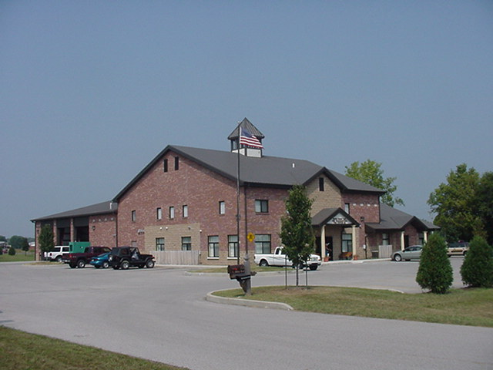 Upcoming events (June – July 2008)

June 13, 2008 (12pm to 10pm) and June 14, 2008 (9am to 10:30 pm) WRTFD 16th Annual Strawberry Festival at Pleasant Grove Elementary School, 5199 W. Fairview Rd.


Saturday, June 28, 2008 Carefree Club
(Public Service Community Appreciation Day) for
White River Twp Fire Department & Johnson County Sheriffs Department
Who’s invited: All officers, firemen, sheriffs and their families.
Where: Carefree Club Pool and Clubhouse 3200 W. County Line Road When: Open to Close Saturday 6/28/08
Hamburgers and Hot Dogs served at 6:00PM Saturday Evening
Bring your swim gear & have a good time sponsored by Carefree Club

Fire Protection District Board Meeting July 1, 2008 – 7pm. Station 53

June 2008
S | M | T | W | T | F | S
1 | 2 | 3 | 4 | 5 | 6 | 7
8 | 9 | 10 | 11 | 12 | 13 | 14
15 | 16 | 17 | 18 | 19 | 20 | 21
22 | 23 | 24 | 25 | 26 | 27 | 28
29 | 30
july 2008
S | M | T | W | T | F | S
 |  | 1 | 2 | 3 | 4 | 5
6 | 7 | 8 | 9 | 10 | 11 | 12
13 | 14 | 15 | 16 | 17 | 18 | 19
20 | 21 | 22 | 23 | 24 | 25 | 26
27 | 28 | 29 | 30 | 31

Classifieds

- Saturday, June 28 time 7am to 2 pm Yard Sale – proceeds benefit the daycare – at Mt. Auburn United Methodist Church

- Saturday, June 28 at 10am Auction – proceeds benefit the new Family Life Center at Mt. Auburn United Methodist Church

- Saturday, July 12, 2008 Community Church of Greenwood’s Gathering Place Annual Rummage Sale and Family Fun Day. If you have any items to donate to the sale call Jess Degenhardt 889-7606 ext 6003

