

May 30, 2008

Inside this Issue
1 Operations
2 Training
3 Did You Know?
3 Birthdays
3 Looking Back
4 Upcoming Events
4 Classifieds

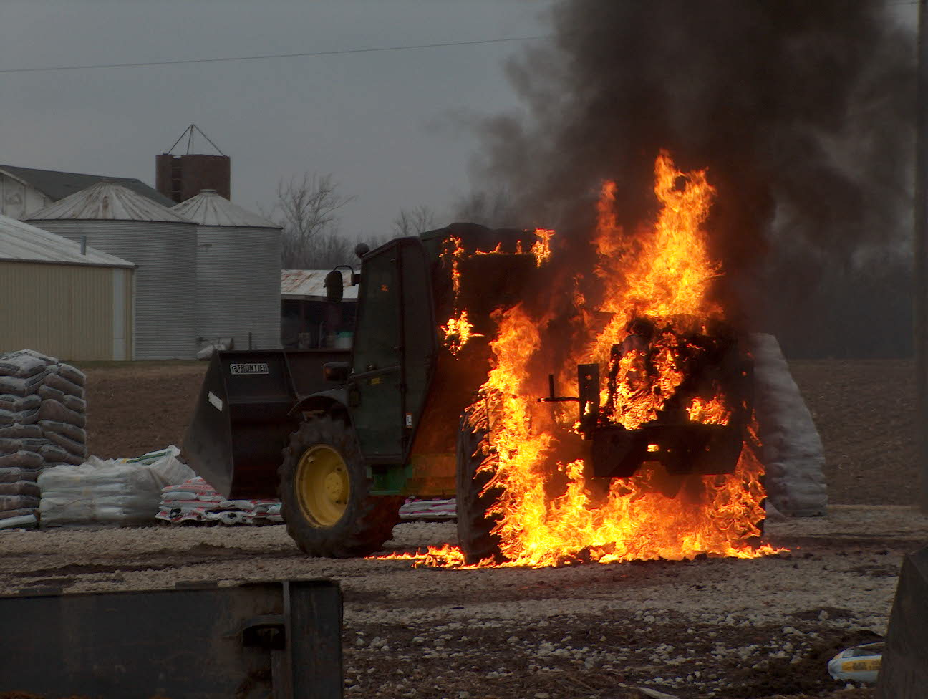 Operations News

We have confirmed with MSA that we will be receiving new PASS devices with the 2007 technology ($8,000 worth – for free) sometime toward the end of June. Please be sure to thank Joe Marsh for all his work with this project. We are still looking to field test both the new MSA and Scott packs under live fire conditions prior to making a decision on purchasing.

Captain Arkins has purchased a new Cyanide meter to utilize during overhaul operations. When it arrives, it will be placed in the Battalion. Training will be provided prior to placing the unit in service.

I know I don’t say it enough, but I want to thank you all for all that you do to make our department great!

Stay smart and be safe!

“To effectively and efficiently provide professional services to our community”

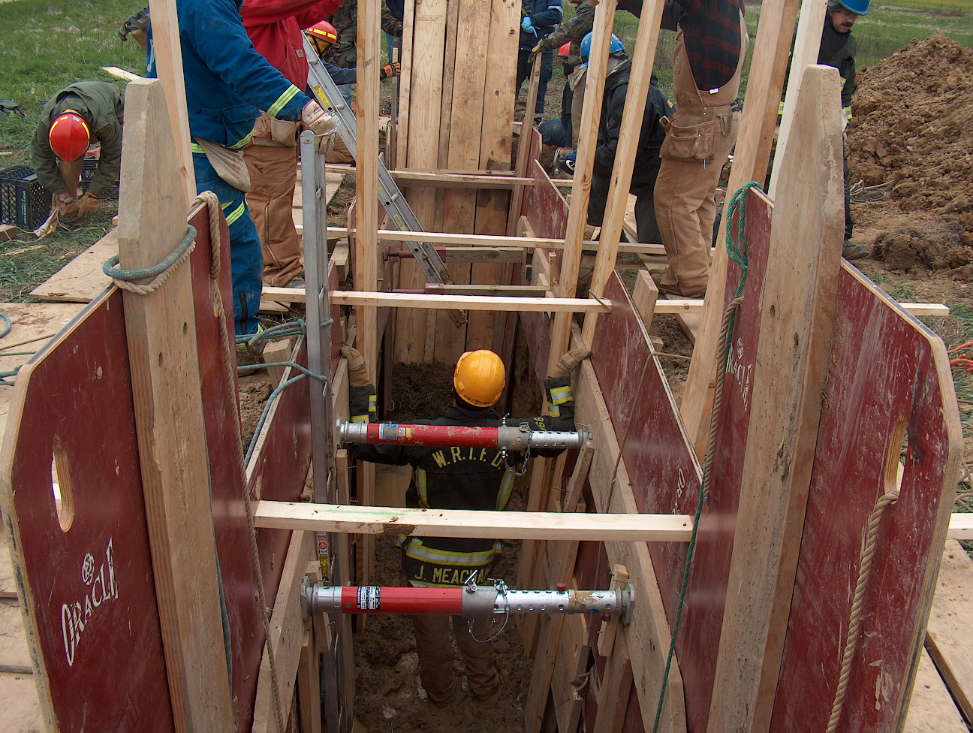 Training News

Six new employees have just completed orientation and will start riding out with different companies soon. Please welcome these individuals aboard and help them get acquainted with our organization.
Matthew Oakley – B Shift Engine 51
Karl Crist – A Shift Engine 53
Craig Lutz – C Shift Ladder 51
Joel Heavner – Sign Up
Bryan Baker – Sign Up
Chris Pelley – Sign Up

There are at least three more shift openings to be filled. Four new applicants will complete the Fire Chief Interview next week and will be scheduled for orientation at the end of this month or first of June.

We will start a new part-time process in the next couple of months as well. If you know of anyone interested, tell them to watch our website for hiring information. Advise them to not call fire headquarters for information.

I have met with each shift and station regarding upcoming training opportunities. Please check with me or your shift training officer for further details.

I am working with the Center Grove School Corp. regarding two structures for 1403 training. More to come on this when available

Upcoming Training Opportunity

Bloomington Fire School – May 31, June 1, 7, 8

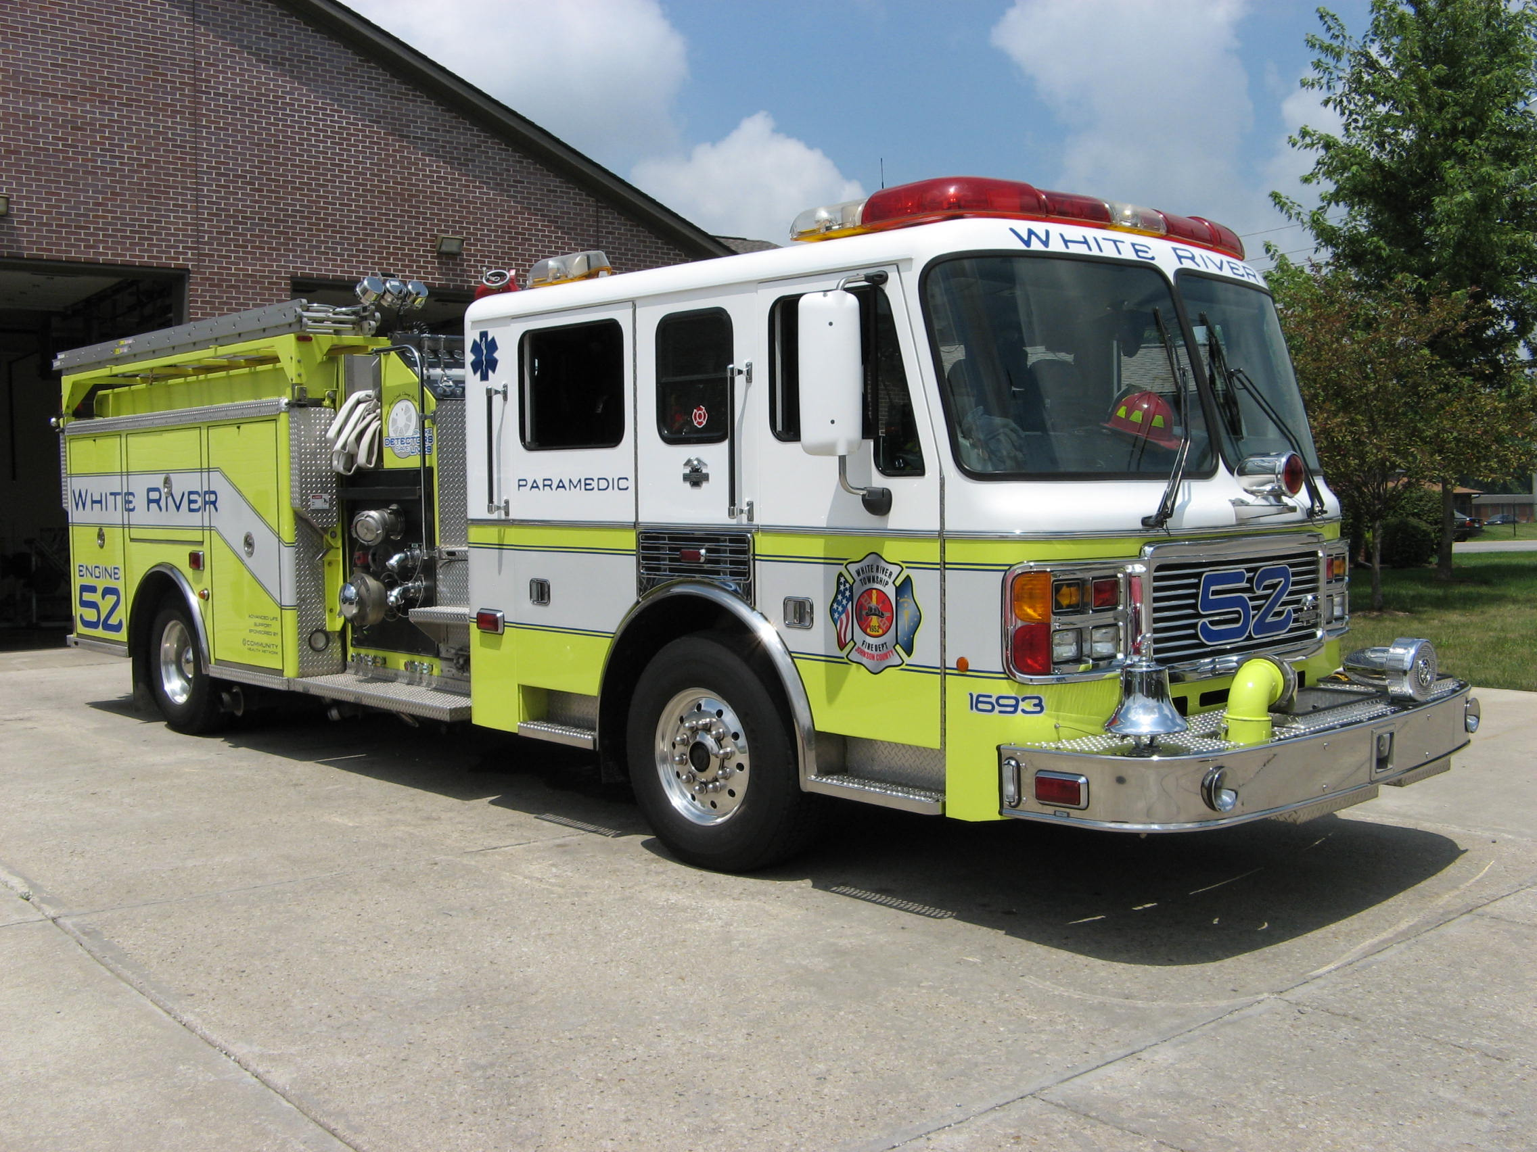 Did you know?

Did you know that we have a pair of visitors at the Indianapolis Zoo for the summer?
They are 2 male koalas which are native to Queensland, Australia. The exhibit opened Saturday, May 24, 2008. “Bamba” and “Coombah” are the first of their kind to visit here since 1994, and are on loan from the San Diego Zoo. They are here on a temporary loan, partially because of what they eat. Koalas eat eucalyptus, and that's the only thing they eat. Indiana winters are not conducive to growing eucalyptus here so we basically have to ship it in from Florida and from Phoenix, Arizona.
The animals are marsupials, not bears, so koala bear is a little bit incorrect. The zoo made extensive renovations to its Forests Biome to make sure the critters have everything they need, including other animals from their home. Plans have also called for the exhibit to include Australian finches, a White’s tree frog, carpet python and bearded dragon lizards. The koalas will stay at the Indianapolis Zoo, 1200 W. Washington St., through Sept. 1.

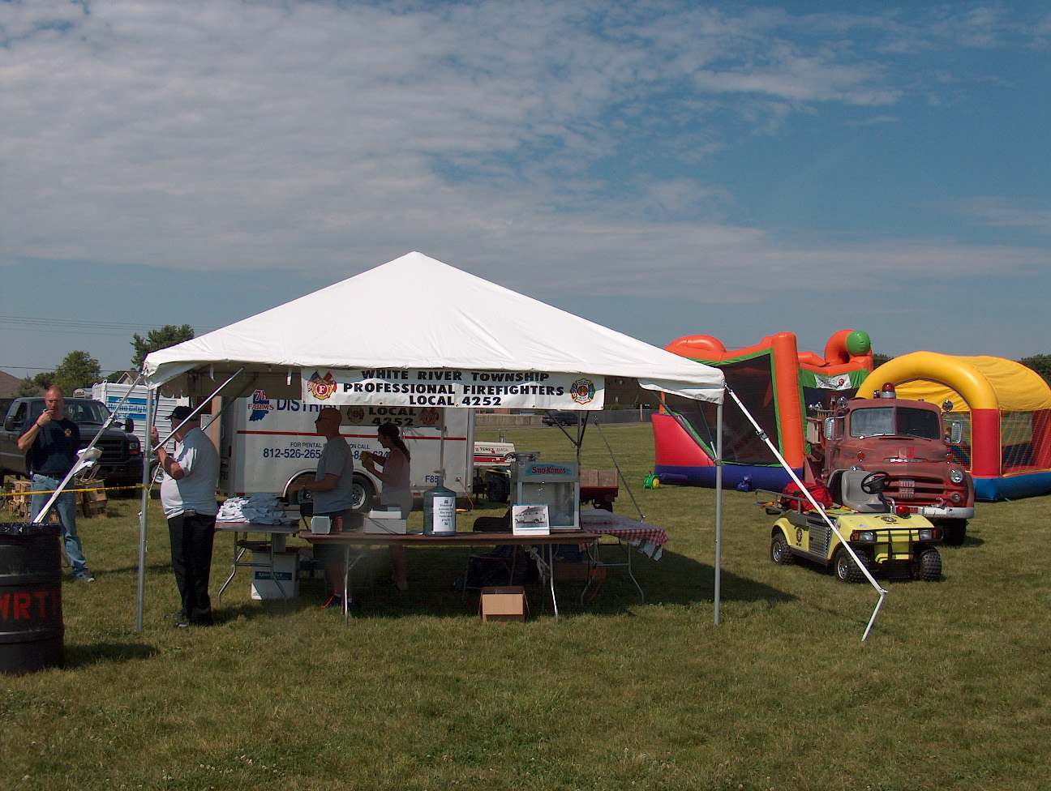 Birthdays (May 30 – June 12)

Andy Cline May 31 Chris Kindred June 7
Brad Jewell June 1 Kevin Skipper June 9
Mike Hoffman June 2 Brent Shepherd June 9

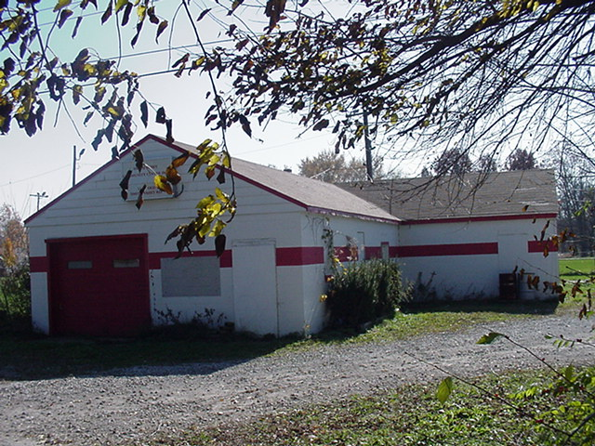 Looking back…..

29 years ago June 2, 1979 Department holds summer picnic
Members of the White River Township Volunteer Fire Department got together today for a day of family, food and fun at the department's annual summer picnic. This year's event took place at the Woodside Day Care Center on Fairview Road.

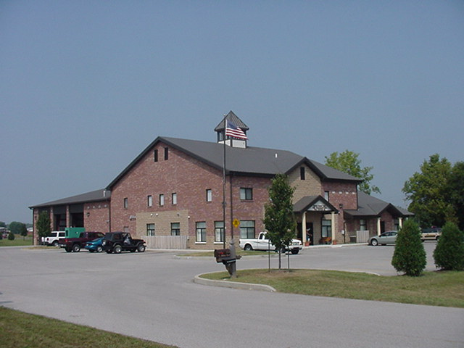 Upcoming events (May - June 2008)

Fire Protection District Board Meeting June 3, 2008 – 7pm. Station 53

June 13, 2008 (12pm to 10pm) and June 14, 2008 (9am to 10:30 pm) WRTFD 16th Annual Strawberry Festival at Pleasant Grove Elementary School, 5199 W. Fairview Rd.


may 2008
S | M | T | W | T | F | S
 |  |  |  | 1 | 2 | 3
4 | 5 | 6 | 7 | 8 | 9 | 10
11 | 12 | 13 | 14 | 15 | 16 | 17
18 | 19 | 20 | 21 | 22 | 23 | 24
25 | 26 | 27 | 28 | 29 | 30 | 31
June 2008
S | M | T | W | T | F | S
1 | 2 | 3 | 4 | 5 | 6 | 7
8 | 9 | 10 | 11 | 12 | 13 | 14
15 | 16 | 17 | 18 | 19 | 20 | 21
22 | 23 | 24 | 25 | 26 | 27 | 28
29 | 30

Classifieds

- Saturday, July 12, 2008 Community Church of Greenwood’s Gathering Place Annual Rummage Sale and Family Fun Day. If you have any items to donate to the sale call Jess Degenhardt 889-7606 ext 6003.

