

May 2, 2008

Inside this Issue
1 Operations
2 Did You Know?
2 Birthdays
3 Looking Back
4 Upcoming Events
4 Classifieds

“To effectively and efficiently provide professional services to our community”

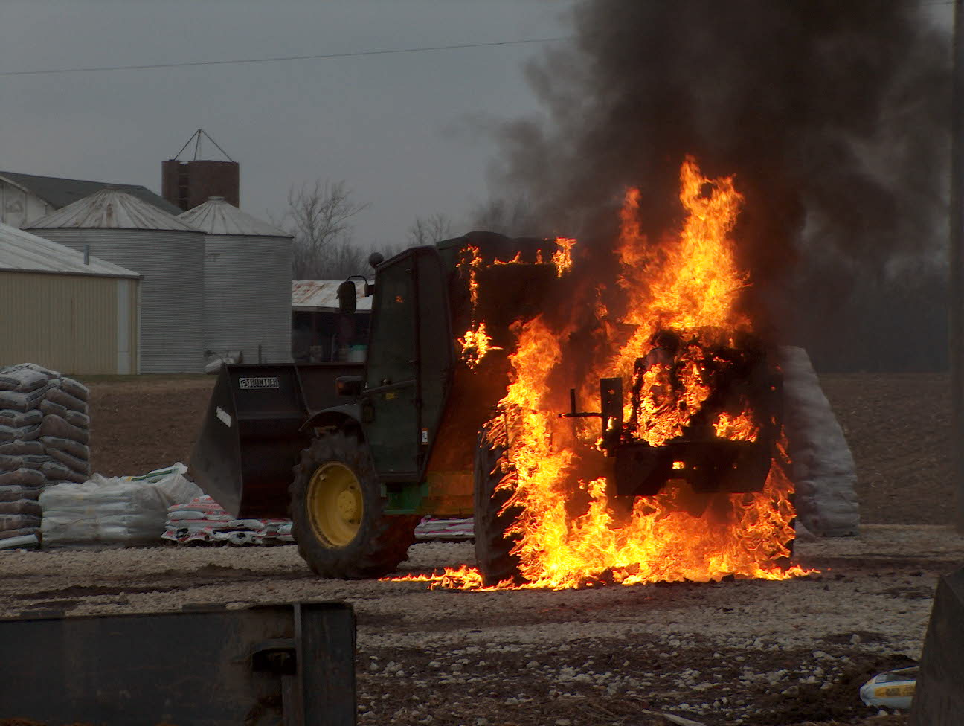 Operations News

After talking to MSA at FDIC, it appears we will be receiving new PASS devices for our current packs. These work on a new type of technology, no longer the ball and track method. We will give you more information when it is received. We are still working on purchasing the new SCBAs in the near future.

We will be purchasing new intake valves for all four engines. This is a TFT intake that is currently on Engine 53. Joe Marsh is currently in the process of purchasing them. If money is left over at the end of the year, an additional intake valve will be purchased for the tanker.

Captain Arkins is investigating prices for the purchase of a cyanide meter. It will either be a stand alone unit or part of a new four gas monitor. This item will be kept on Battalion 5 and will be used to monitoring structures for SCBA removal. Many new studies have shown a direct link between firefighter death and cyanide poisoning from products of combustion.

We will be upgrading our radios in the near future as part of the MECA upgrade to digital. Chief Pell and Mike Combs are working with MECA to organize and facilitate reprogramming schedules. Also, Mike is aware of the problem with New Whiteland Ops 11 and is working on the problem.

Be smart and stay safe.

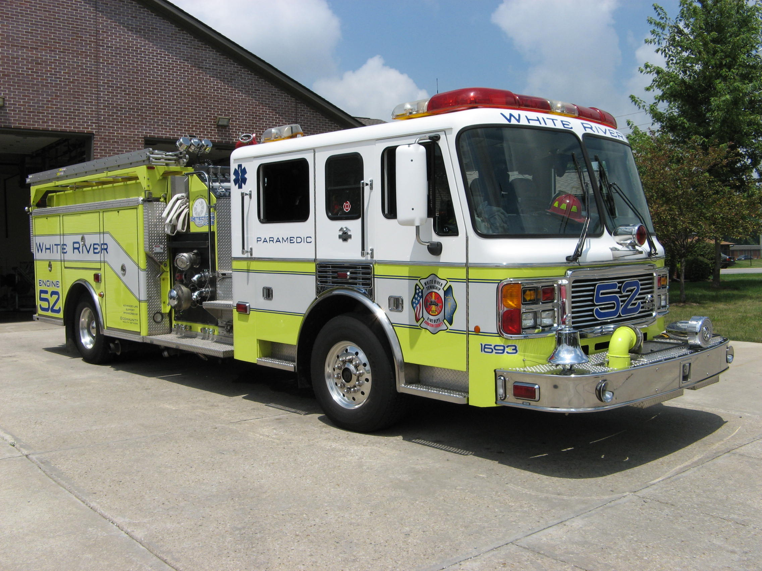 Did you know?

Did you know that the IRS plans to start the first round of economic stimulus payments on May 2? All payments will occur automatically according to the last two digits of Social Security numbers of people who file their tax returns. Those who provide direct deposit information will have their payments deposited automatically. Everyone else will receive a check in the mail, albeit at a slower pace. 

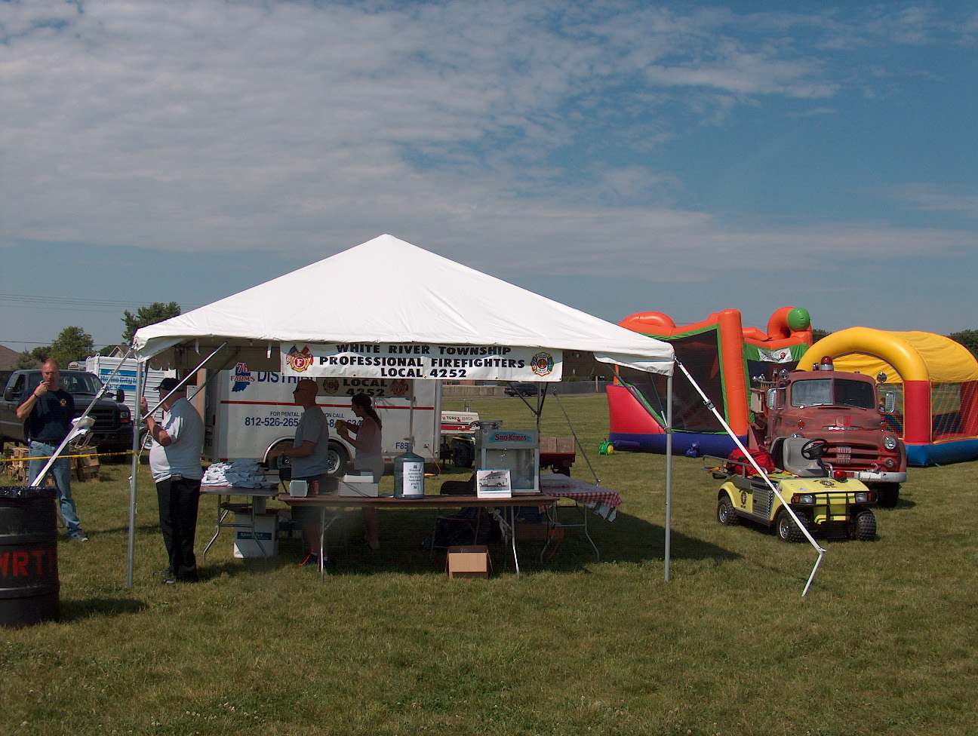 Birthdays (May 2 – May 15)

Ryan Cox May 5
Mike Boone May 5
Scott Wiegle May 14
Crystal Young May 15


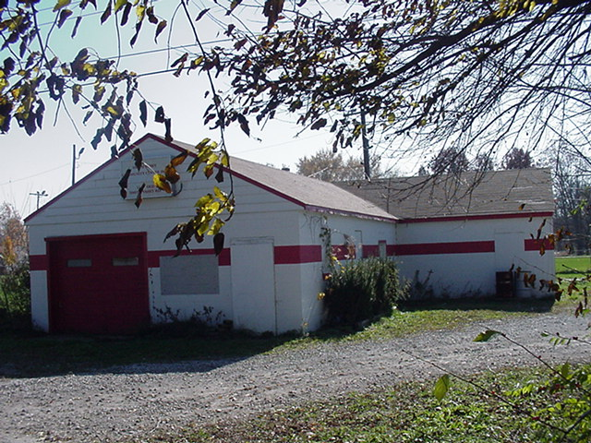 Looking back…..

49 years ago May 4, 1959

Students perform work on fire truck
Students from Arsenal Technical High School did some welding and filling that was needed on a White River Township Volunteer Fire Department fire truck this month. The department purchased the $26 worth of materials and the students provided the labor free of charge.

32 years ago May 3, 1976 Babysitting clinic held at station
The White River Township Volunteer Fire Department recently held a babysitting clinic at the fire station on Runyon Road. The clinic was set up to teach young adult children basic safety information and what to do in case of an emergency.

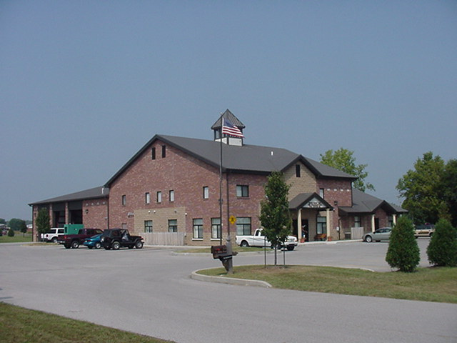 Upcoming events (May and June 2008)

Fire Protection District Board Meeting May 6, 2008 – 7pm. Station 53

June 13, 2008 (12pm to 10pm) and June 14, 2008 (9am to 10:30 pm) WRTFD 16th Annual Strawberry Festival at Pleasant Grove Elementary School, 5199 W. Fairview Rd.


may 2008
S | M | T | W | T | F | S
 |  |  |  | 1 | 2 | 3
4 | 5 | 6 | 7 | 8 | 9 | 10
11 | 12 | 13 | 14 | 15 | 16 | 17
18 | 19 | 20 | 21 | 22 | 23 | 24
25 | 26 | 27 | 28 | 29 | 30 | 31
June 2008
S | M | T | W | T | F | S
1 | 2 | 3 | 4 | 5 | 6 | 7
8 | 9 | 10 | 11 | 12 | 13 | 14
15 | 16 | 17 | 18 | 19 | 20 | 21
22 | 23 | 24 | 25 | 26 | 27 | 28
29 | 30

Classifieds

We have a large White River Township Fire Department family and an even larger extended Fire Department family because we know a lot of people from other departments. Well brothers and sisters let’s give each other a bit of help in this economy.

