

April 18, 2008

Inside this Issue

1 Training
2 Training
2 Did You Know?
3 Looking Back
4 Looking Back
4 Upcoming Events

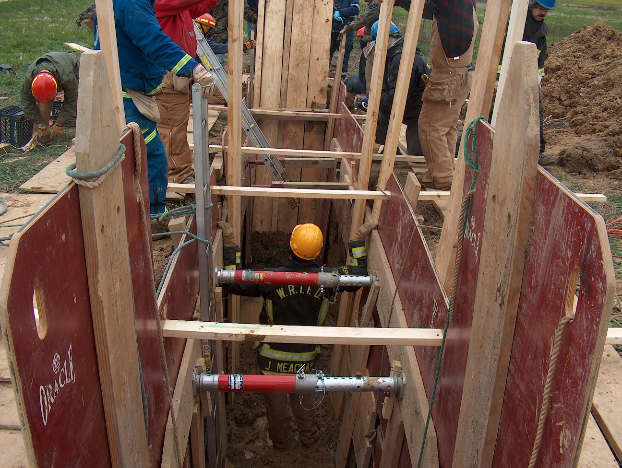 Training News

EMS Firehouse Reporting Issues
Under NIFRS
Incident type- We should only use the 32 codes for any EMS run. This includes where the Medic disregards us, no patient what ever. We should never touch the 30 or 31 codes.
321- EMS call, Excluding vehicle accident with injury
322- Motor vehicle accident with injuries
323- Motor vehicle/Pedestrian accident (MV Ped)
324- Motor vehicle accident with no injuries.
3240- Ambulance mutual aid

Actions taken- There should be only 2 codes used and it is BLS or ALS. This should cover every patient we place in the computer.
32- Provide basic life support (BLS)
33- Provide Advanced life support (ALS)

“To effectively and efficiently provide professional services to our community”

Under the EMS report
Basic tab- EMS patient Disposition. There should really only be 3 codes used under this tab and they are as follows.
2- Refusal (SORS)
6- Dead at scene (DOA)
7- Patient transported

Response tab- Fill is ALS on the scene when possible. It may be the first engine if there is a medic or it may be the medic.

Assessment and treatment tab- Fill out as much as you can. This is a great way to track skills that everyone performs. Be honest, if you miss that is OK but it will point out areas that we need to work on. Fill in everything under the vitals section.

Status and transport tab- Mode of transport there should really only be 2 modes of transport as listed below.
2- Ground Transport
3- Rotor Craft

Destination- make sure you put down the right hospital. I have had people put the right hospital in the report but then pick the wrong one under destination.

Destination determined by_ let us know who made the decision. There should really only be 4 of those.
- Closest Facility
- Protocol (For example Burns to Wishard, Trauma to Wishard or Methodist.)
- On-line Medical direction
- Patient/Family choice

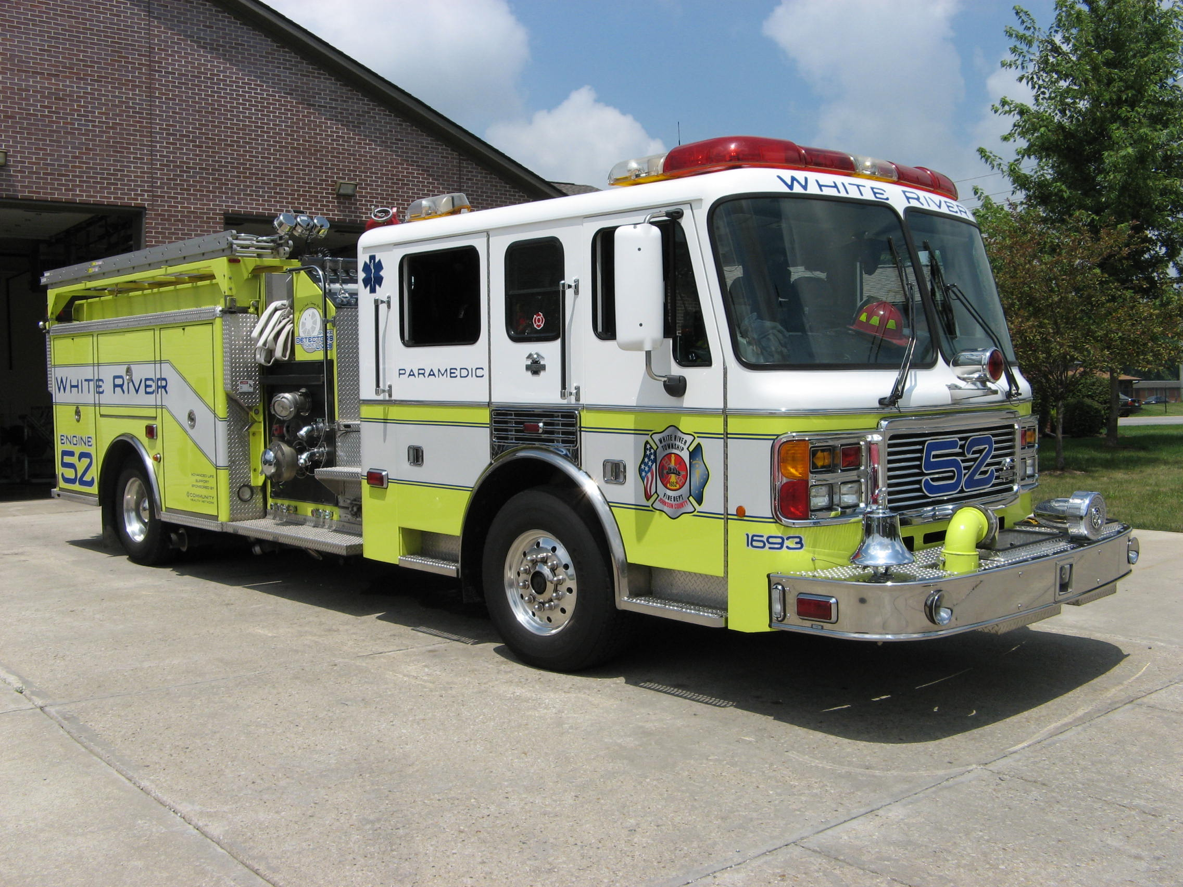 Did you know?

Did you know that the Bangali River (Bengali: বাঙালি নদী) is one of the main rivers in the northern part of Bangladesh (commonly known as North Bengal). As of 2007, the river is in the news because of the possibility that it might merge with the Jamuna River, which could lead to major changes in the geography of the region.

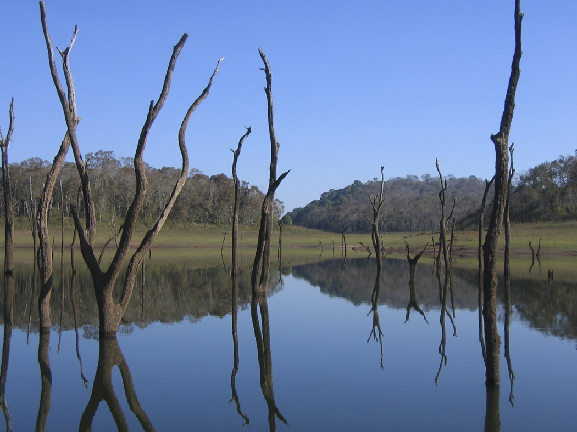

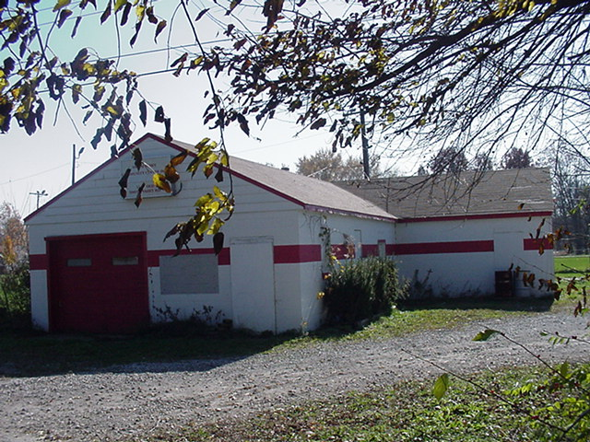 Looking back…..

31 years ago April 20, 1977 New auxiliary formed in county
Seventeen members of the Franklin, Greenwood and White River Township Fire Department auxiliaries met Wednesday night to form a countywide auxiliary firemen's group. The new organization will attempt to work together to provide refreshments for firefighters on the scene of a blaze, raise funds and possibly provide a county disaster fund, according to Sandy McCallister, public relations representative for the group.
Officers for the newly-formed group were elected. They are: Linda Weddle, president; Pat McDaniel, vice-president; Barbara Hawkins, secretary; Peggy Parton, treasurer; Shirley Elliot, chaplain; and Sandy McCallister, public relations. Their next meeting will be held May 16 at 7:30 p.m. at the Franklin fire station. Interested auxiliary members are invited to join the group.
31 years ago April 28, 1977 Big slide gone but not forgotten
It has been more than two weeks since the gigantic slide was mysteriously destroyed by fire at the Orchard Golf Center on State Road 135 in White River Township. During that time, one of the employees at the center has had “second thoughts” about the safety of such slides. Kay Boyd, daughter of Mr. and Mrs. John Browning, who own the center and its recreational facilities, said, “We never realized that the slide was such dangerous playground equipment.” She and the Brownings reiterated that the gigantic slide which was constructed in 1969 at a cost of $40,000 will not be replaced. It has since been dismantled. Mrs. Boyd continued, “If there had been children at the top of that slide when it caught fire, they would have perished. I can see my kiddies who played on the slide many, many times at the top of that thing when it caught fire.”

“It has scared me to many sleepless nights since the fire,” Mrs. Boyd related. “Never will I let my children go on one of these things again. And I’d recommend the same thing for any other parent.” The slide, which towered over the adjacent miniature golf course, driving range and par-three golf course, was made of fiberglass and according to fire officials, consequently burned in “flash fashion.” There is still a mystery to the blaze which broke out during the afternoon of April 12, 1977. Investigators are still trying to find out what caused the blaze to start. Investigators contend there was no insurance loss related to the blaze since the slide was not insured so there was probably no criminal arson. Nonetheless, firefighters and the Browning family would like to know the cause of the fire. Dee L. Corbin of the Indiana State Fire Marshal’s office, who was asked to assist in the investigation, spent some five hours at the scene with Bob Wehrman, Chief of the White River Township Volunteer Department; Dick Van Valer, Deputy Chief of the Greenwood Volunteer Fire Department, and Dave McDaniel, fire inspector for the White River Township Department.

There was no electricity turned on to the slide. It had been turned off during the winter months. This was verified through the Public Service Indiana who furnishes the electricity. The slide was 36 feet high, 165 feet long, 24 feet wide and had 12 lanes to slide down. The slide was made for the Kenworthy Corporation in California from whom the Brownings bought it. The fire was discovered by a man playing miniature golf who reported it to Leonard Dillingham, a maintenance man who was mowing the lawn only a few feet from the bottom of the slide. Dillingham reported it immediately to Mrs. Boyd who picked up the phone in the concession building and notified the White River Township Fire Department. The department received the alarm at 3:38 p.m. It was en route to the scene at 3:40 p.m. and arrived on the scene at 3:46 p.m. En route the driver of the first piece of apparatus called Greenwood to assist because of the amount of smoke he saw. Perry Township Fire Department was also notified at the same time. Greenwood was en route to the scene at 3:44 p.m. with one pumper and a rescue truck, although neither department knew what was on fire. Smoke rose to an estimated 300 to 400 feet in the air and was black enough to be noticed for several miles. By the time White River Township firefighters got to the scene, the entire slide was ablaze and when Greenwood arrived at the scene at 3:55 p.m. it had completely burned down. It took another 15 minutes to extinguish the rest of the remaining flames left by debris with water from the White River Township and Perry Township tankers. The Greenwood pumper unit stood by to protect the other structures near the slide.

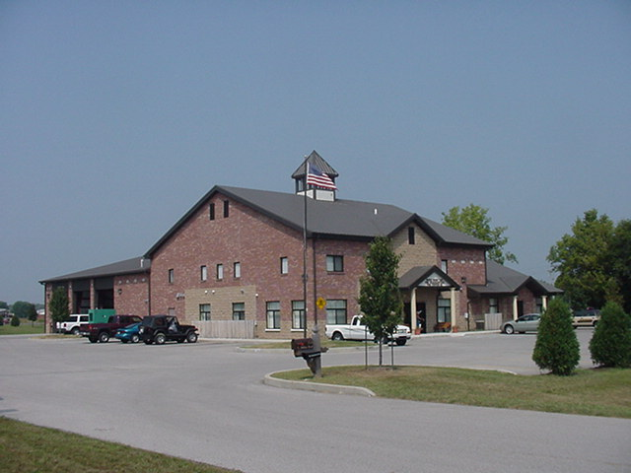 Upcoming events (May 2008)

Fire Protection District Board Meetings for 2008:
May 6, 2008 – 7pm. Station 53

may 2008
S | M | T | W | T | F | S
 |  |  |  | 1 | 2 | 3
4 | 5 | 6 | 7 | 8 | 9 | 10
11 | 12 | 13 | 14 | 15 | 16 | 17
18 | 19 | 20 | 21 | 22 | 23 | 24
25 | 26 | 27 | 28 | 29 | 30 | 31

