

April 4, 2008
 Fire Prevention News
Inside this Issue
1 Prevention
2 Prevention
2 Operations
2 Training
3 Training
3 Did You Know?
3 Birthdays
3 Looking Back
4 Classifieds
4 Upcoming Events

Many of you have asked for some updates on future, new construction taking place in our Fire District. Here are some highlights as to what’s going on or has been submitted for construction in the near future:
Over 1100 new residential lots.
A few of the largest subdivisions are:
170 Lots in the Calvert Farms Subdivision located on Olive Branch just west of Paddock Rd
176 Lots in the Cobblestone Subdivision located on Demaree Road west of 200W
178 Lots in the Harrison Crossing Subdivision located on Peterman Rd north of Smith Valley
160 Lots in the Springhill Subdivision located on Morgantown Rd south of County Line

“To effectively and efficiently provide professional services to our community”

14 new Two-story townhouse buildings
12-Pinehurst Townhomes on Curry Road east of 135
2- Reserve at Royal Oaks on 135 north of Olive Branch

10 new One-Story Condo Buildings
Abby Villas at County Line and Peterman

31 new Three-Story Apartment Buildings
13-Reserve at Stones Crossing on Stones Crossing east of 135
14-Sandy Bay on State Road 37 South of County Line
4- Devonshire II on Curry east of 135

A major health care complex built by Saint Francis Hospital on Bluff Road north of Fairview.
A 10 lot commercial subdivision at Fairview east of State Road 37.
A daycare located on Smith Valley East of RR tracks.
Kroger is building an 18,000 square foot addition which will include the partial demolition of the 3100 Meridian Park Shopping Complex.

For a complete list you can see the “Working Projects” list posted on the wall outside Chief Brown’s office.

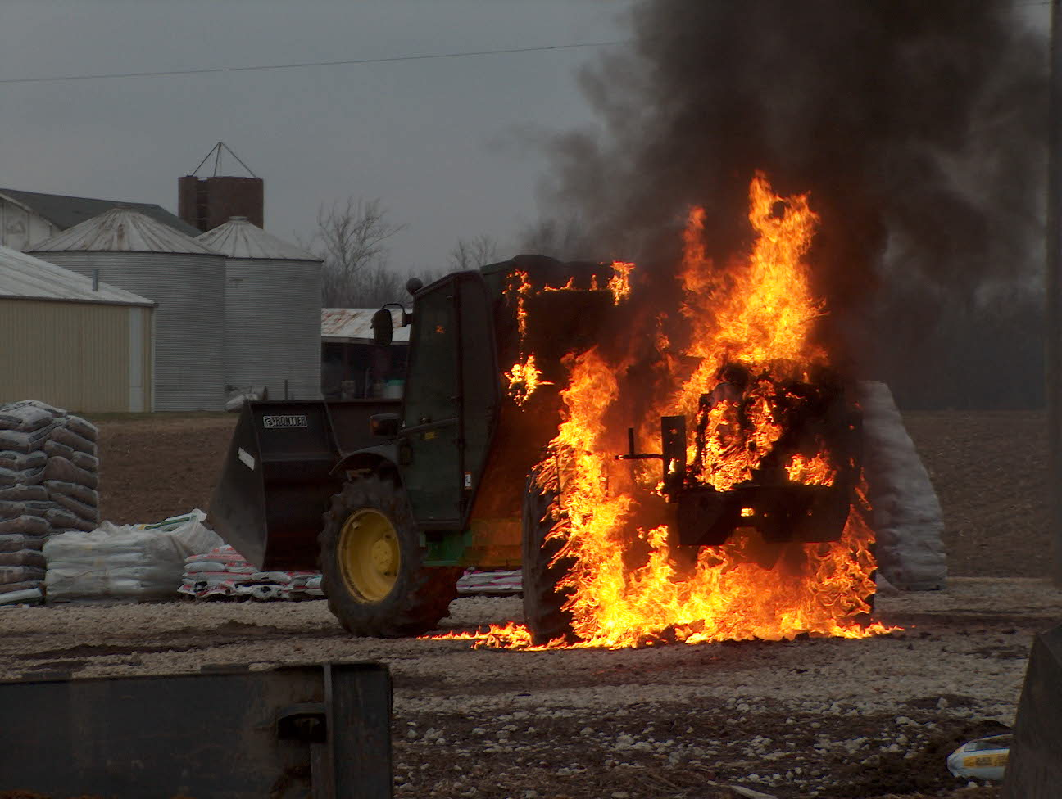 Operations News

Congratulations to Captain Hart on his promotion to Battalion Chief. Captain Hart will officially start as the A shift Battalion Chief on April 13th. Battalion Chief Slauter is moving to B shift and will start April 14th. The Station 52 House Captain position is currently open for bidding by the other Captains, which will be closed on April 8th. I would like to thank Battalion Chief Wilson for all his hard work during the past couple of years which has made us a better fire department.

We have submitted a grant request for the purchase of new turnout gear, totaling $167,778. The FPDB has graciously allowed us to match up to 20 percent, 10 percent more than required. It will be several months before we have any official word from AFG, so remain patient. Our goal is to outfit all firefighters from Captain down to dedicated shift firefighter with two sets of gear. All the sign up firefighters will have one set issued and a back up set if surplus allows. Our goal is to establish a 10 year replacement program.

No further news on the SCBA replacement. We currently have a 2007 standard MSA unit for testing. Scott has committed to providing at least 2-4 units in the near future for testing purposes. I will have further information to provide for you after FDIC.
Have a good week at FDIC. Be smart and stay safe.

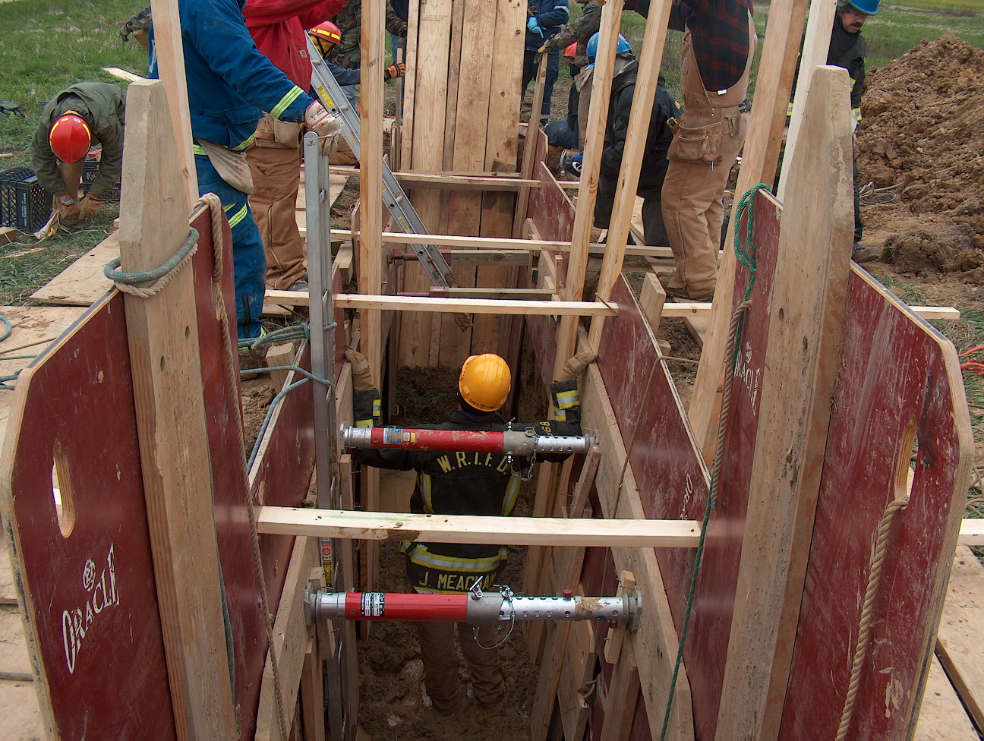 Training News

FDIC is next week. WRTFD is getting 70 passes for the event, obviously not every individual will get their very own pass.
Passes will be available for classroom sessions Wednesday – Friday and exhibits. Please share the passes so everyone can have a chance to attend.

Battalion Chief John Salka, FDNY will be at Community Church of Greenwood on Wednesday April 9 from 6-10 PM for a presentation on leadership. This is a FREE educational opportunity. Do not miss out. Decatur Twp FD will be providing fill in at Station 53 from 6-10 so all on duty personnel will be able to attend.

District 5 (Marion and the doughnut counties) have received a FF Safety and Survival Prop from Indiana Department of Homeland Security. It is currently at 53’s but will be moved to the old 51’s for short-term storage. We will conduct training on the prop the week after FDIC.

Upcoming classes
Fire Instructor I – WRTFD HQ beginning April 14 0830-1630
Bloomington Fire School – May 31 and June 1, 7, 8

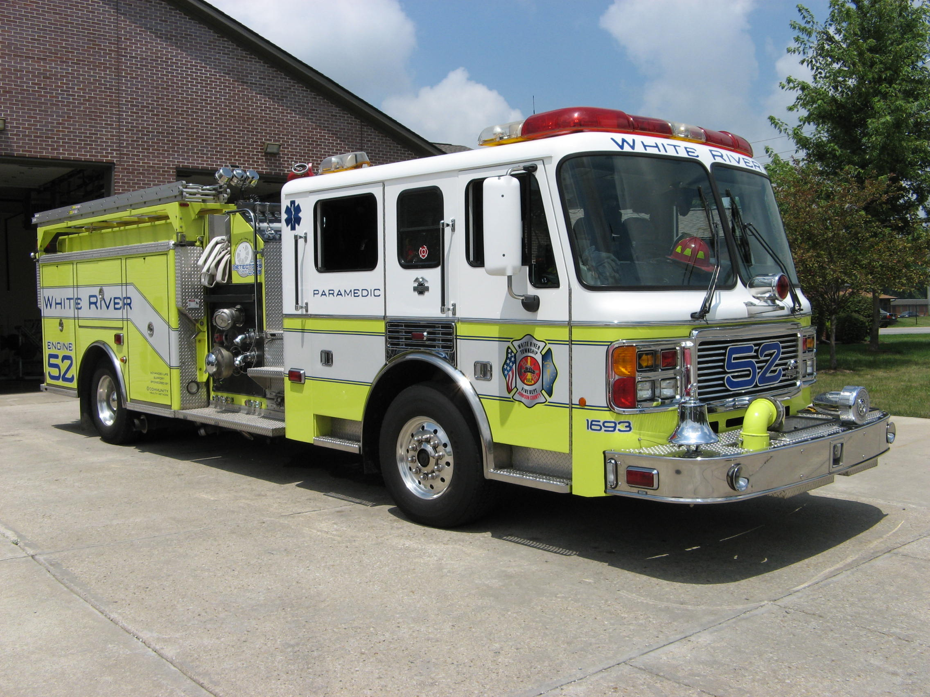 Did you know?

Did you know that Zhang Yuan (Traditional: 張元; Simplified: 张元; pinyin: Zhāng Yuán) (born 1963, Nanjing, China) is a Chinese film director? Zhang received a BA in Cinematography from the Beijing Film Academy in 1989. He is a member of China's Sixth Generation of film directors.

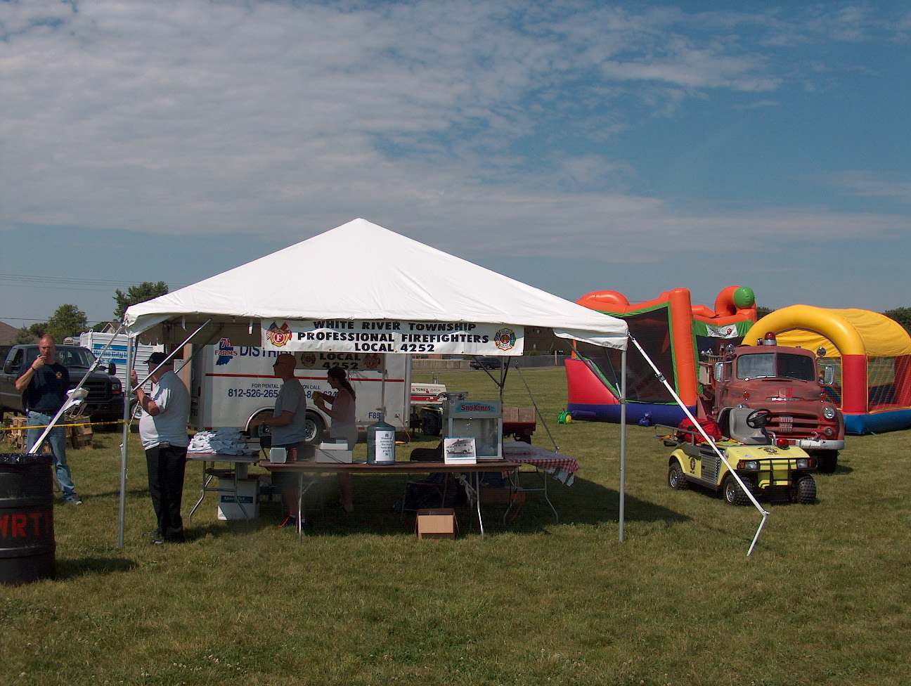 Birthdays (April 4 – April 17)

Ryan Reid April 8
Joe Dietz April 9
Edward Carlson April 10
Charles Fraker April 14
Lisa White April 15
Sean Campbell April 15

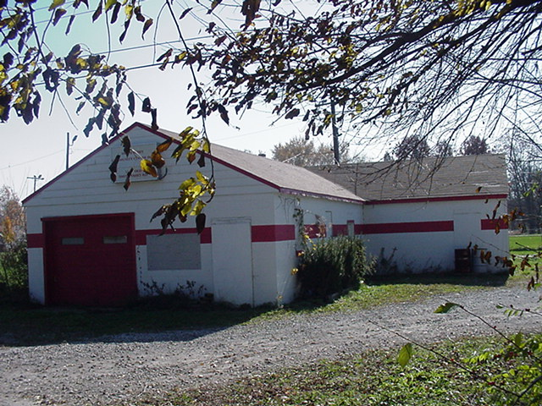 Looking back…..

37 years ago April 10, 1971 Children visit fire station Students from West Grove Elementary School visited the White River Township Fire Station today for an educational lecture on fire safety. The weather was good and the talk was very informative. The combination made for a wonderful afternoon for the students.

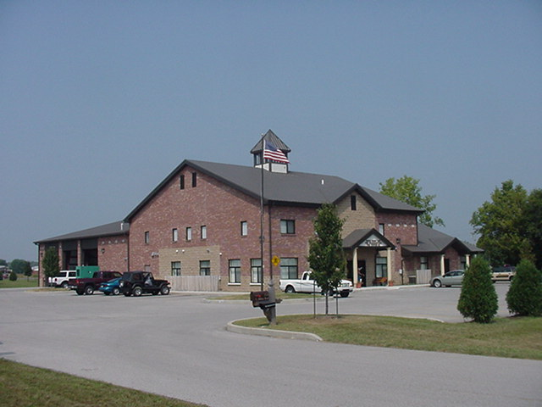 Upcoming events (May 2008)

Fire Protection District Board Meeting May 6, 2008 – 7pm. Station 53

may 2008
S | M | T | W | T | F | S
 |  |  |  | 1 | 2 | 3
4 | 5 | 6 | 7 | 8 | 9 | 10
11 | 12 | 13 | 14 | 15 | 16 | 17
18 | 19 | 20 | 21 | 22 | 23 | 24
25 | 26 | 27 | 28 | 29 | 30 | 31

Classifieds

- If you are interested in purchasing a house in White River Township, I have listed my house for sale through a local realtor. My house is at the corner of Walnut and Paddock Drive behind Mount Pleasant Christian Church. If you would like any information on the house, please send me an email gboots@wrtfd.org
- We will be Blessed with a 7th grandchild in July 2008 (a boy), please let us know if you have a yard sale or neighborhood sale this spring. Thank you, we appreciate it! jemmons@wrtfd.org

