

March 21, 2008

Inside this Issue
1 Administration
2 Administration
2 Training
3 Training
3 Did You Know?
3 Birthdays
4 Looking Back
4 Upcoming Events
4 Classifieds

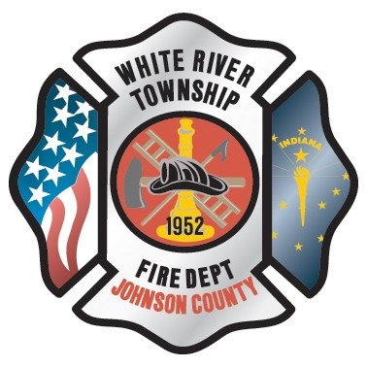 Administration News

Learning Partnership with
Columbia Southern University
White River Township Fire Department and Columbia Southern University have formed a Learning Partnership which allows employees along with their spouses and children of White River Township Fire Department to take advantage of CSU's low tuition rate receive a 10% tuition discount and a free application process.

Columbia Southern University, a leader in online learning, offers a variety of online associate, bachelor, graduate and certificate programs. CSU specializes in a Bachelor of Fire Science Degree Program. The programs offered and information about these programs can be found at www.columbiasouthern.edu.

White River Township Fire Department is listed on Columbia Southern’s website as a Learning Partner and CSU has created a subsite for employees. This discount also applies to the employees’ spouses and children. To take advantage of the 10% partner discount and the free application, employees should submit their Application for Admission and Enrollment at the following site. At this site you will find additional information concerning CSU programs and enrolling at CSU.
http://www.columbiasouthern.edu/alliances/partners/default.aspx?corpid=whtrivertwpfd_in
Columbia Southern University is accredited by the Distance Education and Training Council (DETC). The DETC (www.detc.org) is an accrediting association recognized by the U.S. Department of Education and the Council on Higher Education Accreditation (CHEA). Columbia Southern University is approved for Veterans’ Educational Benefits. If you have further questions, please contact the admissions department at admissions@columbiasouthern.edu or 800-977-8449.

“To effectively and efficiently provide professional services to our community”

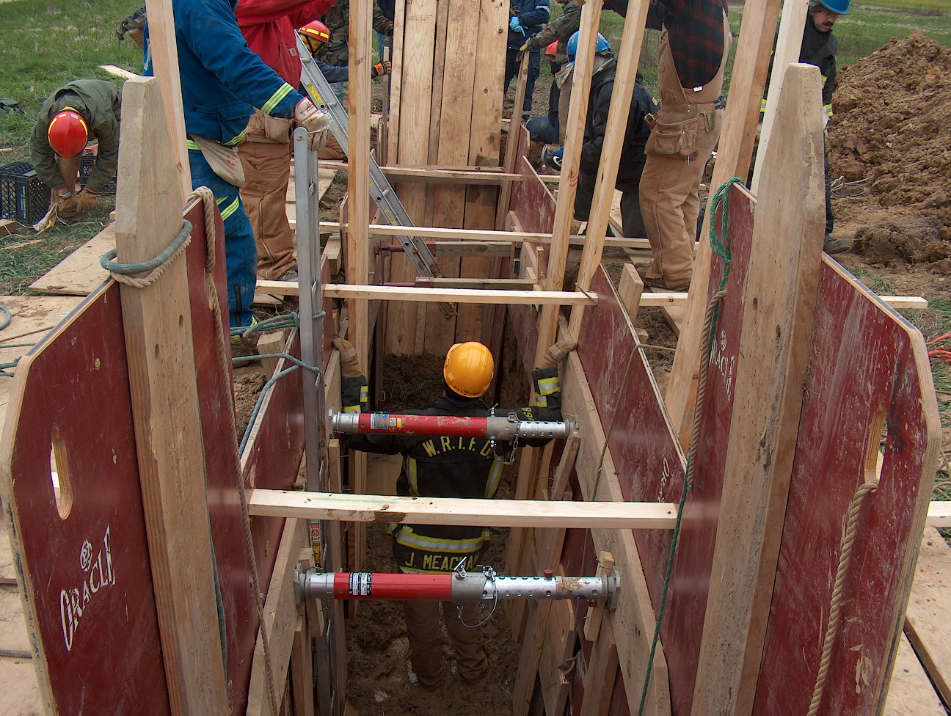 Training News

The following exert is from www.firefighterclosecalls.com. The story stresses the importance of annual physicals. WRTFD is currently working on the 2008 contract with Public Safety Medical for annual physicals. As always train as if your life depends on it, because it does.

It is with regret that we report the Line of Duty Death of Lieutenant Robert T. Kilduff, Sr. who was the Vice President of IAFF Local 718 Boston, and the Legislative Representative of the Professional Fire Fighters of Massachusetts. Lt. Kilduff passed away on Thursday, March 13, 2008 from occupational cancer.
Funeral information is here: http://www.bostonfirelocal718.org .
The following are excerpts from a letter from the late Lieutenant Bob Kilduff. The entire letter is on the Boston local 718 website.

DON'T BE ME
My name is Bob Kilduff. I have been a firefighter for 34 years. Were it not for some help from above, marvelous medical people and dumb luck I would well be on my way to an early death due to occupational cancer. I am telling my story in the hope that another brother or sister Firefighter will not have to share my experience.
Like many of you reading this, I only went to the doctor when hurt. You know the drill: burns, cuts, smoke inhalation and the many orthopedic injuries that are part and parcel with our job. For reasons unknown the thoughts of retirement age prompted me in May of 2003 to get my first physical exam in 30 years. I felt the best I had in years and the test results bore this out. All was well. The doc however advised that I have a colonoscopy due to my age. Not really thrilled, I acquiesced. The procedure was a piece of cake; however, the test revealed a large tumor in my colon which needed to be addressed. Twenty days later a section of my colon was removed. I had to undergo a 6 month chemotherapy program which could have been avoided with early detection. It now appears that my cancer is in remission and the doctors predict these procedures will help save my life.
The issue here is why go to the doctor and learn you're very sick when you can go to the doctor and keep from getting very sick. I have learned the hard way that you must act prudently if you want to see your grandkids grow, have a chance to retire, golf, fish, hunt, go to the track or whatever. If you don't have regular medical checkups your odds of enjoying a longer than normal life is greatly diminished, early detection of cancer is paramount in successful treatment. This will allow you to do what you want to do and not what your doctor will allow you to do.
In 1990 a cancer presumption law was passed by the Legislature in Massachusetts. The reason it was signed into law was that it has been shown that firefighters have a serious problem with cancer. Numerous studies have pointed to the fact that there are over a dozen cancers that attack firefighters more often than the general population. Our exposure to the products of combustion and the resultant carcinogens are the reason and we must be more proactive in protecting ourselves through cancer screening. The Boston Fire Department's Medical Examiner Mike Hamrock deals with cancer and firefighters daily. From his observations, firefighter cancer screening should take place if there is a family history of cancer. For example, colon screening normally scheduled for a fifty year old should take place at age forty due to our higher incidence of the disease. Firefighter deaths due to occupational diseases are far more common than the number of line of duty deaths caused by other means and we must take them seriously.
I ask that you take a few minutes to examine your efforts to help yourself stay healthy. Think for a moment about my experiences over the last ten months and if necessary take the action necessary to help you avoid my fate. Remember, DON'T BE ME. God Bless and stay safe-BK.....

Upcoming Training
HSO (Health and Safety Officer) – Brownsburg FD HQ – March 29 and 30 0830-1630
Fire Instructor I – WRTFD HQ – Monday and Wednesday days 0830-1600 April 14-April 30
ISO (Incident Safety Officer) – Central Nine – Monday and Wednesday nights 1800-2200 April 14-May 14
NFA Terrorism and WMD – Brownsburg FD HQ – April 26 and 27 0830-1630
Advanced 12 Lead EKG – WRTFD HQ – April 29 and 30 0830-1600
ISO – Fishers FD HQ – May 3 and 4 0830-1630

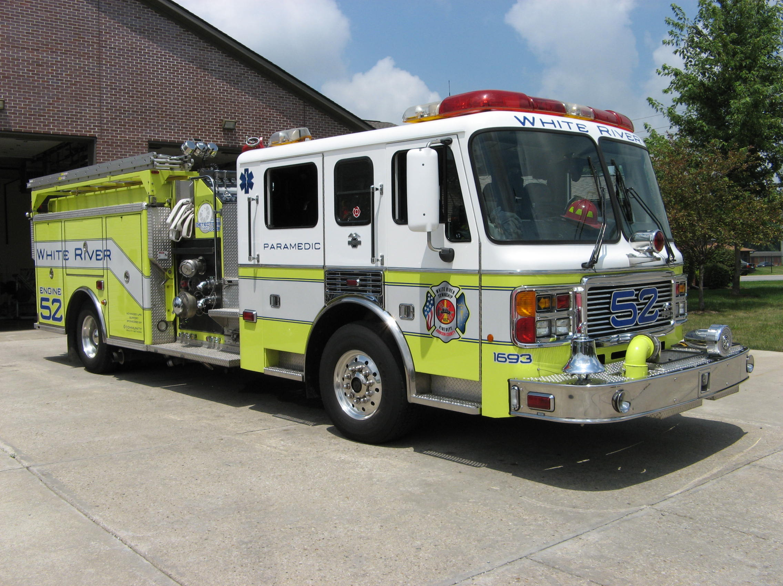 Did you know?

Did you know that the Medal of Honor is the highest military award for bravery that can be given to any individual in the United States? The first Army Medals were awarded on March 25, 1863 and the first Navy Medals went to sailors and Marines on April 3, 1863.

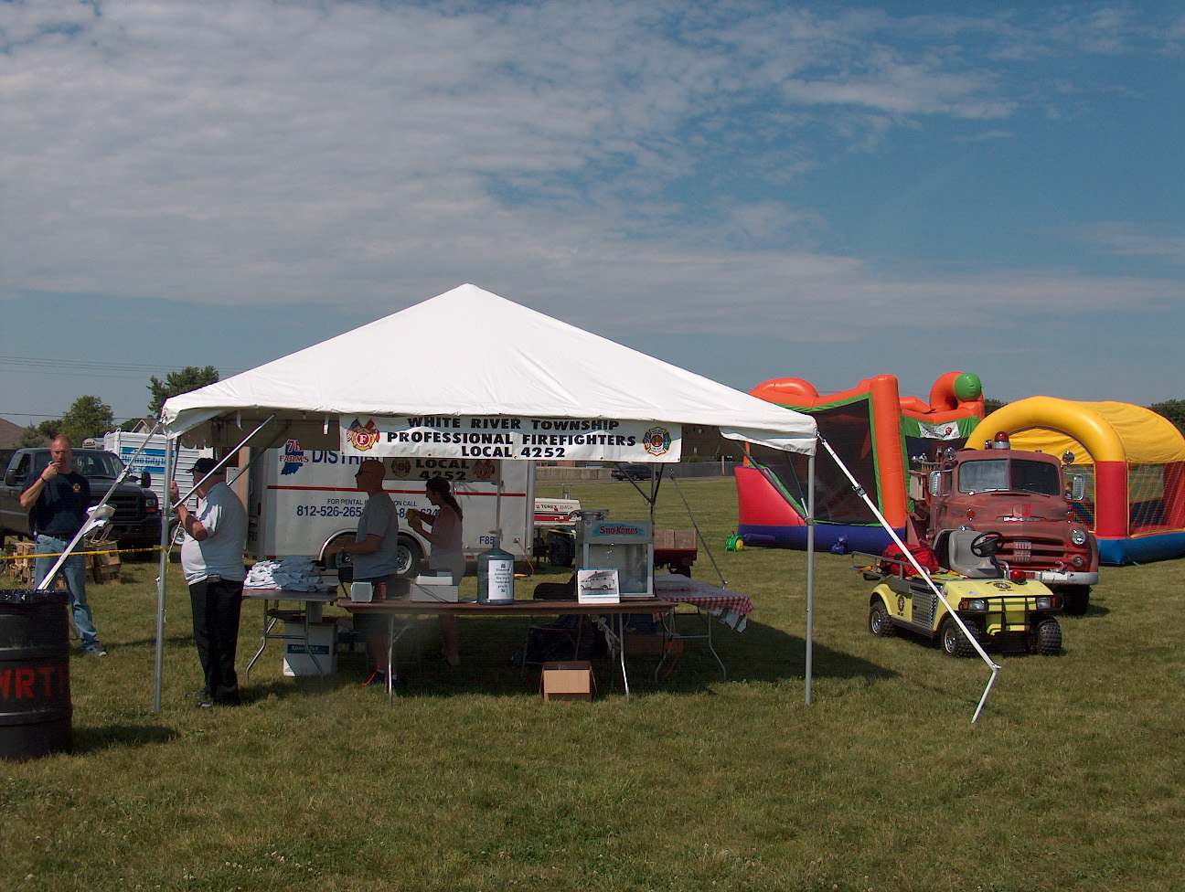 Birthdays (March 21 – April 3)

Jeff Smith March 22 Andrew Roy April 2
Jackie Emmons March 22 Lucas Stanton April 3
Jacob Kocher April 3
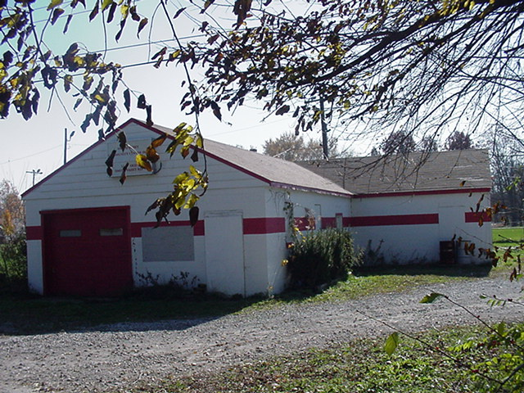 Looking back…..28 years ago. March 28, 1980 Jeep overturns

A White River Township man suffered minor injuries Friday morning when the Jeep he was driving ran off Olive Branch Road and overturned. Ben Thacker, 18, 1021 Berry Lane, White River Township, was thrown from the vehicle, according to a witness. White River Township fireman and Trooper Terry Collinsworth of the Indiana State Police investigated the accident. Chief Joel Thacker’s brother Ben is fine, pictures available at www.wrtfd.org archives.

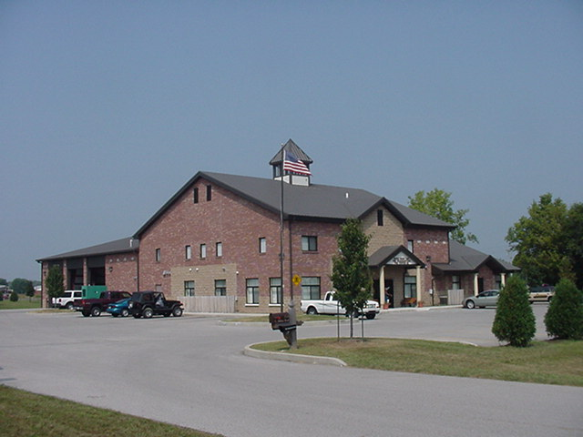 Upcoming events (March 2008 – April 2008)

April 2008
S | M | T | W | T | F | S
 |  | 1 | 2 | 3 | 4 | 5
6 | 7 | 8 | 9 | 10 | 11 | 12
13 | 14 | 15 | 16 | 17 | 18 | 19
20 | 21 | 22 | 23 | 24 | 25 | 26
27 | 28 | 29 | 30
Fire Protection District Board Meeting
April 1, 2008 – 7pm. Station 53

Classifieds
We have a large WRTFD family and an even larger extended Fire Department family, so we know a lot of people. Brothers and sisters let’s give each other a bit of help in this economy.
- Do you have a garage sale or neighborhood sale coming up?
- Do you have an automobile, house or dining room set for sale?
- Did your dog (cat) have puppies (kittens) and they need a good home?
- Does your pair of snake skin boots need a free home?
- Do you need an item, dresser, convertible, velvet picture of Elvis that you have been searching for forever and ever?
Please advertise the sale of your 8 story custom built bird house in our free employee newsletter (larger profit). Send an email to jemmons@wrtfd.org to have your article approved and printed in the newsletter.

