

March 7, 2008

Inside this Issue
1 Training
2 Upcoming Training
2 Did You Know?
3 Birthdays
3 Looking Back
4 Upcoming Events

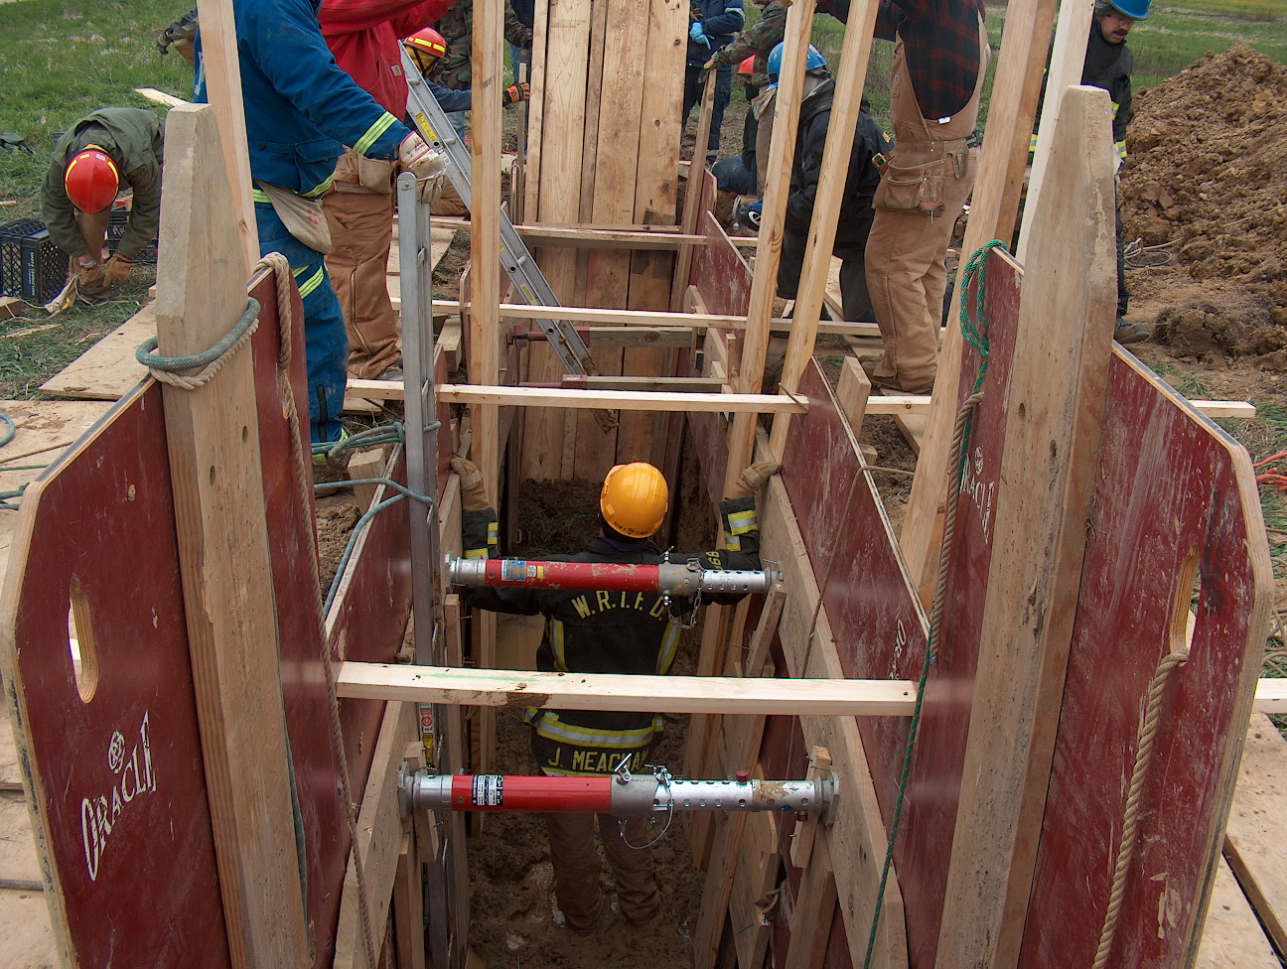 Training News

Mask fit testing is underway. If you have not completed annual respirator fit test, please contact Scott Wiegle, Joe Marsh, Casey Arkins or Myself to get this OSHA mandated testing completed.

WRTFD logged over 17,800 hours of total training in 2007. We probably trained more last year but not all of the training reached Firehouse software. Thanks for a great job of getting a lot of the training in the system. Remember to put any and all company level or outside training in Firehouse so we can continue to produce accurate reports.

We will be taking delivery of two Battle Fogger smoke machines within the next day or two. They will stay in the library. If you wish to use, please sign them out. I will try to keep liquid smoke on hand. If you know you want to use them get with me ahead of time so I can be sure you have everything you need.

The master personnel certification list is complete and Jackie is finishing the excel spreadsheet. Once complete, I will email it out to everyone. If something is incorrect, let me know and produce a certification so I can add it to the list.

I am still working on a couple of acquired structures for non-live fire training. I am also scheduling some time at Wayne Twp and McCormicks training ground for live fire evolutions.

“To effectively and efficiently provide professional services to our community”

Upcoming Training
Duneland School of Emergency Response – March 24,25, 31 and April 1 (www.ifia.org)
FDIC - April 7-12.
Bloomington Fire School – May 31 and June 1, 7, 8 (www.ifia.org)

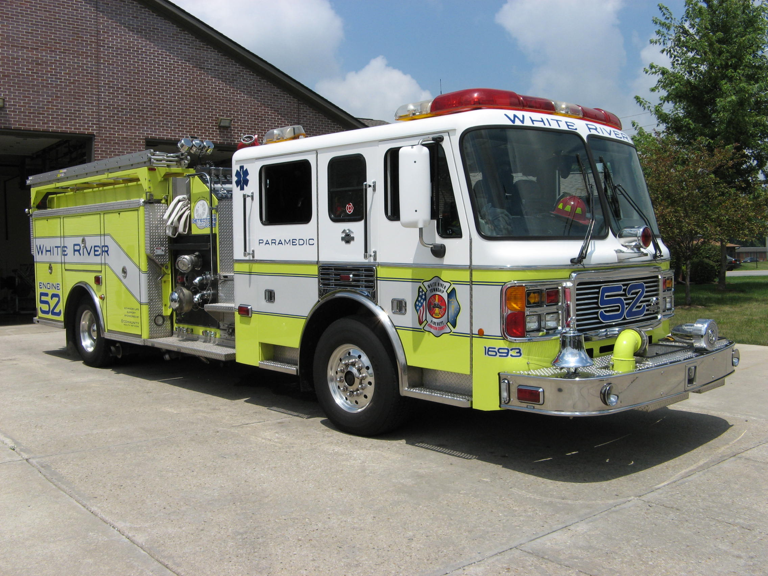 Did you know?

Did you know that St. Patrick’s Day is Monday, March 17th?
No Irish Need Apply: Up until the mid-nineteenth century, most Irish immigrants in America were members of the Protestant middle class. When the Great Potato Famine hit Ireland in 1845, close to a million poor, uneducated, Catholic Irish began to pour into America to escape starvation. Despised for their religious beliefs and funny accents by the American Protestant majority, the immigrants had trouble finding even menial jobs. When Irish Americans in the country's cities took to the streets on St. Patrick's Day to celebrate their heritage, newspapers portrayed them in cartoons as drunk, violent monkeys. However, the Irish soon began to realize that their great numbers endowed them with a political power that had yet to be exploited. They started to organize, and their voting block, known as the "green machine," became an important swing vote for political hopefuls. Suddenly, annual St. Patrick's Day parades became a show of strength for Irish Americans, as well as a must-attend event for a slew of political candidates. In 1948, President Truman attended New York City’s St. Patrick's Day parade, a proud moment for the many Irish whose ancestors had to fight stereotypes and racial prejudice to find acceptance in America.


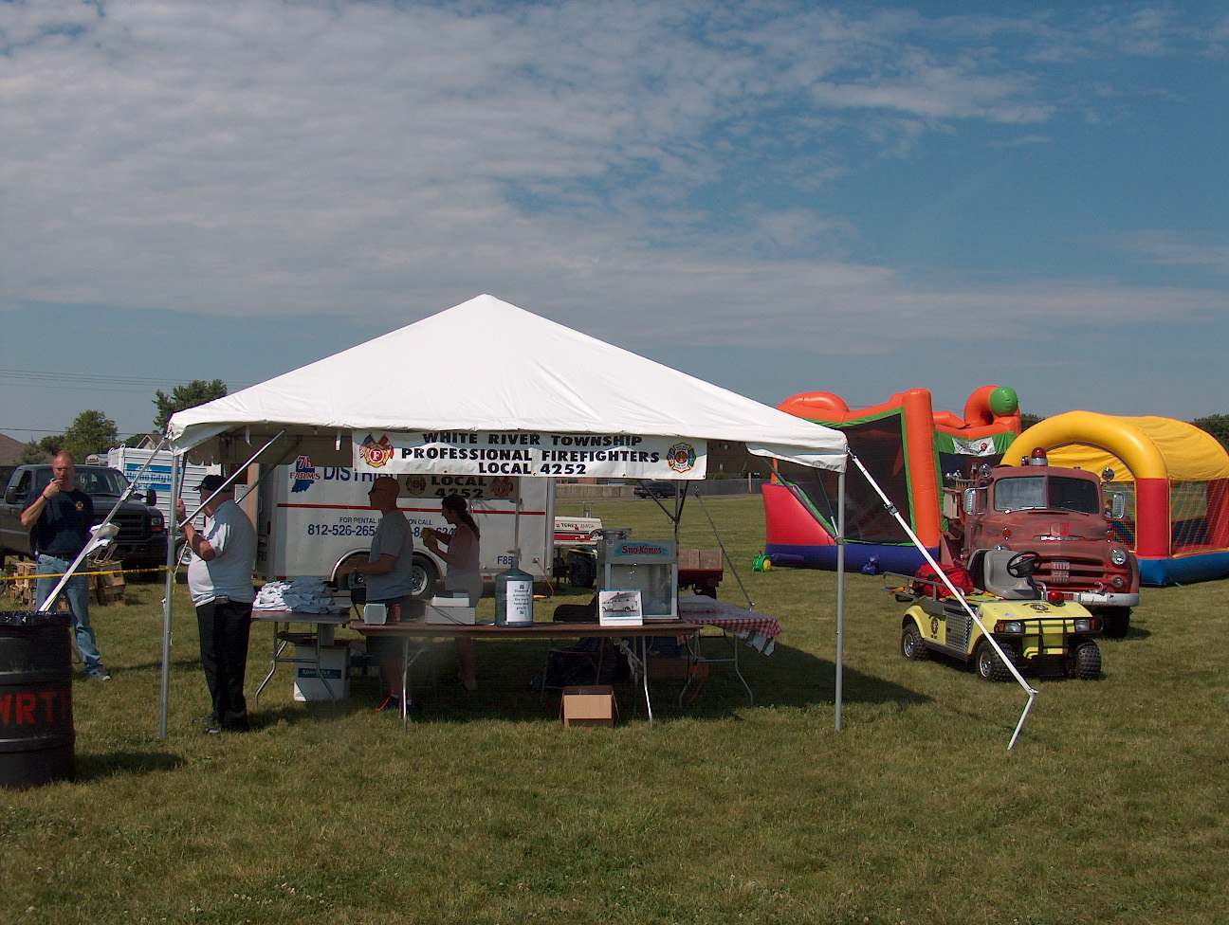 Birthdays (March 7 – March 20)

Dale Saucier March 11
Jeremy Pell March 14
Cynthia Bortz March 19
Steve Rowland March 20

 Looking back…..

26 years ago on St. Patrick’s Day 1982
March 17, 1982 Anxious baby starts life in fast lane
Leslie Ann Williams, all 7 pounds and 6 ounces of her was born about 12:30 a.m. today in the family car on State Road 37 just south of the Johnson-Marion County line.

19 years ago on St. Patrick’s Day 1989
March 17, 1989 Firefighters to lobby for station
Opponents of plans for a new fire station (can you guess which Station?) in White River Township have been asked to meet with firefighters on their home turf to discuss the project.

2 years ago on St. Patrick’s Day 2006
March 17, 2006 Officials push fire safety
After Indiana’s deadliest two-week stretch of house fires in at least a decade — an 11-day period that claimed 19 lives — the state’s top firefighter urged Hoosiers on Thursday to install smoke detectors and take other commonsense steps to avoid tragedy.

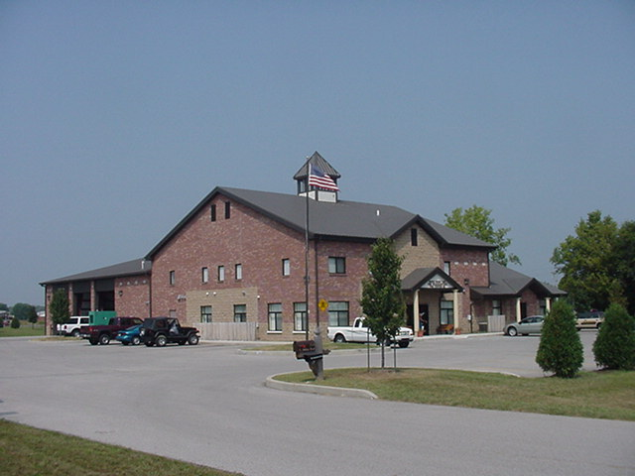 Upcoming events (March 2008 – April 2008)

Duneland School of Emergency Response – March 24,25, 31 and April 1 (www.ifia.org)
FDIC - April 7-12.
Bloomington Fire School – May 31 and June 1, 7, 8 (www.ifia.org)

Fire Protection District Board Meetings for 2008:

April 1, 2008 – 7pm. Station 53

May 6, 2008 – 7pm. Station 53
June 3, 2008 – 7pm. Station 53
July 1, 2008 – 7pm. Station 53
August 5, 2008 – 7pm. Station 53
September 2, 2008 – 7pm. Station 53
October 7, 2008 – 7pm. Station 53
November 4, 2008 – 7pm. Station 53
December 2 , 2008 – 7pm. Station 53

March 2008
S | M | T | W | T | F | S
 |  |  |  |  |  | 1
2 | 3 | 4 | 5 | 6 | 7 | 8
9 | 10 | 11 | 12 | 13 | 14 | 15
16 | 17 | 18 | 19 | 20 | 21 | 22
23 | 24 | 25 | 26 | 27 | 28 | 29
30 | 31
April 2008
S | M | T | W | T | F | S
 |  | 1 | 2 | 3 | 4 | 5
6 | 7 | 8 | 9 | 10 | 11 | 12
13 | 14 | 15 | 16 | 17 | 18 | 19
20 | 21 | 22 | 23 | 24 | 25 | 26
27 | 28 | 29 | 30

