

February 22, 2008

Inside this Issue
1 Training
2 Did you know?
2 Birthdays
3 Looking Back
4 Upcoming Events

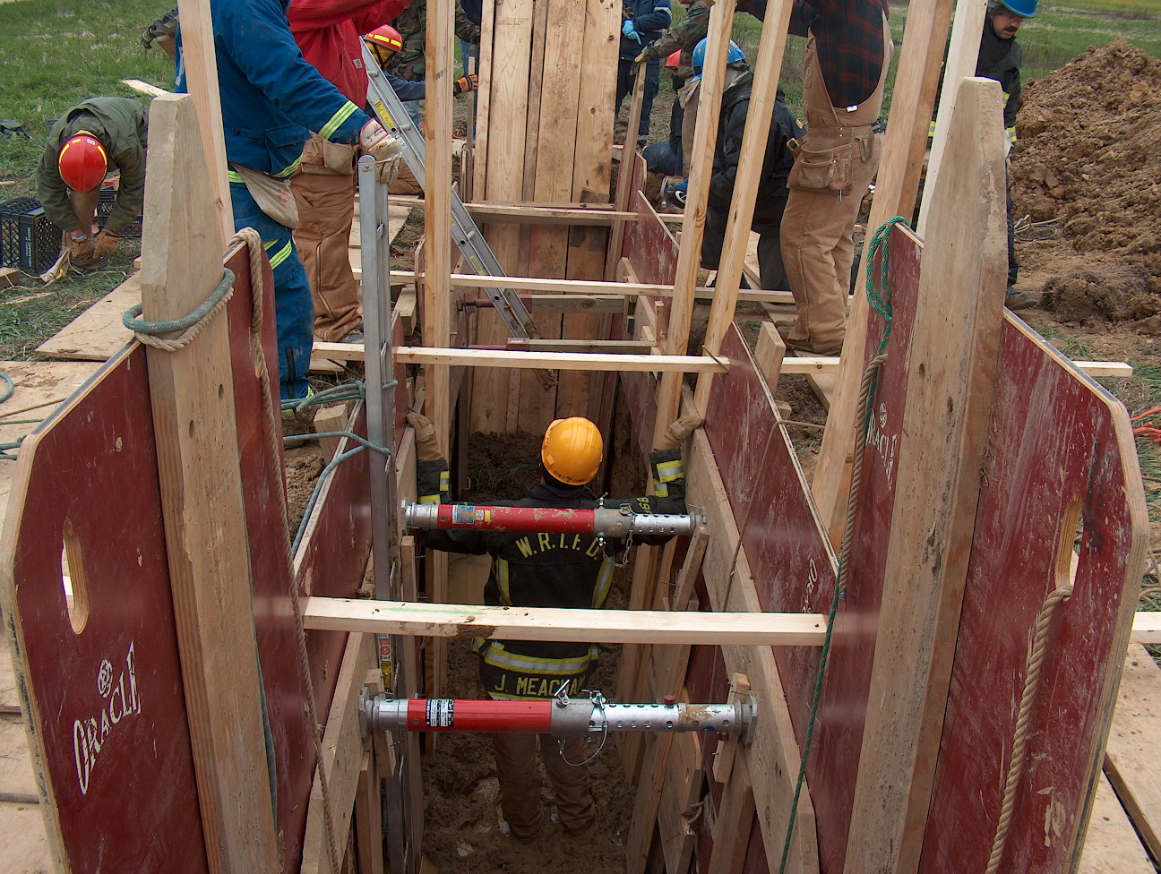 Training News

As you are reading this, the training division is completing an excel spreadsheet of all current personnel’s EMS and Fire certifications. This spreadsheet will be used to track training levels and EMS recertification dates. I will email this out to everyone when completed to check for any errors.

The department has a new forcible entry training simulator. It is called the Friction Force and will be kept at station 51. Training next week will discuss types and methods of forcible entry and all department personnel will get an opportunity to use it. This is a great tool for all companies to use.

A 2008 training course calendar will be out by the end of next week identifying the courses we will present at WRTFD during the year. The information in the calendar is based off of the email response from all of you. Thank you for your input; it will be helpful in identifying the certification needs of the organization.

Upcoming Training Opportunities
Jasper Fire School March 1,2, 8,9
FDIC, Indianapolis April 7-11
Bloomington Fire School May 31, June 1, 7,8

“To effectively and efficiently provide professional services to our community”

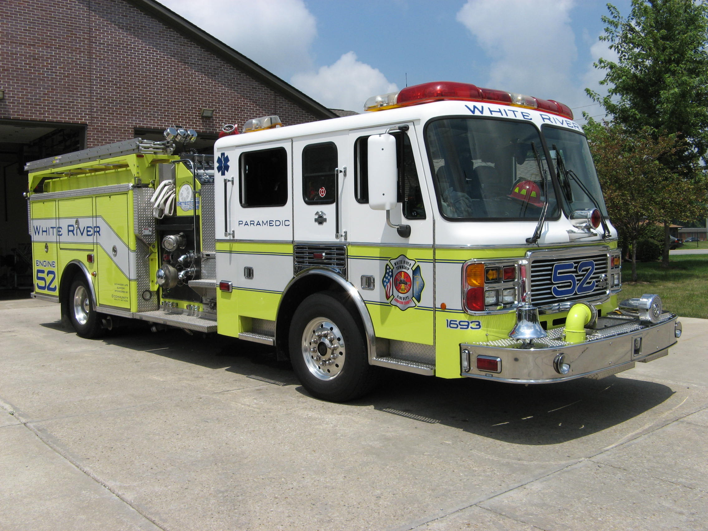 Did you know?

Did you know that??????
Alan Alda's original name is Alphonso D'Abruzzo.
Nicolas Cage original name is Nicholas Coppola.
Jackie Chan original name is Chan Kwong-Sung.
Chubby Checker's original name is Ernest Evans.
Tom Cruise's original name is Thomas Mapother IV.
John Denver's original name is Henry John Deutschendorf Jr.
Carmen Electra's original name is Tara Leigh Patrick.
George Gershwin's original name is Jacob Gershowitz.
Whoopi Goldberg's original name is Caryn Johnson.
Bob Hope's original name is Leslie Townes Hope.
Engelbert Humperdinck's original name is Arnold Dorsey.
Billy Idol's original name is William Broad.
Queen Latifah's original name is Dana Owens.

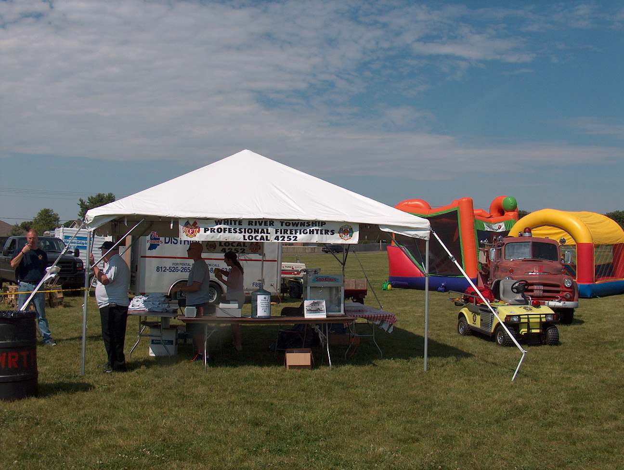 Birthdays (February 22 – March 6)

Ron Metcalf February 23
Rick Woehlecke February 24
Jeff Wilson February 26
Kevin Johnson February 27
Bill Williams February 27
Scott Tichenor March 5

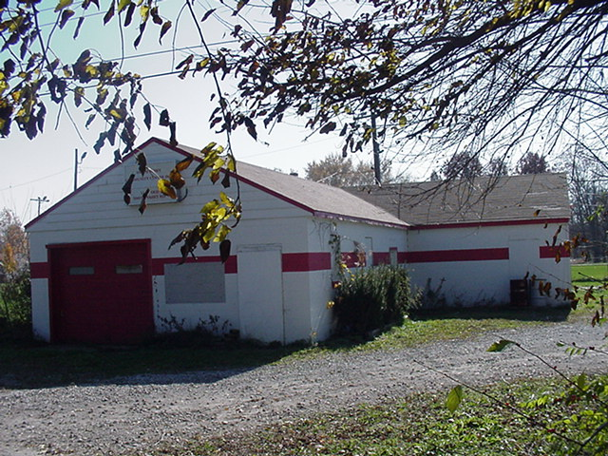 Looking back…..

48 years ago February 29, 1960 Do it yourself unit is $35,000 product
The “do-it-yourself” craze is a way of life in this northern Johnson County community, especially as far as the White River Township Volunteer Fire Department is concerned. From its humble beginning in 1952 as the Smith Valley Volunteer Fire Department, the unit now consists of three pieces of highly mobile and versatile equipment with a total value of more than $35,000. It changed its name to White River in 1956. And it costs the taxpayers of White River Township only about $1500 a year for fire protection for a 36-square-mile area. Headquarters for the department is a concrete block structure in the center of the township, just south of Smith Valley Road. It was built completely by volunteer labor and with materials given or supplied at cost by friends of the community. Russell Young, an electrician by trade, is the chief. His captains are Ralph E. Wilson, a railroad engineer, and Joseph E. Porter, a pipe fitter. Their professions serve them well in repair and construction of new firefighting equipment and installation of facilities at headquarters. These men supervised the building of each piece of firefighting equipment used by the company – a big pumper, a tanker-pumper combination and a grass fire rig. The only apparatus the men didn’t build themselves are the nylon fire hoses.
Other men in the department, each of whom served on the construction crew or equipment repair line, are Edwin Hinkle, heavy dozer operator; Lt. Robert L. Raber, machine operator; William Cloud, dock foreman; Robert Blain, machine operator; Norman Ford, on military leave to the Army; Bob Phillips, chief mechanic; Harry Fleener, inspector at Allison’s; Dave Piper, mechanic; Bob Kelso, millwright; Melvin Burkhart, electrician; Bob Harris, truck driver; Bill Sipes, machine operator; Ed Rice, mechanic; Bill McCreary, Link-Belt foreman, and Donald E. Schornick, accountant. Captain Wilson says the department can reach any place in the area it covers within six to eight minutes after the alarm has sounded. The telephone alarm system was recently installed at headquarters. It is a six-telephone set-up which connects headquarters with the homes of five members of the department. Wives of firemen answer calls as soon as they come in and immediately telephone a specified list of other members of the crew. Within a matter of minutes the entire department is on its way to the fire in private cars while drivers go to headquarters to get the trucks. Each member of the crew has a job to do. One or two of them are assigned dangerous intersections to guard while the trucks speed past to the fire. Others are experts on the grass rig, others at handling the high-pressure hoses.
Capt. Wilson says the busiest season is in the fall and spring when grass fires account for most of the calls. Housing developments next to farm land pose a big problem in that trash fires often set blazes in hay fields and pasture land which can be expensive losses to farmers. That’s why the grass fire rig is such an important piece of equipment in the department. Where does the money come from to pay expenses? The $1300 in tax money helps to pay fixed expenses such as telephone, light and heating bills. All other costs are paid from contributions of citizens in the area collected in a door-to-door campaign by department members. Other funds are raised by the auxiliary who sponsors card parties, suppers and other projects at headquarters. Citizens of the community do not have to pay fire protection fees of any kind. The department will answer a fire call anywhere in its territory or support neighboring community fire agencies in case of an emergency. If the department could find a way to take the hump out of the railroad crossing west of headquarters it would have most of its problems solved. But that they can’t do themselves.

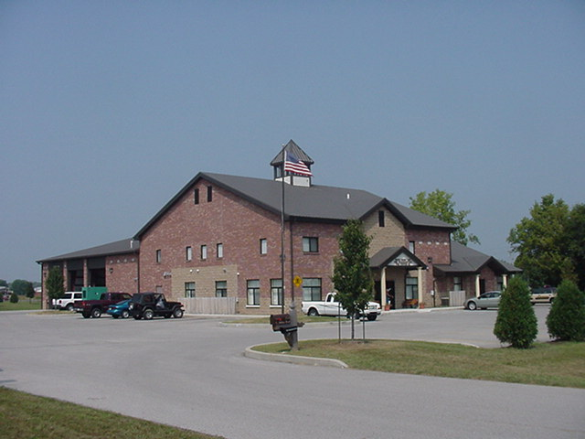 Upcoming events (March 2008 – April 2008)

March 1st Charity Basketball Tournament at Franklin Boys and Girls Club...This is a Public Safety Event and the money to go to the Firefighters working for Habitat for Humanity...

Fire Protection District Board Meetings for 2008:
March 4, 2008 – 7pm. Station 53
April 1, 2008 – 7pm. Station 53 May 6, 2008 – 7pm. Station 53
June 3, 2008 – 7pm. Station 53 July 1, 2008 – 7pm. Station 53
August 5, 2008 – 7pm. Sta September 2, 2008 – 7pm. Sta 53
October 7, 2008 – 7pm. Sta 53 November 4, 2008 – 7pm. Sta 53
December 2 , 2008 – 7pm. Sta 53

March 2008
S | M | T | W | T | F | S
 |  |  |  |  |  | 1
2 | 3 | 4 | 5 | 6 | 7 | 8
9 | 10 | 11 | 12 | 13 | 14 | 15
16 | 17 | 18 | 19 | 20 | 21 | 22
23 | 24 | 25 | 26 | 27 | 28 | 29
30 | 31
April 2008
S | M | T | W | T | F | S
 |  | 1 | 2 | 3 | 4 | 5
6 | 7 | 8 | 9 | 10 | 11 | 12
13 | 14 | 15 | 16 | 17 | 18 | 19
20 | 21 | 22 | 23 | 24 | 25 | 26
27 | 28 | 29 | 30

