

February 8, 2008

Inside this Issue
1 Administration
2 Did You Know
2 Birthdays
3 Looking Back
4 Upcoming Events

 Administration News

The fire service lost one of its own this week. Captain Dave Sherfick was killed in the line of duty when the ambulance he was driving collided head-on with another vehicle. According to witnesses, the other vehicle crossed the center line near SR 144 and Mann Road.

A tragedy such as this has a dramatic affect on everyone in the fire service. It is particularly difficult locally because so many of us knew Dave. Dave was a Captain on the Brown Township Fire Department. He also worked for the White River Township Fire Department from 1995-2001. He was an excellent firefighter and a friend to many on this department.

Captain Sherfick’s services will be held today at 10:00 a.m. at the Mooresville High School auditorium. He will be laid to rest in the Washington Park Cemetery. Our thoughts and prayers are with both his family and the Brown Township Fire Department.

Chief Pell

“To effectively and efficiently provide professional services to our community”

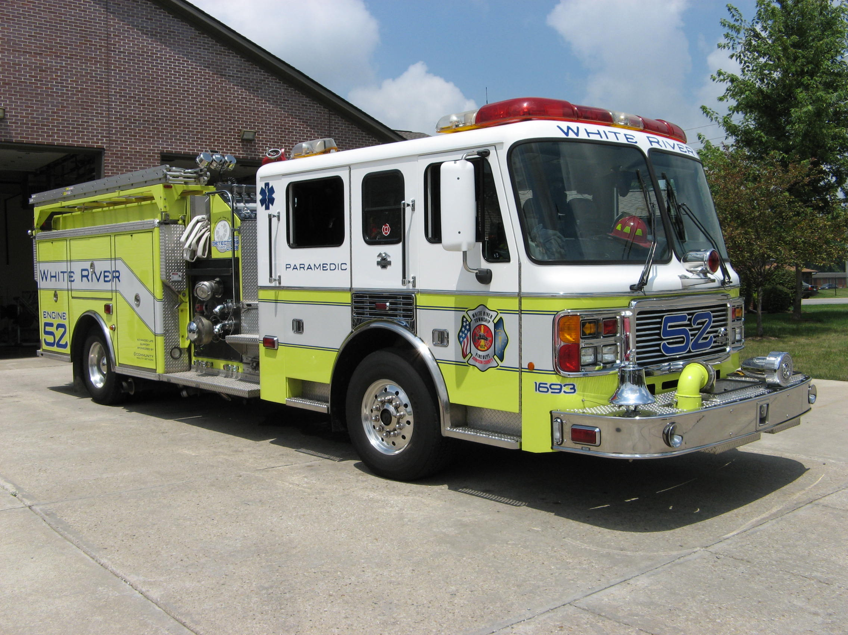 Did you know?

Did you know the Record Temperatures in Indiana?

The lowest temperature recorded was in New Whiteland, Indiana on January 19, 1994 a bitter cold of -36 degrees.

The highest temperature recorded was in Collegeville, Indiana on July 14, 1936 a sizzling 116 degrees.

 Birthdays (February 8 – February 21)

Jason Tibbetts February 10
Michael Rude February 12
Eric Brown February 13
Eric Wiseman February 16
Jeffrey Bowden February 17

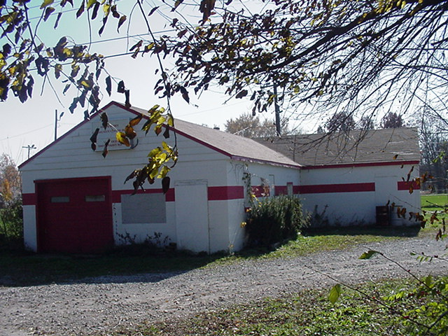 Looking back…..

47 years ago
February 10, 1961 News from White River Twp VFD
The department had one fire the past week. It was on Friday evening, March 3, on Berry road south of the Smith’s Valley road. Mrs. Jack Dorrell was burning some trash and a sudden gust of wind blew some hot ashes into an acre field owned by David Piper. Firemen Robert Kelso and Ralph Wilson arrived at the scene with the grass fire-fighting rig and with the assistance of Piper who is also a member of the department had the fire out in a few minutes. Damage was slight. The department has been getting some first class welding done on the new fire truck by Bob Briggs of our community. Bob has made ladder racks, steps up the back to climb onto the top of the tanker, cut and welded holes for plumbing inlets and outlets. The department expressed appreciation for the work being done by Briggs.
February 12, 1961 Summer home destroyed
The summer home of an Indianapolis woman was destroyed by fire Monday night as a dozen volunteer firemen fought in sub-freezing temperatures to control it. The home is located on Smith Valley Road near State Road 37.
February 19, 1961 Fire destroys empty house
Fire destroyed an empty house owned by Roy Howell, north of Greenwood, Monday night. The structure was located on Stop 11 Road between Highway 135 and Shelby Street and was scheduled to be occupied in about two weeks by new tenants. The building was a five-room affair and was totally destroyed. It was discovered by a passing motorist and firemen from White River Township and Perry Township responded to the alarm and saved a huge barn and several smaller outside structures.

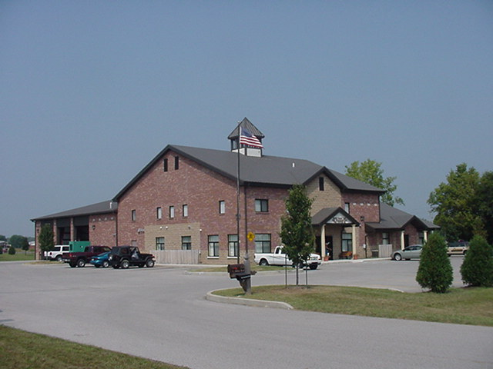 Upcoming events (March 2008 – April 2008)

There are no events in February 2008 at the present time.

Fire Protection District Board Meetings for 2008:

March 4, 2008 – 7pm. Station 53
April 1, 2008 – 7pm. Station 53
May 6, 2008 – 7pm. Station 53
June 3, 2008 – 7pm. Station 53
July 1, 2008 – 7pm. Station 53
August 5, 2008 – 7pm. Station 53
September 2, 2008 – 7pm. Station 53
October 7, 2008 – 7pm. Station 53
November 4, 2008 – 7pm. Station 53
December 2 , 2008 – 7pm. Station 53

March 2008
S | M | T | W | T | F | S
 |  |  |  |  |  | 1
2 | 3 | 4 | 5 | 6 | 7 | 8
9 | 10 | 11 | 12 | 13 | 14 | 15
16 | 17 | 18 | 19 | 20 | 21 | 22
23 | 24 | 25 | 26 | 27 | 28 | 29
30 | 31
April 2008
S | M | T | W | T | F | S
 |  | 1 | 2 | 3 | 4 | 5
6 | 7 | 8 | 9 | 10 | 11 | 12
13 | 14 | 15 | 16 | 17 | 18 | 19
20 | 21 | 22 | 23 | 24 | 25 | 26
27 | 28 | 29 | 30

