

January 25, 2008

Inside this Issue

1 Operations
2 Training
3 Did You Know?
3 Birthdays
4 Looking Back
4 Upcoming Events

“To effectively and efficiently provide professional services to our community”

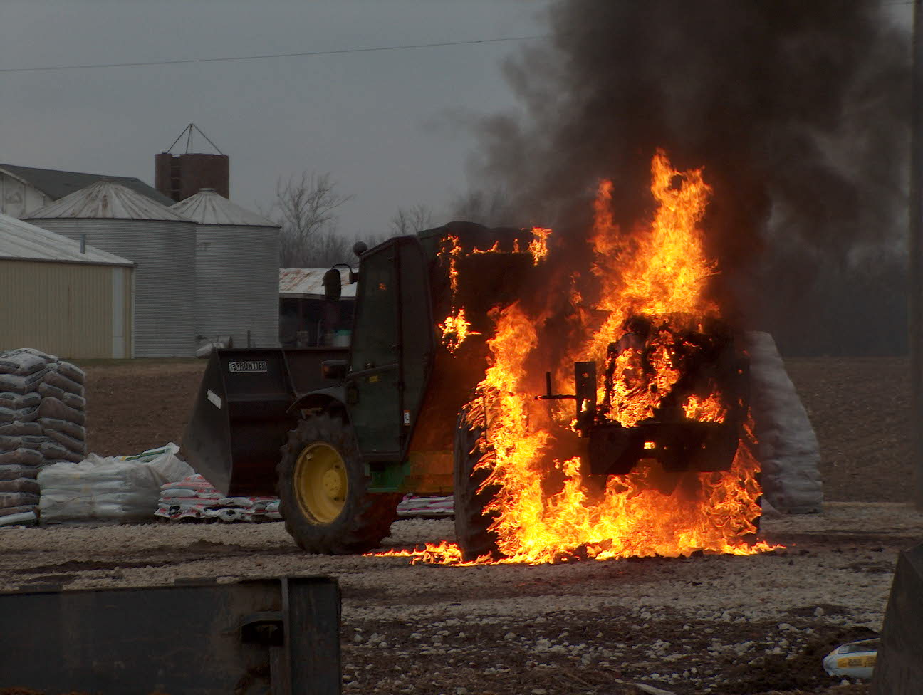 Operations News

We have received 14 new ClearComms for the SCBA masks. These will be distributed after they have been labeled and entered into Firehouse. Unfortunately, we still don’t have enough for every position, but we are continuing to add to the inventory.

No additional news on the SCBA upgrade. We have two Scott SCBAs to use for non-firefighting training. See your shift training officer if you would like to test or train with them. We are still waiting on updated cost estimates from both Scott and MSA.

Please review updated Chief’s Directive concerning daily staffing. Minimum staffing was increased to 18 per shift in order to staff each company with a minimum of four personnel.

Be smart and stay safe!!

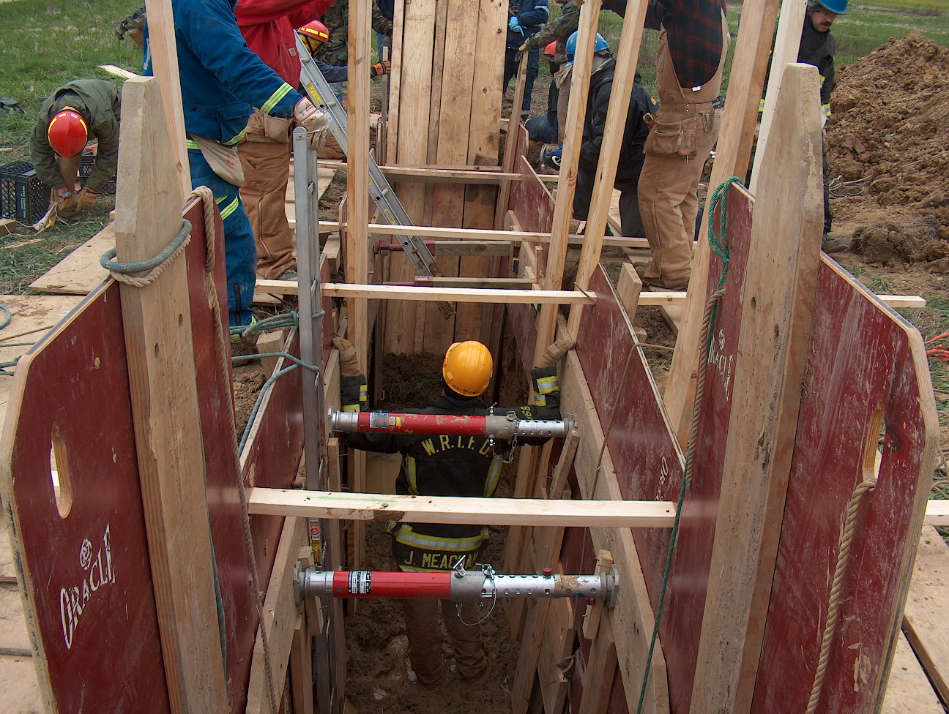 Training News

Training News

It has been a busy January for the Department with personnel attending several different courses here and around the state. There are many more classes to begin locally that I encourage you to look at if interested. There is a large list of programs posted on the board outside my door. C9 is offering Instructor I, Officer I, and Safety Officer this spring. Remember you can obtain college credit for these classes through Ivy Tech and Vincennes.

I will be meeting the shift training officers to plan the 2008 training calendar. Look for increased hands on training through the construction of props and use of acquired structures. Plans to build props in the old Maple Grove building are taking shape. Please forward any ideas you may have to your STO or myself.

Remember, if you are interested in attending a HOT Class at FDIC, registration forms need to be completed ASAP. Several HOT Classes are already full. See me for more details and payment assistance.

Spring semester college classes are underway but it is never too late to plan for summer and fall sessions. I want to encourage all of you to start thinking about this now. See me and I will help get you going in the right direction.

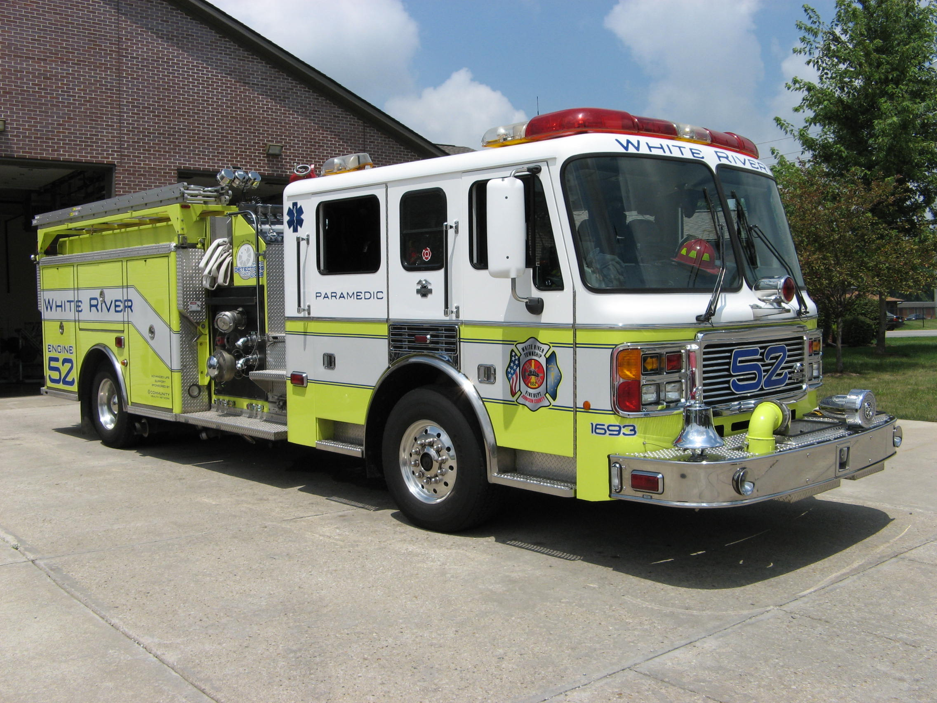 Did you know?

Did you know who the Wealthiest Americans are in 2007?
 | Net worth
Name | $billion | Age | Residence | Source
William Gates III | 59.0 | 51 | Medina, WA | Microsoft
Warren Buffett | 52.0 | 77 | Omaha, NE | Berkshire Hathaway
Sheldon Adelson | 28.0 | 74 | Las Vegas, NV | casinos, hotels
Lawrence Ellison | 26.0 | 63 | Redwood City, CA | Oracle
Sergey Brin | 18.5 | 34 | Palo Alto, CA | Google
Larry Page | 18.5 | 34 | San Francisco, CA | Google
Kirk Kerkorian | 18.0 | 90 | Los Angeles, CA | Investments, casinos
Michael Dell | 17.2 | 42 | Austin, TX | Dell
Charles Koch | 17.0 | 71 | Wichita, KS | oil, commodities
David Koch | 17.0 | 67 | New York, NY | oil, commodities

The true measure of wealth!


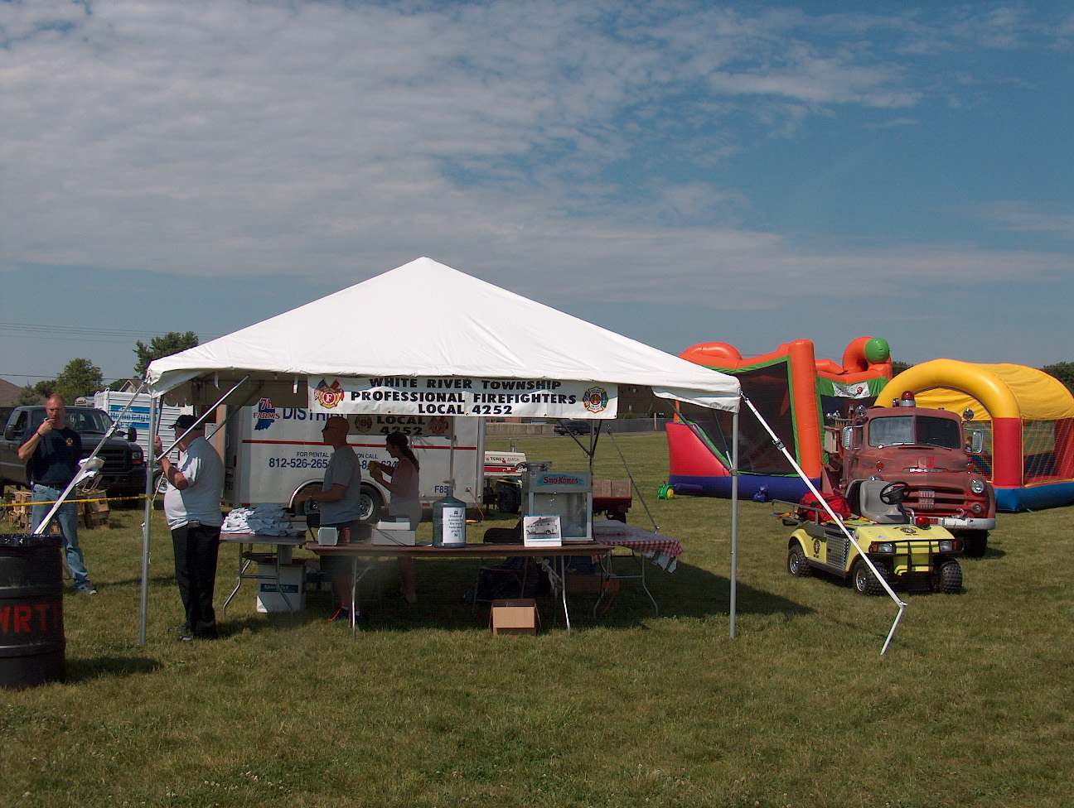 Birthdays (January 25 – February 7)

Joshua Abraham January 28
Brian McRoberts January 28
Jeffrey Campbell January 29
Aaron Bryant January 30
Andrew Carman February 1
Ronald Neibel February 2
Raymond Denson February 3
Andrew Tames February 4
Derrick Watkins February 7

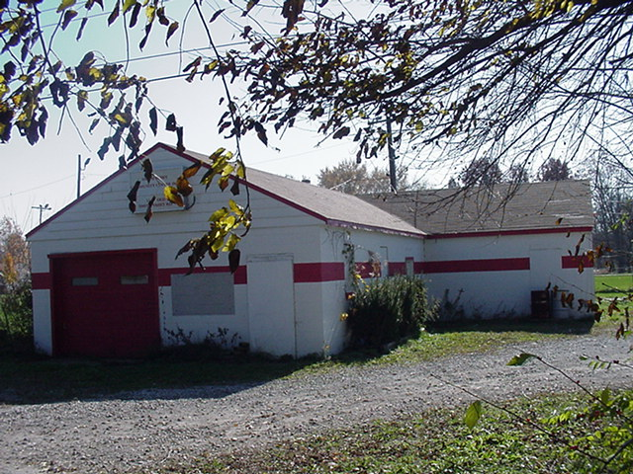 Looking back…..

48 years ago February 3, 1960 Department receives accolades Members of the White River Township Volunteer Fire Department received a letter from the state's top firefighter commending the actions of arson investigators at a recent fire. Fire Chief Russell Young, Captain Ralph Wilson, and Edward Rice were all cited by the state's Fire Marshal's Office for exemplary work to preserve the scene of a suspected arson fire involving an automobile. These actions ultimately led to a quick conviction of the person responsible.

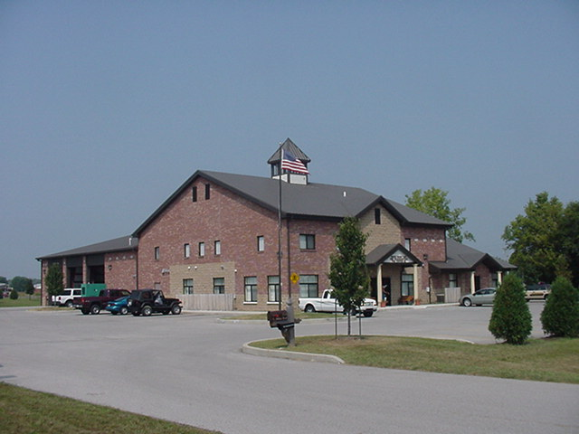 Upcoming events (January 2008 – February 2008)

2008 Awards Banquet Jan 26, 2008 at 6:30 pm at Piper's

Fire Protection District Board Meetings for 2008:
February 5, 2008 – 7pm. Station 53
March 4, 2008 – 7pm. Station 53
April 1, 2008 – 7pm. Station 53
May 6, 2008 – 7pm. Station 53
June 3, 2008 – 7pm. Station 53
July 1, 2008 – 7pm. Station 53
August 5, 2008 – 7pm. Station 53
September 2, 2008 – 7pm. Station 53
October 7, 2008 – 7pm. Station 53
November 4, 2008 – 7pm. Station 53
December 2 , 2008 – 7pm. Station 53

January 2008
S | M | T | W | T | F | S
 |  | 1 | 2 | 3 | 4 | 5
6 | 7 | 8 | 9 | 10 | 11 | 12
13 | 14 | 15 | 16 | 17 | 18 | 19
20 | 21 | 22 | 23 | 24 | 25 | 26
27 | 28 | 29 | 30 | 31
February 2008
S | M | T | W | T | F | S
 |  |  |  |  | 1 | 2
3 | 4 | 5 | 6 | 7 | 8 | 9
10 | 11 | 12 | 13 | 14 | 15 | 16
17 | 18 | 19 | 20 | 21 | 22 | 23
24 | 25 | 26 | 27 | 28 | 29

