

January 11, 2008

Inside this Issue
1 Operations
2 Training
2 Did You Know?
3 Birthdays
3 Looking Back
4 Upcoming Events

“To effectively and efficiently provide professional services to our community”

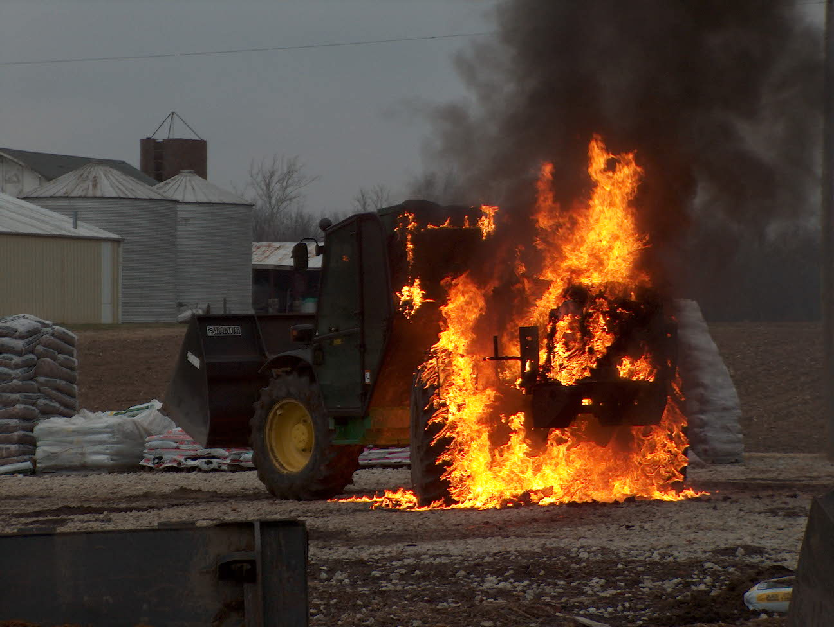 Operations News

I know we are still having some minor issues with dispatching. Mike Watkins has been very helpful and receptive to all comments and concerns. Obviously, some things he can fix and others are a struggle. Continue to bring all dispatch concerns in writing to Chief Engmark or me. I do know that they have a training session scheduled for late January for fire dispatch specifics. This training will be conducted by Captain Santerre and Chief Engmark. It will be held at Station 51 so the dispatchers will have a better understanding of our organization. One last thing: Please don’t get into a disagreement or show an attitude on the radio. This will only escalate problems.

I attended a meeting on Monday in which a representative from the county GIS was present. The county is now in the process of updating all business addresses and putting them in the system. They seem to think that we will be able to start using GIS in the next six months for response purposes.

We purchased several new voice amplifiers for the SCBA masks recently. These will be distributed as soon as they are delivered and then logged in Firehouse. We still don’t have enough for everyone, but we are working towards that goal. Also, we have been given a Scott SCBA for demo purposes and it will be rotated between the stations over the next month. We are still working on the SCBA upgrade. We are waiting on new 2008 pricing numbers from both MSA and Scott.

Tanker 52 has been upgraded with additional equipment to make it more functional as an engine. Engine 55 will also be upgraded as soon as the equipment arrives. That is it for now. Stay smart and be safe.

 Training News

January is turning out to be a very busy month. There are numerous training opportunities this month and through the first part of 2008. Please check the postings on the board outside my office. Please contact me if you are interested in attending any of these opportunities.

Some positive changes for 2008 include:
- Addition of two PC’s to the training room. These will be placed along the back wall of the training room. They will be equipped with internet access and basic Microsoft software. My hope is that more of you will begin or re-start your journey towards an associates or bachelor degree. I believe that personal growth through college level courses will only increase the level of the organization as a whole.
- Monthly company officer training. This schedule will be produced at the January officer meeting. This training will be open to all department members who would like to attend. I believe that this will be beneficial to all interested personnel.

Some upcoming courses
- Fire Instructor I at C9, Mon & Wed Evenings 6-10 beginning January 16
- Incident Safety Officer at Greenwood FD HQ, 8-4 January 19 and 20
- Driver Operator Pumper at WRTFD 830-430 January 21-25

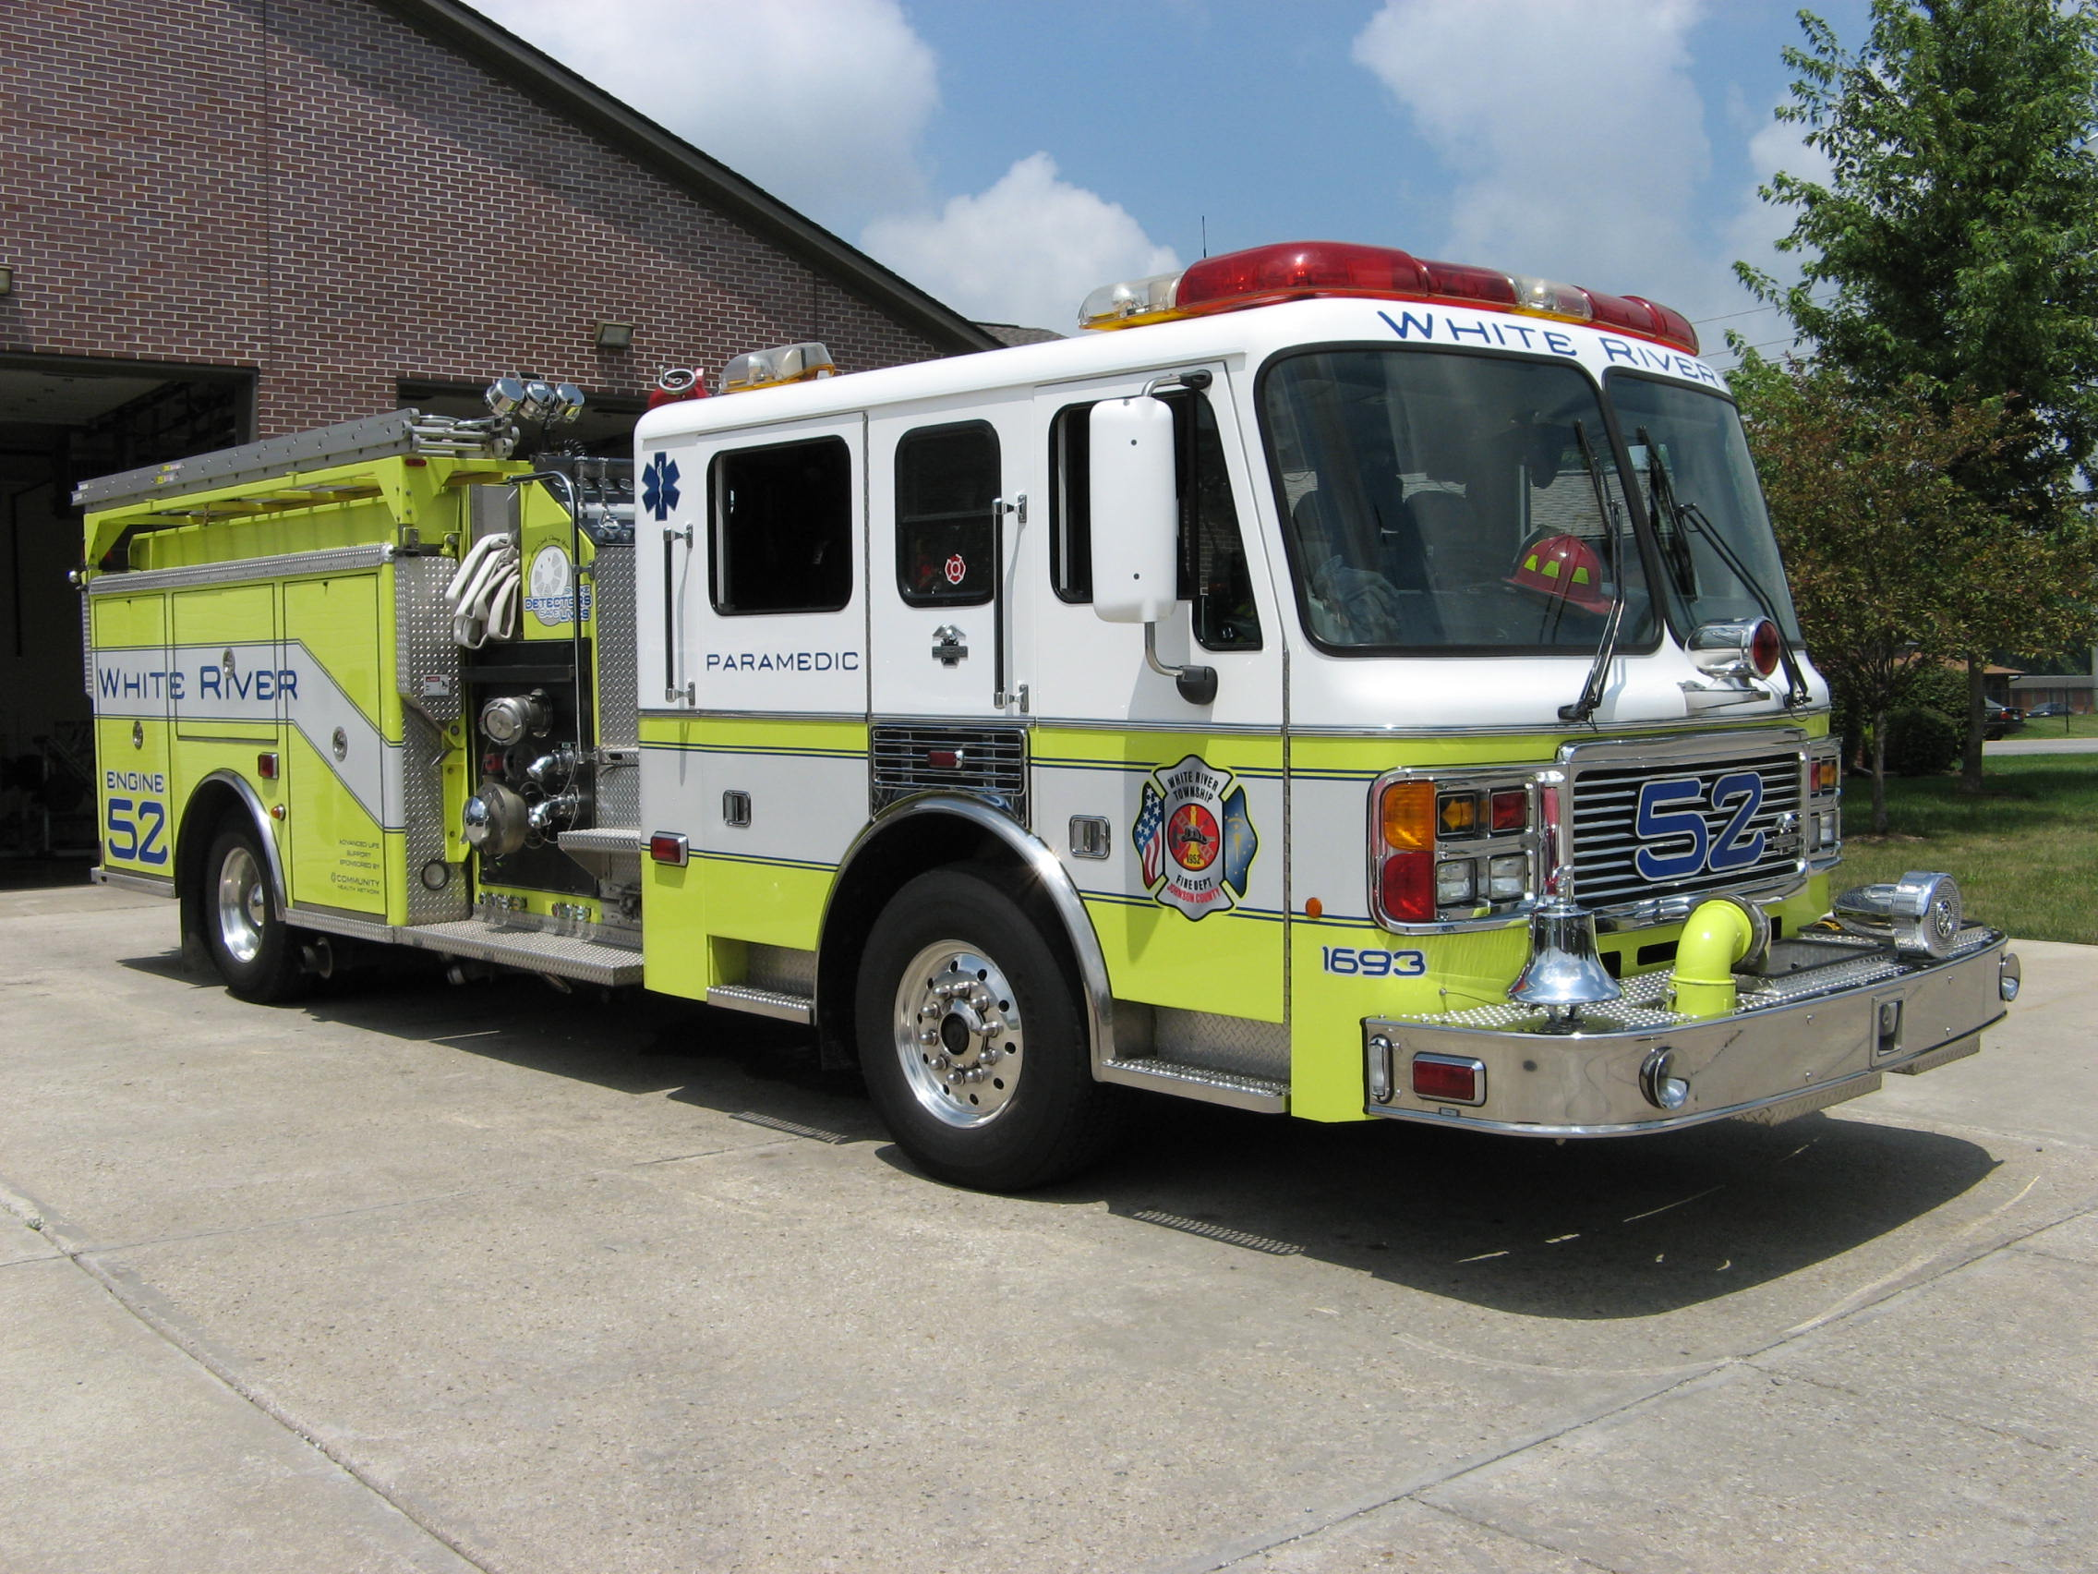 Did you know?

Did you know that January 21, 2008 is the day we observe Martin Luther King Jr. Day?
Martin Luther King Jr. Day is a United States holiday marking the birthdate of the Reverend Dr. Martin Luther King, Jr., observed on the third Monday of January each year, around the time of King's birthday which is January 15. It is one of four United States federal holidays to commemorate an individual person. Martin Luther King Day was founded as a holiday promoted by labor unions in contract negotiations. After King's death in 1968, Rep. John Conyers introduced a bill in Congress to make King's birthday a national holiday, highlighting King's activism on behalf of trade unionists. Unions did most of the promotion for the holiday throughout the 1970s. In 1976, trade unionists helped to elect Jimmy Carter, who endorsed the King Day bill. After that endorsement, union influence in the King Holiday campaign declined, and the King Center turned to support from the corporate community and the general public. The success of this strategy was cemented when musician Stevie Wonder released the single "Happy Birthday" to popularize the campaign in 1980 and hosted the Rally for Peace Press Conference in 1981. Six million signatures were collected for a petition to Congress to pass the law, termed by a 2006 The Nation article as "...the largest petition in favor of an issue in United States History". Congress passed the King Day Bill with an overwhelming veto-proof majority (338 to 90 in the House of Representatives and 78 to 22 in the Senate). At the White House Rose Garden on November 2, 1983, Reagan signed a bill creating a federal holiday to honor King. It was observed for the first time on January 20, 1986.

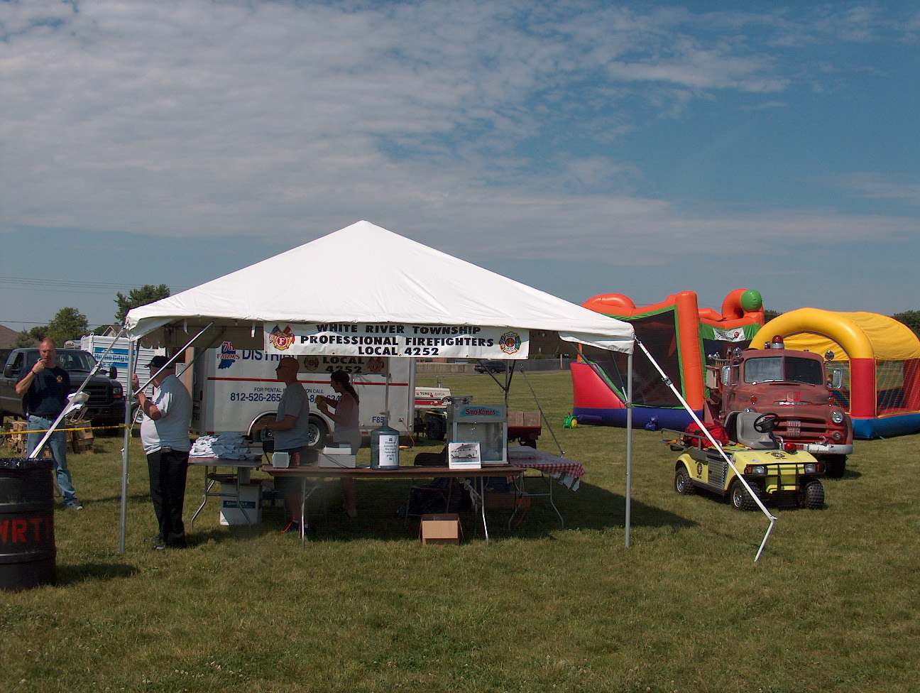 Birthdays (January 11 through January 24)

Robert Stumpf January 13
Darryl Slevin January 18

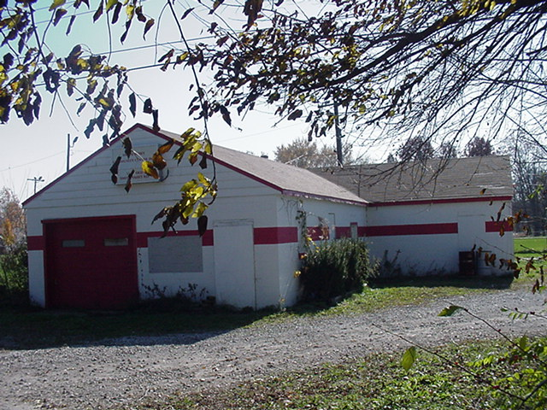 Looking back…..

47 years ago January 20, 1961 Boy, 13, leads 5 in family from blaze A 13-year-old boy led and carried his five brothers and sisters to safety from their burning home early yesterday but two firemen later were injured in battling the blaze which destroyed the 100-year-old house. The parents, Mr. and Mrs. Harold McClain, were away when Gregory McClain spotted flames early yesterday as he and the other children started upstairs to bed. GREGORY carried his sleeping 6-year-old sister, Patricia, to safety and was followed by the others, Timothy, 12, Deborah, 10, Crystal, 8, and Jill, 5.Firemen from four departments battled until 5 a.m. yesterday before extinguishing the blaze at the two-story brick home west of Greenwood. Two White River Township Volunteer firemen were injured. Edward Hinkle of Greenwood suffered burns when blazing wood from the roof fell on his back. Richard Wehrman, R.R. 2, Greenwood, stepped on a nail among the ruins. The home was owned by C. W. Gregg, R.R. 4, Greenwood.

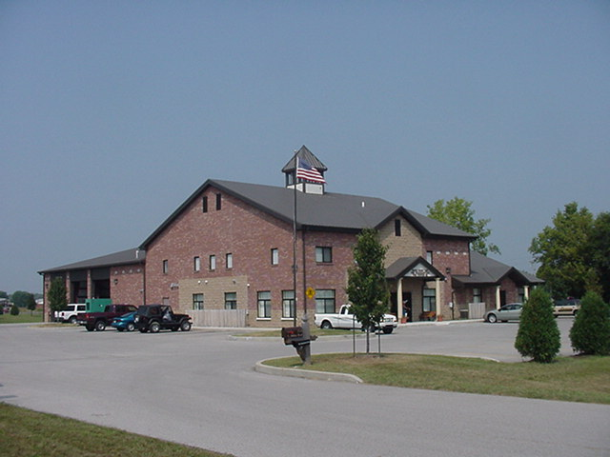 Upcoming events (January 2008 and February 2008)

2008 Awards Banquet Jan 26, 2008 at 6:30 pm at Piper's

Fire Protection District Board Meetings for 2008:
February 5, 2008 – 7pm. Station 53
March 4, 2008 – 7pm. Station 53
April 1, 2008 – 7pm. Station 53
May 6, 2008 – 7pm. Station 53
June 3, 2008 – 7pm. Station 53
July 1, 2008 – 7pm. Station 53
August 5, 2008 – 7pm. Station 53
September 2, 2008 – 7pm. Station 53
October 7, 2008 – 7pm. Station 53
November 4, 2008 – 7pm. Station 53
December 2 , 2008 – 7pm. Station 53

January 2008
S | M | T | W | T | F | S
 |  | 1 | 2 | 3 | 4 | 5
6 | 7 | 8 | 9 | 10 | 11 | 12
13 | 14 | 15 | 16 | 17 | 18 | 19
20 | 21 | 22 | 23 | 24 | 25 | 26
27 | 28 | 29 | 30 | 31
February 2008
S | M | T | W | T | F | S
 |  |  |  |  | 1 | 2
3 | 4 | 5 | 6 | 7 | 8 | 9
10 | 11 | 12 | 13 | 14 | 15 | 16
17 | 18 | 19 | 20 | 21 | 22 | 23
24 | 25 | 26 | 27 | 28 | 29

