

December 28, 2007

Inside this Issue

1 Did you Know?
2 Did you Know?
2 Birthdays
3 Looking Back
4 Upcoming Events

“To effectively and efficiently provide professional services to our community”

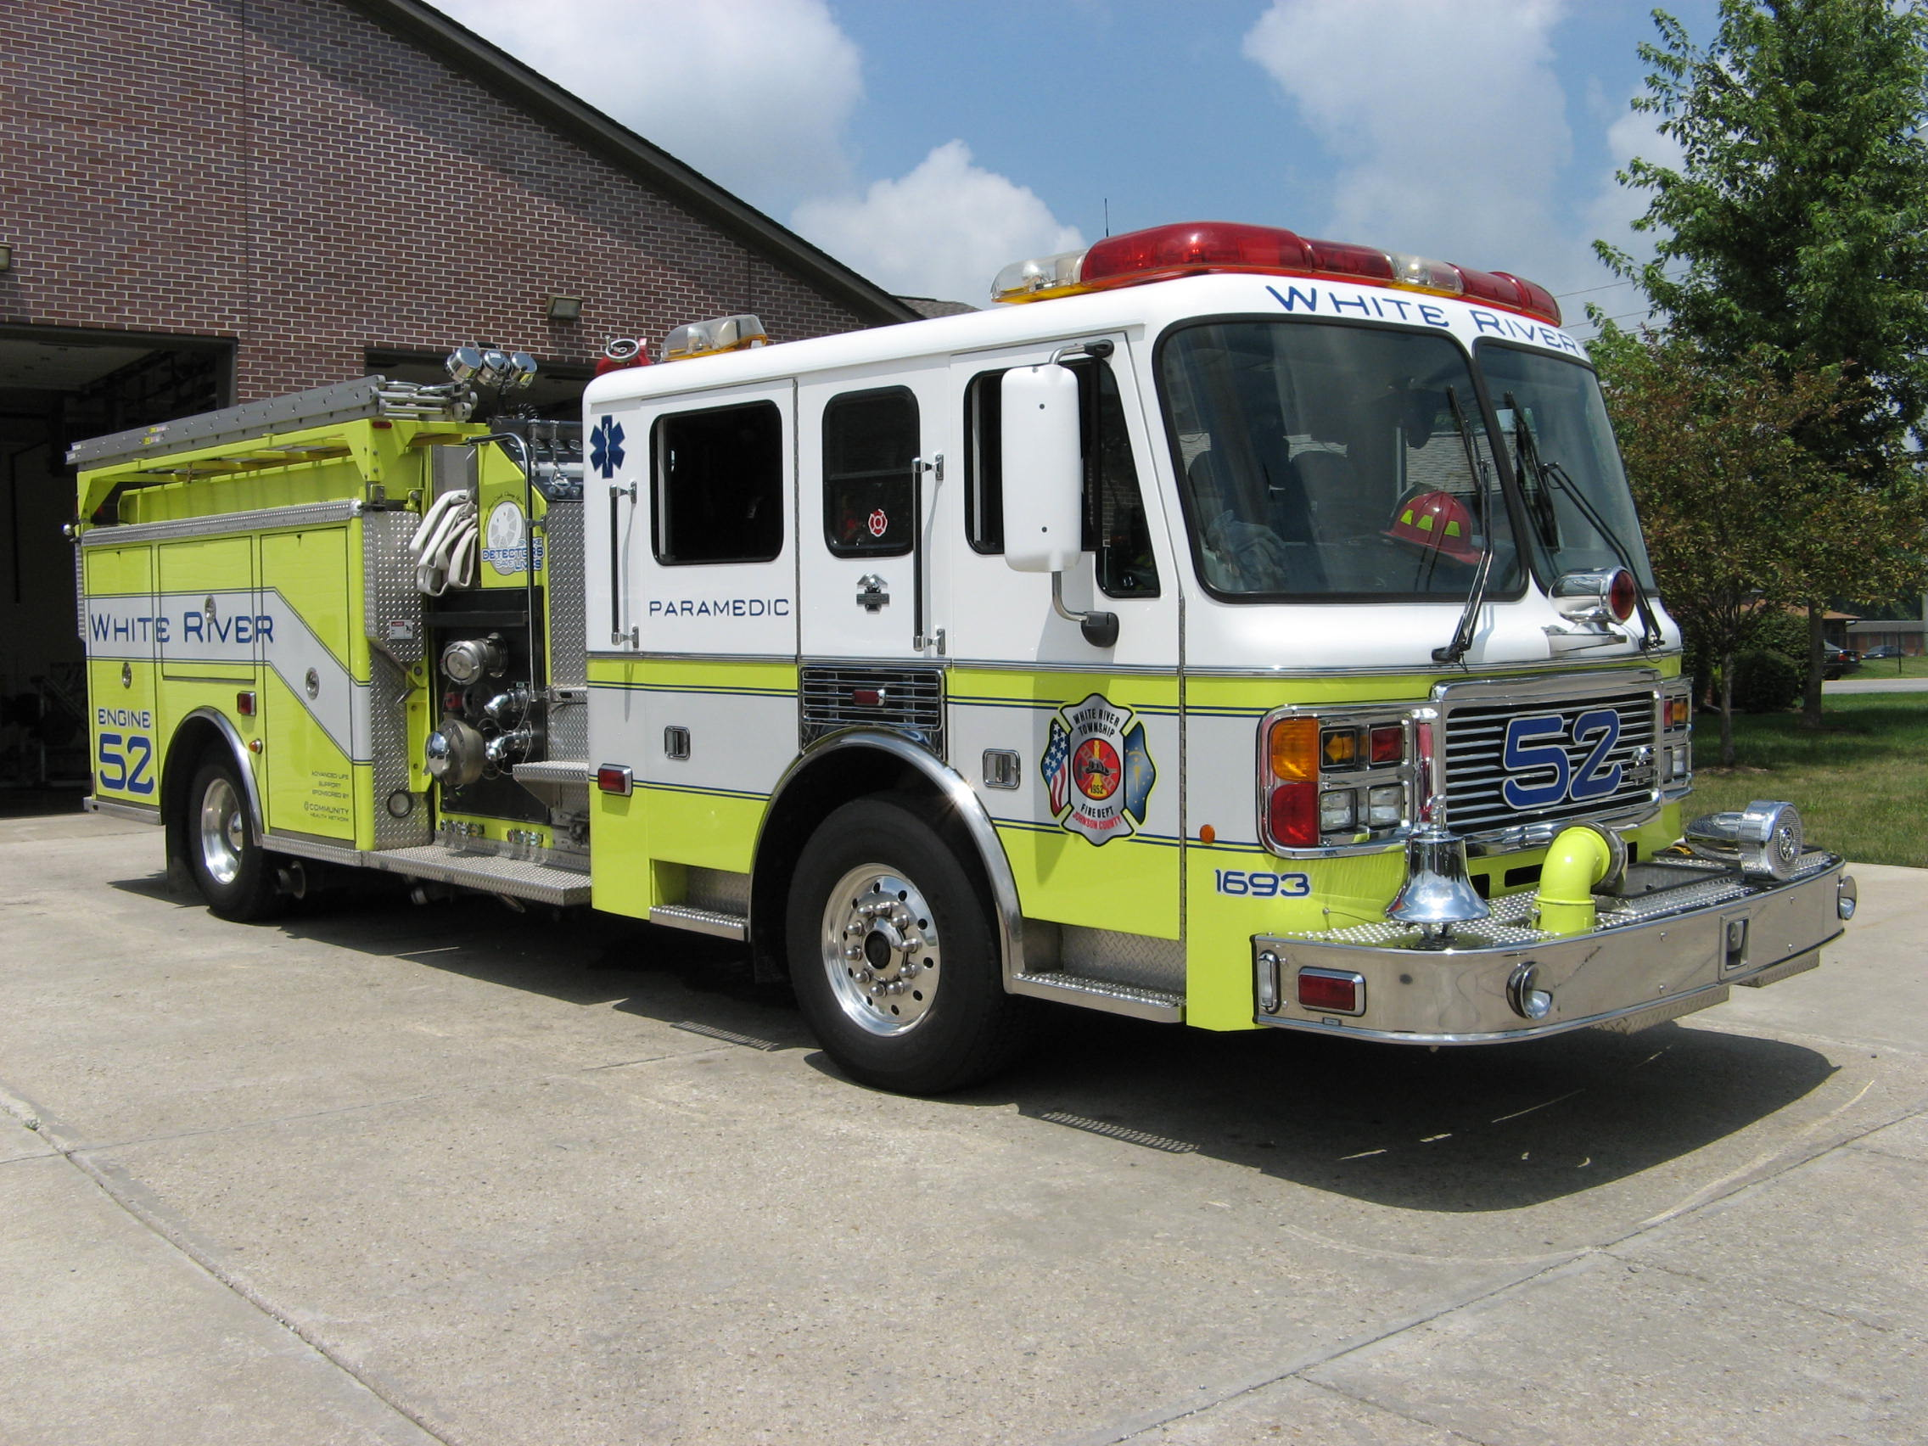 Did you know?

Did you know the top ten news topics of 2007?


- Iraq - President George W. Bush January 10 outlined a new war strategy, notable for a so-called “surge” of some 30,000 additional troops intended to contain ongoing insurgent violence in Iraq
- Economy - The U.S. housing market started to crumble as foreclosure rates spiked in 2007.
- Domestic Politics - The 110th Congress convened with Democratic majorities in both chambers for the first time since 1994, with the House of Representatives led by Representative Nancy Pelosi (D, CA) the first woman Speaker of the House.
- Europe - France and Britain underwent leadership changes for the first time in more that 10 years.
- Product Recalls - Consumer confidence sank as multiple high-profile products were recalled in 2007.
- Global Warming - The Intergovernmental Panel on Climate Change (IPCC) February 2 released Climate Changes 2007, it latest review of climate-related scientific research.
- Nuclear Programs - North Korea agreed February 13 to cease its nuclear programs in exchange for an international aid package.
- Virginia Tech Shooting - In the worst school shooting in U.S. history, 33 people, including the shooter, were killed April 16 at Virginia Tech in Blacksburg, V.A.
- Myanmar - The Myanmar (Burma) military junta cracked down on a burgeoning antigovernment movement, violently breaking up demonstrations and killing at least 9 people (according to the state-run media) September 27.
- Bridge Disaster - An arterial highway bridge over the Mississippi River in Minneapolis, MN collapsed during evening rush hour August 1, killing 13 people and dropping over 50 cars into the river.

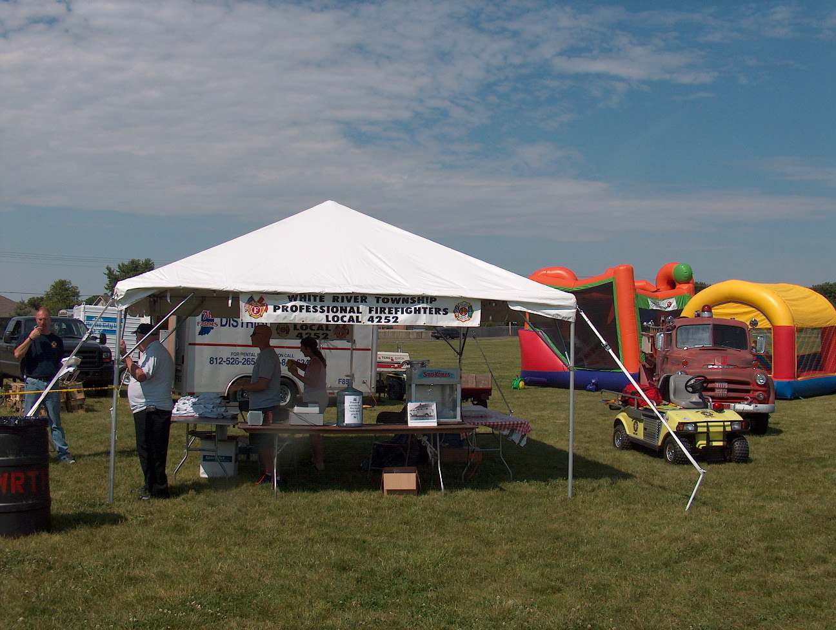 Birthdays (December 28 - January 10)

Benjamin Williams December 30
Scott Alexander January 6
Michael Shoemaker January 8
Scott Klinger January 9
Jason Smith January 9

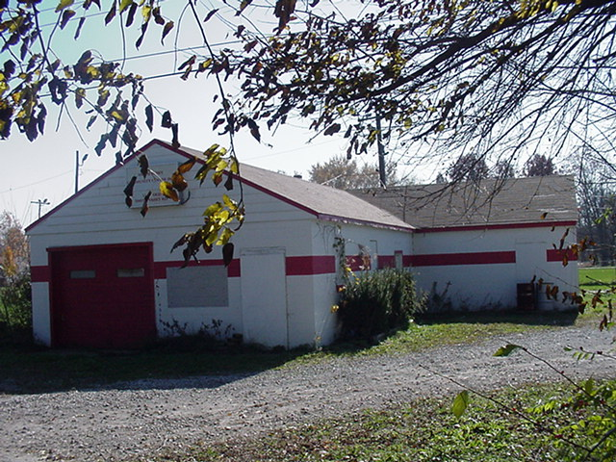 Looking back…..

54 years ago December 29, 1953 Fire equipment expensive In order to provide the best equipment for the men of the Smith Valley Volunteer Fire Department, members shopped around to find the best deal on fire coats and hats. That deal came from the Indiana Fire Prevention Company where each set of a coat and hat will cost $37.35. Boots will cost an additional $7.50 a pair.
1953 2007 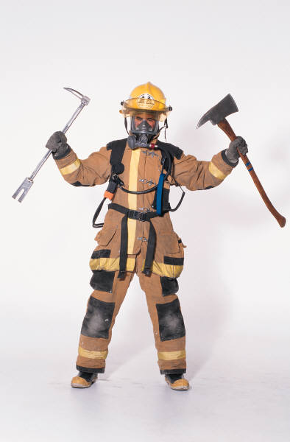

51 years ago December 31, 1956 Fire department budget set for 1957 This is a budget report of the White River Township Fire Department for the next year of operation for the trucks, building and grounds at the fire station in Smith Valley.
$107.43 Truck insurance
102.23 Truck insurance
39.51 Building insurance
200.00 Men insurance
300.00 Telephone
180.00 Lights
300.00 Heat
426.00 Payment on loan for building
448.79 For unknown expenses
475.00 For new resuscitator $2,718.96 Total for year

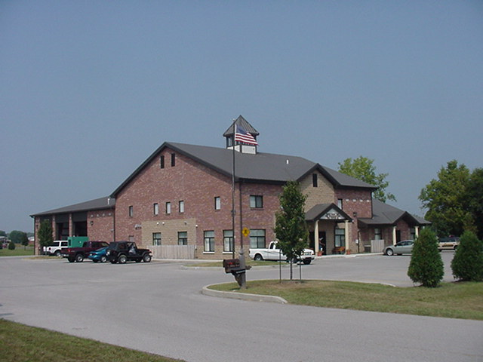 Upcoming events (December 2007 Through 2008)

2008 Awards Banquet Jan 26, 2008 at 7pm. at Piper's

Fire Protection District Board Meetings for 2008:
January 8, 2008 – 7pm. Station 53
February 5, 2008 – 7pm. Station 53
March 4, 2008 – 7pm. Station 53
April 1, 2008 – 7pm. Station 53
May 6, 2008 – 7pm. Station 53
June 3, 2008 – 7pm. Station 53
July 1, 2008 – 7pm. Station 53
August 5, 2008 – 7pm. Station 53
September 2, 2008 – 7pm. Station 53
October 7, 2008 – 7pm. Station 53
November 4, 2008 – 7pm. Station 53
December 2 , 2008 – 7pm. Station 53
December 2007
S | M | T | W | T | F | S
 |  |  |  |  |  | 1
2 | 3 | 4 | 5 | 6 | 7 | 8
9 | 10 | 11 | 12 | 13 | 14 | 15
16 | 17 | 18 | 19 | 20 | 21 | 22
23 | 24 | 25 | 26 | 27 | 28 | 29
30 | 31
January 2008
S | M | T | W | T | F | S
 |  | 1 | 2 | 3 | 4 | 5
6 | 7 | 8 | 9 | 10 | 11 | 12
13 | 14 | 15 | 16 | 17 | 18 | 19
20 | 21 | 22 | 23 | 24 | 25 | 26
27 | 28 | 29 | 30 | 31

