

December 14, 2007

Inside this Issue

1 Administration
2 Training
3 Did You Know?
3 Birthdays
4 Looking Back
4 Upcoming Events

 Administration News

All employees with any health, dental, or vision deductions on their paychecks will notice the new 2008 rates on this next payroll run. As you may recall from previous years, the invoices to the respective insurers are generally due around the 1st of each month. Therefore, in order to pay the January, 2008 bills (which will all show the new rate increases), it is necessary to begin deductions in December.

The only other upcoming change (besides new pay rates beginning with the 1/11/08 check) will be with the Union dues for those who have dues deducted. However, this change won’t take effect until the 1/11/08 check as well due to that bill not being paid until the following month. As of today, these are the only changes that we are aware of (and currently anticipating).

“To effectively and efficiently provide professional services to our community”

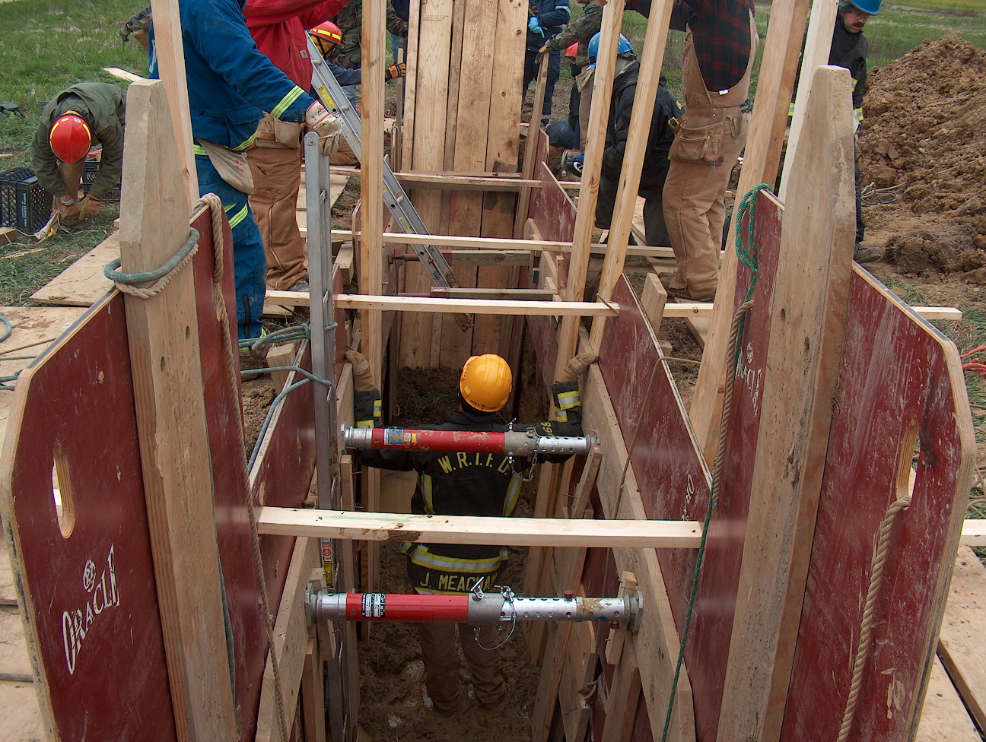 Training News

As 2007 comes to an end, plans are underway to successfully schedule the classroom and hands on training for 2008. I will be meeting with the shift training officers to lay out the 2008 plan. If there is a particular subject that you believe we should discuss, please relay that information to your shift training officer. The focus will remain on fireground basics i.e. engine and ladder operations, incident management and fireground safety. We are looking at taking monthly EMS training online with one of two different programs offered. More information on this change will appear in the near future.

We will continue to utilize the barn at the Runyon Road property until the status of that property changes. Please do not use the vacant station for training as we will be completing the move process with a final move and cleaning of this building in order to possibly sell this property. We have looked at this structure long and hard to find ways to use it for fire department services. The idea of using it for training was once discussed. Issues such as the size of the lot and costs of maintenance and repair have caused that idea to be removed from the table. Securing a site and funding for a future training facility will be a priority in 2008.

In regards to safety, I am pleased to announce that WRTFD significantly reduced its number of firefighter injuries from 2006-2007. We have started to chip away at the “bull in the china shop” mentality and are becoming more focused on health and safety as a department. The bad news is that apparatus incidents have increased. The Training and Safety division will focus on more apparatus operator in-service trainings and creating a sound list of potential operator candidates. Remember to use common sense and pay attention to detail. Don’t take chances when operating any of the vehicles in our fleet.

Continue to build on the knowledge, skills, and abilities needed to efficiently and effectively manage those incidents we have been called to mitigate.

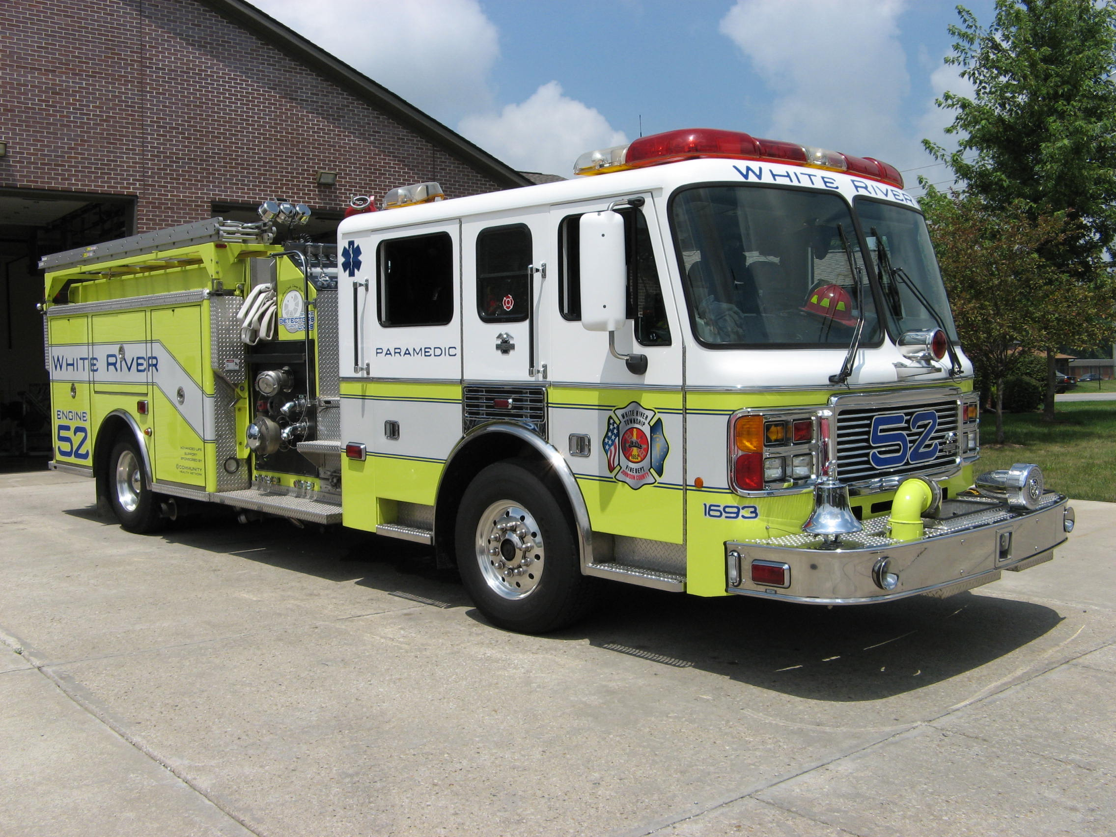 Did you know?

A full grown reindeer can run between 12 and 15 miles an hour pulling a loaded sleigh. They can do this for many hours. Reindeer can carry up to 300 pounds. This is the same as they weigh.

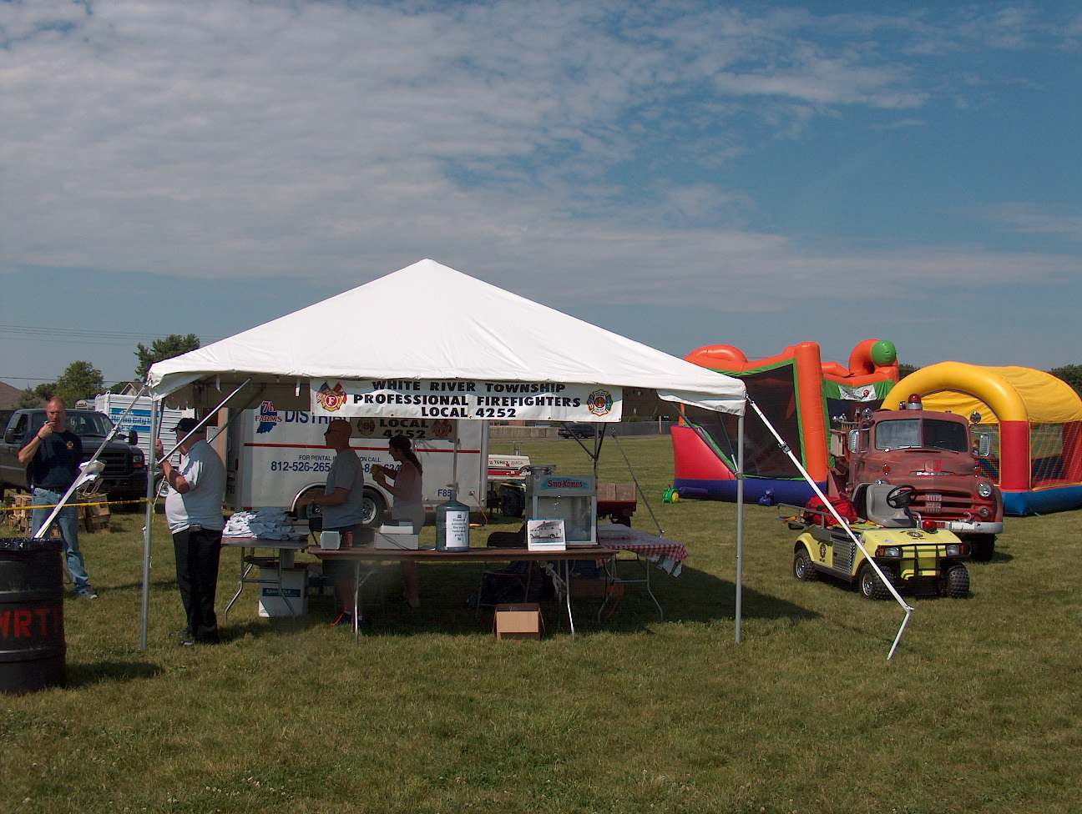 Birthdays (December 14 - December 27)

Shawn Harvey December 15
James Engmark December 17
Travis Sichting December 20
Daniel Huff December 23


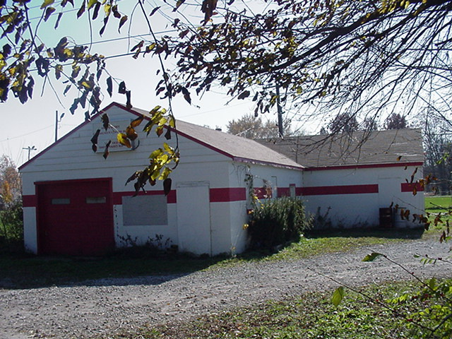 Looking back…..

48 years ago December 17, 1959 Santa visits kids at the firehouse
White River Township Volunteer Firefighters and neighborhood kids were treated to a visit with Santa Claus. The jolly red elf brought sacks of goodies for every good girl and boy.
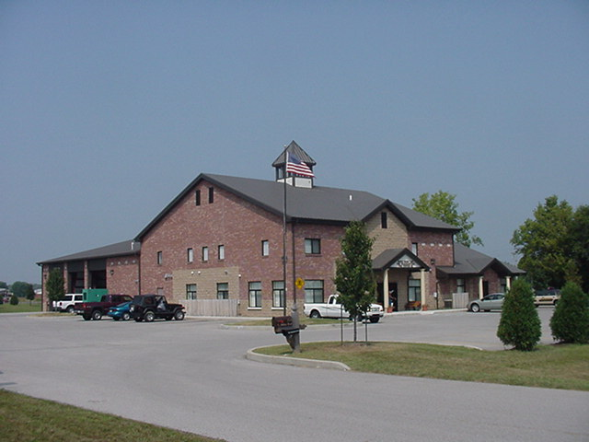 Upcoming events (December 2007 through 2008)

2008 Awards Banquet Jan 26, 2008 at 6:30 pm at Piper's

Fire Protection District Board Meetings for 2008:

January 8, 2008 – 7pm. Station 53 February 5, 2008 – 7pm. Station 53
March 4, 2008 – 7pm. Station 53 April 1, 2008 – 7pm. Station 53
May 6, 2008 – 7pm. Station 53 June 3, 2008 – 7pm. Station 53

July 1, 2008 – 7pm. Station 53 August 5, 2008 – 7pm. Station 53
Sept 2, 2008 – 7pm. Station 53 October 7, 2008 – 7pm. Station 53
Nov 4, 2008 – 7pm. Station 53 Dec 2 , 2008 – 7pm. Station 53
December 2007
S | M | T | W | T | F | S
 |  |  |  |  |  | 1
2 | 3 | 4 | 5 | 6 | 7 | 8
9 | 10 | 11 | 12 | 13 | 14 | 15
16 | 17 | 18 | 19 | 20 | 21 | 22
23 | 24 | 25 | 26 | 27 | 28 | 29
30 | 31
January 2008
S | M | T | W | T | F | S
 |  | 1 | 2 | 3 | 4 | 5
6 | 7 | 8 | 9 | 10 | 11 | 12
13 | 14 | 15 | 16 | 17 | 18 | 19
20 | 21 | 22 | 23 | 24 | 25 | 26
27 | 28 | 29 | 30 | 31

