

November 30, 2007

Inside this Issue
1 Training
2 Did You Know?
2 Birthdays
3 Looking Back
4 Upcoming Events

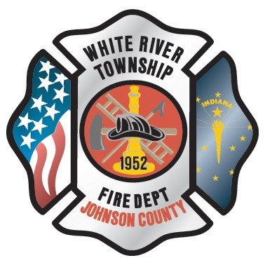 Administration News

“To effectively and efficiently provide professional services to our community”

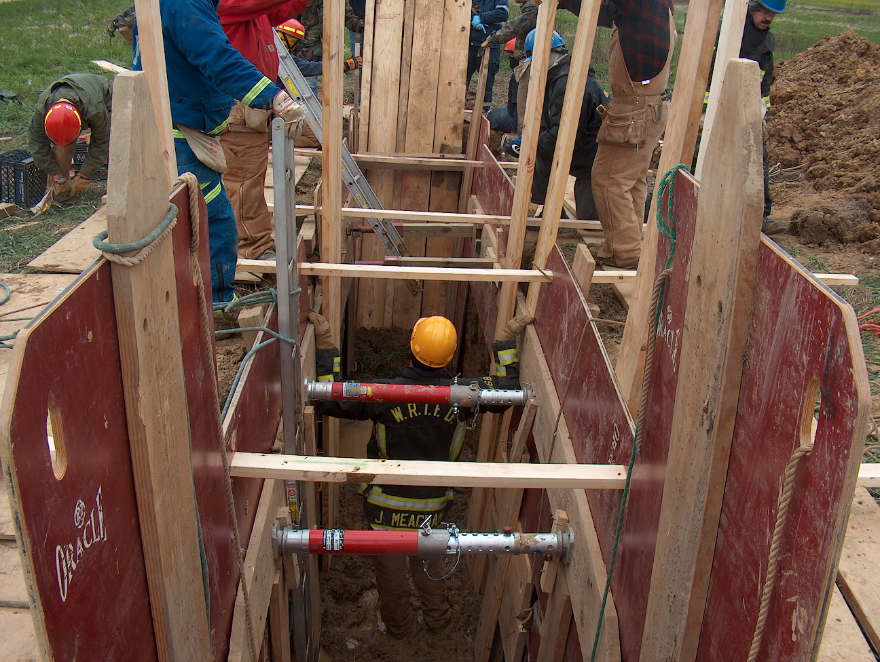 Training News

Since the fire station on Runyon Road is officially closed, the department will now actively begin to sell the property. Please do not conduct any drills in the station itself. We can continue to train in the barn until we make some decisions about the future of that structure.

Although FDIC is 4 months away, it is time to register for the HOT Classes that are conducted on Monday and Tuesday of that week. Part-time personnel are eligible to register but you must register your self and then submit for reimbursement. Please contact me should you have any questions.

We will conduct a Driver Operator – Pumper class beginning January 14, 2008. This class will be open to individuals outside WRTFD. Registration will begin in a couple weeks

Other upcoming classes include
- Fire Inspector I/II Class – Plainfield Fire Department Mondays and Tuesdays 8:30-4:30pm beginning Jan 14 and ending Feb 12. Cost of class $550.00.
Contact Rodney Johnson to register 882-2599.
- Incident Safety Officer Class – Greenwood Fire HQ January 19 and 20. This class is free. Contact Chris Harris if interested 882-2599

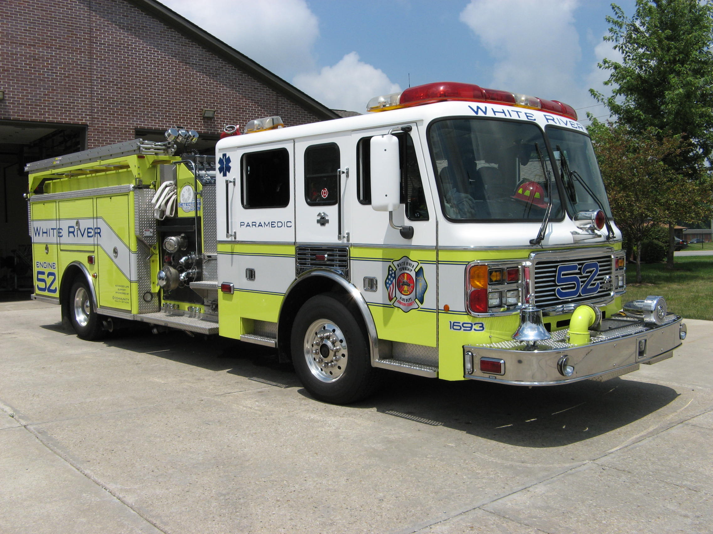 Did you know?

Did you know the Reindeer Facts?
Family: Deer (Cervidae)
Species: Rangifer Tarandus
Size: Approx 1 Metre at the Shoulder
Behavior: Highly gregarious, generally found in a herd

Please watch for more Reindeer Facts in December !!!!!!!!

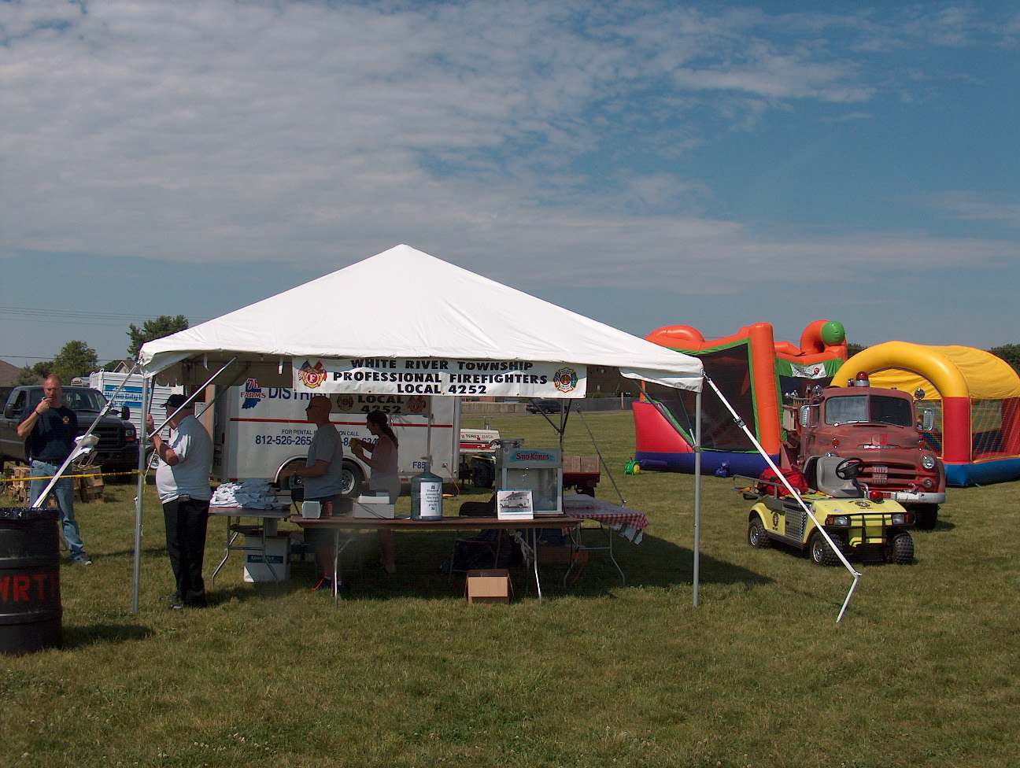 Birthdays (November 30 – December 13)

Joseph Green December 1
Michael Combs December 1
Joshua Justice December 6
Timothy Smith December 10
Nick Alford December 11
Greg Maxwell December 11
Ben Roberts December 11

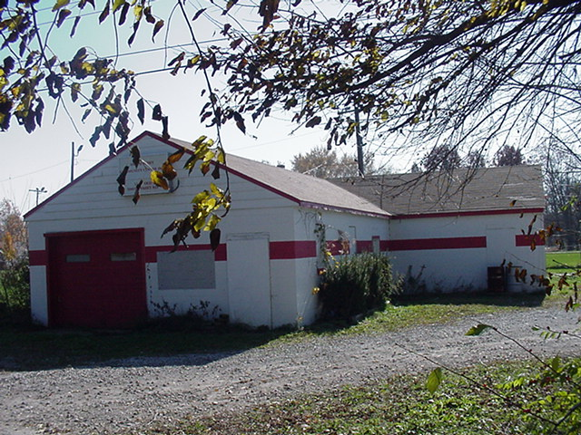 Looking back…..

50 years ago December 12, 1957

Department completes new truck

The first new truck under the new name of White River Township Volunteer Fire Department is now completed and in full, regular service. The 1954 Dodge chassis that was in bad shape was purchased earlier this year at a cost of $201.50. Members of the volunteer department built the body, made necessary repairs, and now boasts a 710 gallon water tank, 500 feet of 1 1/2 inch hose, and a 250 G.P.M. power take-off pump. Altogether the truck has cost the department $3,850 with all the equipment added. The truck makes the department's overall 2nd truck to go in service.

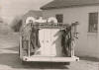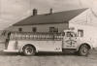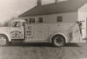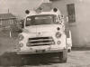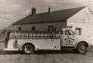

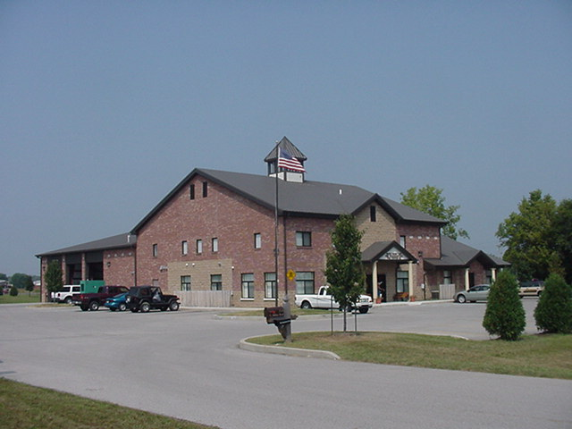 Upcoming events (December)

Fire Protection District Board Meeting – December 4, 2007 – 7pm. Station 53

You are invited to a Free Spaghetti Dinner at the New Firehouse located at 3016 W. Olive Branch Rd.
December 8, 2007 5 pm to 8 pm

December 2007
S | M | T | W | T | F | S
 |  |  |  |  |  | 1
2 | 3 | 4 | 5 | 6 | 7 | 8
9 | 10 | 11 | 12 | 13 | 14 | 15
16 | 17 | 18 | 19 | 20 | 21 | 22
23 | 24 | 25 | 26 | 27 | 28 | 29
30 | 31

