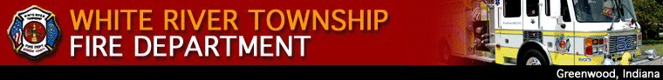

November 2, 2007

Inside this Issue

1 Operations
2 Did You Know?
2 Birthdays
3 Looking Back
4 Upcoming Events

“To effectively and efficiently provide professional services to our community”

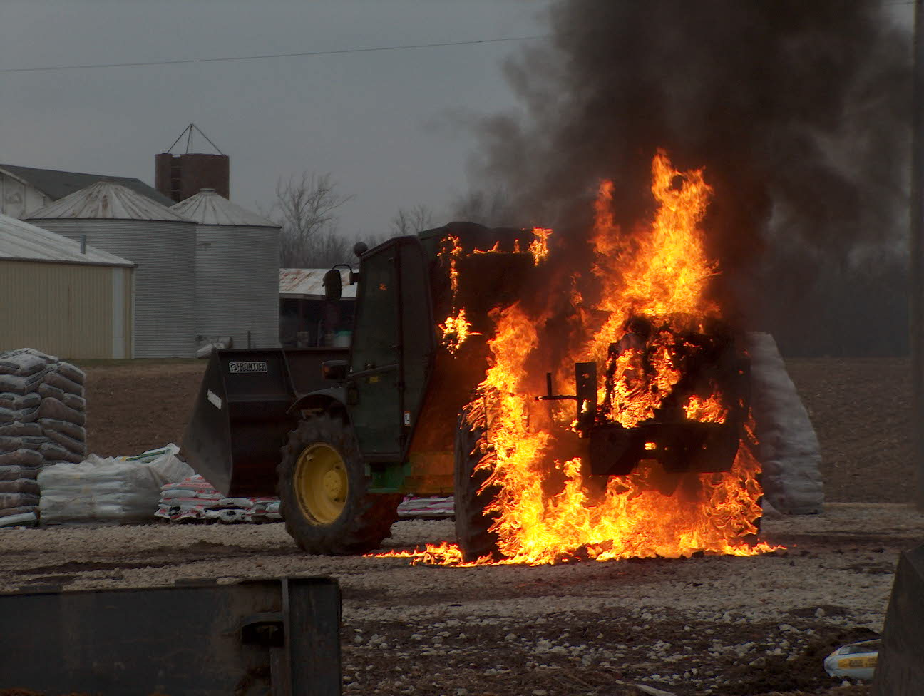 Operations News

Greenwood Police Department has hired Mike Watkins as the new Fire Service Communications Supervisor. Many remember Mike from working at Johnson County Dispatch. Mike is very pro fire dispatch and he will work hard for us.

Please look at the Program section of the department website for mutual aid responses with Rural Metro into Morgan County.

Ladder, pump, and hose testing will be occurring within the next month. Company officers please be flexible with daily scheduling. Private Marsh will oversee ladder testing, Lieutenant Hurrle pump testing, and Engineer Wiegle hose testing.

I would like to thank all who assisted with CPR training at both Middle Schools the past two weeks. I have heard several positive comments about your professionalism and attention to teaching. A Big thanks goes to Captain Hart who coordinated both weeks. The next round of classes will start November 12 and the first two weeks of December.

It is wonderful to see this department come together in the support of Brother Fraker in his time of need. Your care and compassion is remarkable. Times like this are what truly make us a great department.

Continue to be smart and stay safe.

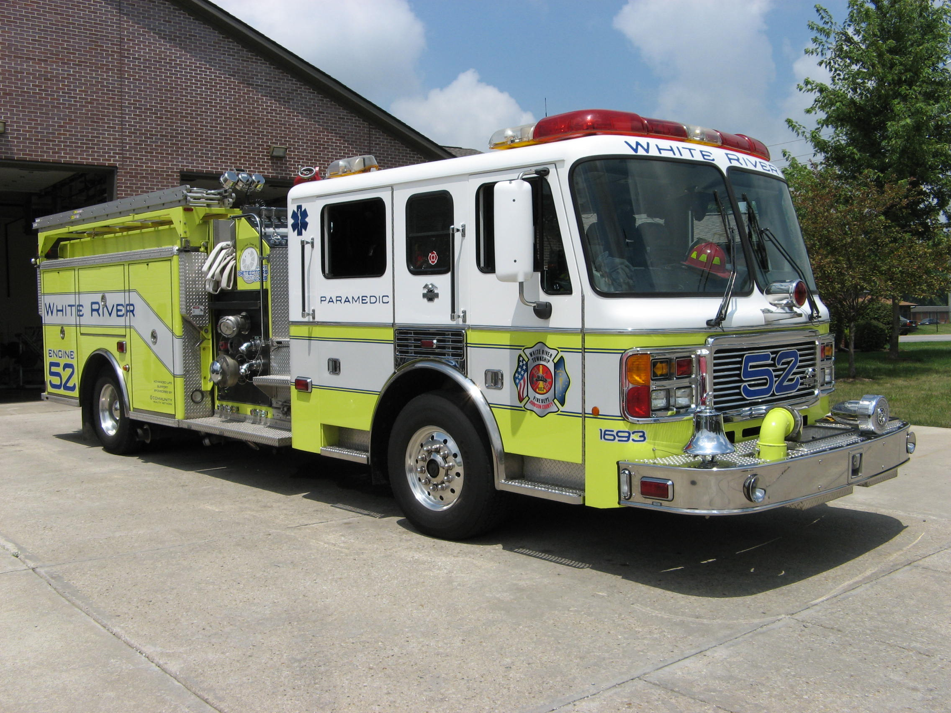 Did you know?

Did you know that a person needs to be a cross between a professional accordion player and an origami expert to refold maps?

Did you know that was a joke? 

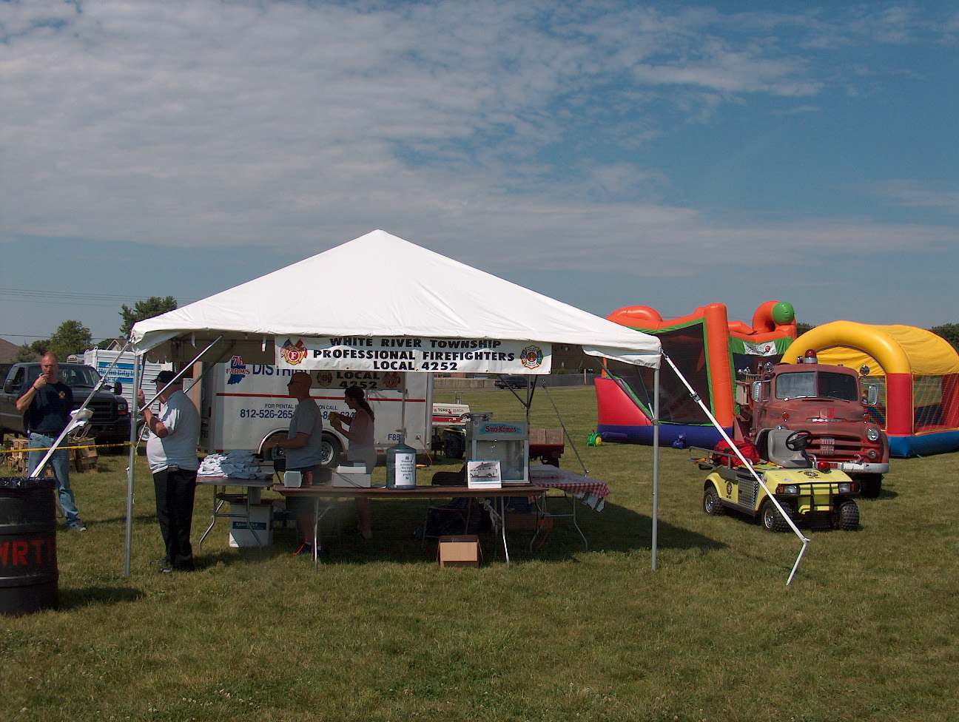 Birthdays (November 2 – November 15)

Greg Hurrle November 4
Bryan Arkins November 6 Tony Slusher November 15

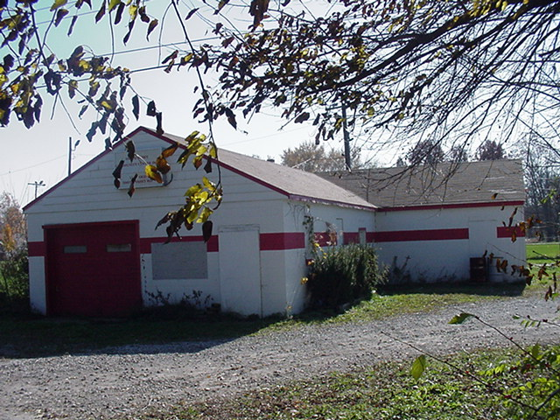 Looking back…..

54 years ago November 2, 1953

Decision made to segregate fire department

At tonight’s meeting of the board of directors of the Smith Valley Community Center, it was brought up to separate the activities of the fire department from the Community Center and form a distinct entity as per the By-Laws of the Community Center. The following is the verbiage from the official meeting minutes.
A discussion was held on segregation of the Fire Department and election of their own set of officers. Tom Garnier made a motion that the Smith Valley Community Center give authority to organize a Volunteer Fire Department. Said Fire Department to elect their own officers. A committee be composed of two members of the Volunteer Fire Department and two members from the Board of Directors to draw up a set of by-laws. Said by-laws to be approved by the board of directors of the Smith Valley Community Center, Inc. Seconded by Dale Heiny. Motion was carried.

43 years ago November 10, 1964 Barn consumed by fire
A fire at a barn owned by Forrest Sutton destroyed the structure following an early afternoon fire at the property. The cause of the fire is unknown and still under investigation.

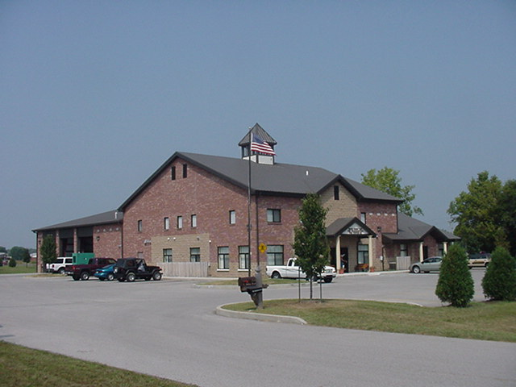 Upcoming events (November - December)

Fire Protection District Board Meeting – November 6, 2007 – 7pm. Station 53

Fire Protection District Board Meeting – December 4, 2007 – 7pm. Station 53
November 2007
S | M | T | W | T | F | S
 |  |  |  | 1 | 2 | 3
4 | 5 | 6 | 7 | 8 | 9 | 10
11 | 12 | 13 | 14 | 15 | 16 | 17
18 | 19 | 20 | 21 | 22 | 23 | 24
25 | 26 | 27 | 28 | 29 | 30
December 2007
S | M | T | W | T | F | S
 |  |  |  |  |  | 1
2 | 3 | 4 | 5 | 6 | 7 | 8
9 | 10 | 11 | 12 | 13 | 14 | 15
16 | 17 | 18 | 19 | 20 | 21 | 22
23 | 24 | 25 | 26 | 27 | 28 | 29
30 | 31

