

October 19, 2007

Inside this Issue
1 Operations
2 Training
3 Did You Know?
3 Birthdays
4 Looking Back
4 Upcoming Events

“To effectively and efficiently provide professional services to our community”

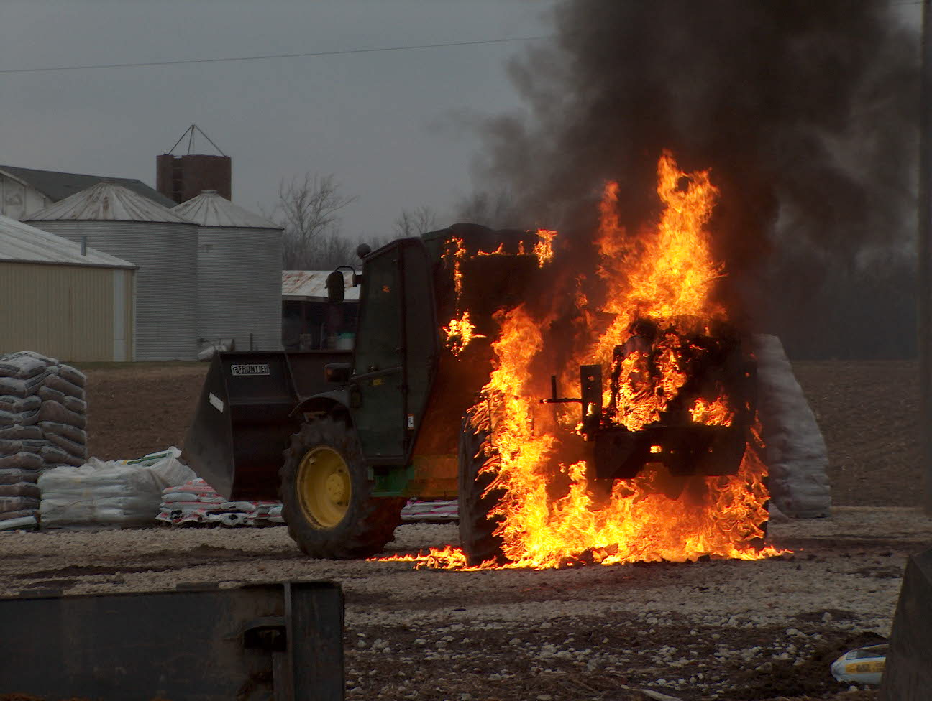 Operations News

I know there are still several questions among the companies concerning the move to Station 51. The Battalion Chiefs met on 10-18-07 to discuss the move operationally and will be conducting shift meetings to discuss issues and answer questions.

We are still in the process of fixing several minor issues on Engine 55. Maintenance fell a little behind due to the fact that Greenwood Fire Department borrowed the engine for a week and then Fire Prevention utilized it during FPW. As soon as the minor issues are fixed, we will put some additional equipment on Engine 55 so it is always run ready.

The new Battalion was taken to Waymire this past Wednesday for installation of the radio, lights, and the slide out trays in the rear. The reason for the delay was some special order items. Private Marsh expects it to be ready in the middle of next week.

All the renumbering of apparatus has been completed by Square One.

Mike Combs has ordered some spare radio parts. Company officers please check your handheld radios and contact Engineer Combs for any needed repairs.

That is it for now, stay smart and be safe.

.

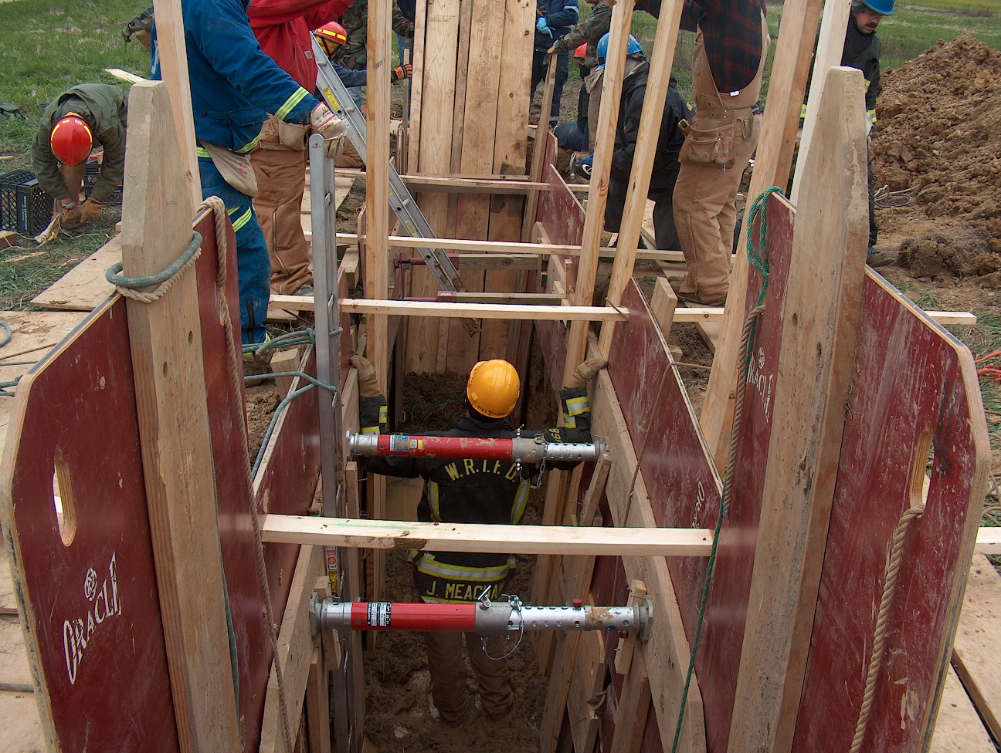 Training News

Hiring Update

By the print of this newsletter Chief Pell will have completed his Fire Chief Interviews. The hiring list will be completed in the next week and the department will be ready to take 1-2 names to the District Board in November. This has been a long process but conducted with the utmost integrity. Thanks to everyone who helped make this a success.

Training news

Annual hazmat refresher was conducted this past week. Nearly 80% of the department completed this OSHA mandated training. If you missed it, please get with your company officer, shift training officer or myself to complete it. If you get it at another department, please provide documentation to me.

Next week we will be conducting flashover training. Monday – Wednesday will be classroom sessions and Thursday, Friday and Saturday we will be at the container on Hanna Ave near the airport. I will provide rotation information to the Battalion Chiefs by next week. Please make an attempt to attend the container portion on one of the three days.

Upcoming Training

Technical Awareness Training will be conducted on November 10 and 11 at Franklin HS. Visit www.indianatechnicalrescue.com to register for the class.

FDIC registration is now available. I suggest you sign up ASAP to guarantee your first choice of HOT Classes. See me for more details.

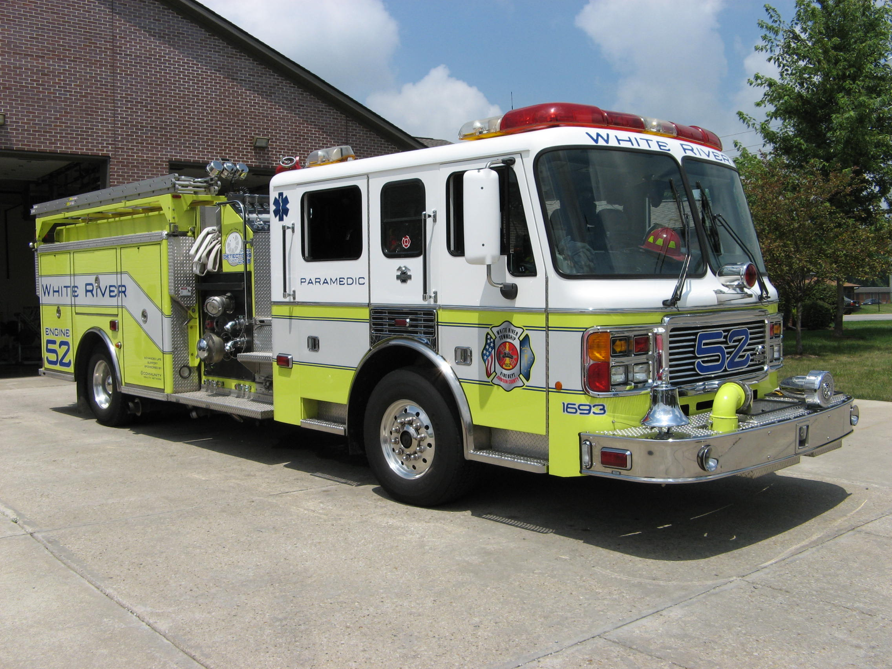 Did you know?

The Gudgeonville Covered Bridge is a covered bridge in Girard, Pennsylvania that crosses Elk Creek in Erie County. It was built using the king post truss design. The bridge has been listed on the National Register of Historical Places since 1980.
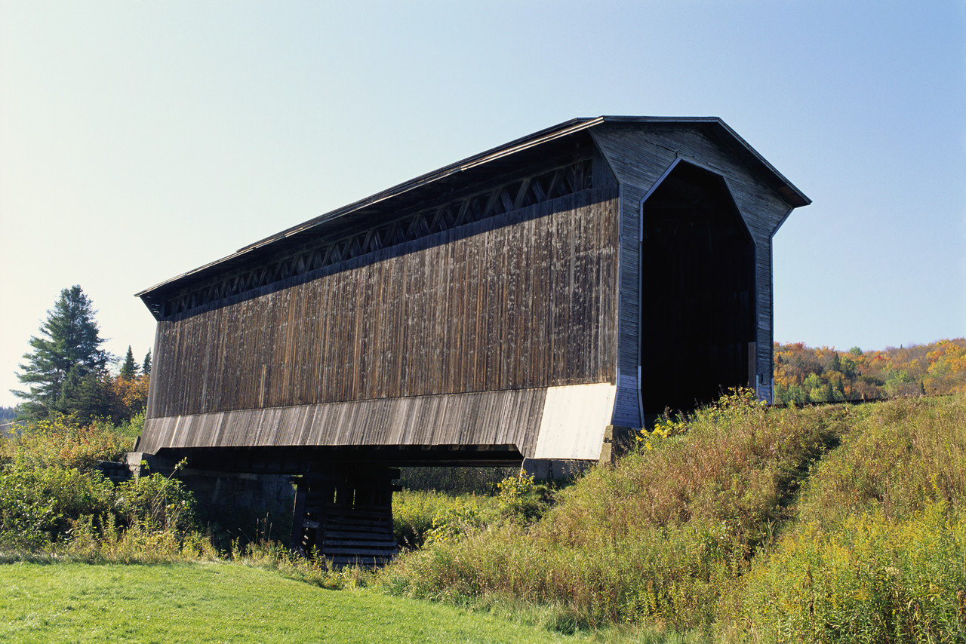

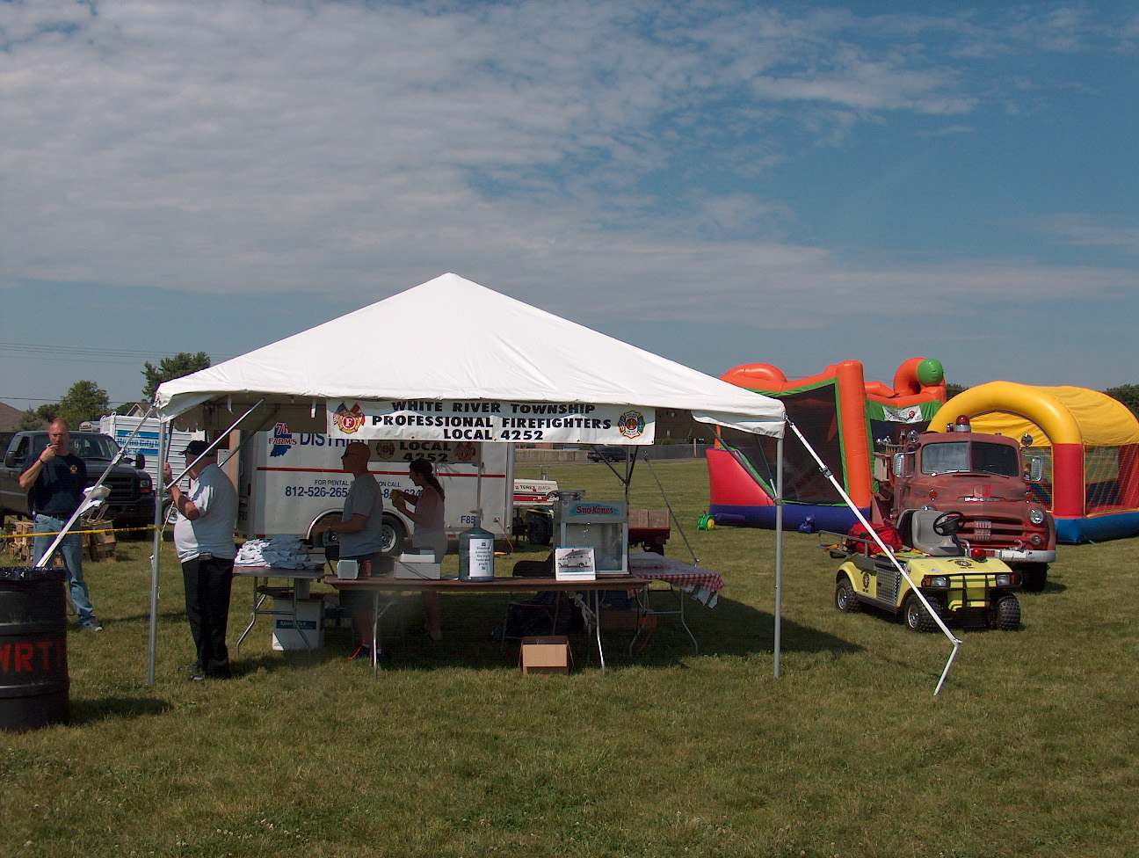 Birthdays (October 19 – November 1)

Kyle Brooks October 19
Steve Ladd October 20
Lorrick McCullum October 20
Sean Santerre October 23
Kyle Blue October 28
Jim Meacham October 28
Carey Slauter October 29

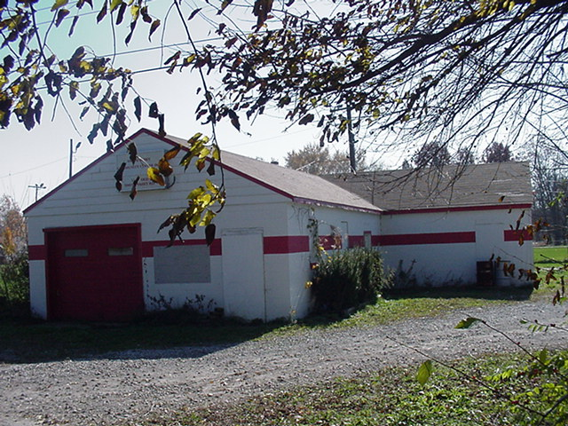 Looking back…..

36 years ago - October 19, 1971 - Crash hurts three
A rural Greenwood couple and teen-age youth were injured Wednesday morning in a two-car collision at Morgantown and Fairview roads in Johnson County. Sheriff's deputies and state police investigated the accident, which occurred about 7 a.m. Injured in the crash were John Shanks, 58, and Mary Shanks, 58, of Greenwood Rural Route Four, and Michael Lynch, ,18, Camby. The Shanks car overturned in a field after the two cars collided at the intersection, deputies said. Two ambulances took the injured to Johnson County Memorial Hospital after the crash. The Shanks couple were treated and later transferred to Indianapolis St. Vincent Hospital in "satisfactory" condition. The Lynch youth was still undergoing emergency treatment and x-rays late this morning, hospital officials said.

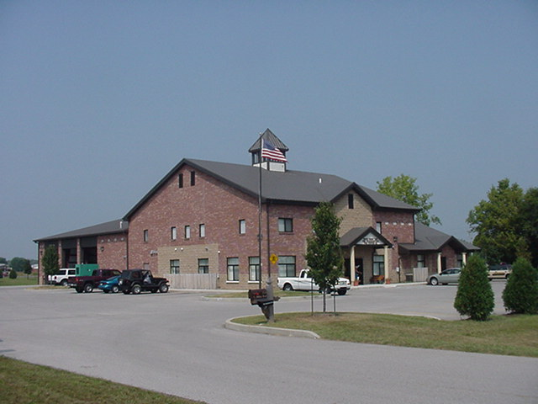 Upcoming events (October - November)

Fire Protection District Board Meeting – November 6, 2007 – 7pm. Station 53

October 2007
S | M | T | W | T | F | S
 | 1 | 2 | 3 | 4 | 5 | 6
7 | 8 | 9 | 10 | 11 | 12 | 13
14 | 15 | 16 | 17 | 18 | 19 | 20
21 | 22 | 23 | 24 | 25 | 26 | 27
28 | 29 | 30 | 31
November 2007
S | M | T | W | T | F | S
 |  |  |  | 1 | 2 | 3
4 | 5 | 6 | 7 | 8 | 9 | 10
11 | 12 | 13 | 14 | 15 | 16 | 17
18 | 19 | 20 | 21 | 22 | 23 | 24
25 | 26 | 27 | 28 | 29 | 30

