

October 5, 2007

Inside this Issue
1 Prevention
2 Training
3 Training
3 Did You Know?
3 Birthdays
3 Looking Back
3 Looking Back
4 Upcoming Events

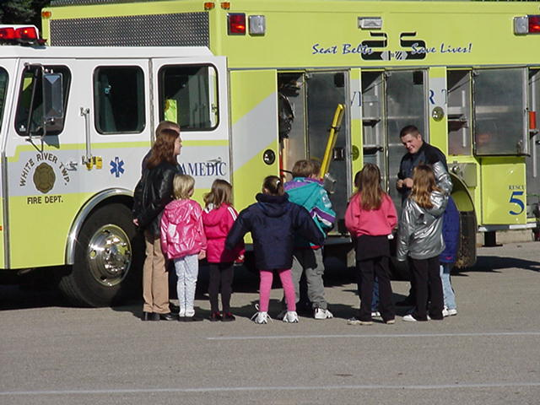 Fire Prevention News

Now that Fire Prevention Week approaches, Chief Brown wants to remind all personnel about our smoke detector program.
As you all know, back in July after extensive testing of the different types of smoke detectors that was conducted locally in Marion County, it was found that the Ionization Smoke Detectors do not respond to slow, smoldering fires until it’s too late for someone to awaken from their sleep and escape a fire. As you know most fires that occur in our homes which result in death, are those fires that smolder and create lots of poisonous smoke in which sleeping persons inhale and then die in their beds before the fire even reaches them.

After the test was completed and Fire Officials from our office and several other Central Indiana Fire Departments reviewed the results, we here at White River immediately determined that we need to provide more than just the Ionization detectors to our residents. This is when the media blast began and we decided that in addition to providing a low cost Ionization Detector, we would also provide a Photoelectric Smoke Detector. This will occur until we exhaust our supply of Ionization Detectors. When we run out of the Ionization Detectors we will then provide a single combination Ionization/Photoelectric Detector.
Please check your apparatus and assure you have an equal amount of Photoelectric and Ionization Detectors and assure that you are providing both to those who inquire. If you wish to view the complete stories, you may visit the archive stories on the website, the dates are 7/26/07 and 8/30/07.

“To effectively and efficiently provide professional services to our community”

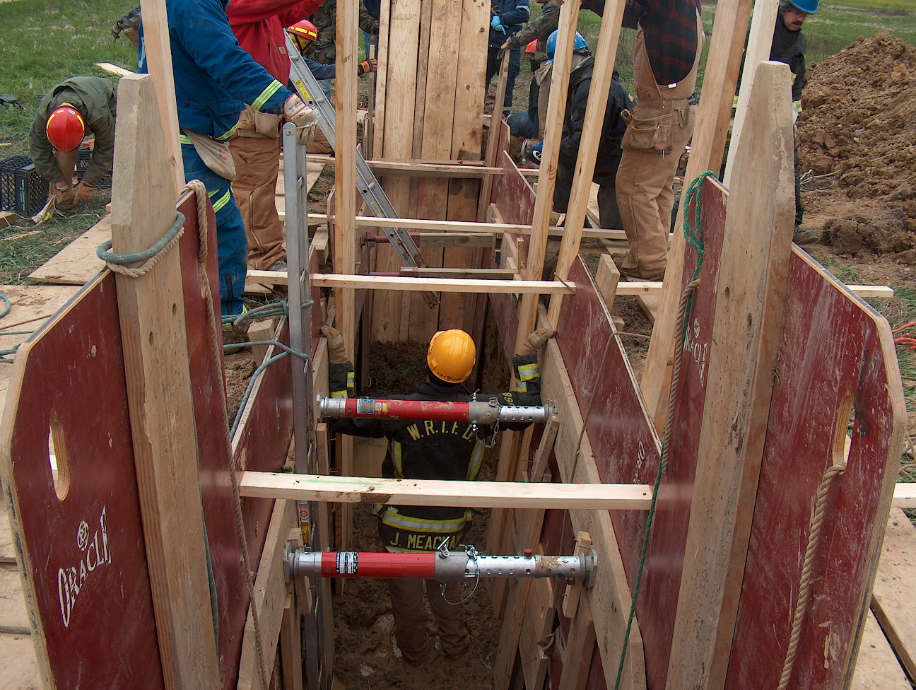 Training News

Training Division

Hiring process update

Reserve process is complete and the department has hired the following people as reserve firefighters. Please make these new employees feel welcome
Greg Moore – Firefighter / EMT C Shift Ladder 53
George Boots – Firefighter / EMT Sign up
Steve Snider – Firefighter / EMT-P B Shift Engine 52
Kevin Johnson – Firefighter / EMT Sign up
Lorrick McCullum – Firefighter / EMT Sign up

Career process is nearly complete. Chief Pell will interview the top ten from the list established by IPSP. Once the Chief’s interviews are complete a final list will be established. A time will be announced later with a specific number of individuals that will be presented to the District Board for conditional offer of employment. Thanks to everyone who assisted with this long tedious process.

Training News

NIMS 300 is complete. This training was required for all company officers and above. A make up class will be announced in the coming weeks. This should be completed by the end of the year.

NIMS 400 will be conducted at Fire HQ on October 18 and 19. This course is required for Captains and above. All department employees are encouraged to attend. Any Captain or Chief Officer with scheduling conflicts should contact Chief Thacker immediately to make other arrangements.

ACLS refresher course will be conducted at Fire HQ on October 17 beginning at 0800. Please notify Capt. Hart or Chief Thacker if you will be attending so they may plan accordingly.

No Training is scheduled next week due to Fire Prevention Week.

HISTORY QUESTION – Why is Fire Prevention Week held annually in October? Discuss this major fire event around the kitchen table and how it affected the fire service from then to now.

Plan accordingly for flashover training the week of October 22. We will spend the first part in the classroom and Thursday, Friday, and Saturday in the container with live burns. Check Firehouse for details

Upcoming Training

Week of October 16 – Hazmat refresher – annual hazmat update and review of department equipment and tactics
October 24 - Audit and Review at Fire HQ 1400 hrs.
November 10 and 11 – Technical Rescue Awareness Course – Go to indianatechnicalrescue.com for information on registering for the course

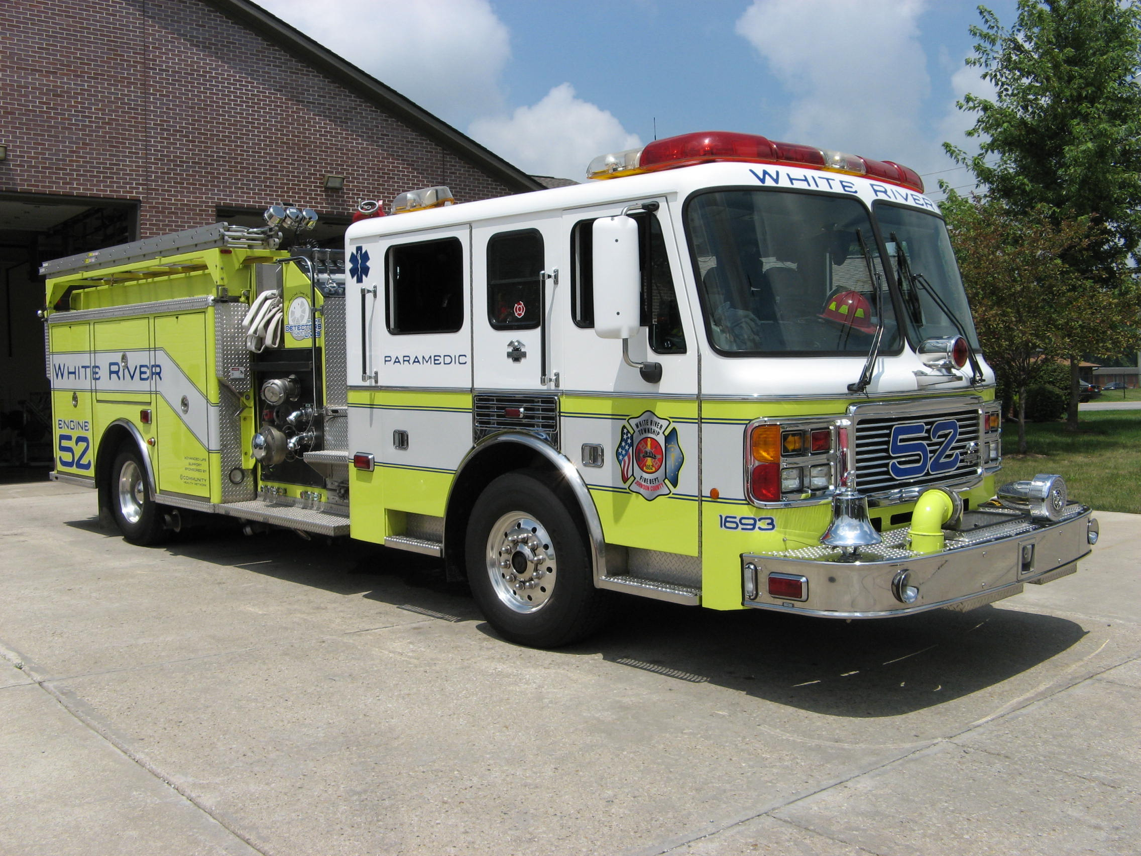 Did you know?

The word Avocation is: a subordinate occupation pursued in addition to one's vocation especially for enjoyment: hobby. It is a noun.

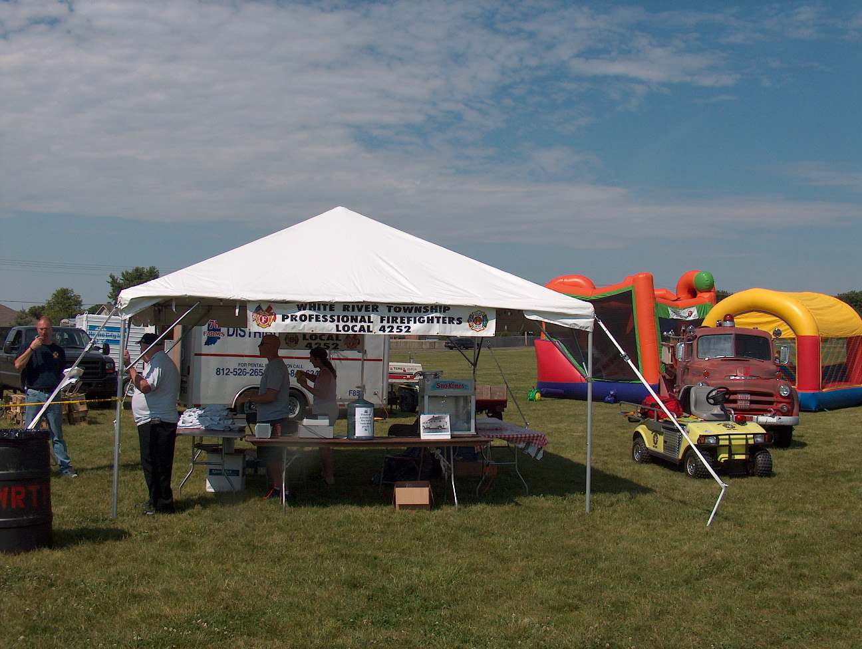 Birthdays (October 5 – October 18)

Eric Williams October 14
Nathan Meredith October 17
Corey McGaha October 18


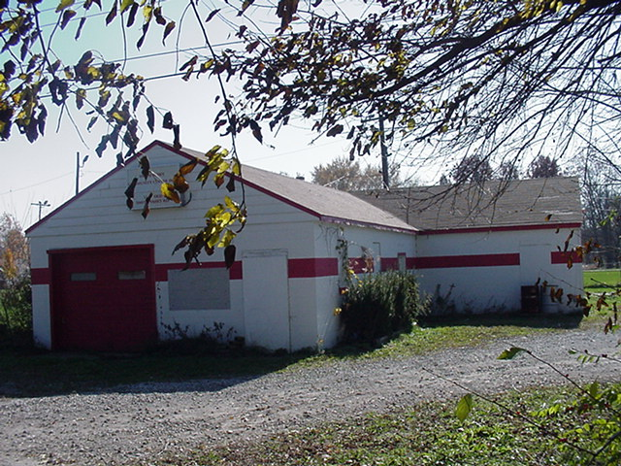 Looking back…..

35 years ago October 9, 1972 Fire destroys truck, office Smith Valley, Ind.- Firemen hampered by a lack of water fought a stubborn fuel fire that destroyed a truck and mobile home office south of Smith Valley today. Capt. Art Barr of the White River Township Fire Department said flames were shooting more than 150 feet into the air from two huge fuel tanks at the site of an asphalt plant alongside Ind. 37. Barr said the plant, operated by McMahan-O’Conner Construction Co. of Rochester, produced asphalt and concrete for widening construction of Ind. 37. It is about 2 miles south of Smith Valley. Fire from the burning tanks, believed to have held more than 5,000 gallons of fuel oil, was noticed at 2 a.m. by State Trooper Russ Miller. It took firemen more than four hours to bring the blaze under control. The plant is about a mile west of Ind. 37 in a gravel pit.
An asphalt tanker caused some concern when firemen arrived. Lines to the tanker were connected to the fuel tanks. When firemen arrived, they fought their way to the shut-off valves in an effort to avert an explosion. More firemen were summoned from Waverly and Bargersville. An estimated 35 firemen with nine pieces of equipment were at the scene. No injuries were reported. Barr said six fire trucks took water from the West Grove Elementary School at Smith Valley before the blazing fuel tanks were brought under control. Cause of the fire has not been determined. He also said the asphalt and concrete plants were not damaged by the fire. Damage has not been estimated.

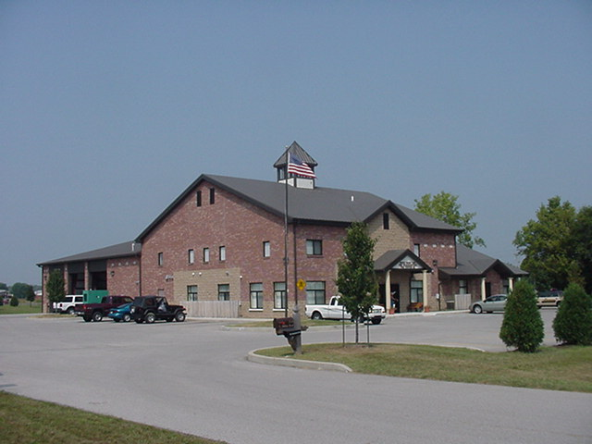 Upcoming events (October - November)

Station 51 Personnel: Please do not forget the 1st tri-annual Station 51 Family Celebration at Independence Park. The date and time: October 6, 2007 at 12 noon. Please bring the Family for food and games. Bring a covered dish. RSVP to Lt. Nick Alford nalford@wrtfd.org.

Fire Protection District Board Meeting – November 6, 2007 – 7pm. Station 53

October 2007
S | M | T | W | T | F | S
 | 1 | 2 | 3 | 4 | 5 | 6
7 | 8 | 9 | 10 | 11 | 12 | 13
14 | 15 | 16 | 17 | 18 | 19 | 20
21 | 22 | 23 | 24 | 25 | 26 | 27
28 | 29 | 30 | 31
November 2007
S | M | T | W | T | F | S
 |  |  |  | 1 | 2 | 3
4 | 5 | 6 | 7 | 8 | 9 | 10
11 | 12 | 13 | 14 | 15 | 16 | 17
18 | 19 | 20 | 21 | 22 | 23 | 24
25 | 26 | 27 | 28 | 29 | 30

