

September 21, 2007

Inside this Issue
1 Administration
2 Administration
2 Operations
2 EMS
3 EMS
3 Did You Know?
3 Birthdays
4 Looking Back
4 Upcoming Events

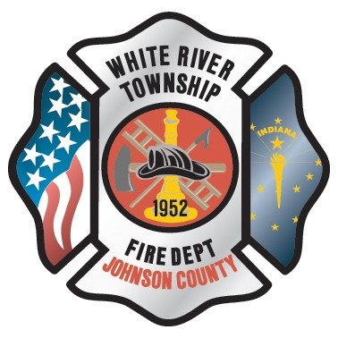 Administration News

Chief Thacker and I have scheduled a meeting with the Company Officers for Thursday, September 27, at 0830, prior to the NIMS training. I would encourage all of the Officers to attend so that both the Senior Staff and Battalion Chiefs are aware of my expectations of the Company Officers. If you are unable to attend, I can meet with you individually.

This meeting will accomplish three things. First, I want the opportunity to explain my philosophy as Fire Chief. Each Chief has his own leadership style. I want everyone to be aware of my leadership style. Secondly, I will explain what my expectations are of the Company Officers. Lastly, everyone will have the opportunity to ask questions or give suggestions.
I have had a very similar meeting with the Senior Staff. In the near future I will also have department-wide meetings. I believe it is important for me to meet everyone on department and the entire department to meet me personally. It is also important for everyone to understand the expectations of the Fire Chief. Each meeting is a slightly different because we all fill different roles in the department. Each person’s responsibility is different based on their role. The core of the meetings is the same, but the expectations section is slightly different based on each group’s role in the department. I look forward to talking to each one of you.

“To effectively and efficiently provide professional services to our community”

Be safe,
Chief Jeremy A. Pell

The second walk-through (punch-list check) for the new fire station is scheduled for September 27th. From there, contractors will have one week to correct any deficiencies still not completed before fines are started to be levied against their contracts. Based on the outcome of the 27th walk-through, we should be close enough to set a move-in date.

Thanks to all those who helped get the new Engine in service. There was a lot of additional work that needed to be done after we took delivery last month and it all came together nicely with the official dedication this past Sunday.

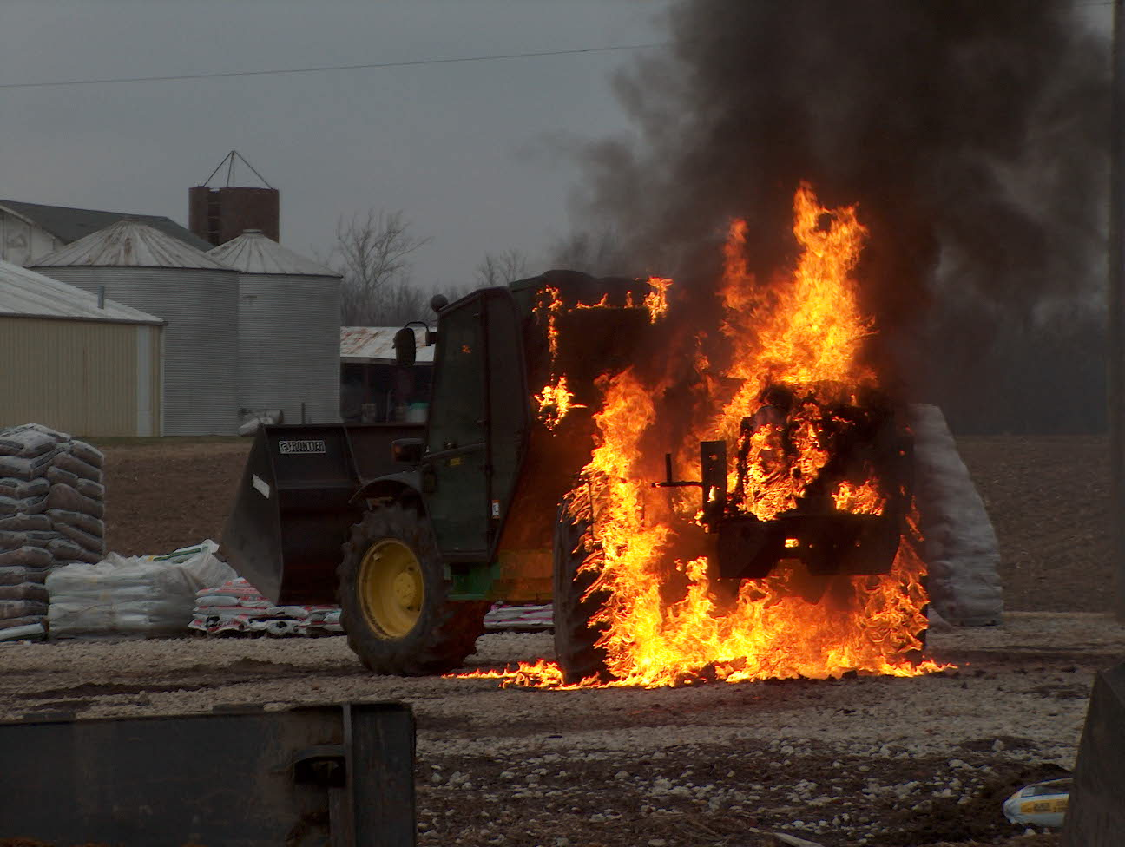 Operations News

We are continuing to work on the GIS mapping project. Currently, we have verified about one half of the district. We should end the project next week. Thanks to all who are participating.

Now that Engine 53 is in service, Engine 55 will remain out of service so the maintenance division can take care of some overdue repairs. After that, some additional equipment will be put on Engine 55. Our goal is to have Engine 55 run-ready without swapping out a lot of equipment.

Once again, we will be providing CPR training to both Center Grove Middle School North and Middle School Central. We will need lots of help to make this project happen. Pay will be $18 per hour. Please consider helping with this important program. We already have a documented save this year from an individual who took a WRTFD CPR course, so we know we do make a difference. I will be sending out more information in the next week or so.

Be smart and stay safe.

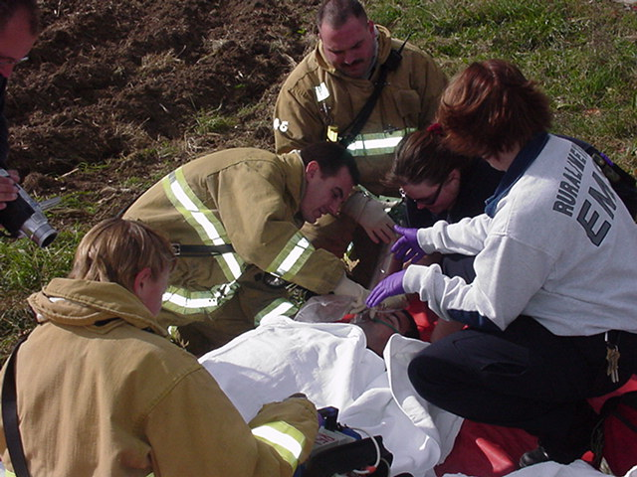 EMS News

We have received a Masimo Rad-57cm Pulse CO-Oximeter. Currently it will be kept on B-5 since we only have 1 however it is on the list for possible end of the year purchase for 2 more. The main focus for the device is for us. As you may be hearing or reading about, a lot of FF deaths are attributed to build up of CO, Cyanide and Phosgene gases in the blood. This device reads O2 saturation, CO saturation and Methemoglobin. We are going to be doing training on it within the next few weeks to bring everyone up to speed. It is mainly going to be utilized in the rehab sector for a quick look to make sure we are not getting a build up of these gases in the blood stream.
Also to go along with rehab, the focus has become more on cooling and utilizing this machine to monitor FF on the fire ground with less emphasis on vitals. Also the NPFA will be releasing newly revised standards on firefighter rehab in the future. If you go on a CO run that turns out to have a sick person, contact dispatch and have B-5 respond to get a reading on the patient. More on this devise to come later.

E-53 new E-series monitor will be ordered within the next few days and be in by mid October. Also we will be getting another AED-PRO to start phasing out the AED-PLUS(Little green machine).

If anyone has any ideas on EMS bags or a different set up for the apparatus, let me know. Our current red airway bags are showing a lot of wear and tear so we are looking at getting new bags before the end of the year.

FYI only, Air-E-Vac Helicopter is currently stationed at Wishard Hospital. It is just another option if LifeLine is out. They are coming to St 53 on October 2nd at 1330 to talk about the helicopter and answer any questions. So currently we have 4 fairly close helicopters. LifeLine at Methodist. Air-E-Vac at Wishard. PHI out of Hendricks County. LifeLine out of Columbus. All I ask is try to get the closest and don’t feel bad about disregarding them if there is one closer, for example calling for LifeLine and they send the Helicopter from Kokomo. Any questions let me know.

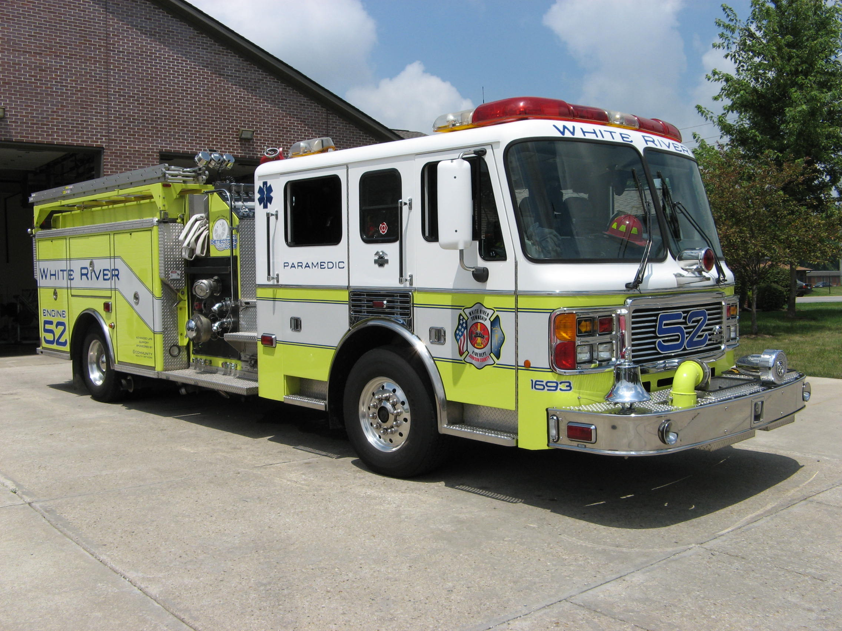 Did you know?

Did you know that fish have a specialized sense organ called the lateral line which works much like radar and helps them navigate in dark or murky water? It also detects changes in water temperature, pressure, and current.

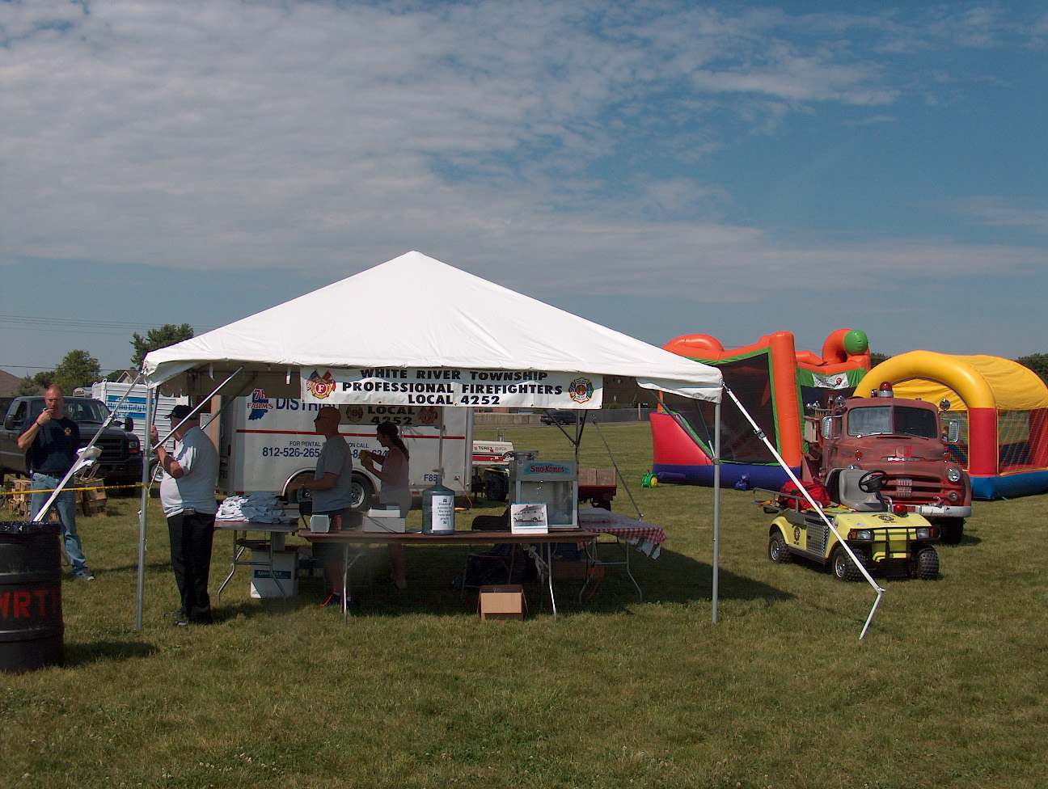 Birthdays (September 21 – October 4)

Thomas Tharpe September 28

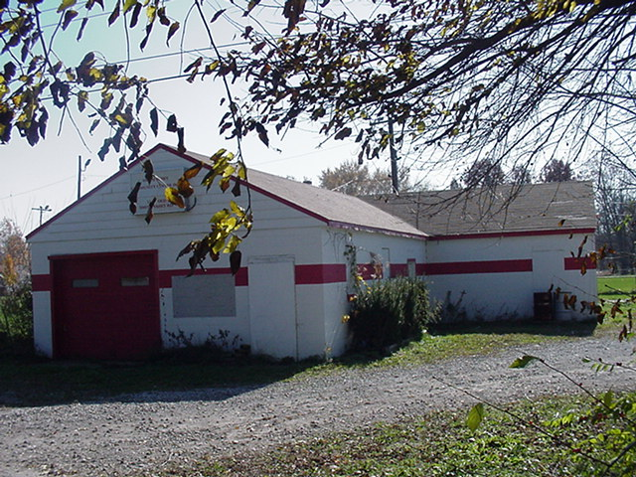 Looking back…..

49 years ago - October 2, 1958 - Firefighters train in first-aid
White River Township Volunteer Firefighters trained in various aspects of first-aid today using new equipment and supplies donated by Haag Drug Store in Greenwood.

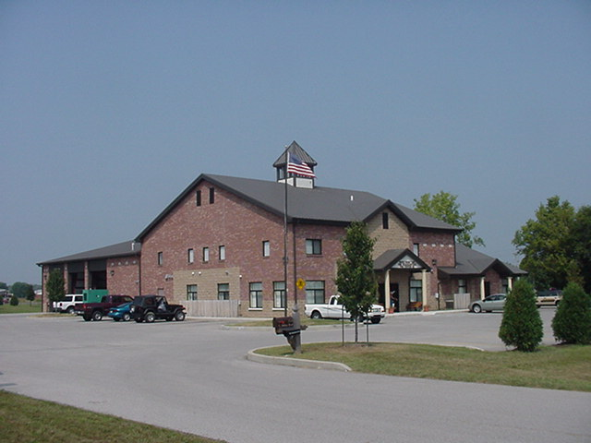 Upcoming events (October)

Fire Protection District Board Meeting – October 2, 2007 – 7pm. Station 53

Station 51 Personnel: Please do not forget the 1st tri-annual Station 51 Family Celebration at Independence Park. The date and time: October 6, 2007 at 12 noon. Please bring the Family for food and games. Bring a covered dish. RSVP to Lt. Nick Alford nalford@wrtfd.org.

oCTOber 2007
S | M | T | W | T | F | S
 | 1 | 2 | 3 | 4 | 5 | 6
7 | 8 | 9 | 10 | 11 | 12 | 13
14 | 15 | 16 | 17 | 18 | 19 | 20
21 | 22 | 23 | 24 | 25 | 26 | 27
28 | 29 | 30 | 31

