

September 7, 2007

Inside this Issue

1 Administration
2 Training
3 Did You Know?
3 Birthdays
3 Looking Back
4 Upcoming Events

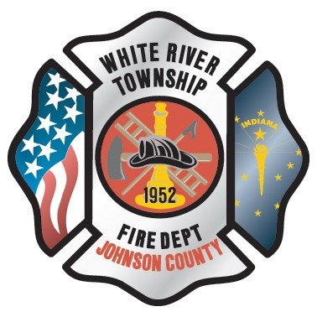 Administration News

Chief Pell will be officially starting in the office this Monday, September 10th. Please join in welcoming him back to the department and stop in to say hello if you haven’t met him yet.

We are doing the first round of walk-throughs (pre-punch list) starting this week at the new fire station. The intent is to finalize the project and establish a final completion date and subsequent occupancy date.

A special thanks to Lieutenant Smith, Mike Ridge, and Tim Smith for braving the 90 degree heat last week and constructing the new mini-barn at Station 53. They saved the department money by doing the project themselves. It really looks great and the work is genuinely appreciated!

Remember that we are now less than four months from going tobacco-free. If you think you will need some help, be sure to see Chief Thacker sooner, rather than later, for guidance. We want to make a positive difference and will be there to help.

“To effectively and efficiently provide professional services to our community”

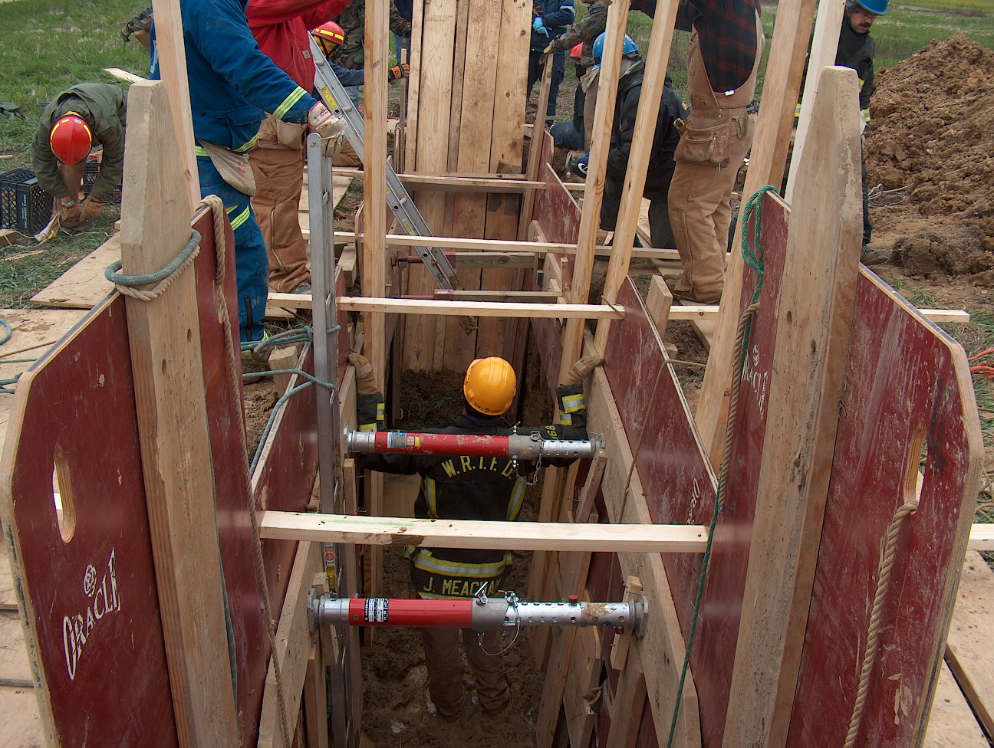 Training News

Training News
Hiring Process Update

Formal structured oral interviews are scheduled for September 13 and 14 at Fire HQ. Once completed the top candidates from the interview will complete the Fire Chief’s interview phase. At the conclusion of the Fire Chief interview, the candidates will be placed on hiring list for conditional offers of employment. The date for district board presentation has not been set.

The top five reserve process candidates will complete their Fire Chief’s interview this Friday. Orientation for the new reserves is scheduled for September 19.

Upcoming Training

All career and reserve engineers will complete the EVOC course during the week of September 10. This training will be conducted at Community Church of Greenwood on Main Street. A separate station for operating the support vehicle with the trailers attached is planned as well.

The week of September 17 we will be conducting the Seattle FD air management course. Each firefighter will complete eight stations and repeat those stations until their SCBA are completely empty and their mask is sucking to their face. Using a stopwatch, times will be recorded for on air, low air alarm, and out of air. This training should provide a basic timeframe for individual operational periods using the SCBA.

NIMS 300 is scheduled for September 26, 27, and 28 at Fire HQ. All company officers please make arrangements so you can attend. This class is open to all department personnel but mandated for company officers and above.

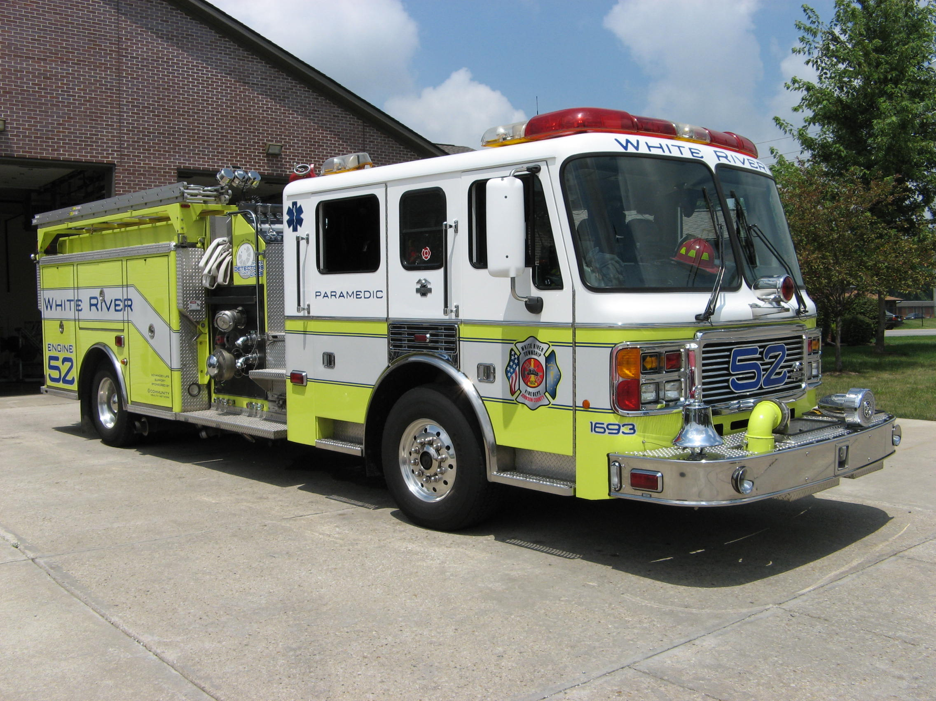 Did you know?

Did you know that there are over 25,000 identified species of fish on the earth? There are more species of fish than all the species of amphibians, reptiles, birds and mammals combined.



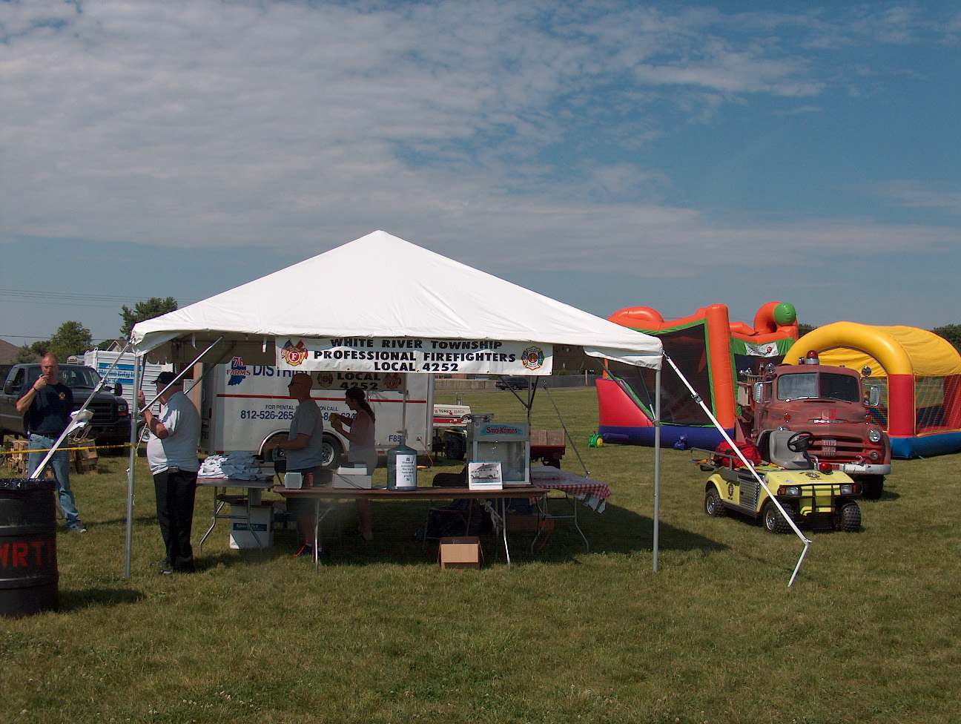 Birthdays (September 7 – September 20)

Derek Norcross September 7
Dennis Speer September 12
Anthony Mangus September 12
Joseph Marsh September 13
Dustin Harris September 13
Christopher Phillips September 14
Jason Bailey September 19

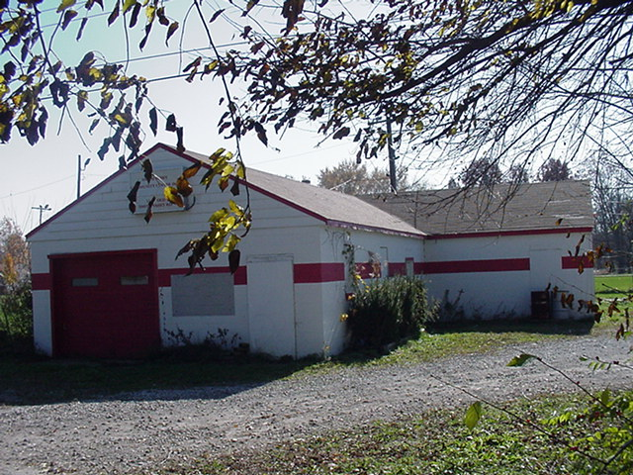 Looking back…..

50 Years ago September 14, 1957 New fire truck details Members of the newly formed White River Township Volunteer Fire Department designed the body and had it mounted on a 1954 Dodge chassis. The truck has a 710 gallon water tank, spacious equipment storage compartments on either side and at the rear, and is equipped with 500 feet of 1 ½ inch hose, two 100 feet reels of 1 inch high pressure hose, one 350 g.p.m. portable pump, one 250 g.p.m. power take-off pump and one portable lighting generator, plus standard equipment. The truck is centrally housed in White River Township at Smith Valley. Total cost of the truck and equipment, $3,850.00, was donated by residents and firemen of White River Township.

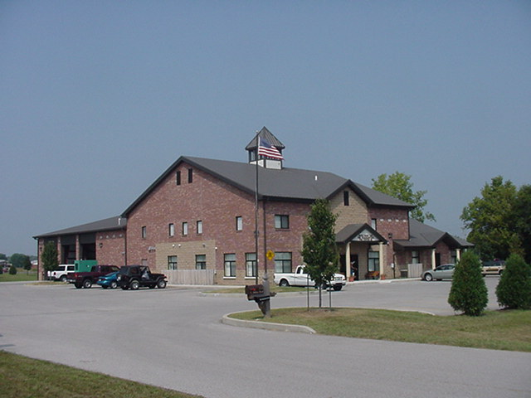 Upcoming events (September 2007)

Volunteer Firefighter Reunion – September 16, 2007 - 2 p.m. Station 53
All former volunteers are invited to attend a get-together to visit with old friends and acquaintances.
Light snacks and drinks will be provided by the fire department, so all you need to bring is you! Families are welcome as well.
Come out to see how the fire department has changed over its 55 year history! Current employees are invited as well so they can meet some of the people who helped shape the department into what it is today.
September 2007
S | M | T | W | T | F | S
 |  |  |  |  |  | 1
2 | 3 | 4 | 5 | 6 | 7 | 8
9 | 10 | 11 | 12 | 13 | 14 | 15
16 | 17 | 18 | 19 | 20 | 21 | 22
23 | 24 | 25 | 26 | 27 | 28 | 29
30

