

August 24, 2007

Inside this Issue
1 Administration
2 Training
3 Did You Know?
3 Birthdays
4 Looking Back
4 Upcoming Events

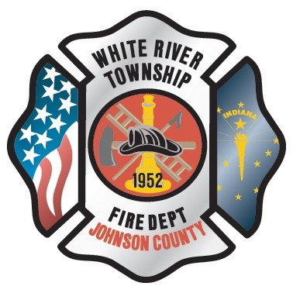 Administration News

The senior staff met last week for its semi-annual management retreat which was held off-site at the Center Grove Presbyterian Church. The focus of the meeting primarily settled on long-term goals for the department and further defining its vision. Senator Waltz, Representative Frizzell, and Tom Hanify were all also in attendance as the department begins to strategize future funding options. The retreat was very informative and productive and we look forward to setting into motion some of the plans that were developed. There will be much more on the particulars as they come to fruition and are rolled out.

The Station 51 project is in the ‘twilight’ stages of completion. That said, we’re still looking at several more weeks to tie up loose ends and do the punch (some of which may require some significant time). Therefore, we’re pushing the tentative move date back to mid-October. I’m hoping this is a worst-case scenario, but historically speaking, it’s probably realistic. It seems like it’s taking longer than it should, but this is a very complex building and our mantra all along is that we’d rather have it done right with the highest quality of craftsmanship than have it thrown together just to get moved in. We will accept the building only after it is 100% complete and finished to our satisfaction.

Chief Pell has completed all stages of the PERF review and physical and we are now simply waiting on the PERF board to meet and sign off on the application. We’re anticipating this to be done today or Monday. This would put a tentative start date around September 10th (or September 17th if the PERF board takes an extra week).

“To effectively and efficiently provide professional services to our community”

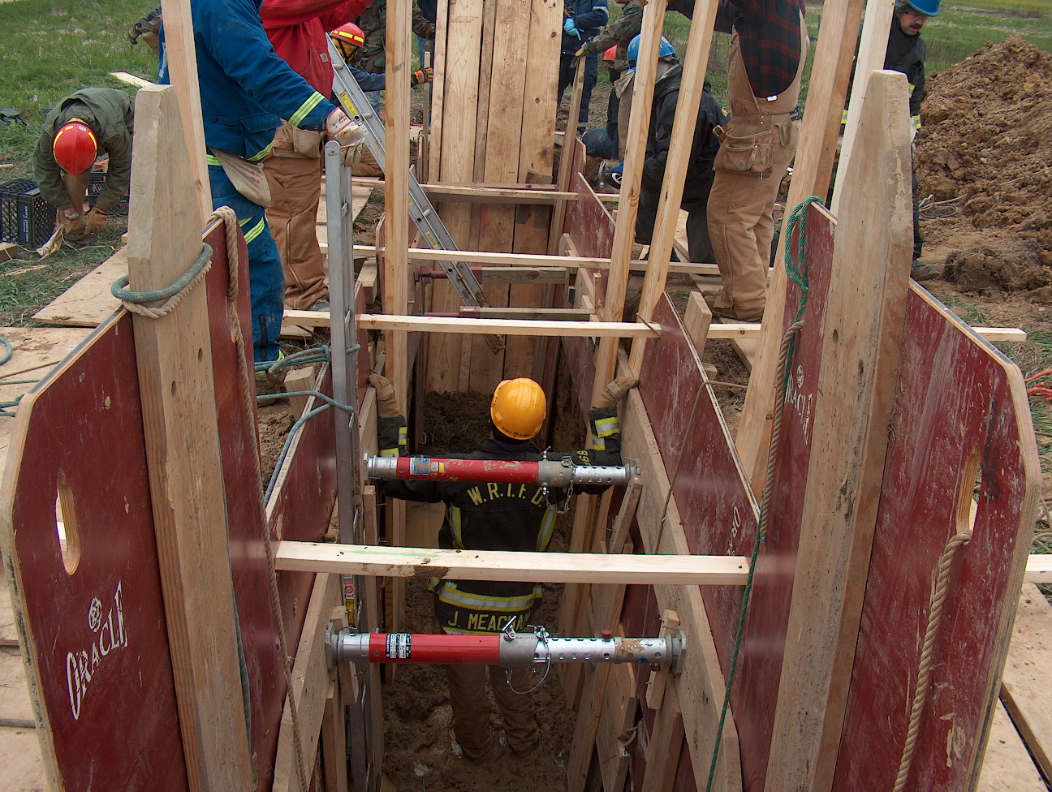 Training News

Hiring process update

Career process is between the written and the interview phase. Letters were mailed out today to candidates with information about the written exam. Interviews will be conducted on September 13 and 14 at Fire HQ.

Reserve process is in the interview stage. Chief’s interviews will be scheduled within the next two weeks and orientation is scheduled for September 19

Upcoming Training

EVOC for all current engineers - the week of September 10
SCBA Air Management training - the week of September 17
Indianapolis Fire School is September 22, 23, 29, 30
NIMS 300 (required for all company officers and above) September 26, 27,28

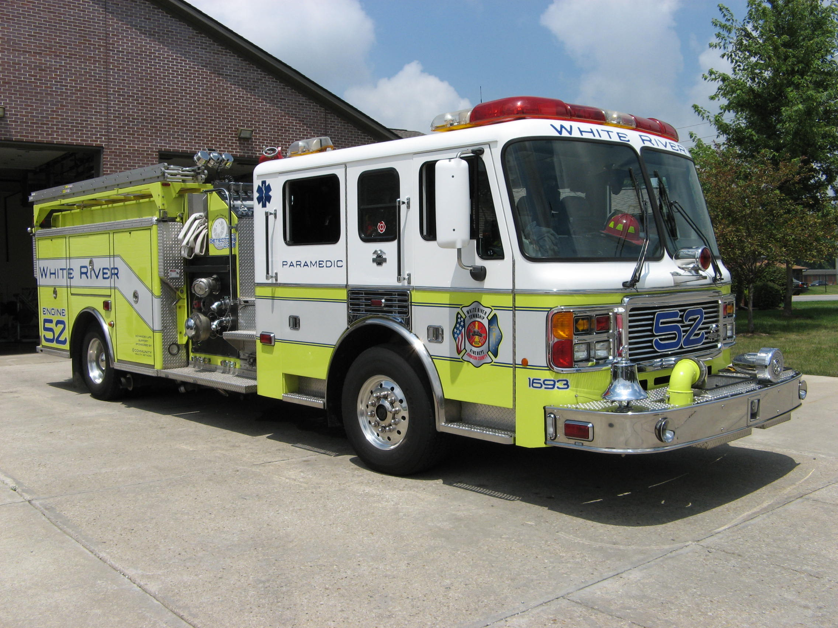 Did you know?

Did you know that a walking catfish can live out of water for days at time? They have a special chamber in their lungs to help them breathe.

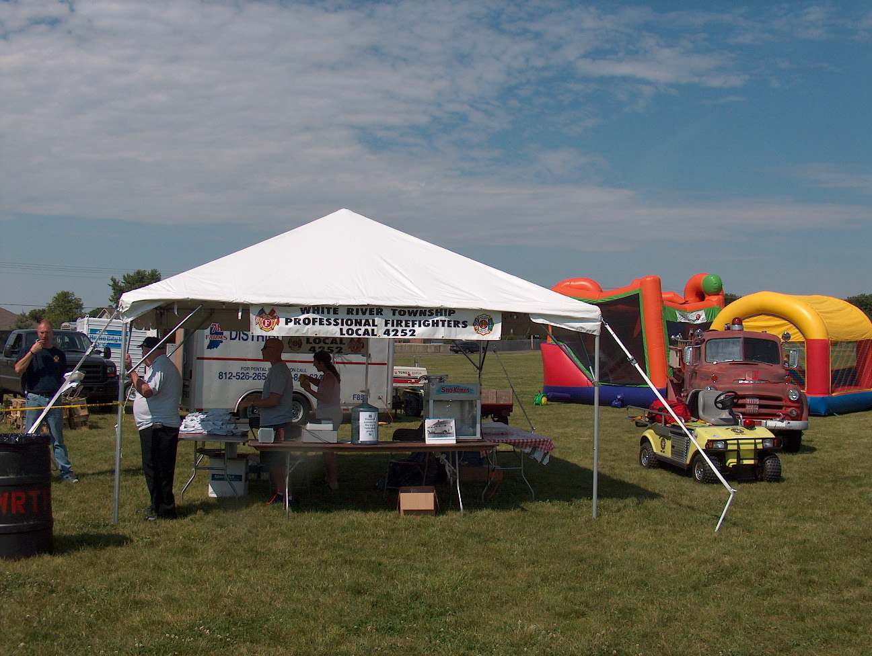 Birthdays (August 24 – September 6)

William Roudebush August 24

Joel Thacker August 24

Nicholas Smith August 25

Scott Cassin August 28

Scott Daugherty August 30

Matt Dwyer September 04



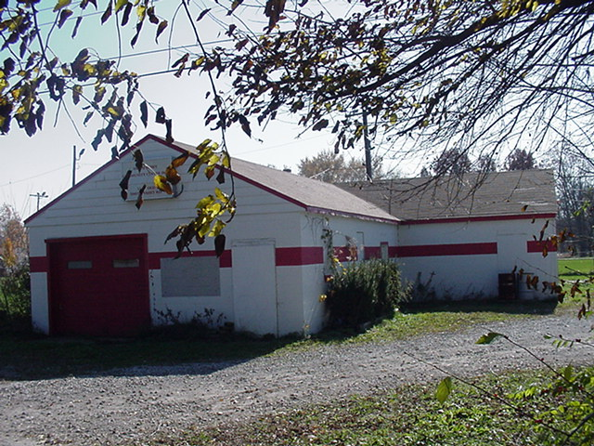 Looking back…..

35 years ago August 24, 1972 First aid run in White River
White River township firemen made a first aid run on State Road 135 near the Meridian Drive-In at 2:10 p.m. Thursday. Voca Branon, 13, Indianapolis, was injured in a fall from a tree swing. She was taken to St. Francis Hospital for treatment.

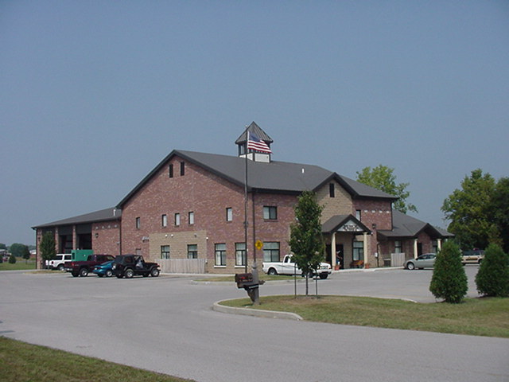 Upcoming events (August - September)

Fire Protection District Board Meeting – September 4, 2007 – 7pm. Station 53

Volunteer Firefighter Reunion – September 16, 2007 - 2 p.m. Station 53
August 2007
S | M | T | W | T | F | S
 |  |  | 1 | 2 | 3 | 4
5 | 6 | 7 | 8 | 9 | 10 | 11
12 | 13 | 14 | 15 | 16 | 17 | 18
19 | 20 | 21 | 22 | 23 | 24 | 25
26 | 27 | 28 | 29 | 30 | 31
September 2007
S | M | T | W | T | F | S
 |  |  |  |  |  | 1
2 | 3 | 4 | 5 | 6 | 7 | 8
9 | 10 | 11 | 12 | 13 | 14 | 15
16 | 17 | 18 | 19 | 20 | 21 | 22
23 | 24 | 25 | 26 | 27 | 28 | 29
30

