

August 10, 2007

Inside this Issue
Change Page #’s
1 Administration
2 Operations
2 Training
3 Training
3 Did You Know?
3 Birthdays
4 Looking Back
4 Upcoming Events

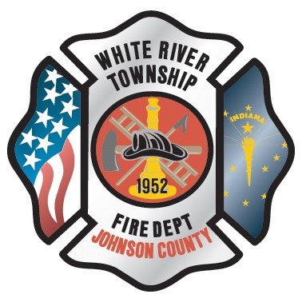 Administration News

Chief Pell has completed all of his PERF-required items and is now waiting on the results of the PERF board hearing. It is anticipated at this time for him to start working somewhere in the vicinity of September 1st. He will however be in and out of each of the stations next week for visitations and meetings.

As of today, the Station 51 project has a substantial completion date set of August 20th. I personally believe that this might be a bit optimistic. I would give it an additional two weeks after that. Then we begin the punch list period which will probably take two to four weeks. This puts us at the middle to end of September for a move. This is VERY tentative and could swing either way depending on many factors out of our control.

“To effectively and efficiently provide professional services to our community”

The district board gave final approval at Tuesday’s meeting to move ahead with the purchase of 1.5 acres of land at Fairview and Bluff Roads for the future Station 54.

The department also received approval from the County on Monday to move forward with the sewer line for Station 53. The line will run down Smith Valley to the Wakefield lift station. Engineering drawings are currently being drafted.

Station 51 (on Runyon Road) will go up for sale sometime next month once we know for sure when the final move date is. It will be sold by a sealed bid process.

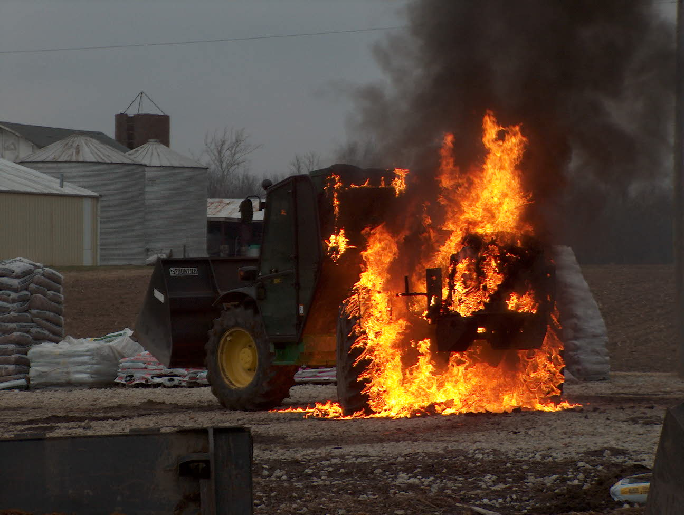 Operations News

We have started the GIS mapping project for Johnson County. The company officers have been informed of project details. Station 53 has already been working in their response area. As soon as it cools down a little, I will get maps to the other stations. Our goal is to have this project completed by October 1. See Battalion Chief Slauter with any questions.

Slowly but surely, the new engine is moving along. It is scheduled for striping at Square One next Monday. Captain Arkins is almost done with tool mounting. The computer tray has been ordered and is due on Friday. We are still waiting on the fire hose to be delivered. Engineer Combs is working on radio installation. See Captains Arkins with any questions.

The battalions have all consolidated into one vehicle. We are trading in one battalion explorer and the two expeditions with the purchase of the new battalion vehicle. Currently, one of the battalion explorers is now a pool car. When all is done, we will have an explorer for a back up battalion and an explorer for fire prevention. The new battalion expedition is due in this week. Also, with the consolidation of battalion vehicles, a laptop is now available and it has been put on Ladder 53. That is all for now, stay smart and be safe.

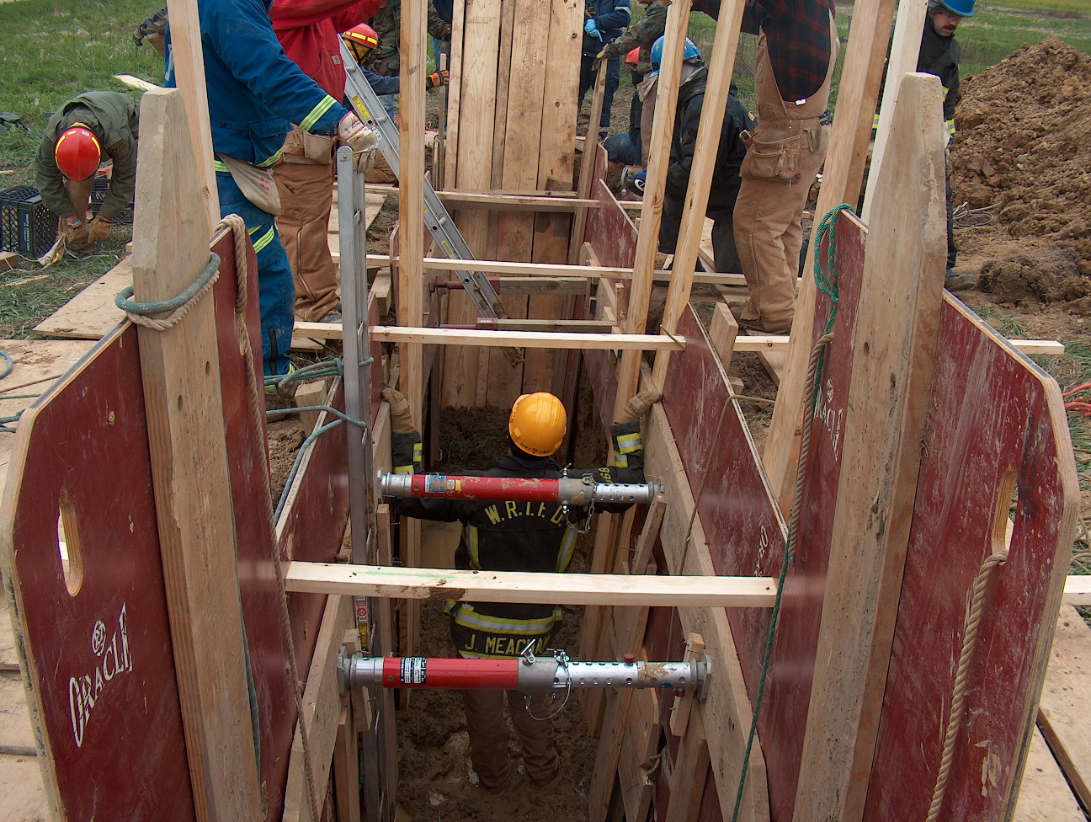 Training News

Due to the hot weather, some of the outdoor training activities have been postponed. Please plan ahead for flashover training on October 25, 26, and 27 and air management training during the week of September 17

The department is currently in the middle of two hiring processes. Career process written exam is this Saturday at Center Grove Middle School Central with interviews to follow in about 30 days. The Reserve process written and agility will be conducted on the 17 and 18 of this month. If you are interested in assisting with either of these processes, contact me at your convenience.

If you had bloodwork drawn for the annual physicals and have yet to sign up for a physical, you can contact Public Safety Medical Services at 317-972-1180 to schedule your time. Please contact PSM if you cannot make your scheduled appointment so they may make other arrangements. See me with any questions.

Mark you calendars for upcoming training dates

August 22 Lt. Bob Pressler, FDNY Rescue 3 (ret) will be here at WRTFD. If you are not on shift and plan on attending, submit an RSVP if you have not already in order for me to arrange the appropriate venue to seat all attendees.

August 27 -30 Indianapolis Hazmat Conference. See the information sheet on the bulletin board outside my office for more details

September 22, 23, 29, 30 Indianapolis Fire School at Hamilton Southeastern H.S. in Fishers. Visit the IFIA website for more information and a list of courses.

September 27, 28, 29 NIMS 300 at WRTFD HQ (required for all officers)

October 18, 19 NIMS 400 at WRTFD HQ (required for captains and all chief officers)

TRAIN AS IF YOU LIFE DEPENDS ON IT…BECAUSE IT DOES!

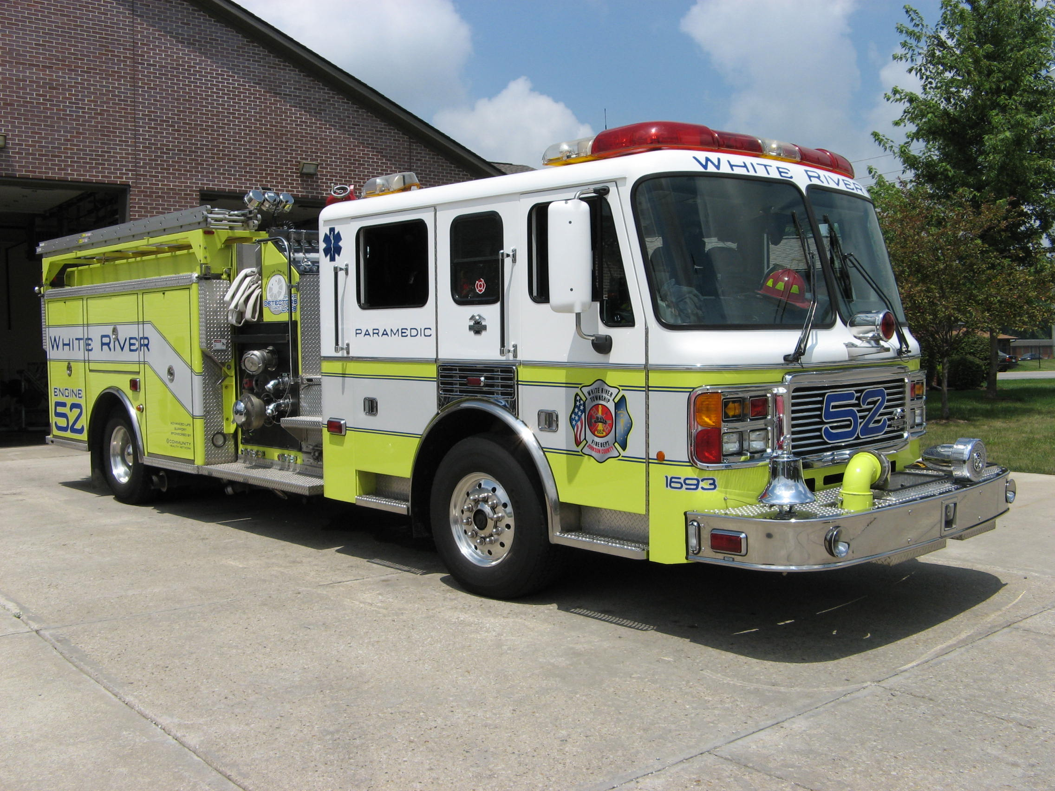 Did you know?

Did you know that the fastest fish is the sailfish? It can swim at more that 60 miles an hour.

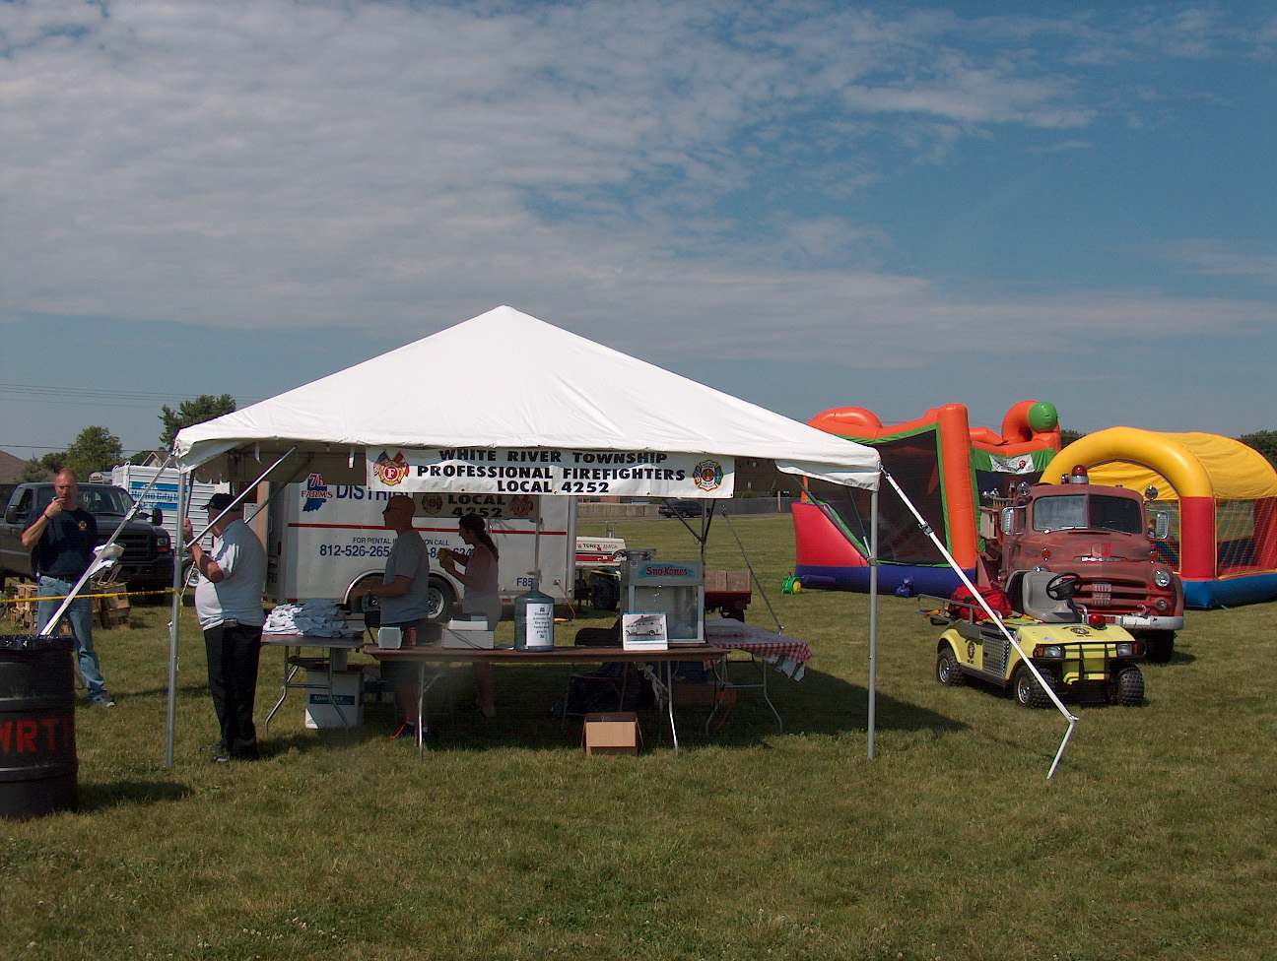 Birthdays (August 10 – August 23)

Brian Scott August 11
Gregory Hedge August 15
Daniel Strong August 19
Justin Walls August 22


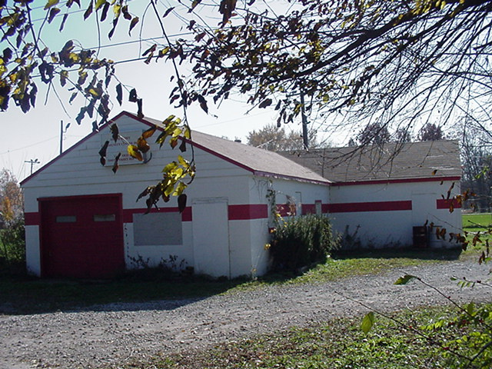 Looking back…..

29 years ago August 18, 1978 Flea Market a success The White River Township Volunteer Fire Department held its annual flea market over the weekend next to the Bargain Bobs Shoe Store on State Road 135. The annual event is largely sponsored by the department's Ladies Auxiliary and was a huge success this year.
28 years ago August 14, 1979 Rummaging through the rummage There were plenty of rummage and shoppers Saturday when the White River Township Fire Department held a sale to raise funds for the department. Piles of clothes, shoes, sporting goods, small appliances and the like were sold from an empty lot on State Road 135 just north of Greenwood Road.

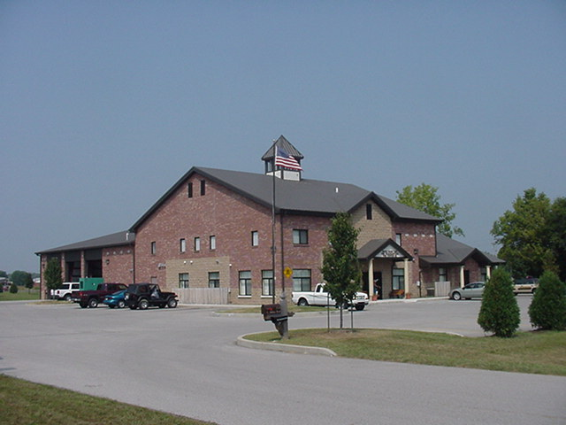 Upcoming events (August - September)

Fire Protection District Board Meeting – September 4, 2007 – 7pm. Station 53

Volunteer Firefighter Reunion – September 16, 2007 - 2 p.m. Station 53
August 2007
S | M | T | W | T | F | S
 |  |  | 1 | 2 | 3 | 4
5 | 6 | 7 | 8 | 9 | 10 | 11
12 | 13 | 14 | 15 | 16 | 17 | 18
19 | 20 | 21 | 22 | 23 | 24 | 25
26 | 27 | 28 | 29 | 30 | 31
September 2007
S | M | T | W | T | F | S
 |  |  |  |  |  | 1
2 | 3 | 4 | 5 | 6 | 7 | 8
9 | 10 | 11 | 12 | 13 | 14 | 15
16 | 17 | 18 | 19 | 20 | 21 | 22
23 | 24 | 25 | 26 | 27 | 28 | 29
30

