

July 27, 2007

Inside this Issue

1 Administration
2 Training
2 Did You Know?
3 Birthdays
3 Looking Back
4 Upcoming Events

 Administration News

Unfortunately, I have no new news on when Chief Pell will begin in the office. The one thing outside of our control is the PERF acceptance. Even though he already is a member, there are still some hoops we need to jump through to transfer his account to our department. I would suspect we are still several weeks out however.

Station 51 is finally beginning to take its final shape. The inside is quickly nearing completion and the outside landscape work is slated to begin on August 7^{th.} The phone line boring was started last evening so we should now be able to finish the paving next week. The next on-site meeting is scheduled for Wednesday (8th) and a FINAL completion date is expected to be set. My best guess at this point is a completion date of around August 22nd and then a few weeks after that to handle punch-list items. So, we’re probably looking at somewhere around the middle of September for a move-in date.

“To effectively and efficiently provide professional services to our community”

Because of the rainout on July 26th, the photo session for all of the department’s rolling stock has been postponed until Tuesday, August 7th beginning at 12:30pm. We have use of the high school’s northeast parking lot and scissor lift for a two-hour period. We will have all 27 pieces on site for a “group photo”. If you are available off-duty to come in and help drive equipment down there, we could sure use the help.

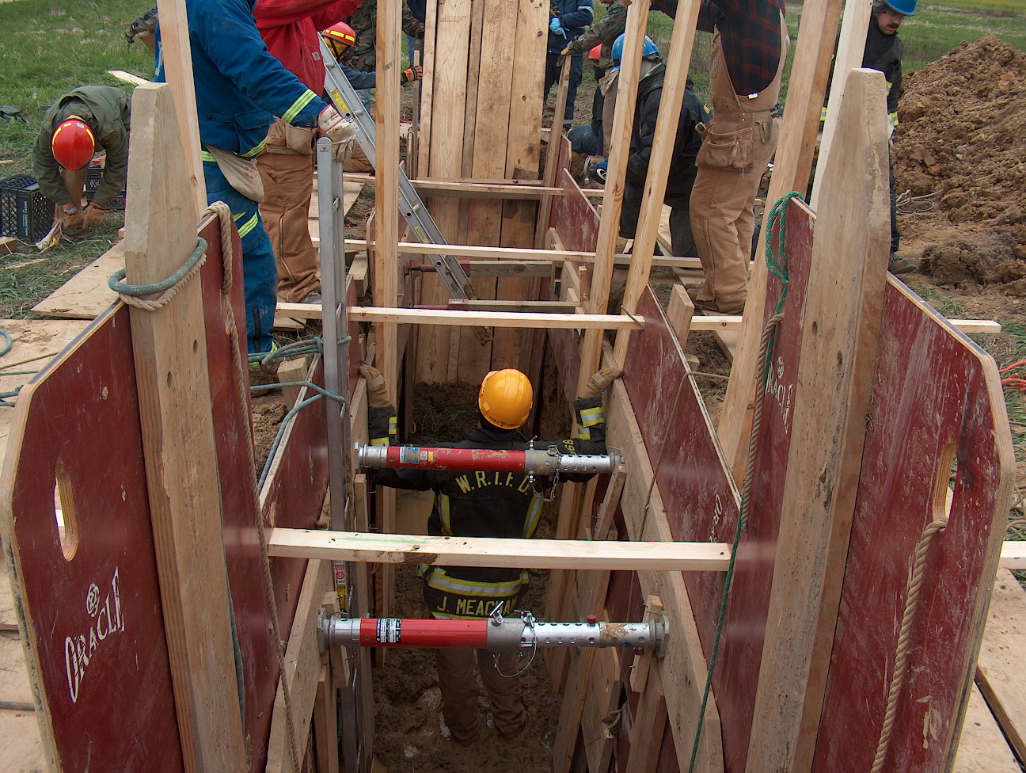 Training News

The Trench Collapse Operations Course was completed July 9-11. The course consisted of one day of lecture and tool lab and two days of hands on evolutions at the old McCarty Mulch site on Olive Branch road. Josh McCarty donated the land and Josh Abraham donated his excavation expertise in cutting the trenches. Special thanks to Lt. Tony Slusher and Firefighter/Engineer Jory Cox for putting this program together.

Reminder of Flashover training on August 2, 3, and 4. This is a Thursday, Friday, and Saturday. Personnel that have never been are encouraged to attend and will receive priority with burn time.

Lt. Bob Pressler, FDNY Rescue 3 (Ret.) will be presenting a lecture on engine and truck company operations at WRTFD on August 22 from 0830-1700. Please contact me via email if you plan on attending so an appropriate venue may be selected based on attendance. Don’t miss this incredible opportunity to hear one of the nations experts speak at our department.

The WRTFD is beginning another Reserve process starting on July 30. Watch for more details as they come available.

New Albany Fire School is scheduled for August 11, 12, 18, 19. Go to www.ifia.org to check out a list of classes. Contact ASAP if you would like to attend.

TRAIN AS IF YOUR LIFE DEPENDS ON IT…BECAUSE IT DOES

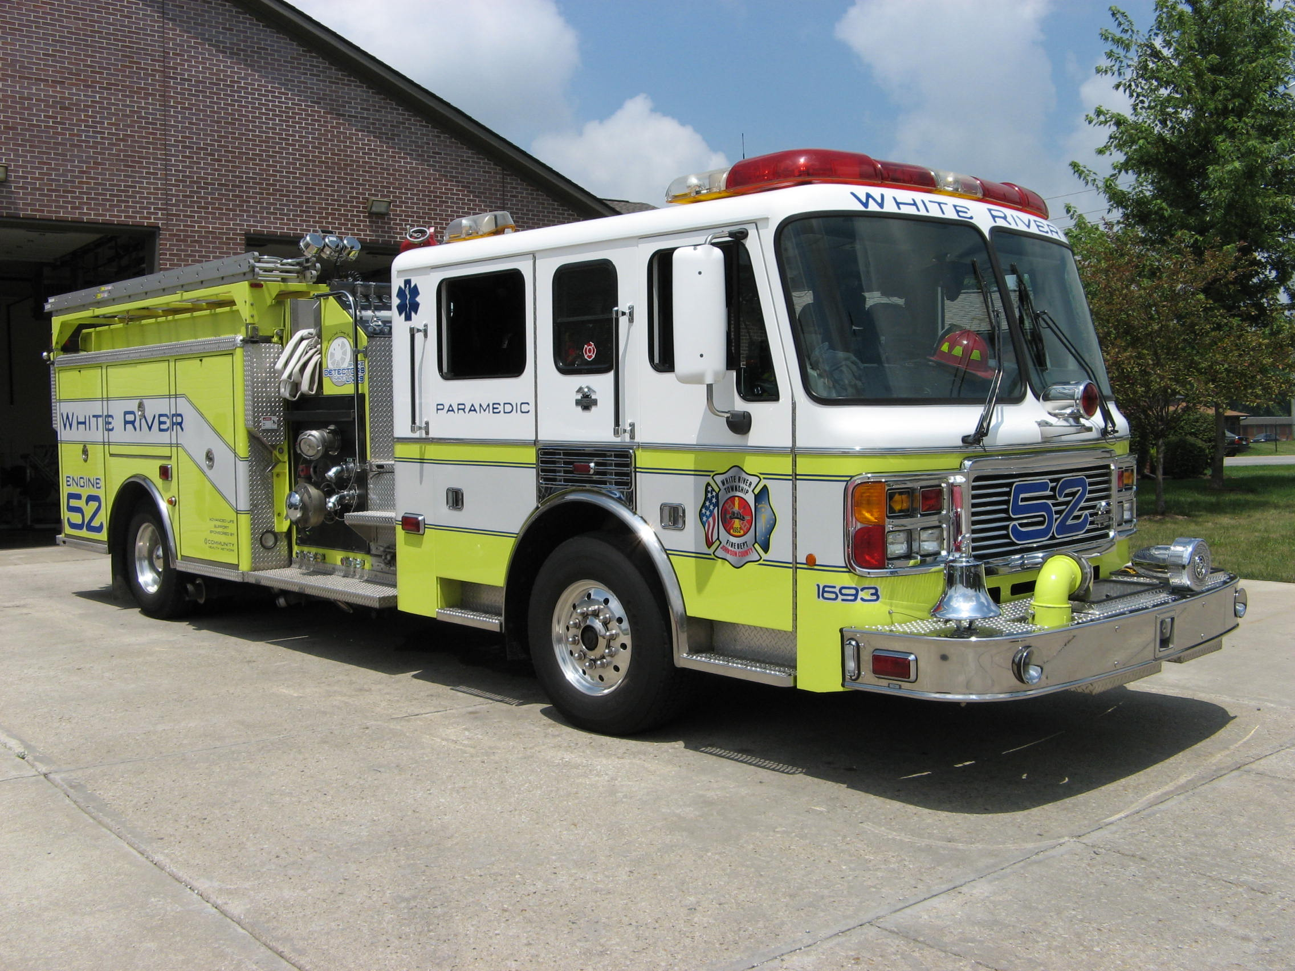 Did you know?

Did you know that 36 lives were lost in the Hindenburg disaster on May 6, 1937 at Lakehurst, NJ?

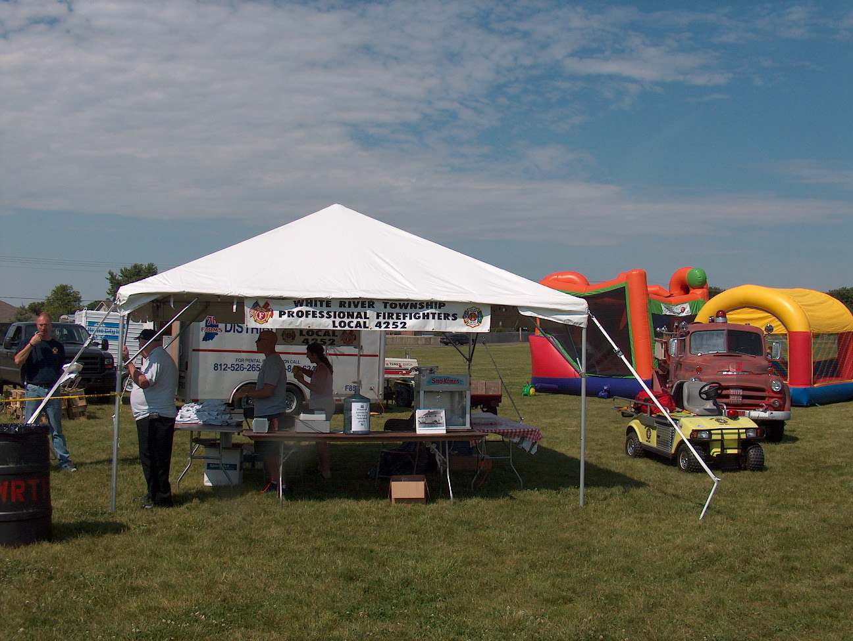 Birthdays (July 27 – August 9)

Michael Ridge July 31
Jonathan Whitham July 31
Mark Hart August 2
Matthew Myers August 9

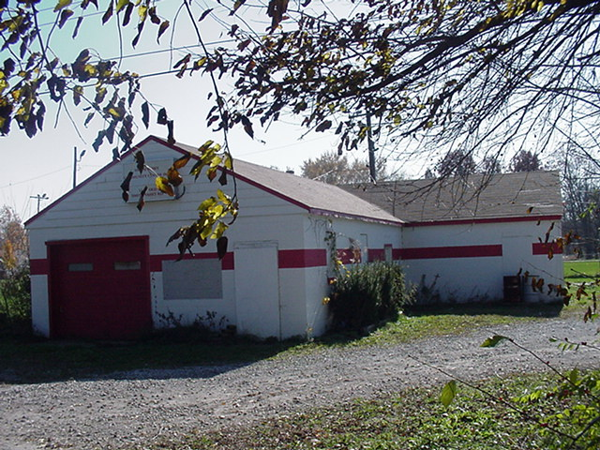 Looking back…..

30 years ago - August 4, 1977 - Firefighters complete training Firefighters from Franklin, New Whiteland and White River Township Fire Departments recently completed a state certified course of 60 hours in advanced firefighting. The course, which began in February, was instructed by Lt. Jack Matthews of the Franklin Department. Certificates were presented during a Thursday morning ceremony by Franklin Fire Chief Bill Cantwell and Franklin Mayor F. Edward Vandivier.
30 years ago - August 6, 1977 - Demolition Derby ends county fair The concluding event for the 1977 Johnson County 4-H and Agricultural Fair was the annual demolition derby sponsored by the White River Township Jaycees.

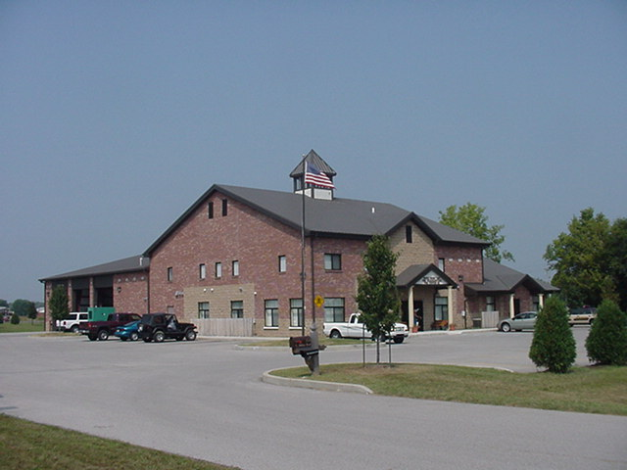 Upcoming events (August - September)

Fire Protection District Board Meeting – August 7 – 7pm. Station 53

Volunteer Firefighter Reunion – September 16, 2007 - 2 p.m. Station 53

August 2007
S | M | T | W | T | F | S
 |  |  | 1 | 2 | 3 | 4
5 | 6 | 7 | 8 | 9 | 10 | 11
12 | 13 | 14 | 15 | 16 | 17 | 18
19 | 20 | 21 | 22 | 23 | 24 | 25
26 | 27 | 28 | 29 | 30 | 31
September 2007
S | M | T | W | T | F | S
 |  |  |  |  |  | 1
2 | 3 | 4 | 5 | 6 | 7 | 8
9 | 10 | 11 | 12 | 13 | 14 | 15
16 | 17 | 18 | 19 | 20 | 21 | 22
23 | 24 | 25 | 26 | 27 | 28 | 29
30

