

July 13, 2007

Inside this Issue

1 Administration
2 Operations
2 Training
3 Training
3 Did You Know?
3 Birthdays
4 Looking Back
4 Upcoming Events

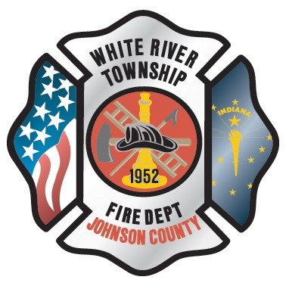 Administration News

I have been informed by the District Board that the final decision on the Fire Chief Position should be made at next Tuesday’s (17th) District Board meeting. The meeting is at headquarters and is scheduled for 7pm. This is the regularly scheduled meeting for July.

Next Friday (July 20th) is White River’s day at the fair to provide fire coverage. If you are interested in volunteering your time, especially in the evening, please sign up with Captain Skipper.

Officers, don’t forget about the mandatory Officer Development Course scheduled for next Thursday, July 19th at 08:30 at Headquarters. We are planning on being finished by noon.

“To effectively and efficiently provide professional services to our community”

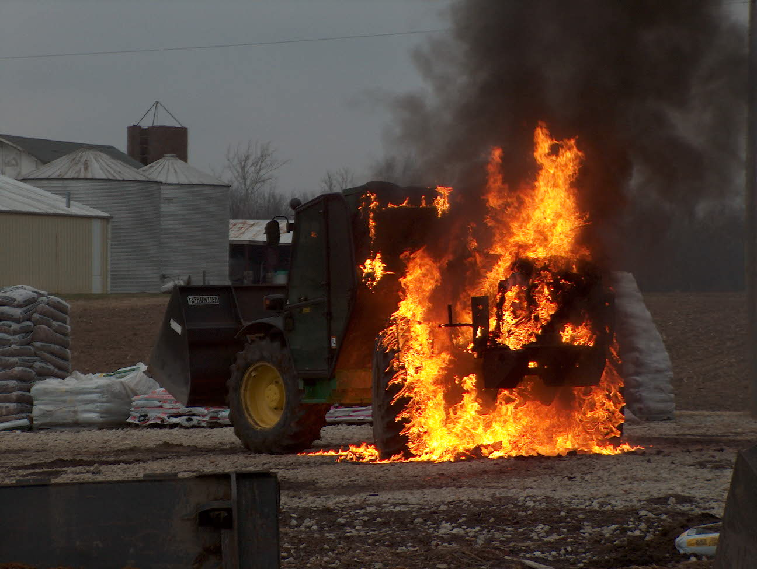 Operations News

The new Engine 53 was delivered on July 6th. There are a couple of items that still need to be corrected by Towers Fire Equipment and that is currently being coordinated. Captain Arkins and the maintenance staff are working on equipment mounting and organization. The engine is also being scheduled for computer installation and graphics. It appears now it will be about a month to complete all these items. For now, crews should familiarize themselves with the engine. We will start drivers training after Towers completes the operator’s training. The engine is fully insured, so it is OK to pull it outside of the bays. Please see Battalion Chief Slauter or Captain Arkins with any questions.

The following lateral moves have taken place:
Lieutenant Scholl to Engine 53 B shift
Lieutenant Tichenor to Engine 53 C shift (Effective August 7th)
Engineer Woehlecke to Station 51 A shift

No personnel bid on the C shift float position, so it will remain open until the current hiring process is completed. Stay smart and be safe.

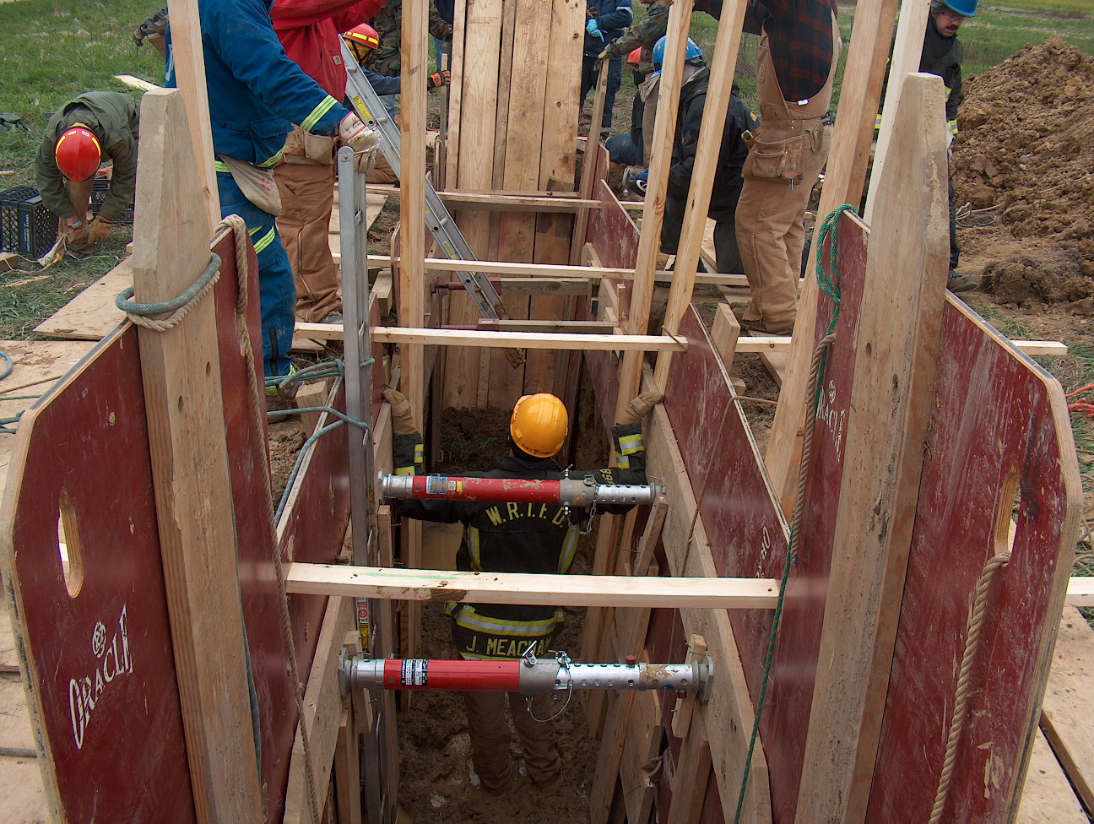 Training News

The Machinery Vehicle Extrication Course was completed with two days of practical skills evaluation on June 19 and 20 at Hix Salvage yard in Indianapolis. Hix donated twenty cars over the two day period and seventeen department personnel completed the course. Special thanks to Lieutenant Alford and Firefighter/Engineer Brooks for putting this program together.

The Stand Down for Firefighter Safety was a success as company officers and their personnel presented very informative material on Line of Duty Deaths (LODD’s) from across the county. Discussion was directed toward identifying policy and procedure that can help WRTFD prevent these LODD’s from occurring in the future.

Building on the discussion of the Stand Down, Flashover Training will be conducted on August 2, 3, and 4. This is a Thursday, Friday, and Saturday. I encourage night time personnel to attend one of the dates.

EVOC refresher for all engineers and driver operators will be held in September. We will complete a short classroom session and then setup the driving course for all to complete.

The training division has been given a key card for the old Maple Grove Elementary on Morgantown Road. The entire north corridor has been set aside for local public safety agency training. There will be structured department training in the building over the next several months. If any company officer would like to use the building for non-destructive training, let me know and I will provide the key card. We just need to notify the school at least 24 hours in advance if training is to occur. Feel free to contact me at your convenience if you wish to use the building.

TRAIN AS IF YOUR LIFE DEPENDS ON IT…BECAUSE IT DOES

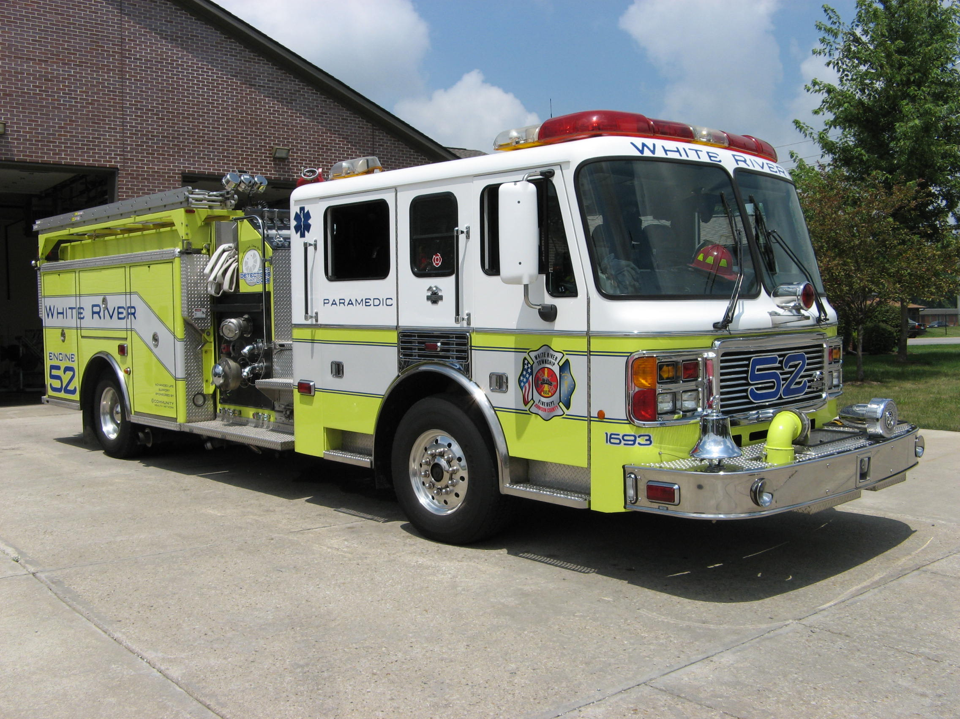 Did you know?

Did you know that the smallest fish is the Philippine goby that is less that 1/3 of an inch when fully grown?

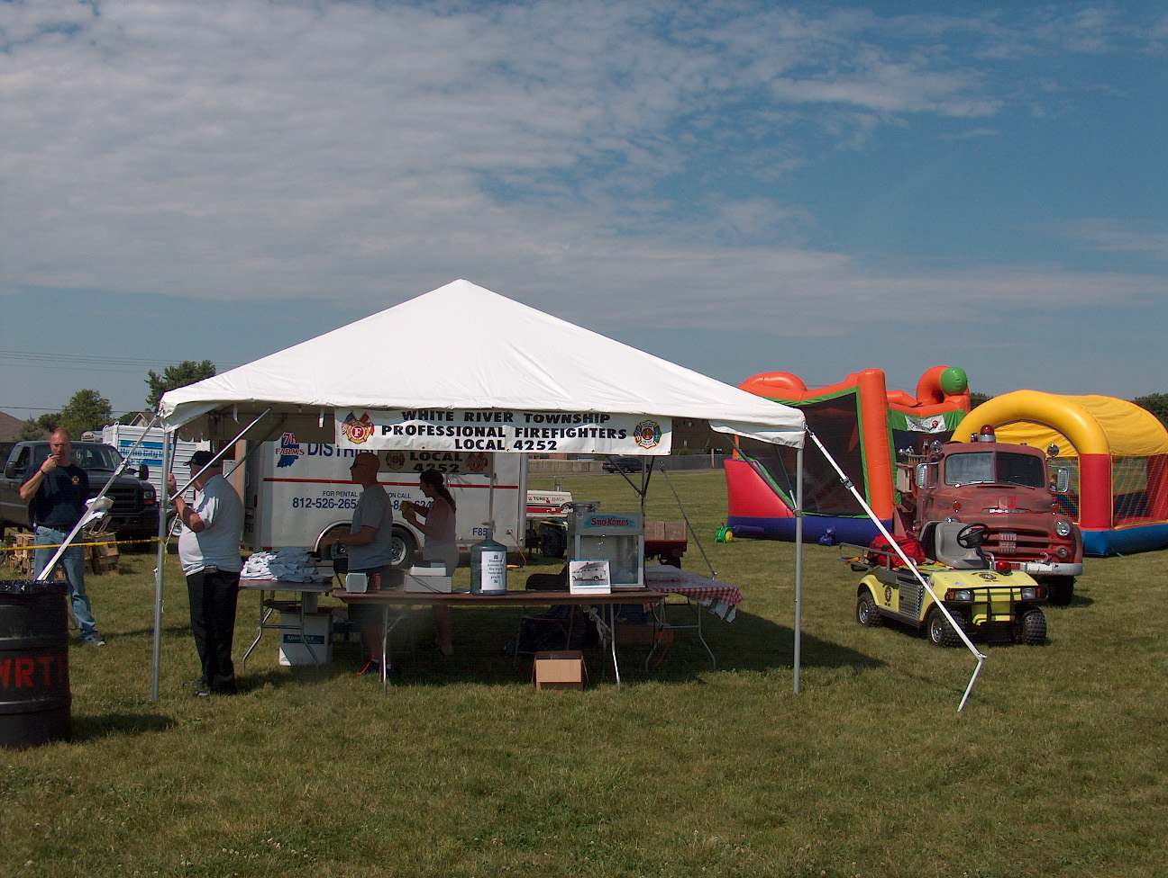 Birthdays (July 13 – July 26)

Jory Cox July 13 Joe Settles July 18
Mike Winterhalter July 13 Jason Ramey July 19



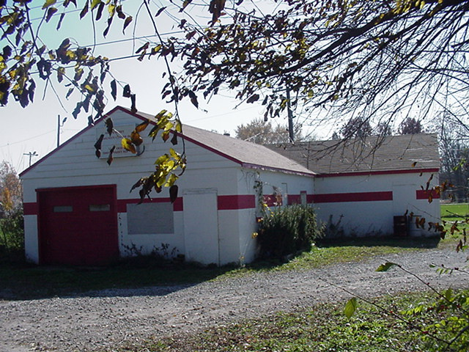 Looking back…..

49 years ago – July 20, 1958
Auxiliary donates tables & chairs The Ladies Auxiliary of the White River Township Fire Department in Smith Valley donated several tables and chairs to the department recently. The tables and chairs will be used for meetings and other gatherings at the station.

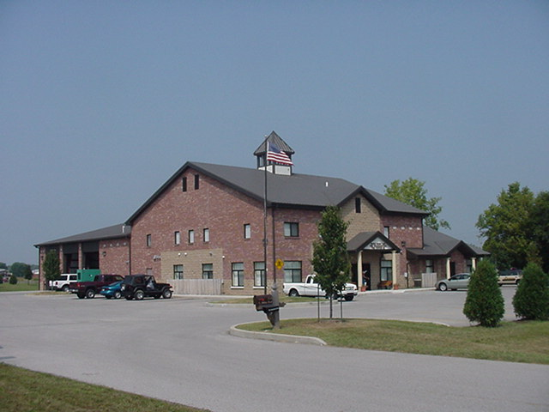 Upcoming events

Fire Protection District Board Meeting – July 17 – 7pm. Station 53

JULY 2007
S | M | T | W | T | F | S
1 | 2 | 3 | 4 | 5 | 6 | 7
8 | 9 | 10 | 11 | 12 | 13 | 14
15 | 16 | 17 | 18 | 19 | 20 | 21
22 | 23 | 24 | 25 | 26 | 27 | 28
29 | 30 | 31

