

June 29, 2007

Inside this Issue
1 Administration
1 Operations
2 Operations
3 Operations
3 Did You Know?
3 Birthday
4 Looking Back
4 Upcoming Events

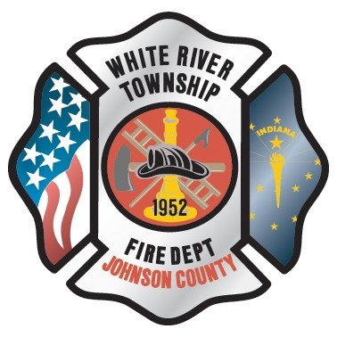 Administration News

Due to the departure of Lt. Williams, his former position (E52A) was awarded via a lateral transfer to Lt. Cox. Lt. Green then was awarded the R51A position. Additionally, Engineer Bailey transferred to E53A to fill the position created by the promotion of Engineer Tichenor to Lieutenant. Currently, E53B (Lt) and R51A (Eng) positions are open for lateral transfers. Those interested should submit their requests to me by Tuesday, July 3rd at Noon.

We are working on an updated shorts policy and possibly considering uniform shorts for use on duty. More to follow as we complete discussions.

“To effectively and efficiently provide professional services to our community”

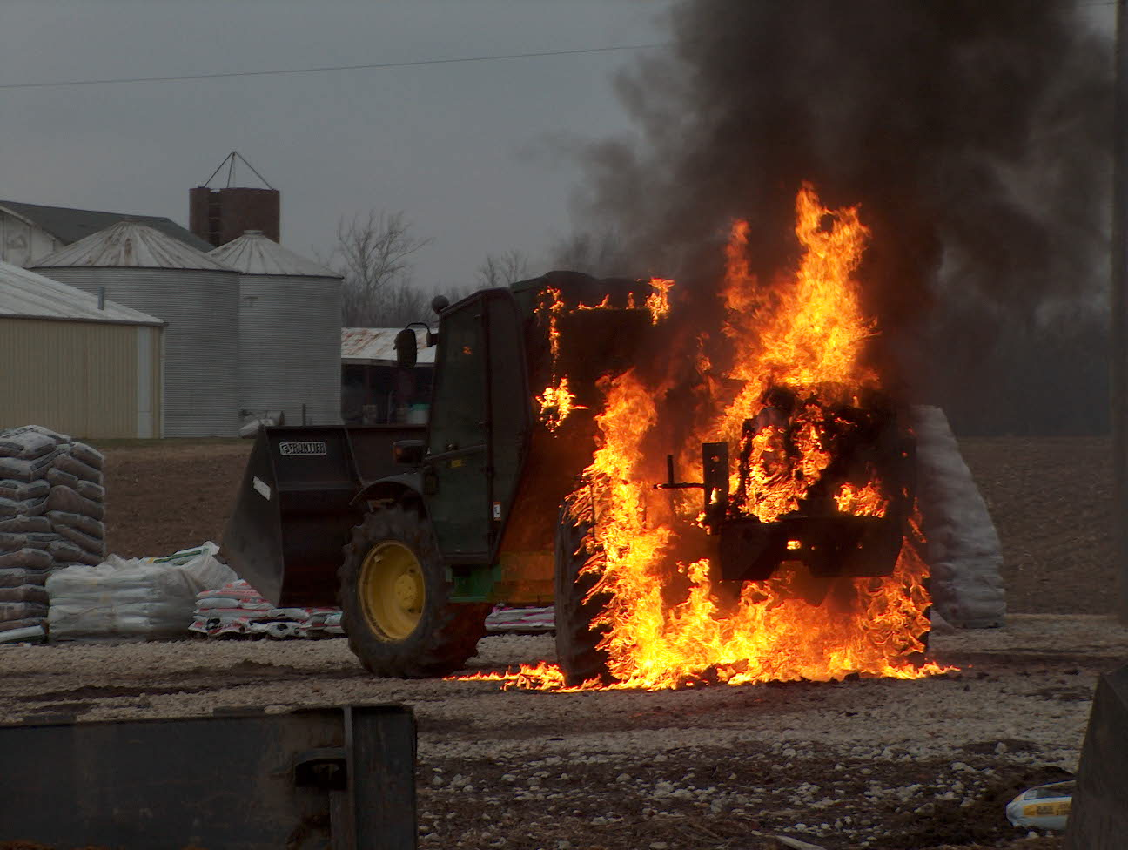 Operations News

The GIS coordinator for Johnson County has been working hard to get information ready to be placed into a GIS information system and mapping program. In order to make this happen, the fire departments in the county are going to be needed to assist with addressing. We have been given maps that address the need to be verified and added if currently missing. This project will involve all stations and shifts by driving the fire district to confirm these addresses.
This project will begin sometime in July and must be completed by October. This information will be put into the county GIS system and will be used by our department in the future and enhance our apparatus computer system functions. These functions will include mapping, utility and fire hydrant locations, overhead views, and eventually a CAD system for dispatch. Obviously, this project will not happen overnight, but it is a positive start. See Battalion Chief Slauter with any questions.

I have heard some rumors about staffing levels at each station when the new Station 51 opens. As of right now, the division heads and battalion chiefs have made no formal policies or SOGs concerning minimum staffing levels at each station. When we do, we will let you know.

The new Engine 53 should be delivered the first week of July.

The maintenance division is still having trouble getting reports of maintenance requests for apparatus and equipment placed into Firehouse. Jeff Bowden has been working hard to make repairs to apparatus to resolve lingering issues. Please place requests in Firehouse when issues are found.

Pending budget approval by the Fire Protection District Board, we will be purchasing new SCBAs in 2008. We have talked with Scott and MSA and are looking at both companies to determine the best fit for our department. One issue brought up has been changing to 30 minute bottles. It appears that we will stay with the 45 minute bottles for the following reasons:

- The cost of purchasing all new 30 minute bottles and changing the brackets in all apparatus would put us way over the budget. The cost of one 30 minute bottle list price is about $1125, and we would need to purchase about 70 spares. This doesn’t include the cost of changing all the SCBA seat brackets to fit 30 minute bottles.

- After talking to both Scott and MSA, they use the same bottle manufacturer; the weight difference is about 4 pounds between 30 and 45 minute bottles. The air consumption rates for 30 minute bottles during their testing ranges between 15-25 minutes for a 30 minute bottle and 25-35 minutes for a 45 minute bottle. This doesn’t include the low air alarm sounding at 25% capacity. Both manufacturers said that to account for 25% air left for evacuation, subtract another 7 minutes from working time. This potentially would allow only 8 minutes of working time on air. I realize the concerns about less weight, greater maneuverability, and decreased stress on the body with smaller bottles, but Chief Thacker, Battalion Chief Wilson, Battalion Chief Engmark and I all agree that it is in our best interest to keep the 45 minute bottles.

We should be getting some demo SCBAs that meet the new 2007 standards to use in the future for evaluation. Our intention is to let as many people as possible test these units. Please see Battalion Chief Slauter with any questions or comments.

Remember to keep the 9 brothers from South Carolina and one brother from FDNY and their families in your prayers. Stay smart and be safe.

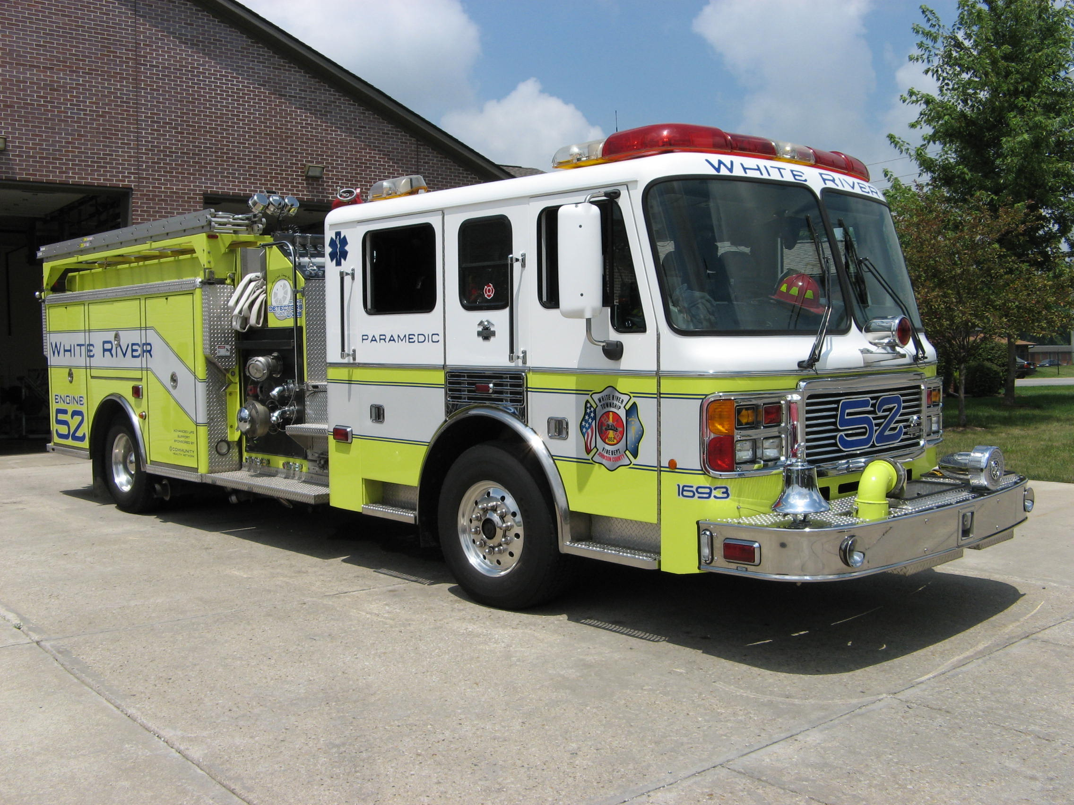 Did you know?

Did you know that the largest fish is the great whale shark which can reach fifty feet in length and weigh up to 15 tons?

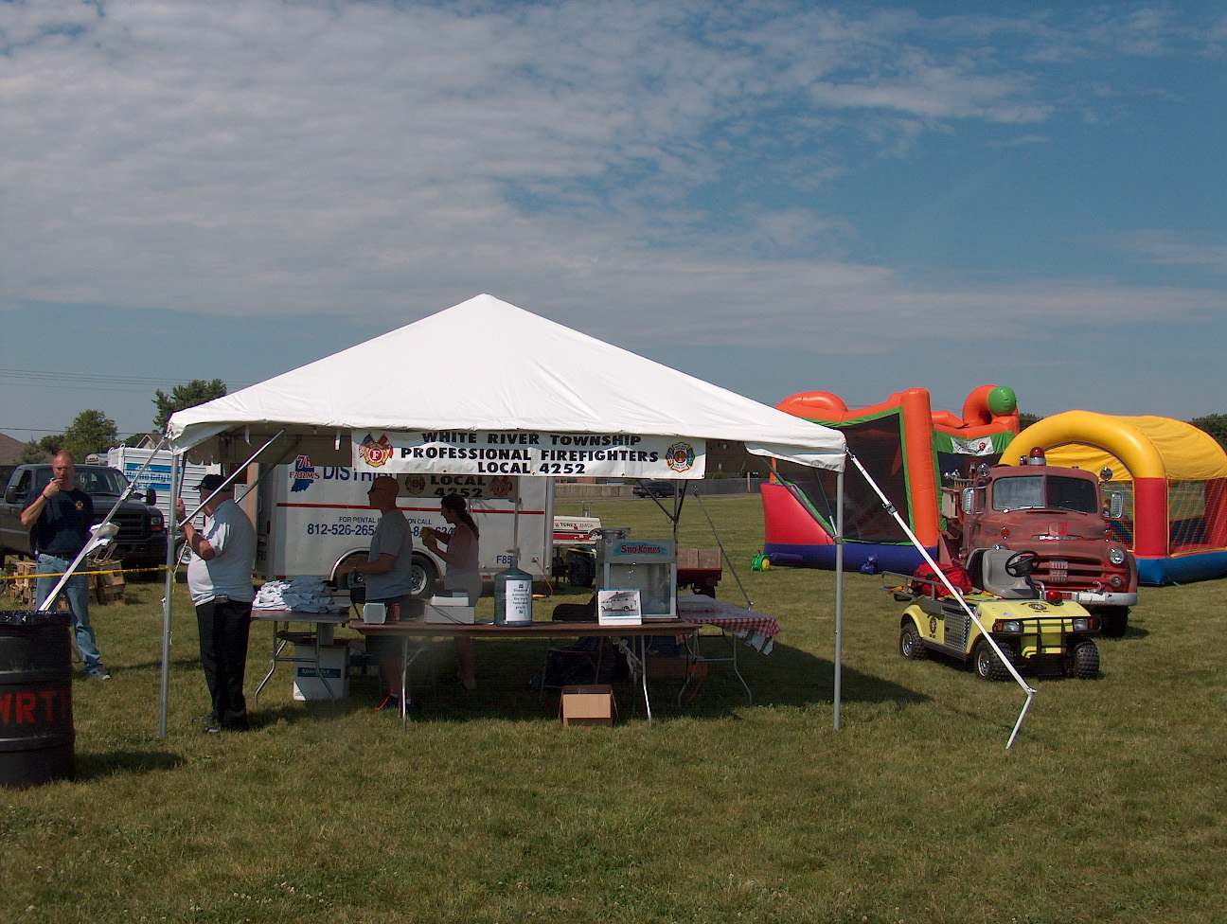 Birthdays (June 29 – July 12)

Troy Franks July 2



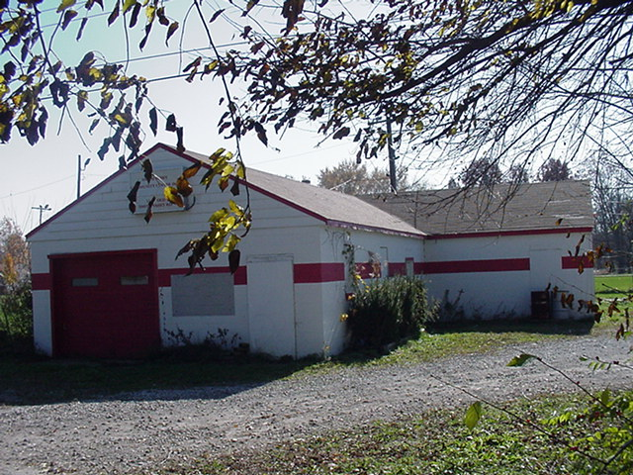 Looking back…..

July 6, 1960 – 47 years ago - Fire department gets new flag


Members of the White River township volunteer fire department received a new 50-star American flag recently from the Ernie Pyle Post No. 1120, Veterans of Foreign Wars on the south side of Indianapolis. Three of the White River firemen recently attended a meeting of the Veteran’s organization to receive the new flag.

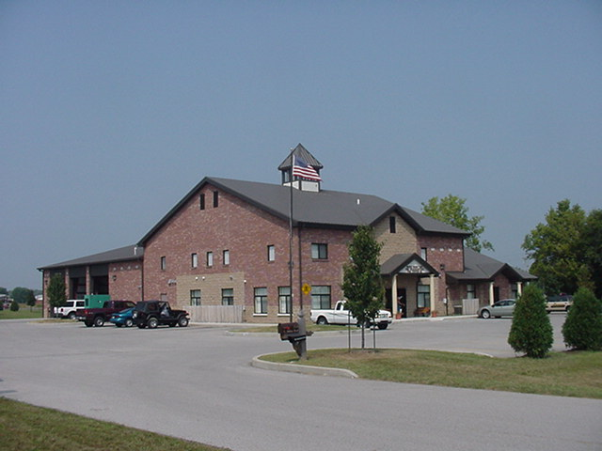 Upcoming events (June - July)

Fire Protection District Board Meeting – July 3 – 7pm. Station 53

Fire Protection District Board Meeting – July 17 – 7pm. Station 53
JUNE 2007
S | M | T | W | T | F | S
 |  |  |  |  | 1 | 2
3 | 4 | 5 | 6 | 7 | 8 | 9
10 | 11 | 12 | 13 | 14 | 15 | 16
17 | 18 | 19 | 20 | 21 | 22 | 23
24 | 25 | 26 | 27 | 28 | 29 | 30
JULY 2007
S | M | T | W | T | F | S
1 | 2 | 3 | 4 | 5 | 6 | 7
8 | 9 | 10 | 11 | 12 | 13 | 14
15 | 16 | 17 | 18 | 19 | 20 | 21
22 | 23 | 24 | 25 | 26 | 27 | 28
29 | 30 | 31

