

June 15, 2007

Inside this Issue
1 Administration
2 Operations
2 Training
3 EMS
4 Did You Know?
4 Birthdays
4 Looking Back
4 Upcoming Events

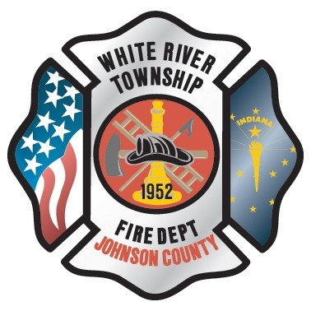 Administration News

The department has added three new policies to the Employee Manual: Posting of an Open Shift, Permanent Trades between Operations Personnel, and Shift Trades between Operations Personnel. (All under the Scheduling policy) Please review these additions via the electronic copy on the department’s website. See Battalion Chief Slauter with any questions.

As many of you have now already heard, Lieutenant Mark Williams will be leaving our agency to return to Fishers Fire Department. His last shift will be today. On behalf of the entire administration, I would like to sincerely thank Mark for his dedication and professionalism throughout his career here at White River. Mark is a great asset to have on your team and will be truly missed. We wish him the best of luck in his new endeavor.

Because of the vacancy created by Lieutenant Williams, we will need to promote an Engineer off of the current Lieutenants list. The next person on the list is Scott Tichenor, who has since accepted the position. Please help us in congratulating Scott on his promotion to Lieutenant! Scott will assume this role (although he has been doing so in a ride-out capacity for some time now) on an official basis starting on June 27th. All open positions created by the departure of Lieutenant Williams will follow the Open Shift policy as stated in the policy manual. Chief Slauter will be handling the logistics.

“To effectively and efficiently provide professional services to our community”

The Fire Chief process continues to roll along with the field being narrowed to seven. Two of the seven are Chief Thacker and I. The others are Jeremy Pell (Deputy Chief of Warren Twp), a Chief Officer from Fishers, and a Chief Officer from Evansville Fire Department. Interview dates are being set and are hopefully going to be completed by the next District Board meeting. No other information is currently available.

I wanted to take a moment and thank everyone who helped at this year’s Strawberry Festival; especially Chief Brown and Chief Slauter for taking up the extra slack because of my absence. Strep Throat could not have hit at a worse time! Anyway, the weather was perfect for both days and we undoubtedly had the largest turnout ever. We actually ended up on the plus side in the revenues department so we’ll be able to make a few more capital equipment purchases for next year. When I finally was able to make it out there on Saturday evening, it was quite amazing to see the event from a “patron” perspective and watch everyone having a great time at our festival. I witnessed one particular family that had three kids, all with sno-cones and ears of corn. The whole group was smiling as they walked off to look at fire trucks. I am truly proud of being part of an organization that can make things like this happen!

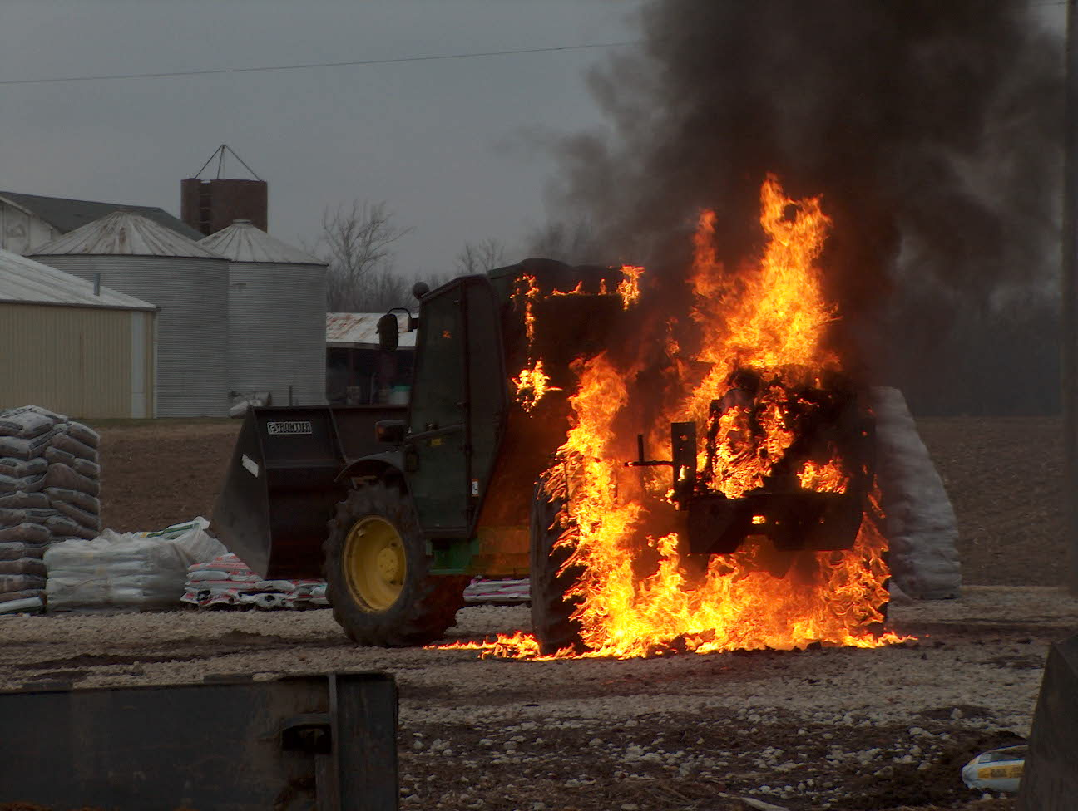 Operations News

Engine 53 is due for completion the last week of June. Battalion Chief Slauter, Captain Arkins, and Private Marsh will be traveling to the Crimson Factory in South Dakota during June 27-28-29 to complete the final inspection. If all goes well, Engine 53 should be in-service on later than August 1st.

Battalion Chief Engmark is still working on redistricting and updating the box alarm responses associated with moving to the new Station 51.

Effective June 11th, another Rural Metro Medic was placed in service in Greenwood. Currently, the Rural Metro units are stationed at GFD 93 and 94, and WRTFD 52. Medic 52 will pick up some additional responses with GFD Engine 92. Captain Hart will monitor the additional response load for Medic 52 and adjust this area if a delay in WRTFD is noted. Please see Captain Hart with any questions. Stay smart and be safe.

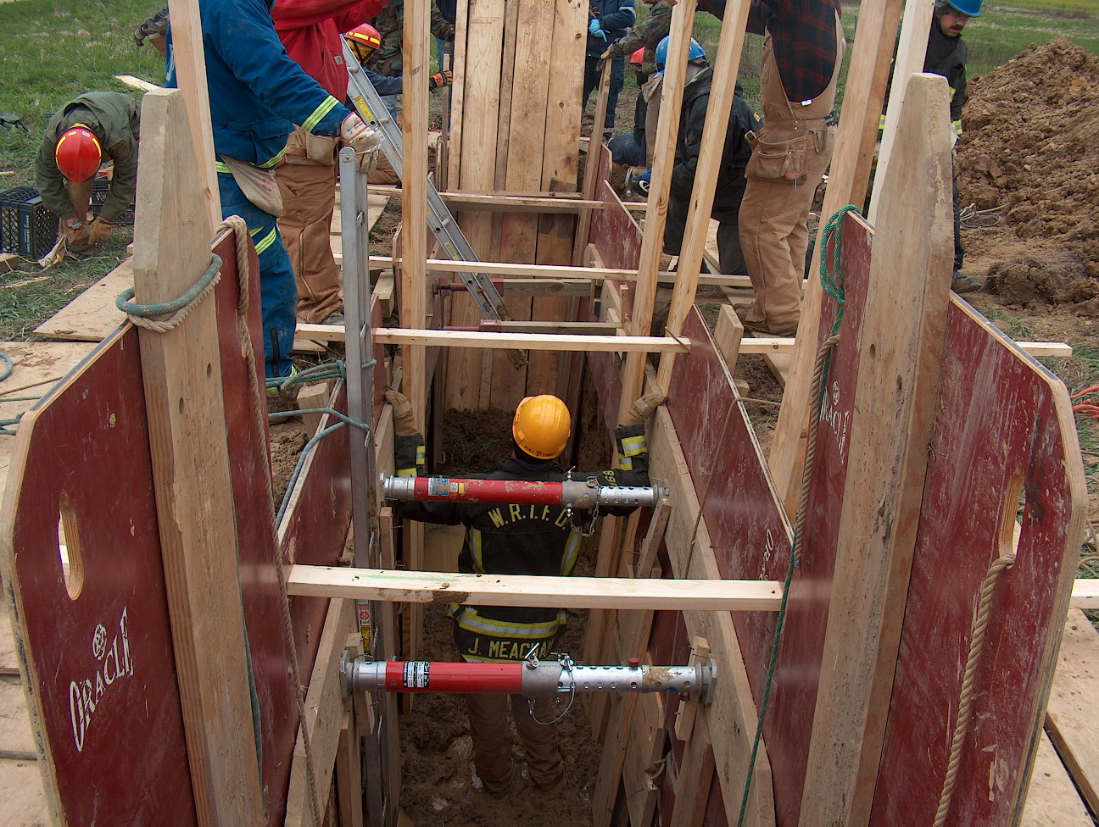 Training News

The Fire Officer Strategy and Tactics Class is nearing the end. The written and practicals will be on Thursday June 28.

The practicals for the Machinery and Vehicle Extrication Operations Course will be June 19 and 20. Those of you completing the course please meet at HQ on the 19th at 0830 so we can carpool to Hix.

NIMS 300 and 400 are now available throughout the state. NIMS 300 will be mandatory for all WRTFD Company Officers and NIMS 400 for Captains and above. These classes will be offered at WRTFD in September. I will follow with specific dates in the near future.

I have been in discussion with Center Grove Schools about the vacant elementary school south of CGHS. CG Schools will be giving public safety agencies a wing of the school for training purposes.

Finally, next week is Stand Down For Firefighter Safety; think about the sacrifices made by firefighters who have fallen in the line of duty. As each of the companies research and prepare presentations, let us work hard to maintain an organization that is committed to the basics of safety and education in the fire and emergency field.

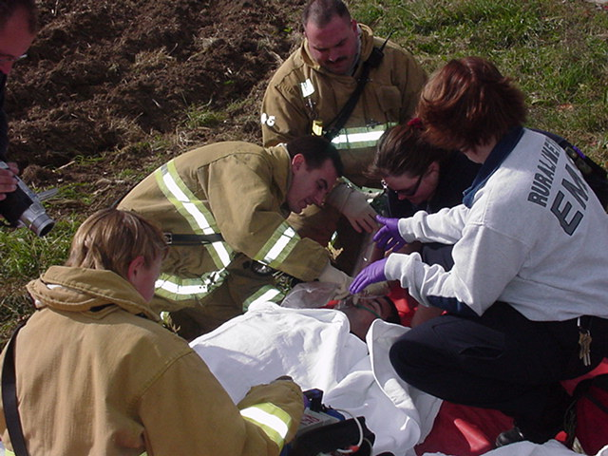 EMS News

You may be hearing the rumor about the possibility of Medic 53. I can tell you nothing is set in stone yet but it is in the works. Everything is hinging on when Rural Metro moves out of Perry Township. After talking with Rural Metro management, they do not want to decrease the amount of "911" medics they have which leaves 3 from Perry that they are looking for homes. If Medic 53 does happen, they will help cover western Bargersville, Northern Morgan County and obviously 53's district and where ever else is needed. It would not be different than what M-52 does now but it would keep medic 52 in our district more.

We have submitted the Fire Act Grant for the Ambulance which I can tell you is in peer review right now and they are going to start awarding it sounds like the end of July. It sounds like the focus is still on transporting ambulances. We are still waiting for the dates for the Safer Act to be released so stay tuned. The goal is still January of 2009 to start our own ambulance.

A new piece of equipment we are going to be getting is a CO finger probe detector. It operates just like a SaO2 sensor however it will do CO also. This is something that will be able to be used when we go on a CO run and have a sick person to see there CO levels. More importantly we are going to use it in rehab for us. There has been a lot of links between FF’s dying of CO and Cyanide poisoning after getting back to the firehouse following a fire. I have got the manufacture to finally tell me they are in R&D to incorporate cyanide into this monitor and they will upgrade it when it is released. We will be doing training on it when it comes in. It will be on E-52 it try it out but I have spoke with Chief Cassin about getting 2 more by the end of the year so 3 stations will have one. Any questions on anything let me know. Cap. Hart

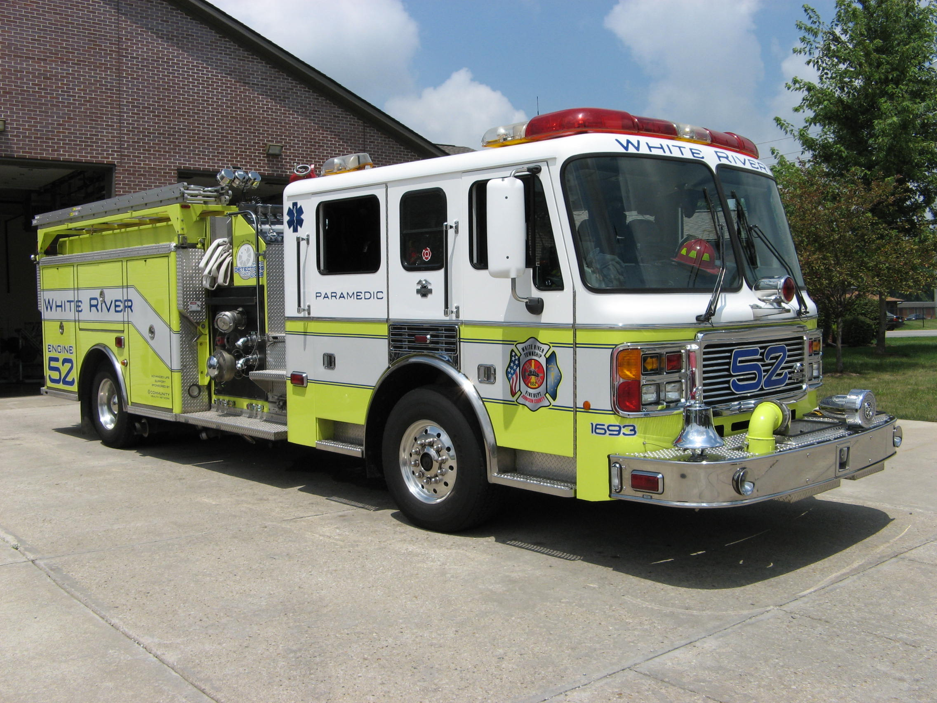 Did you know?

Did you know that a seahorse is actually a fish?

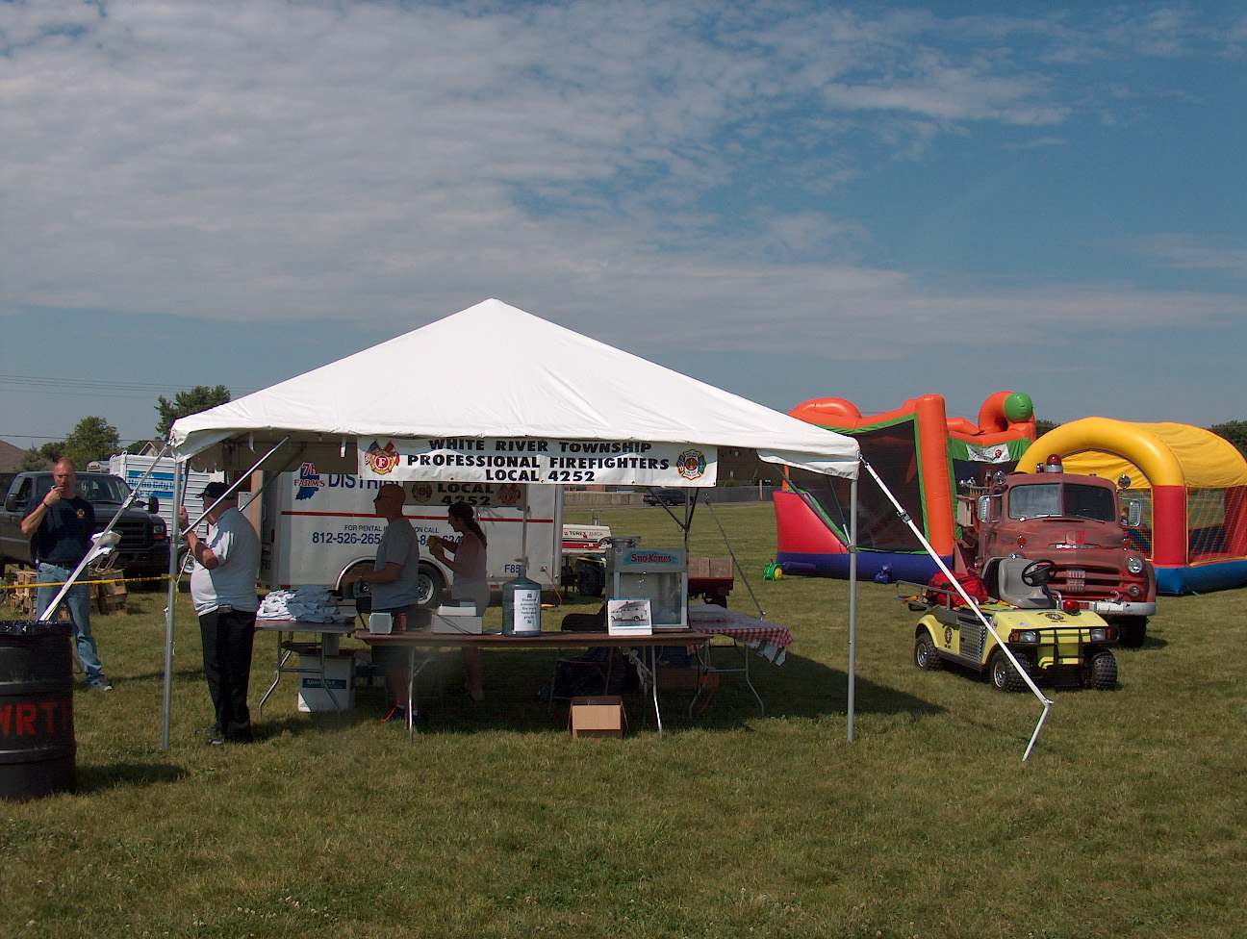 Birthdays (June 15 – June 28)
Craig Zollars June 18 Carlos Sanchez June 28
Logan Kerr June 19 David Scholl June 28
Chad Witham June 27

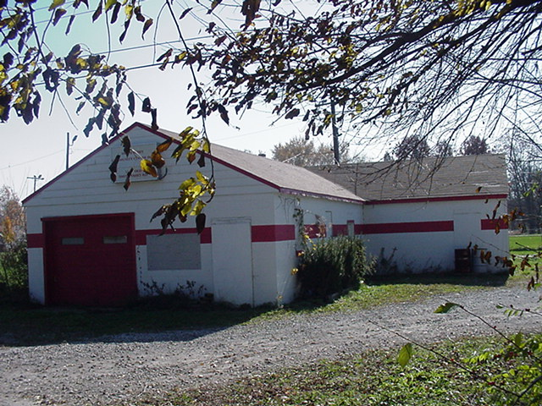 Looking back…..
51 Years Ago -- June 28, 1956
The members of the Smith Valley Volunteer Fire Department voted to form a new fire fighting unit which will be known as the White River Township Volunteer Fire Department.
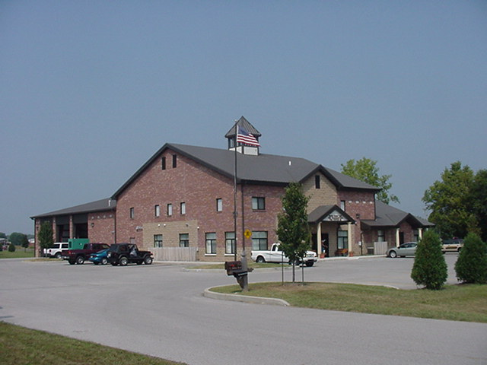 Upcoming events (June - July)
Johnson County Firefighters Association Dinner and meeting Thursday, June 21st at Headquarters starting at 7 p.m.

5th Annual Golf Outing – Friday, June 22 – Hickory Stick Golf Course at 4422 Hickory Stick Boulevard will begin at 10am

Fire Protection District Board Meeting – July 3 – 7pm. Station 53
JUNE 2007
S | M | T | W | T | F | S
 |  |  |  |  | 1 | 2
3 | 4 | 5 | 6 | 7 | 8 | 9
10 | 11 | 12 | 13 | 14 | 15 | 16
17 | 18 | 19 | 20 | 21 | 22 | 23
24 | 25 | 26 | 27 | 28 | 29 | 30
JULY 2007
S | M | T | W | T | F | S
1 | 2 | 3 | 4 | 5 | 6 | 7
8 | 9 | 10 | 11 | 12 | 13 | 14
15 | 16 | 17 | 18 | 19 | 20 | 21
22 | 23 | 24 | 25 | 26 | 27 | 28
29 | 30 | 31

