

June 1, 2007

Inside this Issue
Change Page #’s
1 Administration
2 Administration
2 Operations
3 Did You Know?
3 Birthdays
4 Looking Back
4 Upcoming Events

 Administration News

Simply put, one of our fundamental jobs as managers is to ensure employee safety. This is of course a very broad statement and covers a lot of ground with many different aspects. One of these many aspects involves our concern for long-term employee health. In part of reviewing what we can do in this particular area we discovered several things.

First, would be doing whatever it takes (from an employee perspective) to become a tobacco-free agency.

Second, is instituting and promoting a comprehensive physical fitness program. Both of these items are part of a holistic health program to ultimately achieve the aforementioned goals. Obviously, the benefits are many and easy to point out. However, in order to realize these goals by January 1st there is much to do. We want to proactively utilize the next seven months gearing up and putting the necessary components, programs, and policies in place. Many of you have already quit tobacco and started fitness routines on your own, which is truly commendable. For those that are going to need help, our doors are wide open. We have many resources available to us and want to help in whatever way we can. Please see Chief Thacker for more information if interested. We have demonstrated countless times in the past that if we are all together on something we can accomplish anything, and this I am sure will be no different.

“To effectively and efficiently provide professional services to our community”

The division heads have adopted a core value statement for the department. Those of you who were fortunate to see Chief Lasky speak are familiar with these values. We feel strongly that these core values are the foundation for our department and the service delivery to our community. Our core values are integrity, duty, honor, and pride. Please review this new policy online in the employee manual for definitions of these core values. Along with the new mission statement, the core values will be posted at the fire stations in the near future.

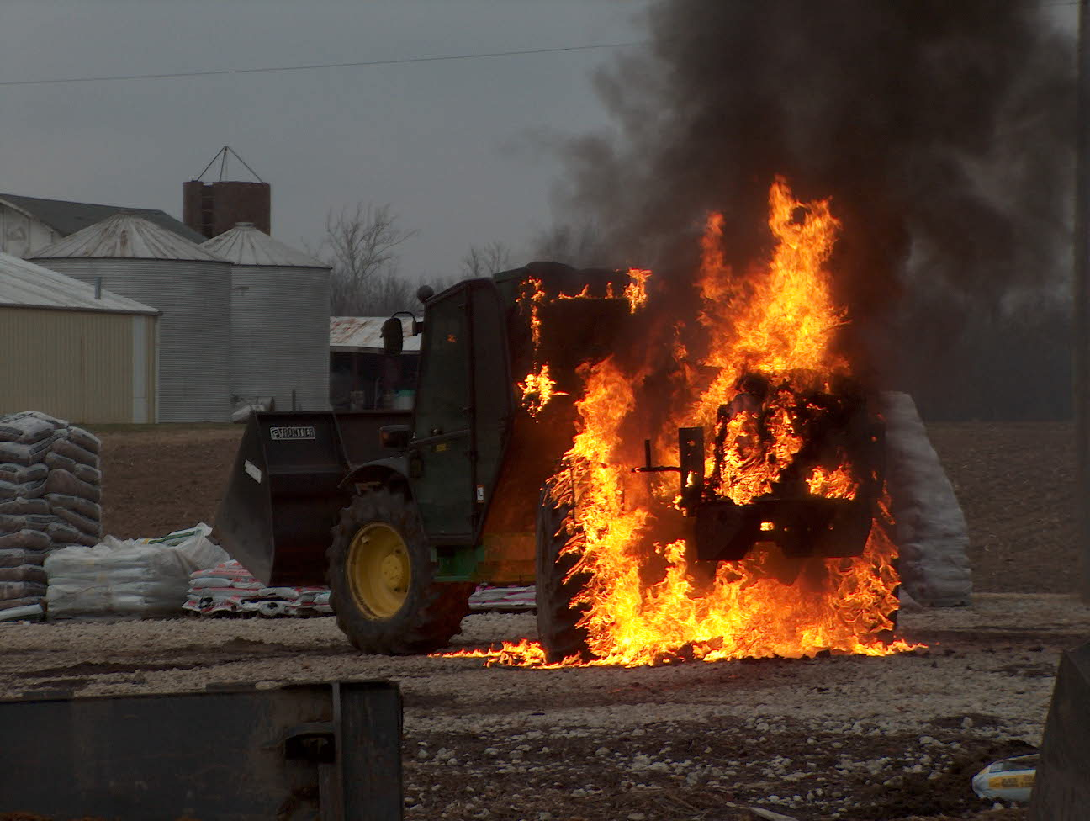 Operations News

Captain Arkins, Lt. Hurrle and Jeff Bowden conducted a mid point inspection for the new Engine 53 at the Crimson facility on May 22-23. A few minor corrections were made, but the final inspection and delivery date is still slated for the second or third week of June. Captain Arkins is working on equipping Engine 55 (reserve engine) so it will always be ready for immediate service.

Battalion Chief Wilson is still working on revising our current SOGs and adding new SOGs as needed. The SOGs will be categorized into similar groups and will also be posted online. These revisions and new SOGs will be reviewed during training sessions.

Battalion Chief Engmark is currently working on redistricting and creating the new box assignments for the opening of Station 51. If you have any comments concerning dispatch service, please contact Battalion Chiefs’ Slauter or Engmark.

Stay smart, be safe, and never lose your love for our great profession.

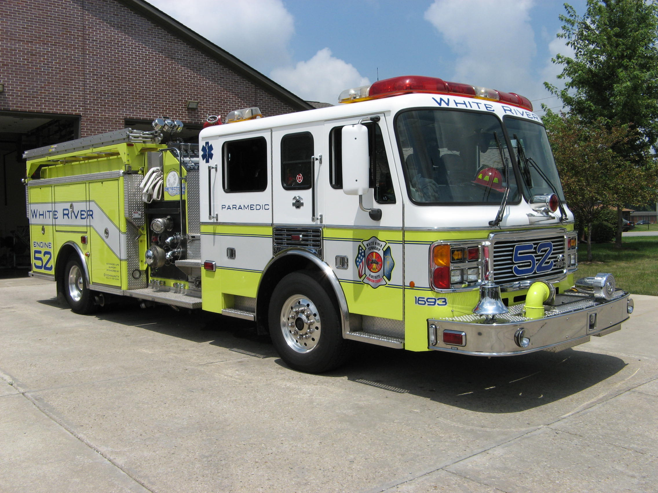 Did you know?

Did you know that the World's deepest point in the oceans is the Marianas Trench (depth is 36,200 feet deep)?

The location is east of the Mariana Islands in the western Pacific Ocean and is 1,554 miles long and averages 44 miles wide.



Birthdays (June 1 – June 14)

Brad Jewell June 1

Mike Hoffman June 2
Chris Kindred June 7
Kevin Skipper June 9
Brent Shepherd June 9

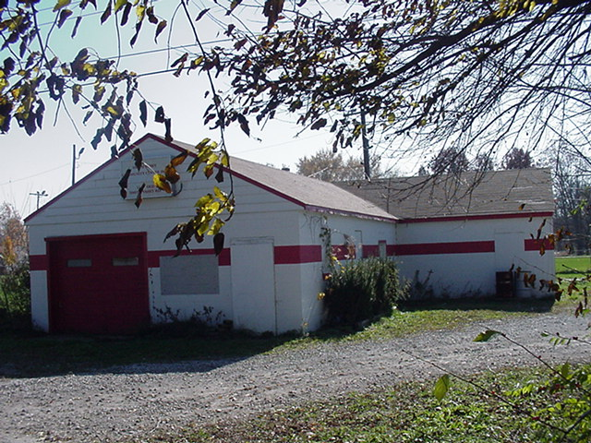 Looking back…..

49 Years ago --- June 12, 1958
Firefighters respond to a house fire
White River Township Firefighters responded to a house fire early this morning. They found the home of Mr. and Mrs. Charles Butler of Greenwood RR4 with flames showing confined to the rear of the residence. They blame the fire on defective wiring in the rear of the house.

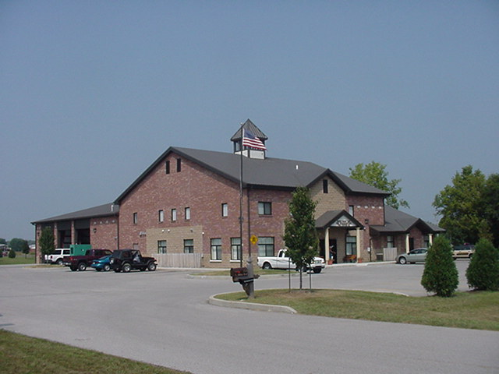 Upcoming events (June)

Fire Protection District Board Meeting - June 7 – 7pm. Station 53

15th Annual Strawberry Festival – Pleasant Grove Elementary School
Friday June 8 (3pm – 10pm) and Saturday June 9 (9am – 10:30pm)

Johnson County Firefighters Association Dinner and meeting Thursday, June 21st at Headquarters starting at 7 p.m.

5th Annual Golf Outing – Friday, June 22 – Hickory Stick Golf Course at 4422 Hickory Stick Boulevard will begin at 10am

JUNE 2007
S | M | T | W | T | F | S
 |  |  |  |  | 1 | 2
3 | 4 | 5 | 6 | 7 | 8 | 9
10 | 11 | 12 | 13 | 14 | 15 | 16
17 | 18 | 19 | 20 | 21 | 22 | 23
24 | 25 | 26 | 27 | 28 | 29 | 30

