
Volume 17 Issue 3

May 18, 2007

Inside this Issue
1 Administration
1 Operations
2 Training
3 Did You Know?
3 Birthdays
3 Looking Back
4 Upcoming Events

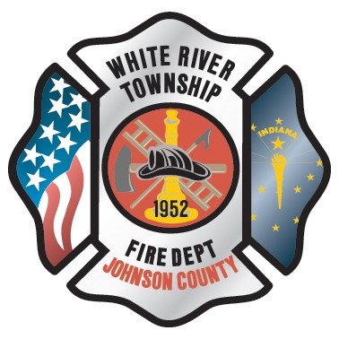 Administration News

I heard a rumor earlier this week that a few folks have been discussing “merging” with another fire department. I would like to stop this one dead in its tracks in that there IS NOT, nor HAS THERE BEEN, any discussions of the sort going on. The primary driver for this type of issue would be the saving of taxpayer dollars. There currently is no combination of events that could lead to this scenario, so the issue is a non-issue.

“To effectively and efficiently provide professional services to our community”

Be sure to read up on two new polices that were issued earlier this week. The first one pertains to suggestions and new ideas and the second one details how to report near-miss incidents. They both can be found in the manual as well as posted at each station.

Also be sure to read the news article posted on the web site regarding the Flag Day project that is being put together by Firefighter Huff. A special thank you to Dan for working on this endeavor.

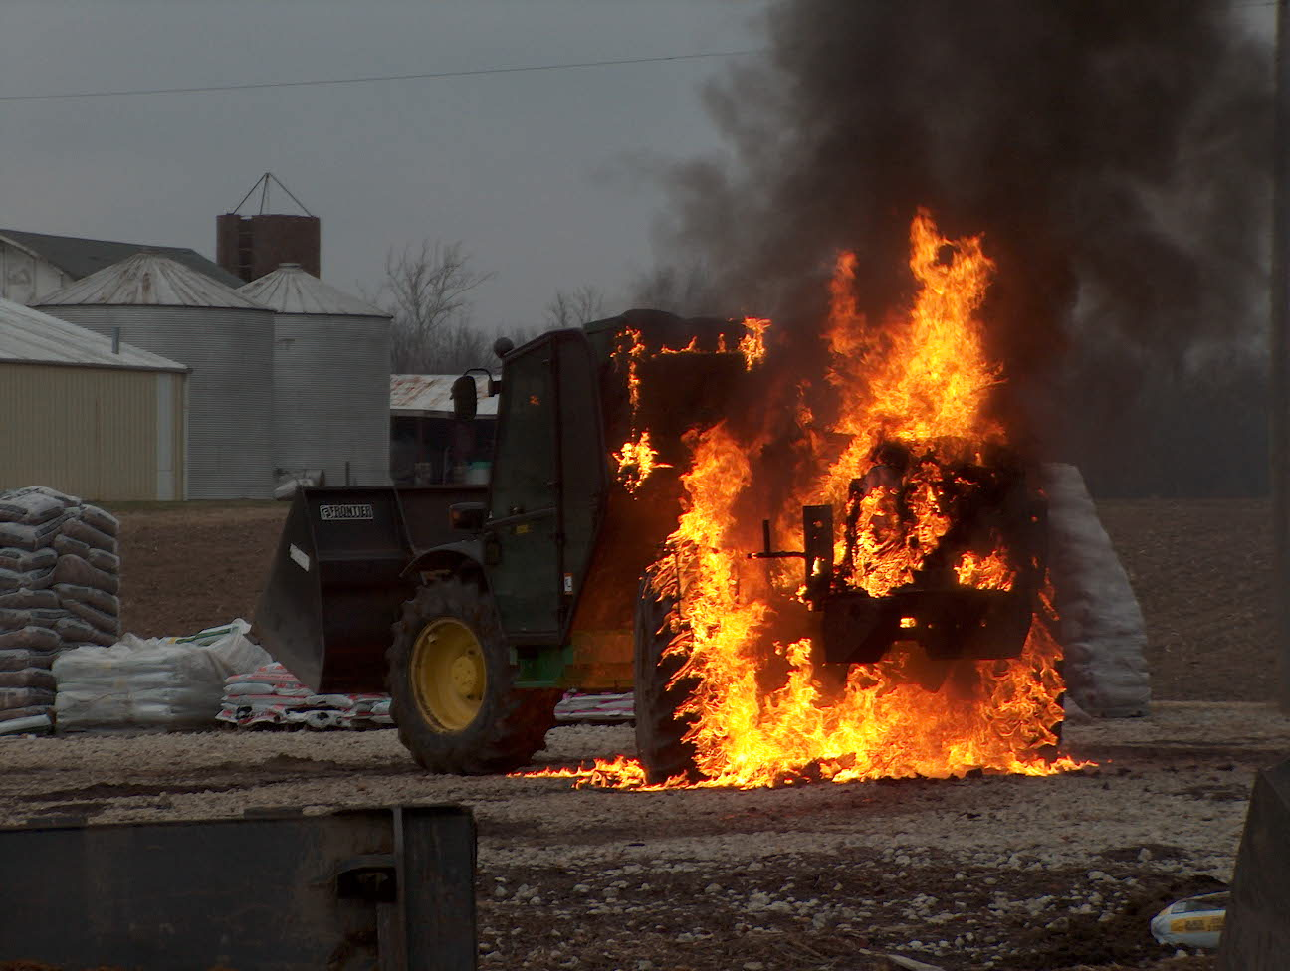 Operations News

A date of completion has been set for Engine 53, which is the second or third week of June. Captain Arkins, Lt. Hurrle, and Jeff Bowden are flying to South Dakota May 22nd to complete the mid-point inspection. The final inspection trip will be the second week of June. I anticipate a quick turnaround time from delivery to placing the unit in service.

We have been working for about a year on an upgrade to our SCBAs. The main hold-up has been NFPA releasing the 2007 standards. We did not want to spend $100,000 and in a few months to have the SCBA’s out of date. After learning of a new program that MSA released at FDIC, there is now the possibility of purchasing new SCBAs. Deputy Chief Cassin, Joe Marsh, and I are working on the details and putting some figures together with MSA. I hope to have more information for you in the next newsletter. Whatever we decide, we will have SCBAs that will meet the 2007 standards sometime near the first of the year.

Thanks to all who participated in the Ardent Sentry exercise. I am sure that you heard both good and bad feedback from the crews attending. A big thank you to Captains’ Arkins and Settles for having their teams and equipment prepared to work. I heard good comments concerning the Collapse Team and their scenario. Unfortunately, the Decon Team never had a chance to actively participate. Also, thank you to those you worked over time to fill in the open positions. Be smart and stay safe.

Remember that if you use a Pool Car to make sure it complies with our re-fueling guidelines (at or above ¾ full) upon return. Additionally, it must be clean (washed if necessary) both inside AND out as well as any used equipment returned to ready status. Car 555 is the primary vehicle for general use, as Car 556 is filled with prevention materials and is used daily as such.

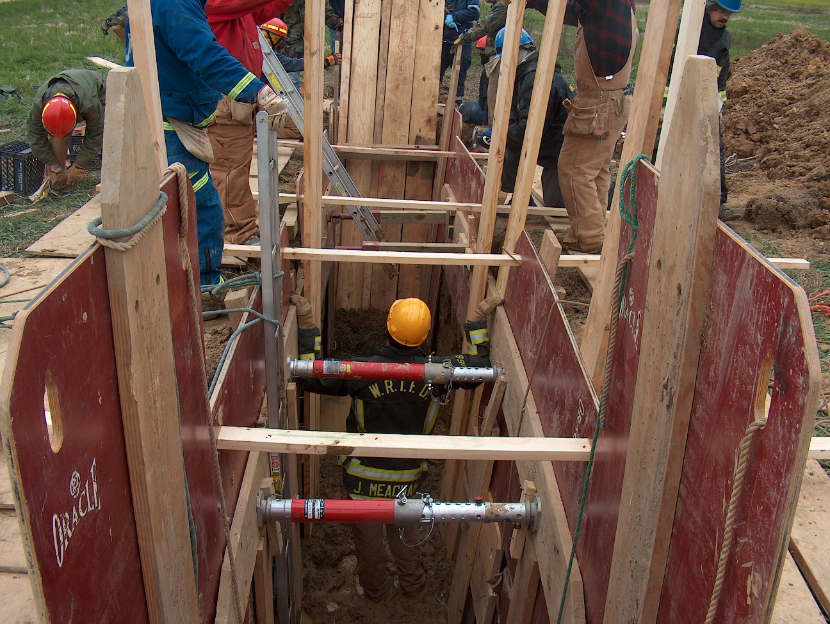 Training News

The Indiana Fire Officer Strategy and Tactics class is underway. This class will run every Thursday night from 6-10 pm through June 28. Feel free to sit in on any classes in which you are available.

Lt. Green has secured three structures at the corner of Smith Valley RD and Morgantown RD for upcoming training. Due to the proximity to this busy intersection, we will not perform live burn operations. We will however be able to accomplish many other fireground functions. Dates are still being worked out with the developer and the training staff.

A house owned by Center Grove Schools has been secured for live fire training later this summer. Also, Maple Grove will be available for more training. I will be speaking with Center Grove representatives about the opportunity to use the structure for a variety of training scenarios before it is razed later next year.

Stand down for Firefighter Safety 2007 is approaching. This year I am going to assign each company officer the task of researching with their crew a firefighter fatality. The company officer along with their crew will present this information on their respective shift the week of June 17. More information will be delivered to the company officers in the next few weeks.

The Reserve (part-time) process is nearing completion and eight applicants have just finished the final portion of the process. Shifts will be awarded and orientation will be scheduled for later this month with new personnel to start the first week of June.

The career hiring process is also underway and we are averaging fifteen applications per day. CPAT and written testing is scheduled over the next three months. The process should conclude around October.

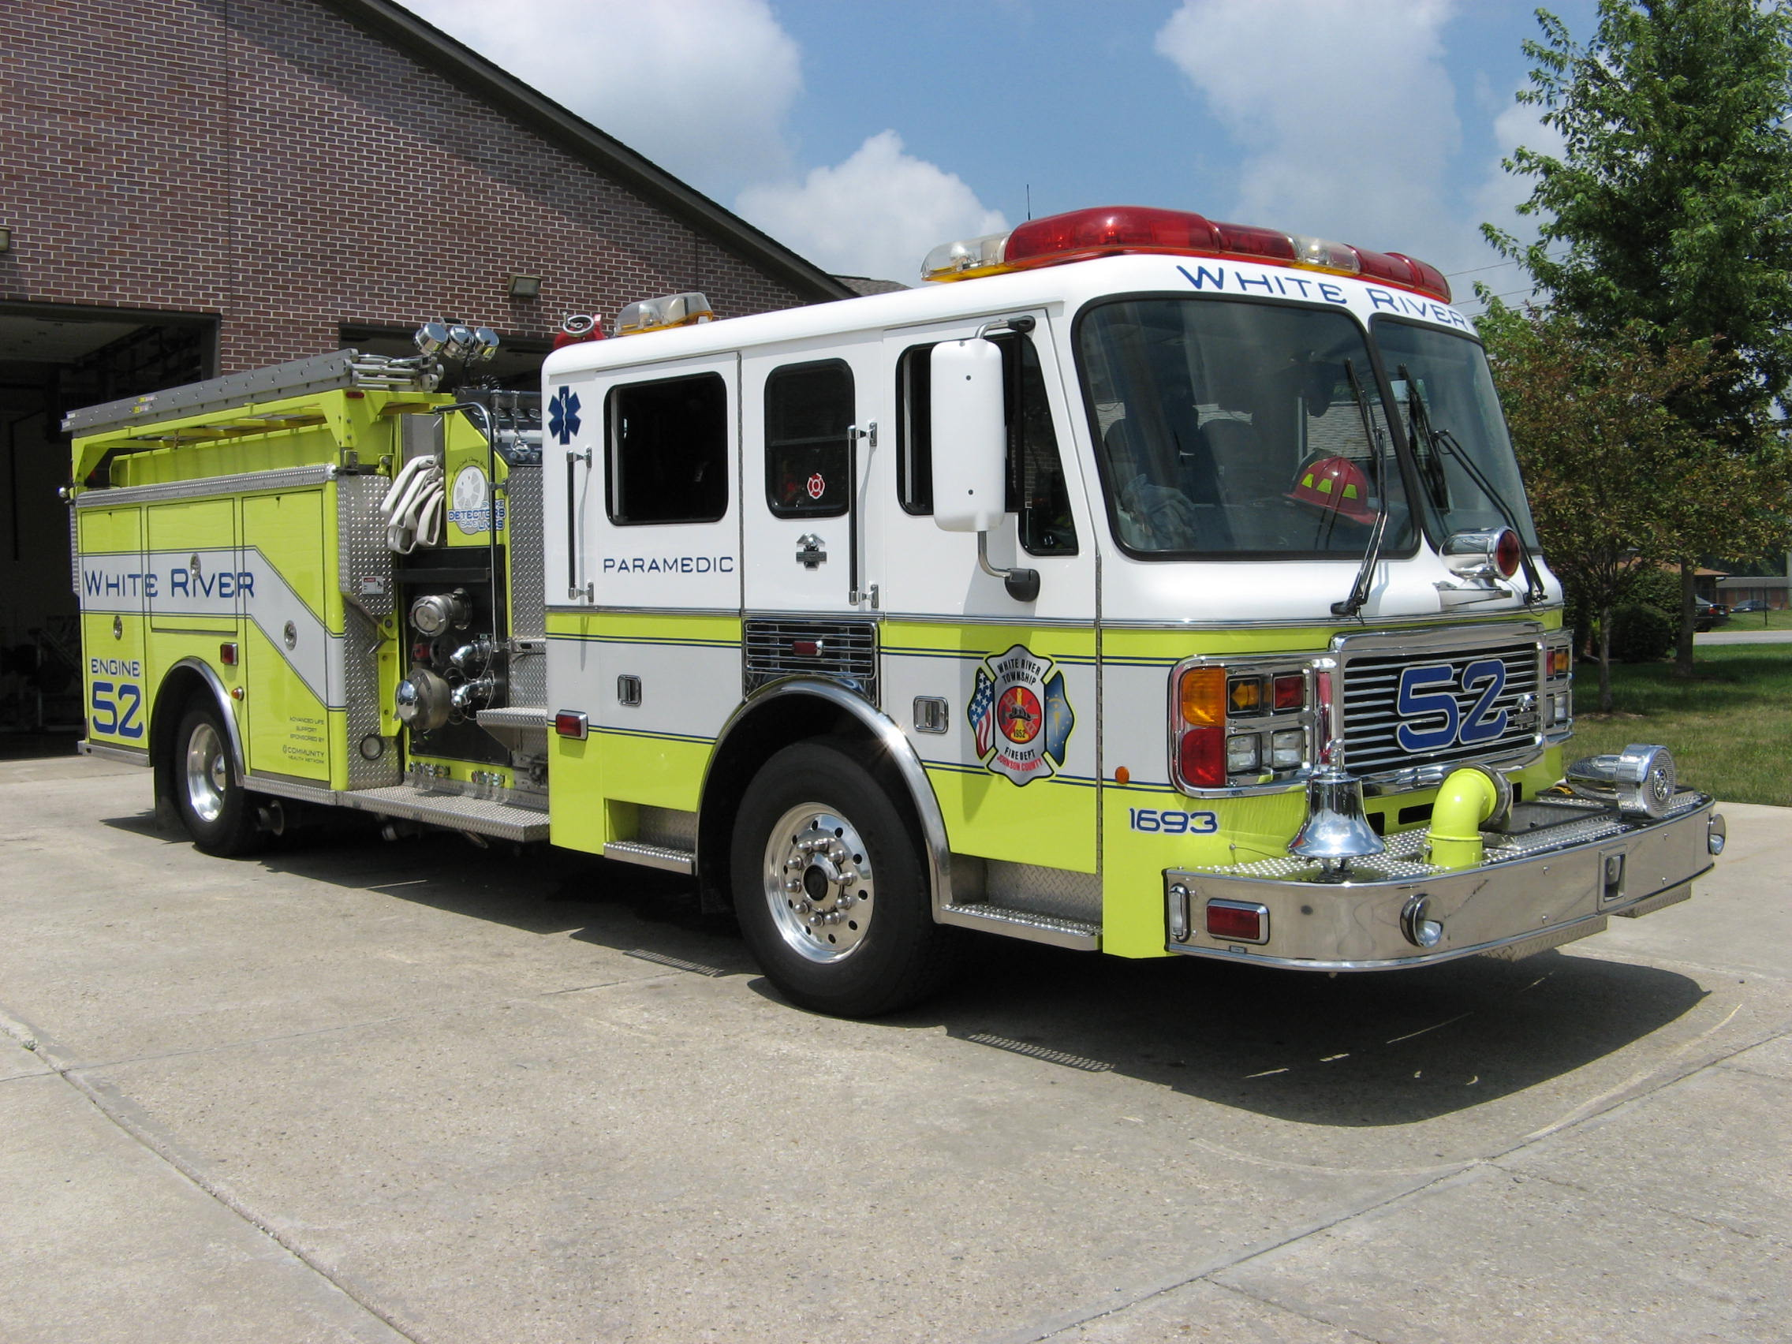 Did you know?

Did you know that Martin O'Malley, who plays the Mayor in the movie Ladder 49, was the real Mayor of Baltimore and spoke at the Democratic National Convention in 2004?

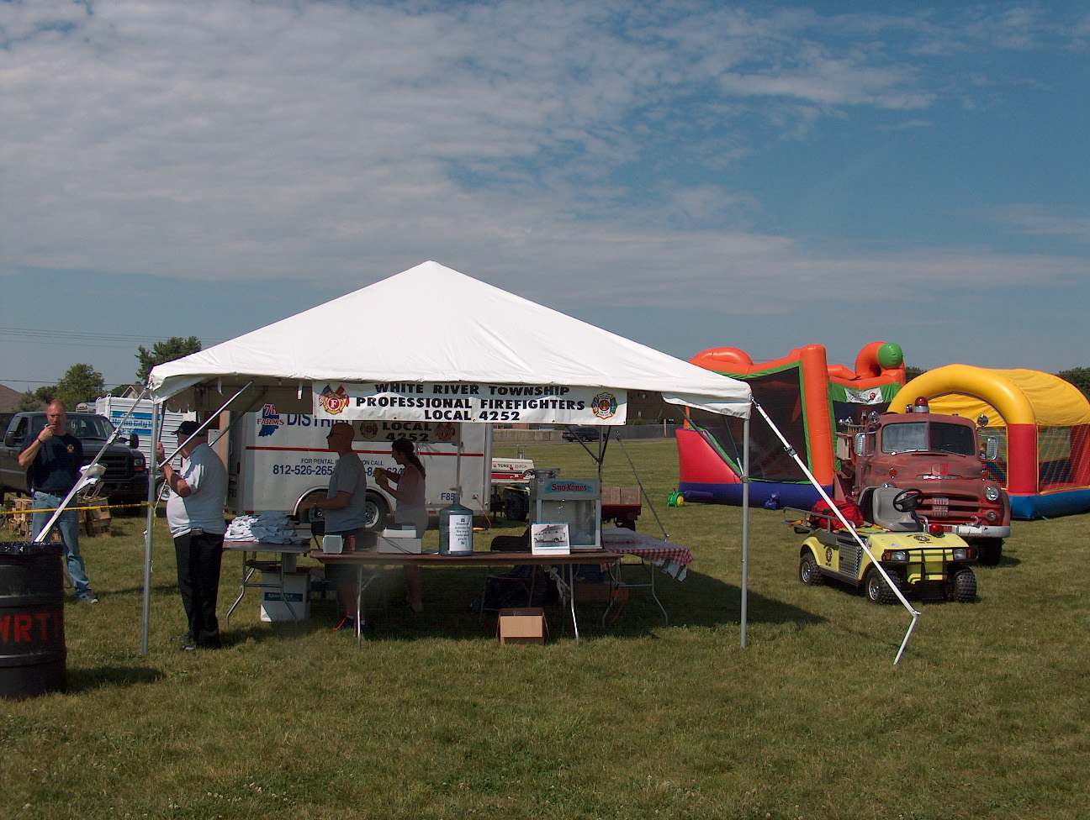 Birthdays (May 18 – May 31)

Mike Arany – May 23
Wayne Fletcher – May 27
Andy Cline – May 31

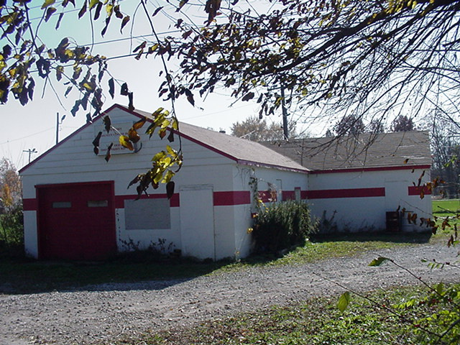 Looking back…..

May 30, 2002 White River firefighter featured in national ad Firefighter Ray Skipper was recently featured along with his partner in a nationally publicized ad campaign touting the effectiveness of proper turn-out gear. The ad centers around their narrow escape after being trapped inside a burning building. It is shown in several major firefighting magazines.

May 28, 1982 Festival officially under way with parade
The White River Township Fire Department held its May Fest parade earlier today along Fairview Road in northern White River Township. The parade officially opened the weekend-long event and stretched from the Mount Pleasant Church at Bluff Road down to the Marsh Grocery store parking lot at State Road 135. There were many entries in the event including the duo "Tons of Fun" who held a captive audience with their antics. Much fun was had by all as the Festival and Fish Fry got under way. The Fish Fry is being held in the field next to the Bargain Bob's Shoe store on State Road 135, just north of Smith Valley Road.

May 22, 1972 Dog alerts family to house fire
A family pet dog awoke a rural Greenwood family early today after an electrical fire broke out in the basement of the home, and firemen said the barking dog probably prevented extensive damage from occurring. There were no injuries. The fire was reported at the Lawrence Smith residence, Greenwood rural route three. The home is located on Olive Branch Road near Mullinix Road. White River firemen were called to the home at 3:18 a.m., but Mr. Smith was able to extinguish the electrical fire before it could spread.

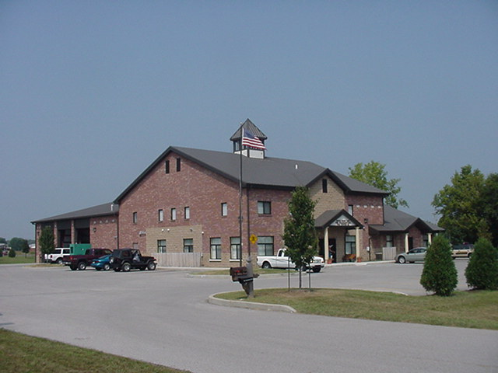 Upcoming events (May - June)

Fire Protection District Board Meeting - June 5 – 7pm. Station 53

15th Annual Strawberry Festival – Pleasant Grove Elementary School
Friday June 8 (3pm – 10pm) and Saturday June 9 (9am – 10:30pm)

Johnson County Firefighters Association Dinner and meeting Thursday, June 21st at Headquarters starting at 7 p.m.

5th Annual Golf Outing – Friday, June 22 – Hickory Stick Golf Course at 4422 Hickory Stick Boulevard will begin at 10am
May 2007
S | M | T | W | T | F | S
 |  | 1 | 2 | 3 | 4 | 5
6 | 7 | 8 | 9 | 10 | 11 | 12
13 | 14 | 15 | 16 | 17 | 18 | 19
20 | 21 | 22 | 23 | 24 | 25 | 26
27 | 28 | 29 | 30 | 31
JUNE 2007
S | M | T | W | T | F | S
 |  |  |  |  | 1 | 2
3 | 4 | 5 | 6 | 7 | 8 | 9
10 | 11 | 12 | 13 | 14 | 15 | 16
17 | 18 | 19 | 20 | 21 | 22 | 23
24 | 25 | 26 | 27 | 28 | 29 | 30

