
Volume 17 Issue 3

May 4, 2007

Inside this Issue
1 Administration
2 Training
2 EMS
2 Did You Know?
3 Birthdays
3 Looking Back
4 Upcoming Events

 Administration News

As a result of the Fire Protection District Board meeting on Tuesday, the timeline for the fire chief selection process has been established. Applications for fire chief will be available beginning Monday May 7 and will be due by the end of the month. The applications will be narrowed to a group of approximately ten applicants for further interviews with representatives of both the district board and the department. Selection recommendations will be presented to the entire District Board either July or August.

We will keep you updated as more information becomes available.

The 2008 department budget was also presented Tuesday night for the informal review. The June district board meeting will provide time for the public to make comments regarding the budget. See any staff chief with questions or comments regarding the budget.

The station 51 project is moving forward at a much faster rate now that some utility issues have been resolved. The contractor and architect stated that the project should be complete around the end of June or first of July.

“To effectively and efficiently provide professional services to our community”

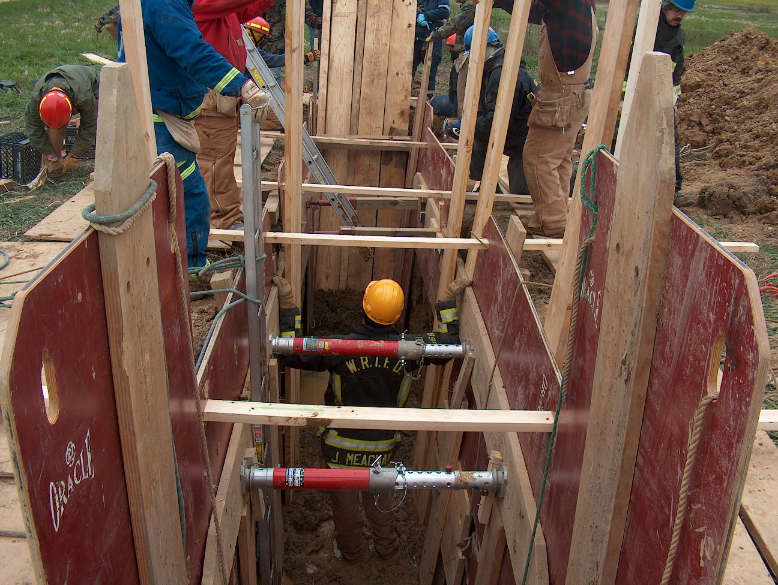 Training News

WRTFD will conduct a Fire Officer Strategy and Tactics course beginning Thursday May 10 at 6p-10pm. The class will meet every Thursday ending June 28. Please contact Chief Thacker if interested in attending. This class is free to department members.

Interviews for the reserve process will be conducted Thursday and Friday, May 3 and 4. Look for successful applicants to start shift work in early June.

Applications for the career selection process will be available during the week of May 14. Many of you have offered to assist with the application phase. Chief Thacker will create an application process work schedule. This will be available by Friday May 4. If others are interested in assisting, contact Chief Thacker via email by Friday May 11.

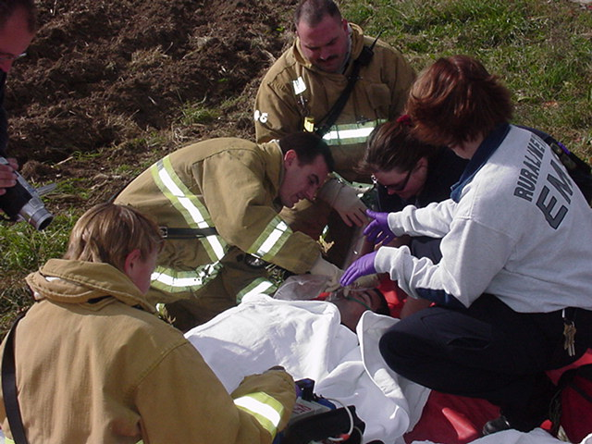 EMS News

The ambulance project got approval to proceed after the May 1st district board meeting. By the time you read this the Fire Act Grant will have already been sent. Next step would be applying for the SAFER Grant to assist in the staffing of the ambulance for the first 4 years. If everything goes well, start date will be January 1st, 2009. The district board was very supportive of this project and felt this was the logical next step for the fire department. If you have any questions about it, please let me know.

FYI: The entire 8th Grade at MSC is now trained in CPR. St Francis Catholic Church has purchased a second AED for the new school. Center Grove Presbyterian has also purchased an AED.

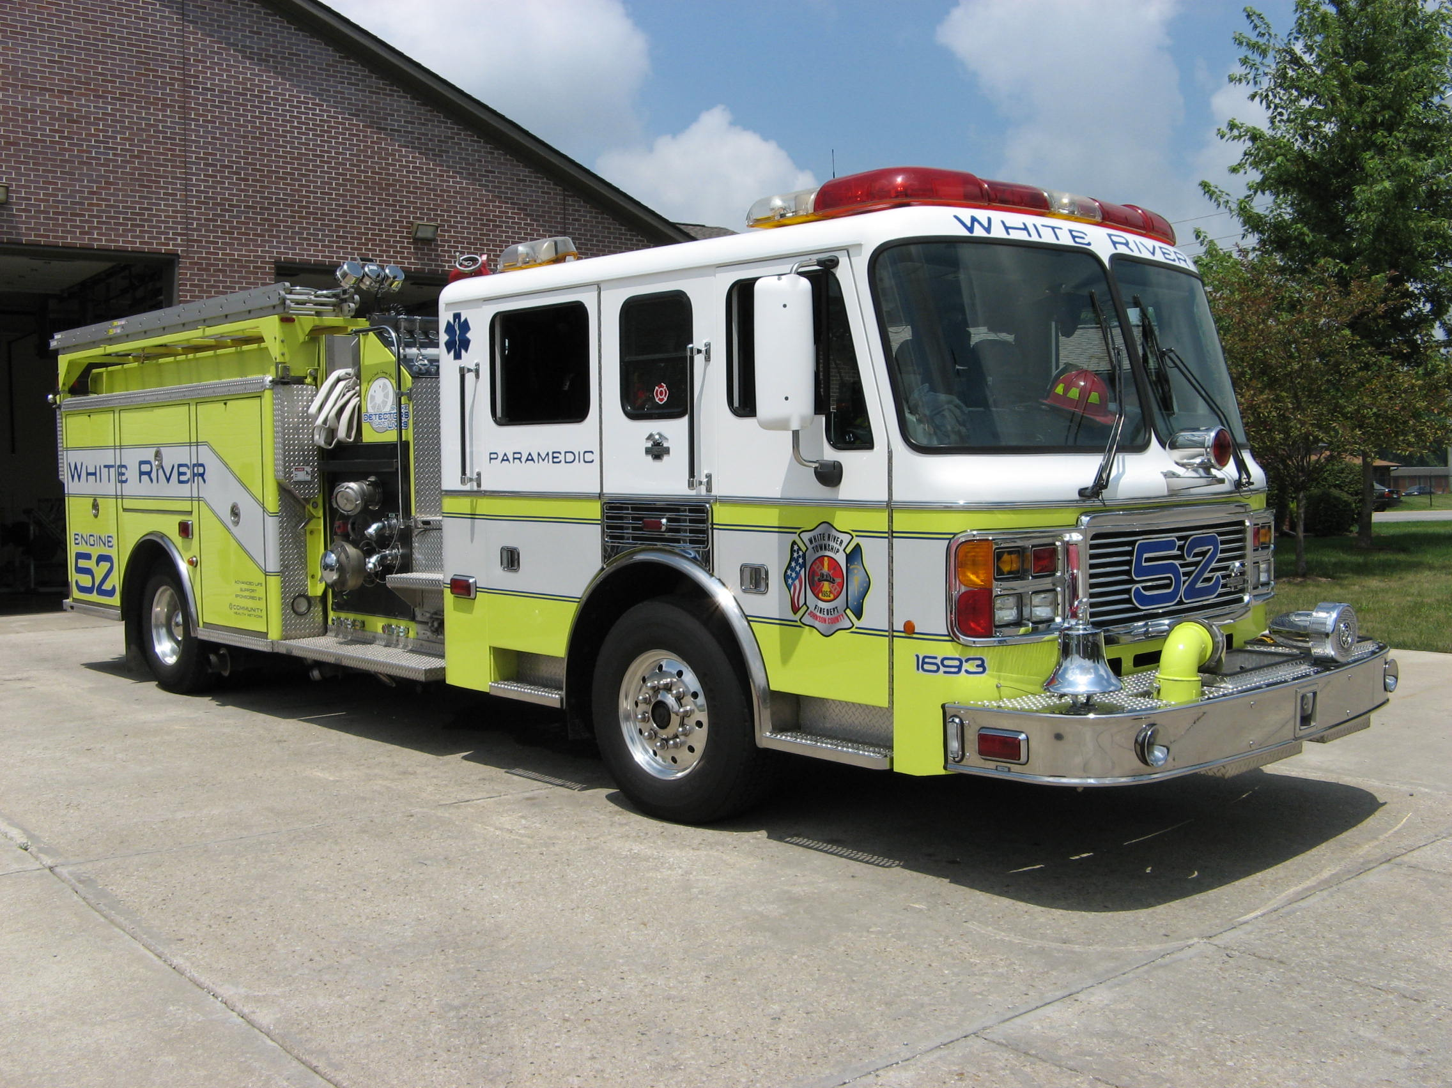 Did you know?

Did you know why Dalmatians are considered firehouse dogs? In the early days of the fire service, fire trucks were horse drawn. In those days nearly every firehouse had a resident Dalmatian. The job of the Dalmation was to direct the horses, keep the horses company and guard the firehouse. Today we do not keep horses in the fire station, but many firehouses still have a Dalmatian. The resident Dalmatian is still responsible for guarding the firehouse and the fire trucks.

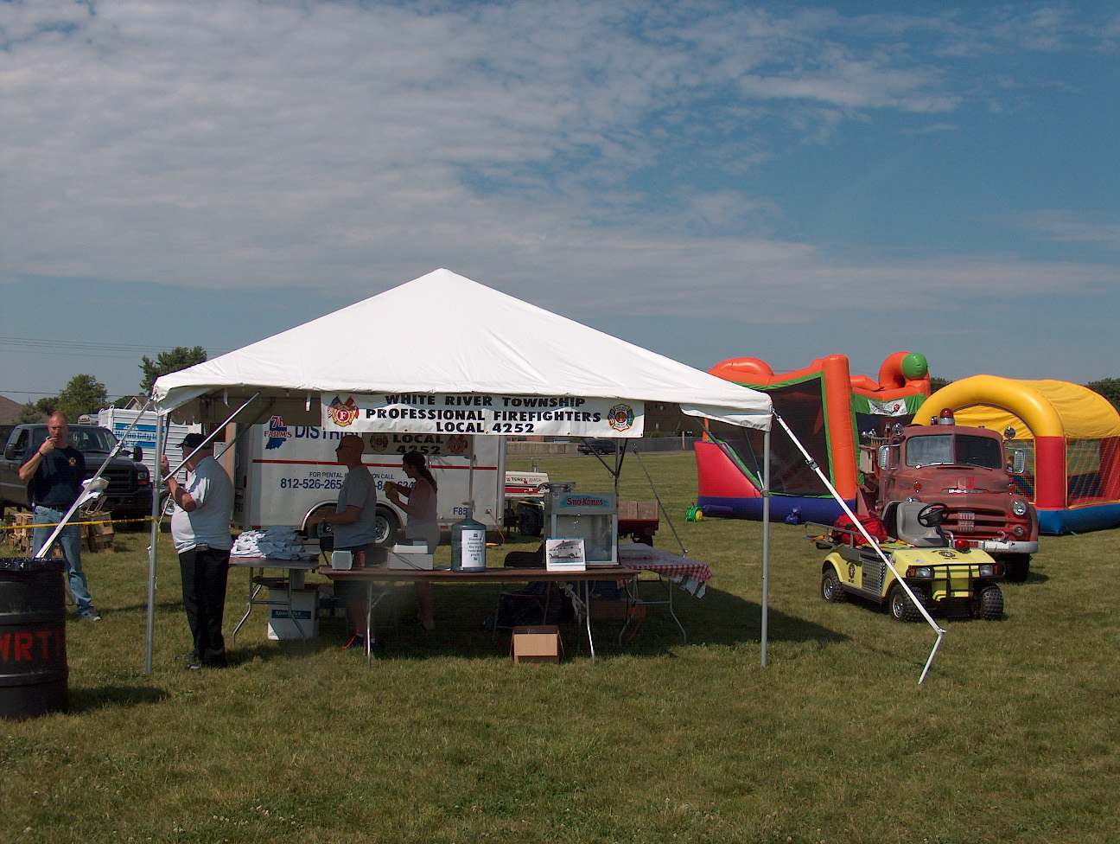 Birthdays (May 4 – May 17)

Mike Boone May 5 Scott Wiegle May 14
Ryan Cox May 5 Crystal Young May 15

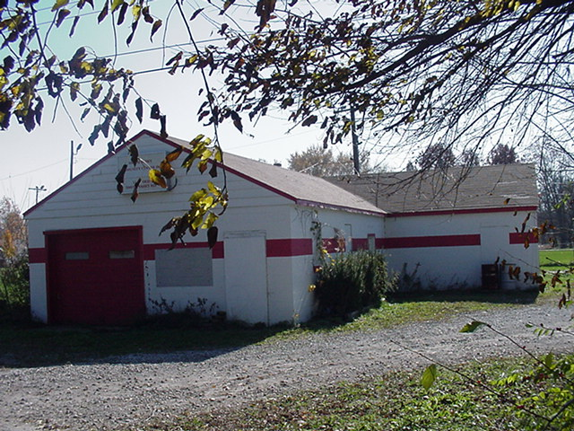 Looking back…..

May 2002 White River Twp Fire Dept bike team to 500
Bike Team Members from White River Township Fire Department participated in the annual Mini-Marathon as part of the 500 Festival events this year. Runners were treated for heat exhaustion, heat cramps, dehydration, sprains/strains, etc. In case any runners took a fall during Saturday’s 500 Festival Mini-Marathon, local medics were on hand to pedal to the rescue. Following the lead of some area hospitals and ambulance services, the White River Township Fire Department has formed an emergency medical service bicycle team. A well-equipped bike team shares many of the capabilities of an ambulance crew but can respond even more quickly at crowded public events.
May 1997 Tires fuel junkyard fire
A junkyard fire, fueled by more than 5,000 tires, could be seen for at least 20 miles Wednesday. Firefighters were called at 3:37 p.m. Wednesday to the Brickyard Import Auto Salvage in Bethany, south of Mooresville. For three hours, 120 firefighters from 11 different departments battled the fire, which spewed thick black smoke and made popping noises as shock absorbers exploded.
May 1987 Fish Fry a success
The White River Township Fire Department held its annual Fish Fry this past weekend on State Road 135. This year’s Fish Fry offered the usual food offerings but also included various events for the public including an automobile extrication demonstration, a simulated car fire, and helicopter rides, which were a big hit. Officials state that even thought it rained one of the evenings, turnout was better than expected.

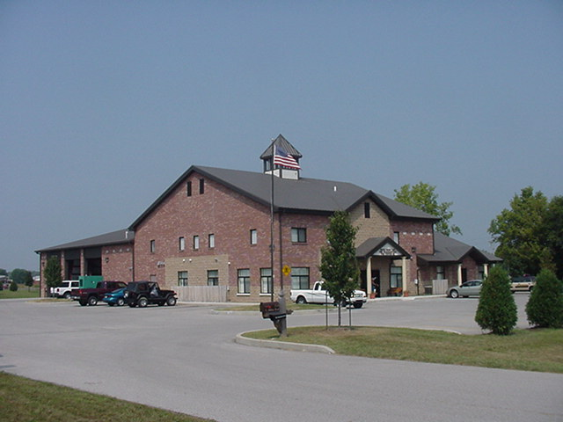 Upcoming events (May - June)

Fire Protection District Board Meeting - June 5 – 7pm. Station 53

15th Annual Strawberry Festival – Pleasant Grove Elementary School
Friday June 8 (3pm – 10pm) and Saturday June 9 (9am – 10:30pm)

5th Annual Golf Outing – Friday, June 22 – Hickory Stick Golf Course at 4422 Hickory Stick Boulevard will begin at 10am

May 2007
S | M | T | W | T | F | S
 |  | 1 | 2 | 3 | 4 | 5
6 | 7 | 8 | 9 | 10 | 11 | 12
13 | 14 | 15 | 16 | 17 | 18 | 19
20 | 21 | 22 | 23 | 24 | 25 | 26
27 | 28 | 29 | 30 | 31
JUNE 2007
S | M | T | W | T | F | S
 |  |  |  |  | 1 | 2
3 | 4 | 5 | 6 | 7 | 8 | 9
10 | 11 | 12 | 13 | 14 | 15 | 16
17 | 18 | 19 | 20 | 21 | 22 | 23
24 | 25 | 26 | 27 | 28 | 29 | 30

