
Volume 17 Issue 3

April 20, 2007

Inside this Issue

1 Administration
2 Operations
2 Training
3 Upcoming Training
3 Did You Know?
3 Birthdays
4 Looking Back
4 Upcoming Events

 Administration News

This year’s
Strawberry Festival is scheduled for Friday and Saturday, June 8th and 9th, again at the Pleasant Grove Elementary School.

As in year’s past, we need EVERYONE’S help. It is now officially two months away, so there is plenty of time to adjust schedules so you can plan to help out. All that is asked is that everyone associated with this department helps out in some way, preferably by filling in a time slot or two on the event schedule. And remember, family and friends are welcome as well. If everyone chips in, we’ll have more than enough to pull off this agency’s biggest event of the year.
-------------------------------------
“To effectively and efficiently provide professional services to our community”
-------------------------------------

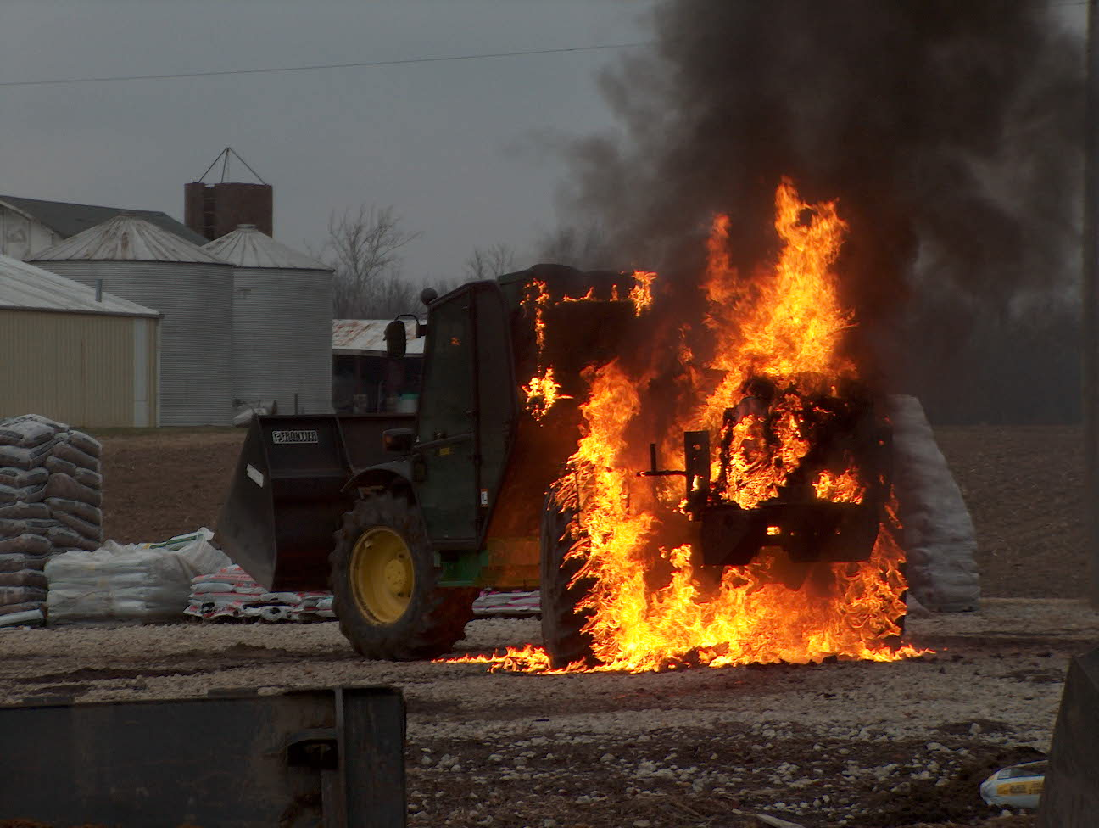 Operations News

We are beginning to inherit a few vacant structures in our response area that are waiting to be razed for future development. These structures are in poor condition and haven’t been maintained. In the past couple of weeks, both Greenwood Fire Department and our department have experienced suspicious fires in vacant structures. Let’s remember to approach fire situations in these structures very cautiously. Strongly consider defensive operations until you evaluate and consider the structure safe to send firefighters inside. Our risk statement says “Risk a life to save a known life, take a calculated risk to save valued property, and take no risk to save that which is already lost”, and vacant structures awaiting demolition are already lost.

The chassis for Engine 53 is to be delivered on April 22-24 to the Crimson Factory. Crimson will be starting on the box prior to delivery of the chassis. We will know more after meeting with Crimson at FDIC and will let you all know the status and completion dates. Be smart and stay safe.

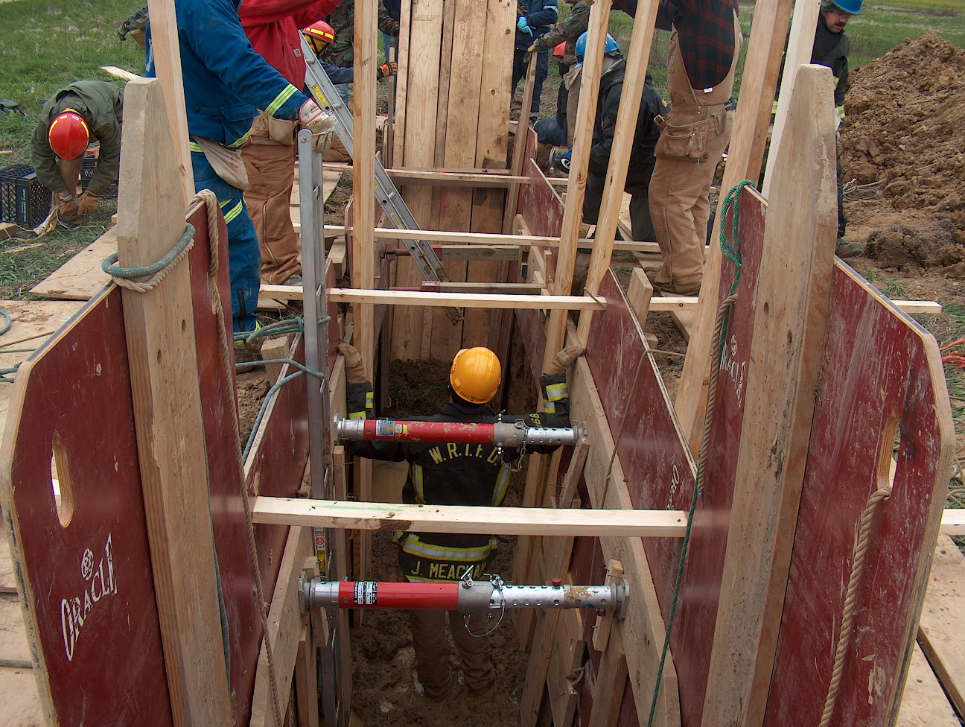 Training News

As of this writing, FDIC is in full swing. All members either have a pass or have unused passes available for classroom sessions and exhibits. I highly encourage all members to attend a classroom session if possible. Thanks to those of you that work hard behind the scenes in order for the show to be a success and for the image of White River Township Fire Department to remain strong.

There is a Shift Training Officer vacancy on the A-shift; anyone interested in filling this position should contact me at your earliest convenience.

Beginning in May, the training division is going to provide a somewhat different format. The first week of the month will be dedicated to covering the Fire Officers Handbook of Tactics by John Norman. This is the finest text on tactics and we will go through it as a department. Theses classes will not provide the Strategy and Tactics prerequisite needed for NFPA Fire Officer I. If you need the prerequisite class, see me at your earliest convenience. The second week of the month will be dedicated to programs developed by the Shift Training Officers. These classes will be mostly hands on and each STO will be responsible for four trainings throughout the year. Weeks three and four will continue to be EMS and Special Operations respectively. Company level training will be conducted by the Company officer at various times throughout the week. This new format will provide a little more structure and cover information that the entire department will find useful.

Upcoming training events.

Register now for summer classes through Ivy Tech or Vincennes. If you need assistance, please see me.

Alan Brunacini, retired fire chief of Phoenix Fire Department, will be coming to New Haven, Indiana on Saturday May 19. Cost is $50 and includes breakfast and his new book, The Anatomy and Physiology of Leadership. See the flyer hanging outside my door for more information.

New Albany Fire School dates are August 11, 12, 18, and 19. More information can be found at www.ifia.org

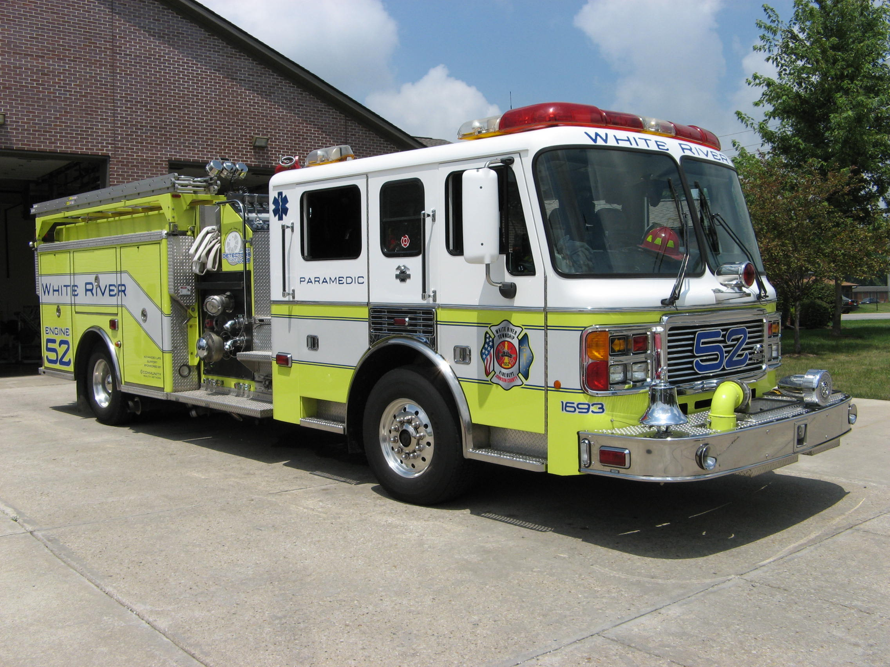 Did you know?

Did you know that during the filming of the movie Ladder 49 the big warehouse scene fire caused a panic in Baltimore? The fire was visible from I-95 and the Baltimore Beltway, so Good Samaritans kept called the fire department to report it. So many people called that the fire department ended up calling radio stations to confess that the scene was being filmed and to request that people stop tying up emergency lines.

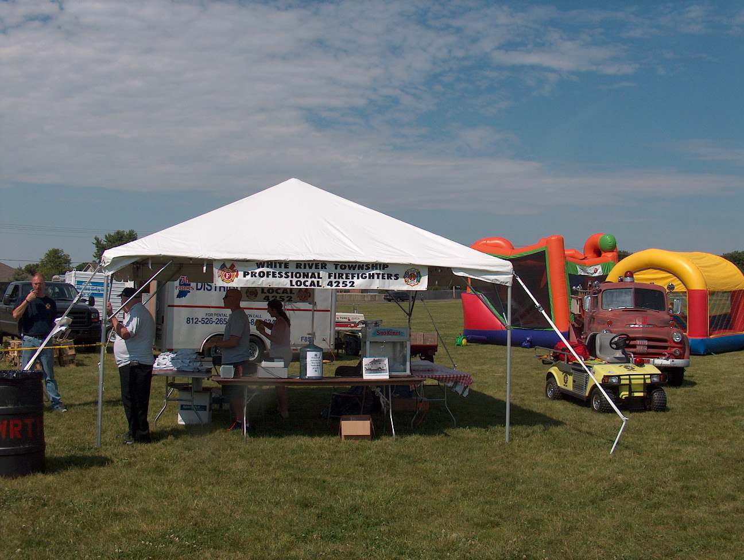 Birthdays (April 20 – May 3)

Carmen Electra April 20 Tony Danza April 21
Jack Nicholson April 22 William Shakesspeare April 23
Kelly Clarkson April 24 Al Pacino April 25
Ulysses S. Grant April 27 Jay Leno April 28
Uma Thurman April 29 Tim McGraw May 1
Bianca Jagger May 2 Doug Henning May 3

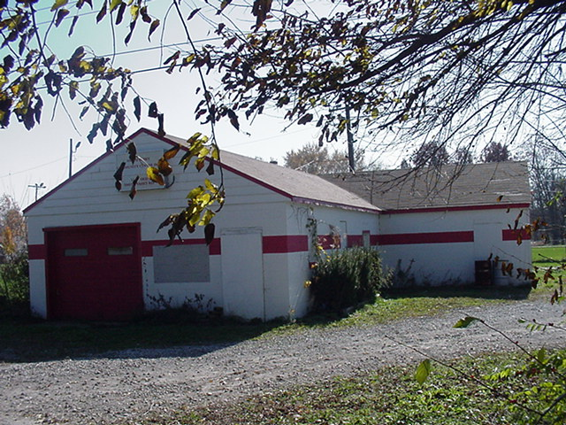 Looking back…..

5 Years ago --- April 30, 2002 White River Twp Fire Department visits Las Vegas! Eight members of the White River Township Fire Department visited Las Vegas, Nevada recently on a week-long odyssey that included a memorial to those lost in the September 11th terrorist attacks. T-Shirts were left in memory of the firefighters that were killed in the line-of-duty that day. The shirts were presented and hung on the temporary memorial at the New York, New York Hotel and Casino in Las Vegas.
5 Years ago --- May 3, 2002 FD participates in Home Depot grand opening The White River Township Fire Department helped welcome The Home Depot to the neighborhood at their official grand opening. Activities included an extrication demonstration by firefighters and a building project for the children. Home Depot awarded the fire department with a new set of tools for their rescue truck as thanks for participating in the grand opening ceremony.

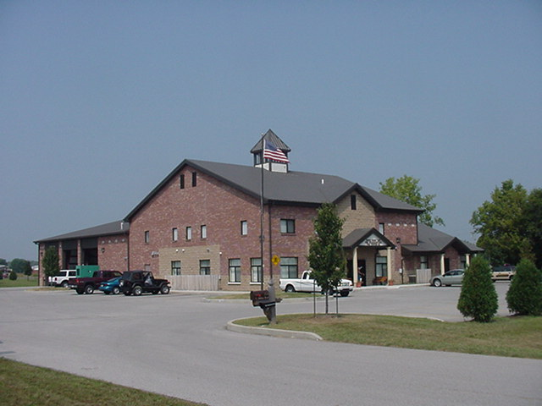 Upcoming events (April - May)

Johnson County Firefighters Assn monthly dinner will be on 4/26/07 at 7pm at Bargersville Fire Station #1.

May 1 - Fire Protection District Board Meeting – 7pm. Station 53
April 2007
S | M | T | W | T | F | S
1 | 2 | 3 | 4 | 5 | 6 | 7
8 | 9 | 10 | 11 | 12 | 13 | 14
15 | 16 | 17 | 18 | 19 | 20 | 21
22 | 23 | 24 | 25 | 26 | 27 | 28
29 | 30
May 2007
S | M | T | W | T | F | S
 |  | 1 | 2 | 3 | 4 | 5
6 | 7 | 8 | 9 | 10 | 11 | 12
13 | 14 | 15 | 16 | 17 | 18 | 19
20 | 21 | 22 | 23 | 24 | 25 | 26
27 | 28 | 29 | 30 | 31

