
Volume 17 Issue 3

April 6, 2007

Inside this Issue

1 Administration
2 Administration 2 Operations
3 Training
3 Did You Know?
3 Birthdays
4 Looking Back
4 Upcoming Events

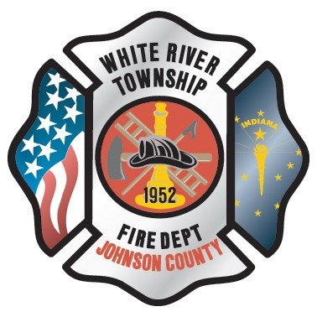 Administration News

Just wanted to take a quick moment to review a couple of policies that I observe we are slipping in. Both are on the lesser end of the significance scale but nonetheless they are official department policies and therefore we should adhere to them.

The first involves smoking and tobacco use. Remember, our current policy prohibits these activities anywhere but designated areas at each station. This includes on the scenes of emergency incidents as well as special details.

The second involves parking. We need to aim our personal vehicles into a designated and striped parking space upon arrival at the station. This does NOT include the ones with the picture of the wheelchair on it. This will ultimately protect you and the department in the event of a backing accident in the parking lot.

“To effectively and efficiently provide professional services to our community”

Congratulations to Rick Woehlecke, the newest career employee of the White River Fire Department. Rick was approved by the Fire Protection District Board to replace Eric Wiseman on 4-3-07. As soon as the required PERF paperwork is completed, hopefully next week, Rick will begin on A shift temporarily until some staffing issues are corrected, then he will be assigned to C shift.

In preparation for the 2008 budget, the department is working on some future projects. These are consolidating the battalion chief officers into one vehicle and discontinuing the practice of take home vehicles. This is mainly due to the fact that we have adequate staffing of in the office to fill Command positions on the fireground. Also, this move will save the department about $36,000 annually and the three battalion chiefs support this move.
Another item of discussion is the investigation of fire-based ALS transport services at White River. The staff and Captain Hart are looking at different options for staffing and equipment purchase, primarily AFG and SAFER Grants. Both of these items were discussed at the April FPDB meeting and the department was directed to continue to research and move forward with both ideas. More information will be coming out in the near future. The last area is realignment of office staff positions. We are attempting to remove administrative responsibilities from operations personnel to improve efficiency. More information will be released at the May FPDB meeting during 2008 budget discussions.

As far as the hiring of a Fire Chief, the FPDB decided to table this item at the April meeting. They are still in the process of finalizing the requirements and job description for this position. They did discuss a possible timeline that identified an August hiring goal. No other items were discussed.

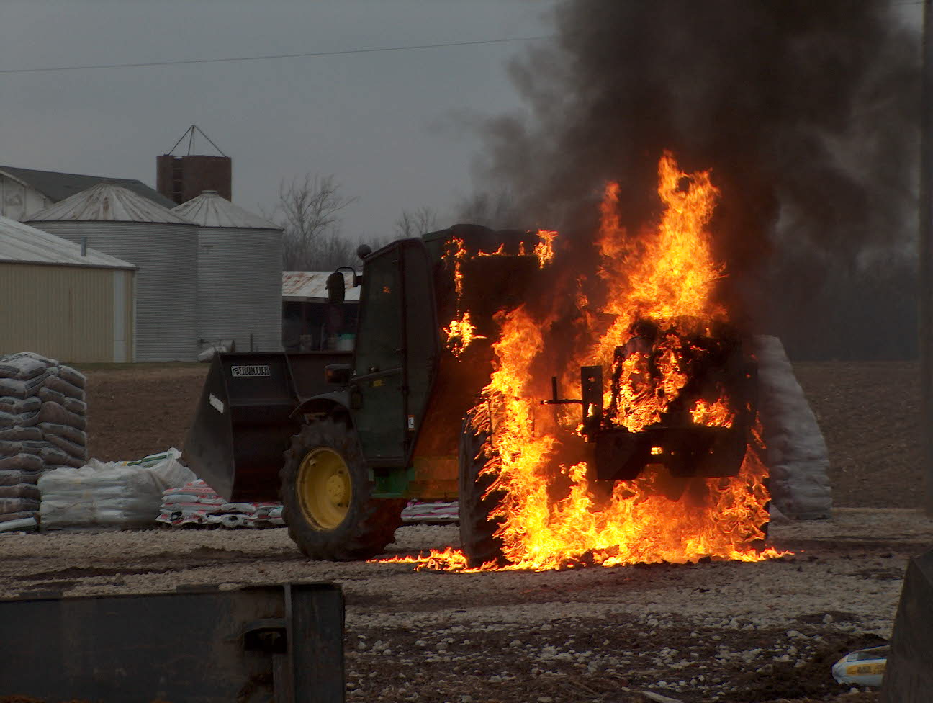 Operations News

A part-time hiring process will begin April 9 to replace day sign up positions and a few open shift positions. The goal is to have these individuals ready for work by the first week of June.

During HOT Monday and Tuesday at FDIC, White River will detail one engine and Ladder 53 for evolutions. If interested in assisting, contact Chief Thacker next week. Remember, you must have permission from your BC if you are on shift during these days.

Ladder 53 suffered serious transmission damage this week. It is currently being repaired and should be back in service the middle of next week. In the mean time, Aerial 91 will respond on all box alarms and Rescue 51 will respond on box alarms and alarm responses incase Aerial 91 is not available. This is the same was we have always done when the ladder is out of service. See your BC with any questions.

Be smart and stay safe.

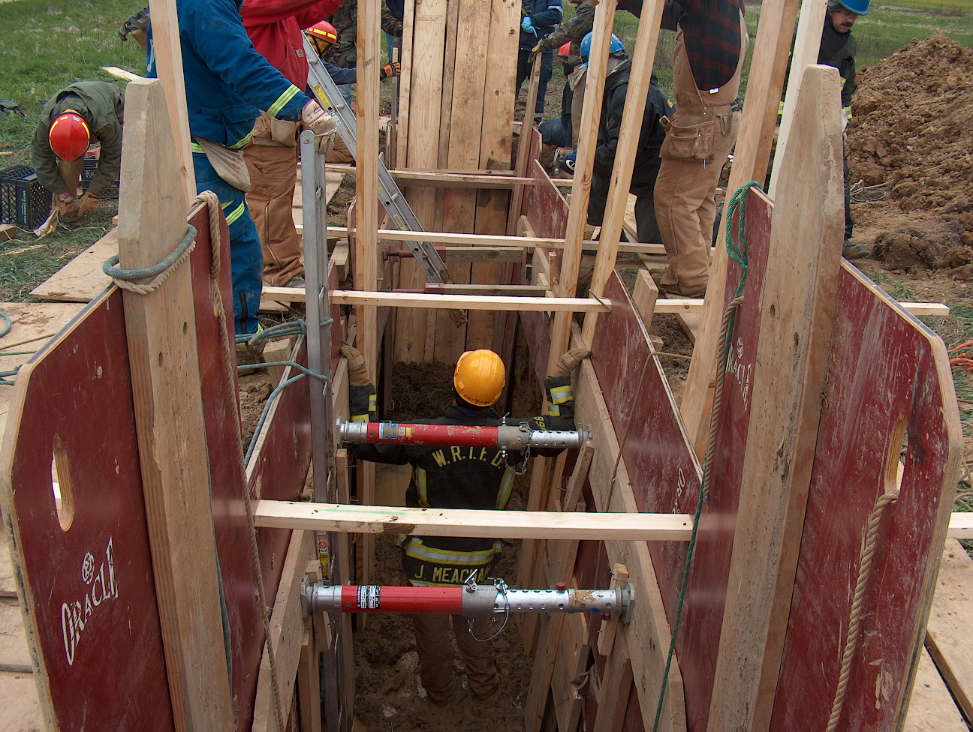 Training News

With the weather changing to more favorable conditions, the goal of the training division is to provide the department with a number of hands on training opportunities. Schoolcraft developers were kind to donate the two buildings on SR 135 for outstanding training over the last week. I am working with other developers in the area to take advantage of other vacant structures for training. More information as it becomes available.

The department will begin a reserve (part-time) process on April 9 and assistance will be needed with written and agility testing as well as interviews. Please contact me if you are interested.

A full time process will begin in May. The senior staff has decided to remove the driver operator requirement for this process as to create a true firefighter list for future hiring. The CPAT portion of the process will be conducted in cooperation with ESEC. Members of the department will be needed to assist with this process as well. More information to follow in the coming weeks.
Stay Safe

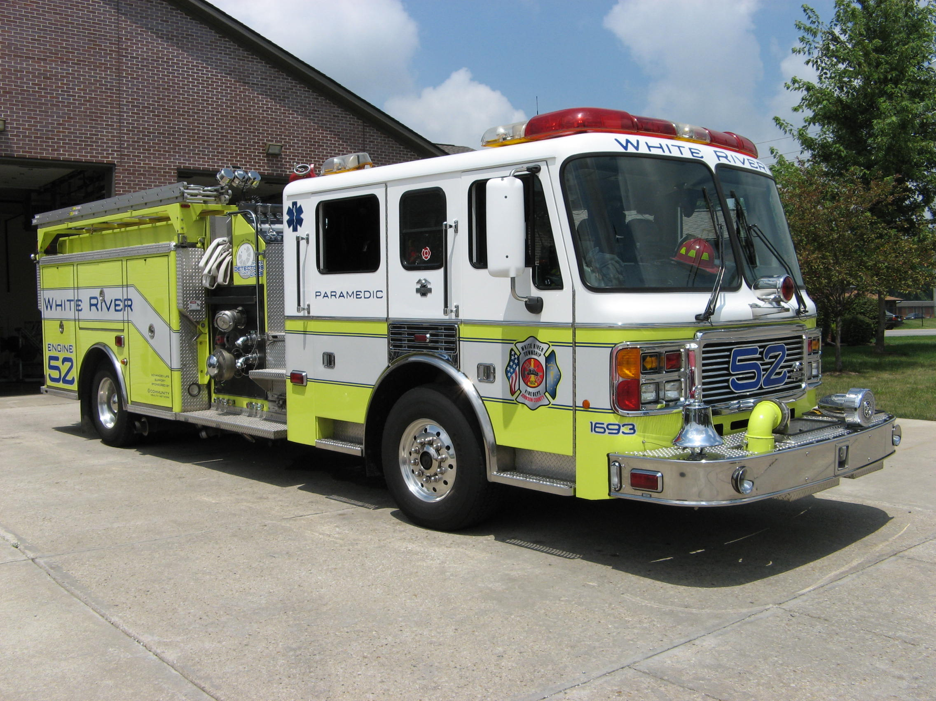 Did you know?

Did you know that Kermit the frog delivered the commencement address at Southampton College located in the state of New York in 1996? 

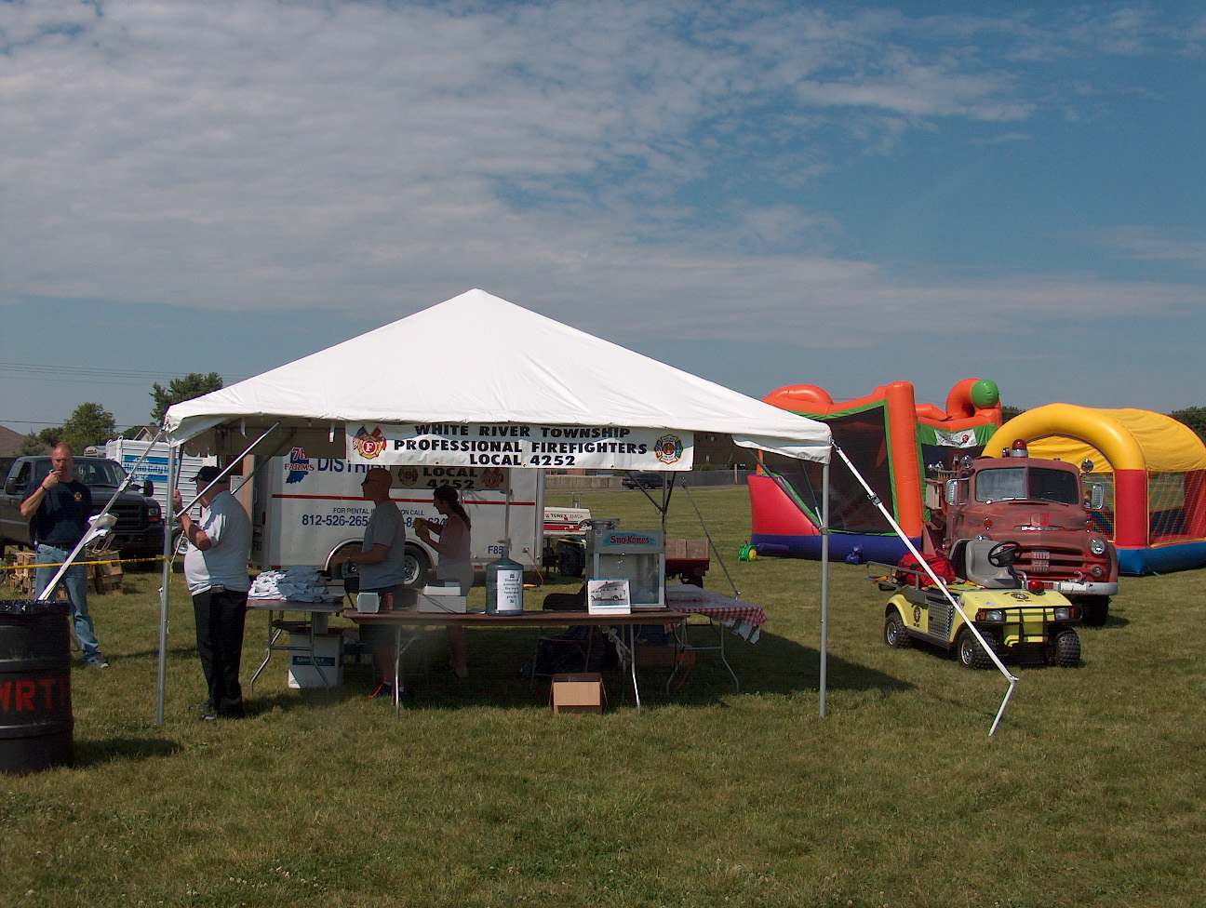 Birthdays (April 6 – April 19)

Ryan Reid – April 8
Edward Carlson – April 10 Lisa White – April 15
Charles Fraker – April 14 Sean Campbell – April 15

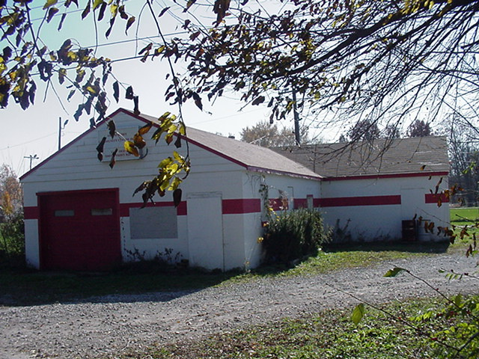 Looking back…..

25 Years ago - April 14, 1982
Two injured while driving to school: Rick J. Whalen, 16, 4364 Redman Drive, Greenwood, was injured in a single-car accident on Morgantown Road, north of Stones Crossing Road. Whalen was driving to school when he lost control of his car and hit a telephone pole. A passenger with Whalen, Richard C. Hill, 16, 4478 Redman Drive, Greenwood, also was injured in the accident.

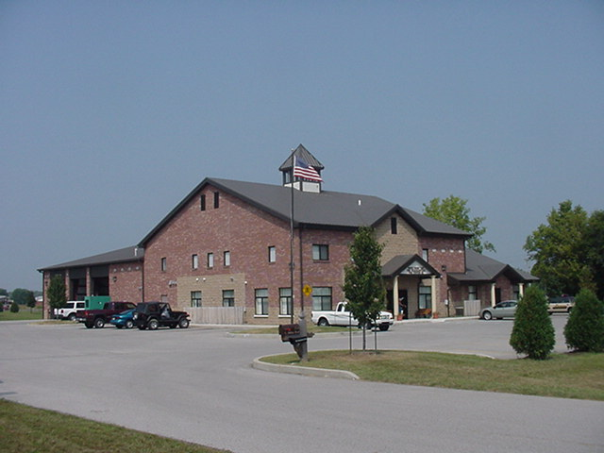 Upcoming events (April – May)

May 1 - Fire Protection District Board Meeting – 7pm. Station 53

April 18 – ‘Arms of Life’ Charity Cookout – 6pm to 9pm. Center Grove High School - The purpose of the Jake and Travis Arms of Life Fund is to honor the lives of Jake and Travis Findley and insure that another tragic accident like this does not happen to our community again. Jake and Travis lost their lives on February 3, 2007 when the SUV they were riding in collided with a train on Stones Crossing Road. This crossing does not have cross arms or flashing lights to warn drivers of oncoming trains. The goal of our fundraising effort is to add flashing lights and cross arms to the railroad crossings at Stones Crossing Road, Whiteland Road, Smokey Row and Olive Branch. This will help protect the hundreds of school buses, thousands of school children and our community in general who use these railroad crossings every day.
APRIL 2007
S | M | T | W | T | F | S
1 | 2 | 3 | 4 | 5 | 6 | 7
8 | 9 | 10 | 11 | 12 | 13 | 14
15 | 16 | 17 | 18 | 19 | 20 | 21
22 | 23 | 24 | 25 | 26 | 27 | 28
29 | 30
MAY 2007
S | M | T | W | T | F | S
 |  | 1 | 2 | 3 | 4 | 5
6 | 7 | 8 | 9 | 10 | 11 | 12
13 | 14 | 15 | 16 | 17 | 18 | 19
20 | 21 | 22 | 23 | 24 | 25 | 26
27 | 28 | 29 | 30 | 31

