
Volume 17 Issue 3

March 23, 2007

Inside this Issue

1 Administration
2 Operations
2 Did You Know?
2 Birthdays
3 Looking Back
3 Upcoming Events

 Administration News

By now you should have read the letter I sent to you via e-mail regarding some of the upcoming as well as immediate adjustments to our daily operations. If you have not yet had a chance to read it, please take a moment to do so. There should be a copy posted at each station as well.

Also be sure to read the policy change pertaining to the Cadet Program as well as Observers and Students regarding riding curfew times.

We are currently in the process of preparing a presentation for the district board outlining the goals and intentions of the current administration (as mentioned in the aforementioned letter). The timing of the delivery has not yet been set in stone, but look for it at an upcoming board meeting.

“To effectively and efficiently provide professional services to our community”

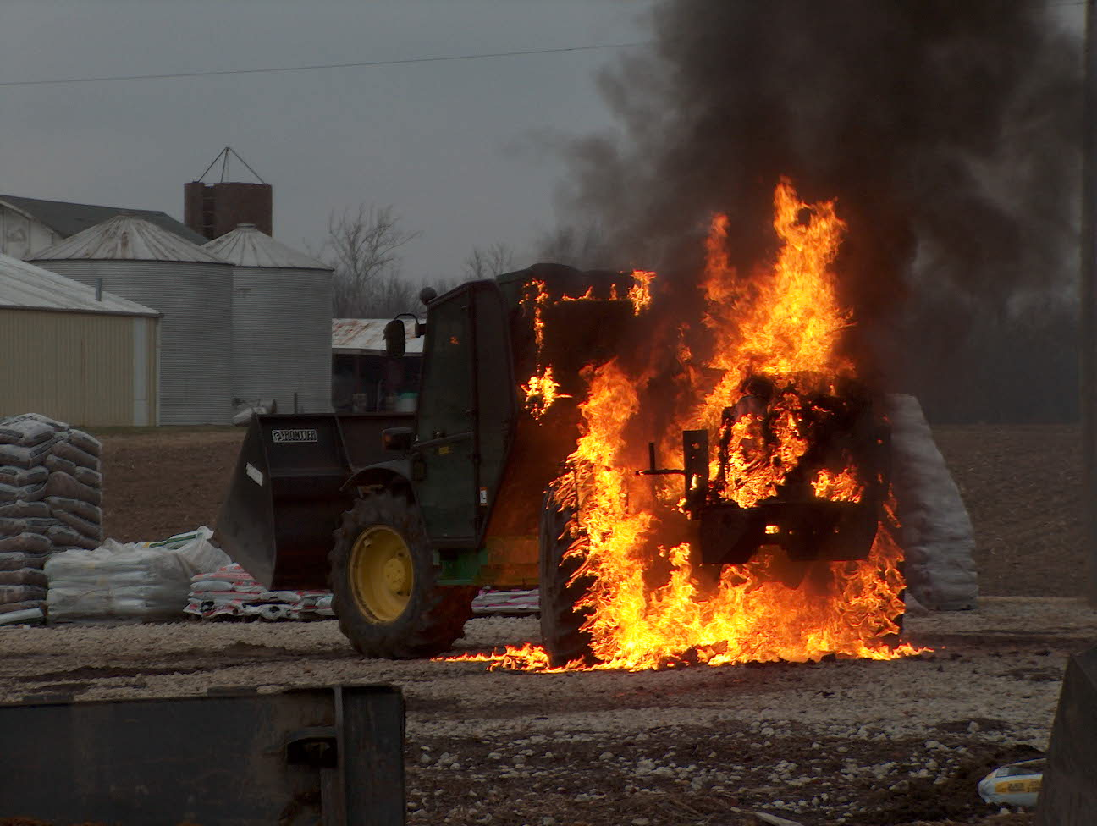 Operations News

The following career positions have changed: Eric Wiseman from career to part-time employee (Congratulations to Eric on his career move to IFD), Engineer Tim Smith is now assigned Engine 52 engineer on B shift, and the float position on B shift is now open for bidding until 3-27-07, 1200.

There are two part time positions on A shift: Engine 53 and Ladder 53 night spots. Please see Battalion Chief Slauter is you are interested. If no one internal accepts these positions, they will be filled by new part time employees.

The new Engine 53 chassis is ready to be delivered to Crimson (South Dakota) in the next couple of weeks and is slated to be finished late spring/early summer. The last update I received was March 10.

That is it for now, keep up the good work you do and stay safe.

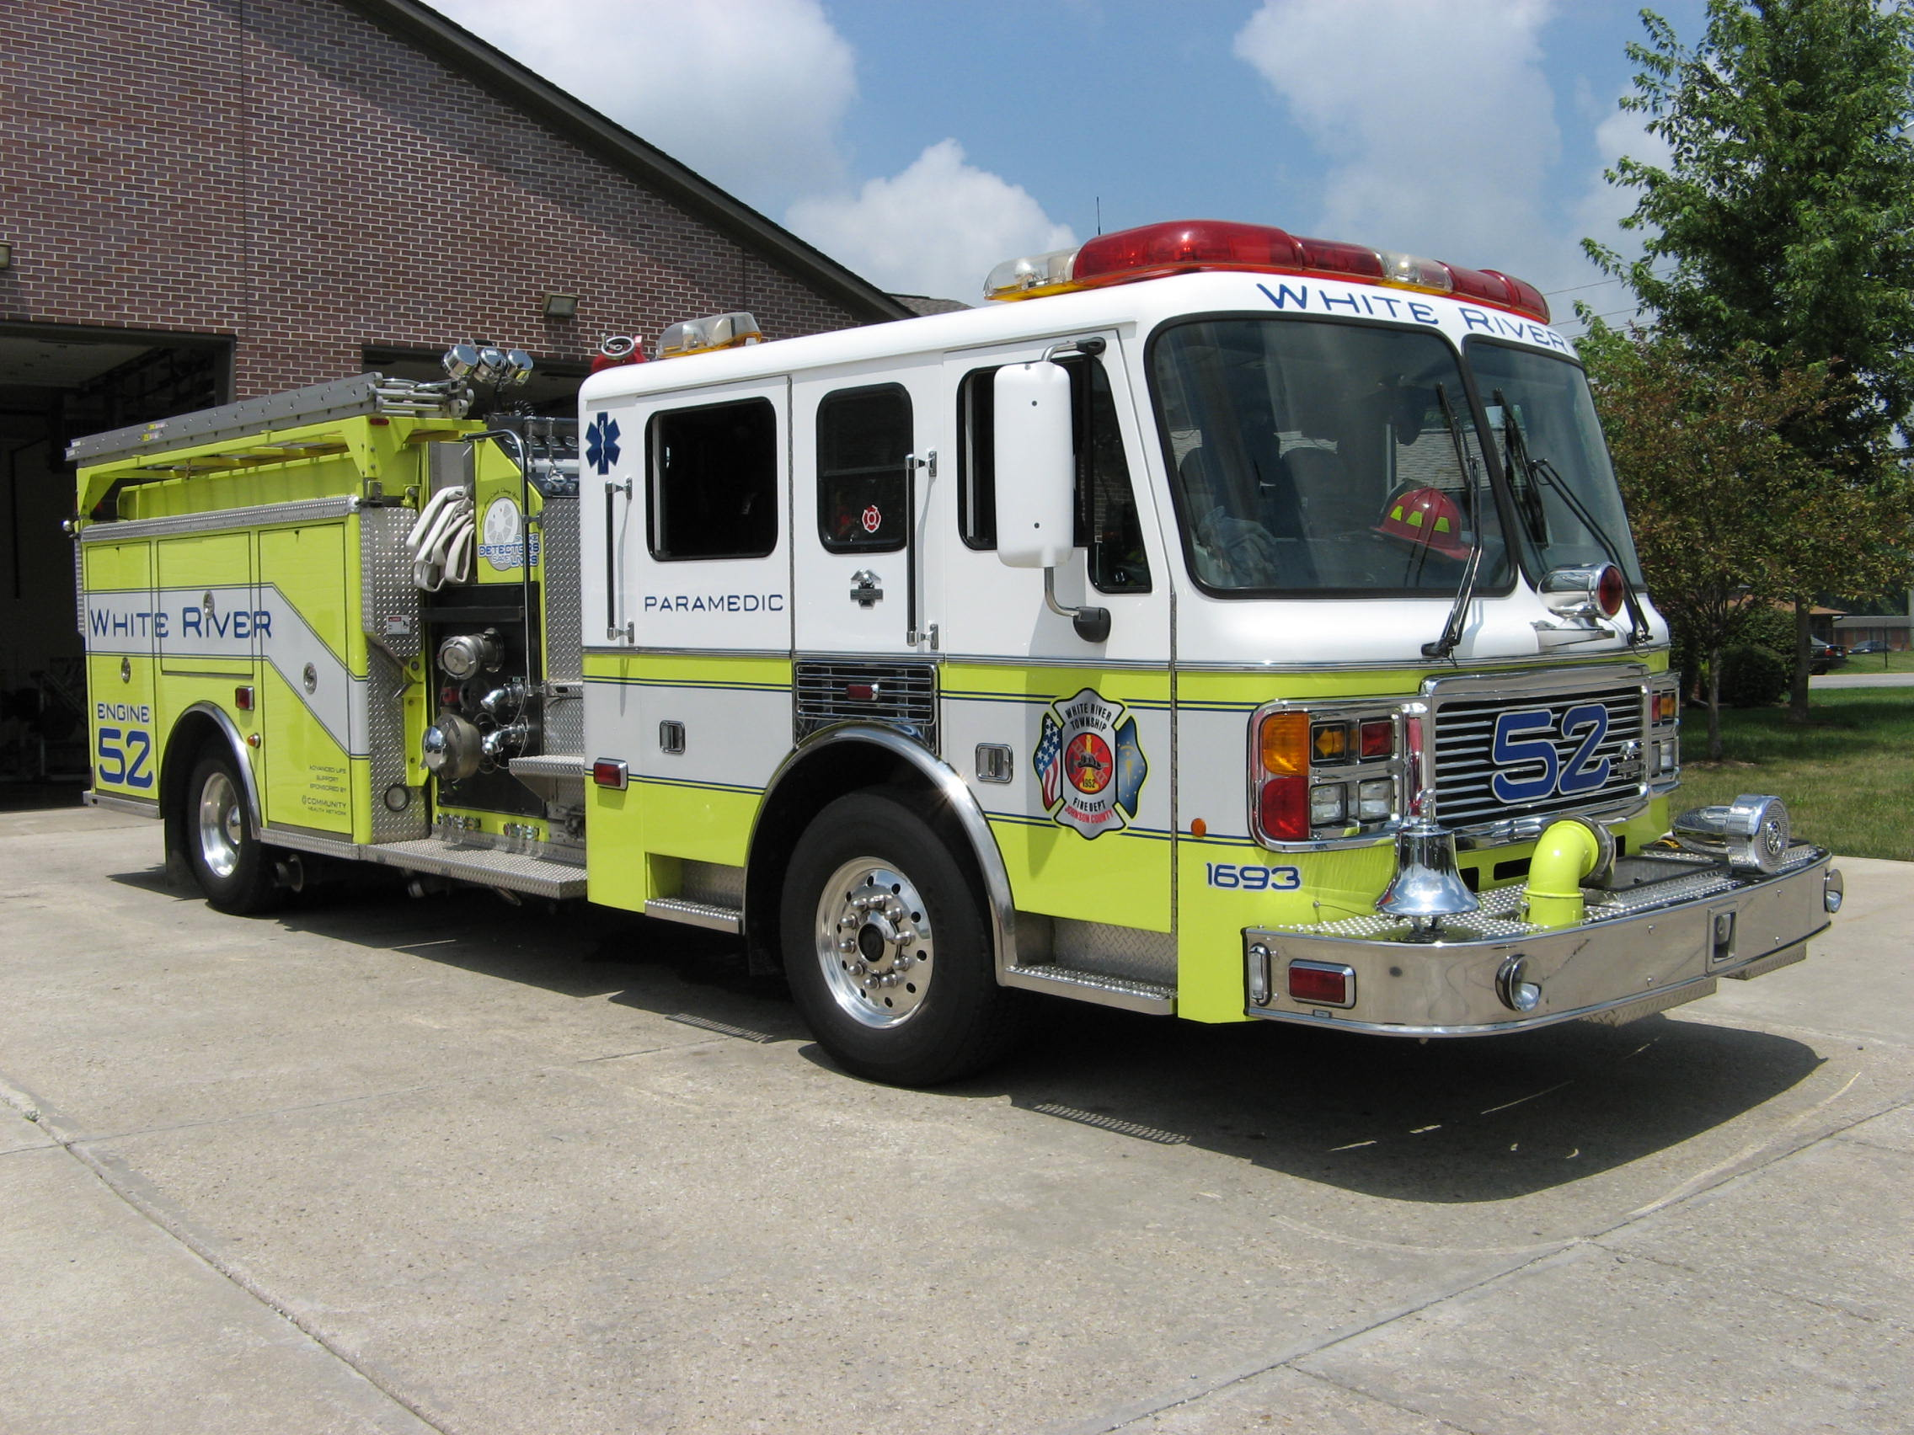 Did you know?

Did you know why fire hydrants are different colors? Red fire hydrants have a flow rate under 500 gallons per minute. Yellow fire hydrants have a flow rate between 500 and 999 gallons per minute. Green fire hydrants have a flow rate between 1000 and 1499 gallons per minute. Blue or light blue fire hydrants have a flow rate of 1500 gallons per minute or higher.

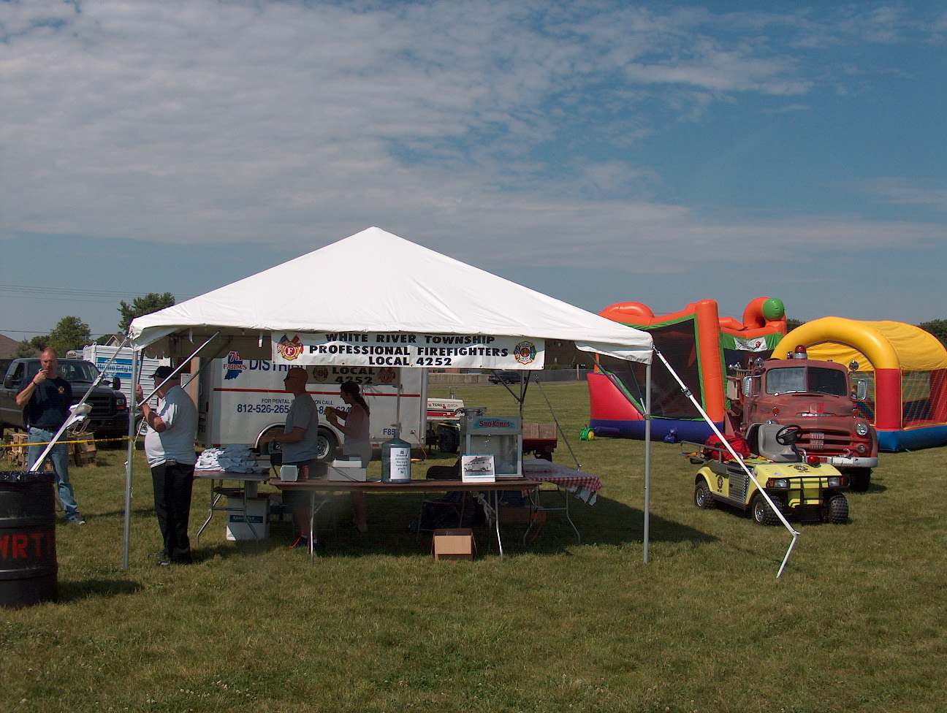 Birthdays (March 23 – April 5)

Andrew Roy – April 2
Jacob Kocher – April 3
Lucas Stanton – April 3

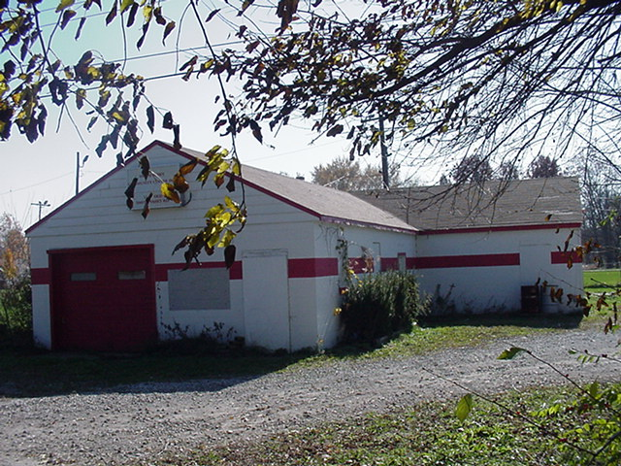 Looking back…..

30 Years ago - April 4, 1977
Series of field fires extinguished
Sunday morning while many Johnson County residents were on their way to Church for special Easter services - a number of Johnson County firefighters were answering a call for help as a number of raging grass fires were spreading along the ConRail (Penn Central) railroad tracks from Greenwood to Whiteland. Fire officials are blaming a ConRail freight train which was sending sparks intro dry grass, as the cause of at least six fires which spread from County Line Road to Whiteland Road Sunday morning.
Firefighters from Greenwood, White River Township, and Whiteland battled the grass fires throughout Sunday and into the early evening. The firefighters were assisted by a number of nearby residents, including one youth on a trail bike who carried messages from field to the command post, and a farmer who brought out a tractor to plow over the field and contain the fire.

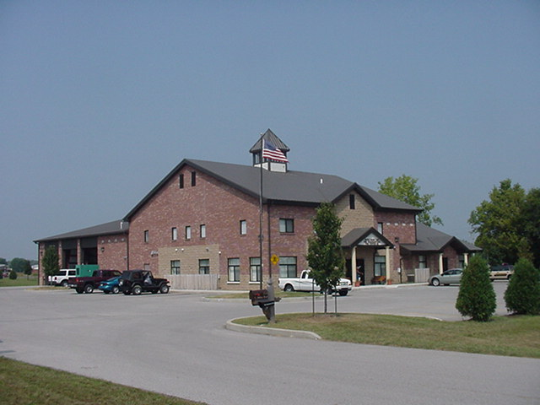 Upcoming events (March - April)

April 3 - Fire Protection District Board Meeting – 7pm. Station 53

March 2007
S | M | T | W | T | F | S
 |  |  |  | 1 | 2 | 3
4 | 5 | 6 | 7 | 8 | 9 | 10
11 | 12 | 13 | 14 | 15 | 16 | 17
18 | 19 | 20 | 21 | 22 | 23 | 24
25 | 26 | 27 | 28 | 29 | 30 | 31
APRIL 2007
S | M | T | W | T | F | S
1 | 2 | 3 | 4 | 5 | 6 | 7
8 | 9 | 10 | 11 | 12 | 13 | 14
15 | 16 | 17 | 18 | 19 | 20 | 21
22 | 23 | 24 | 25 | 26 | 27 | 28
29 | 30

