
Volume 17 Issue 3

March 9, 2007

Inside this Issue

1 Administration
2 Administration
2 Operations
2 Training
3 Training
3 Did You Know?
3 Birthdays
4 Looking Back
4 Upcoming Events

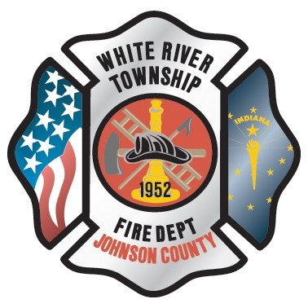 Administration News

As you all know, Chief Tibbetts officially worked his last day at White River on Friday, March 2nd which culminated in the farewell sendoff that was held in his honor that afternoon. The Fire Protection District Board has since named Chief Cassin as the interim Fire Chief until a replacement has been chosen. The specifics of the process have yet to be determined so it may be some time before the vacancy has been permanently filled. I would like to start by putting the message out there that although there is a change in the works with the upper management of this department, there should be no immediate effects at the operational level. With that being said, there is however a few items that I feel need some immediate attention and those particular issues are being handled as a priority. Details of these concerns will be addressed under separate cover early next week after discussions with other staff members have taken place. In the meantime, keep up the good work and stay safe.

The 2007 Salary Survey is now complete. After nearly three months of work, the results are posted on our web site at www.wrtfd.org/survey.htm. Thanks to all those who helped with the project, particularly Jackie.

You may have seen some employees of the State Board of Accounts around lately as we are still in the process of completing the state financial audit. We are almost finished and their final report should be forthcoming.

“To effectively and efficiently provide professional services to our community”

The Firehouse Software / Spillman CAD system integration is now complete. This is the system that allows our FH system to ‘capture’ the dispatch information and place it on our server thereby eliminating the need to call for times. See the memo in your e-mail inbox for more details.

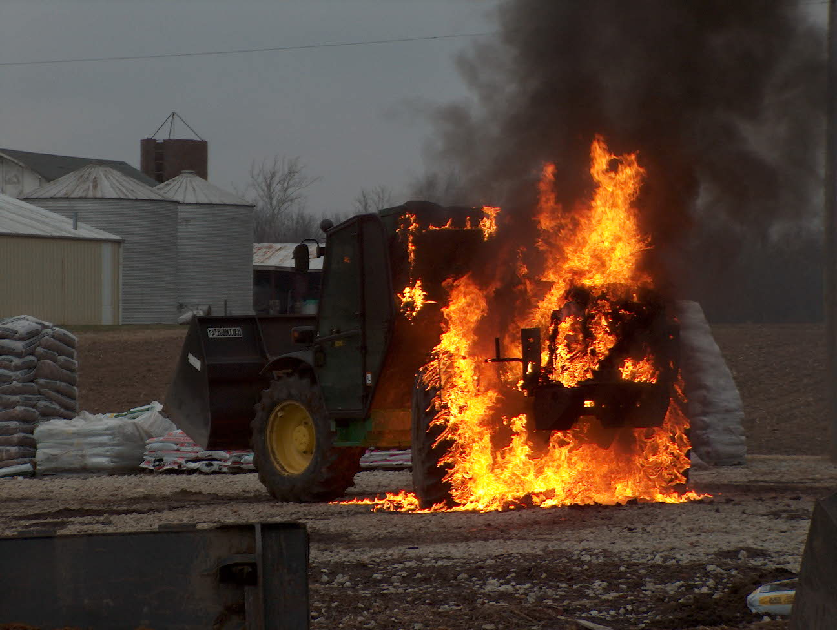 Operations News

There are several new SOGs that are ready to be put into our operations over the next month. Chief Thacker and I will be working out training times to introduce these new SOGs to the crews. Battalion Chief Wilson is working on organizing and formatting these SOGs and they will be released when he completes this task.

There are a few open part time shifts currently open. The Chief Officers are waiting for some other issues to settle and then we will conduct a part time hiring process. Please see Battalion Chief Slauter with any questions.

Remember that if you sign up for schedule hours, please have your requests entered into the computer by 10th for the following month.
That is it for now, be and stay safe and continue the great job that you do everyday.

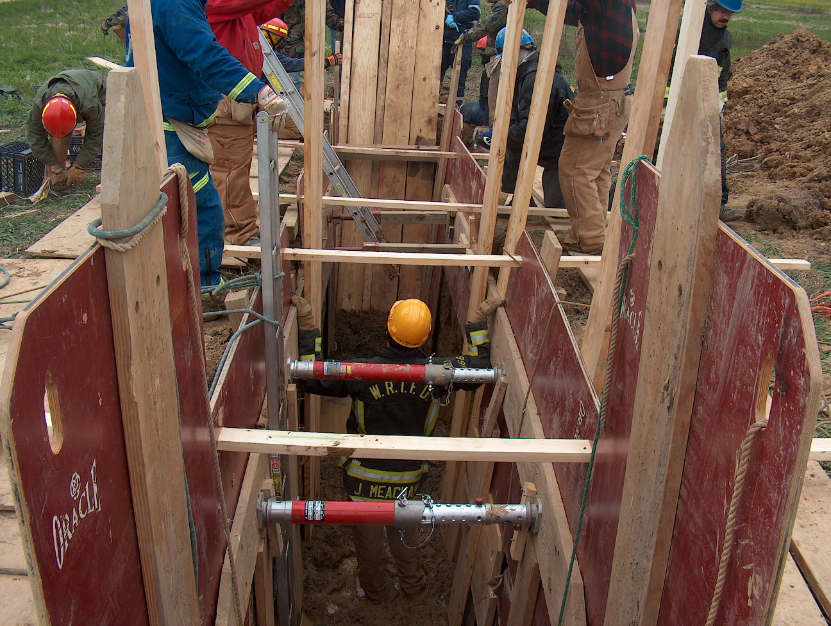 Training News

As always the training division has been busy planning and conducting classroom and hands on programs.
Currently a Driver Operator – Pumper class and Fire Investigator class are being conducted in the training room. Check the schedules with Chief Brown (Fire Investigator) and Mike Rude (pumper) if there are some times you would like to sit in for further knowledge. If you are interested in joining the Pumper Class please contact me or Mike Rude immediately, this class just started on March 6.

Practical exercises were conducted this week at the Wayne Twp Fire Training Tower. All shifts and stations participated in company level and combination drills. We will offer this training at least two more times this year. I will try to schedule at least one set of the practicals for a weekend in which night time personnel may possibly attend. We will critique the training and review methods of fire attack next week.

Thanks to Jackie for completing the FDIC badge paperwork. All department members, including auxiliary, will be receiving a FULL CONFERENCE PASS to FDIC 2007. This pass is good Wednesday through Friday classes and exhibits. Plan to spend some time attending the classroom sessions.

Upcoming Training Opportunities Include:
Indiana Weekend at the National Fire Academy – March 17-18.
Chief Vincent Dunn FDNY (ret) in Lafayette hosted by Lafayette FOOLS –
March 17

Duneland Fire School – March 23, 24, 25, 30, and April 01

See me to get information on any of these programs

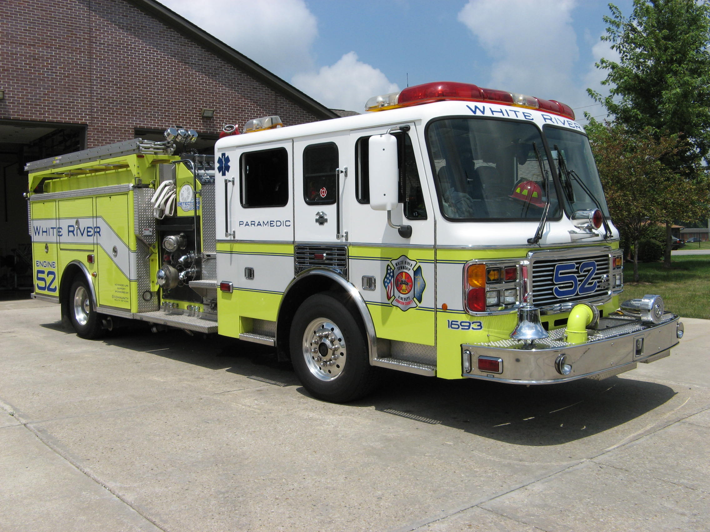 Did you know?

Saturday March 17th is Saint Patrick’s Day. The legends say that Saint Patrick drove all the snakes out of Ireland -- that they all went into the sea and drowned.
The first American celebration of Saint Patrick's Day was in Boston, Massachusetts, in 1737. As the saying goes, on this day "everybody is Irish!" Over 100 U.S. cities now hold Saint Patrick's Day parades, the largest is held in New York City.
What's good luck on Saint Patrick's Day? Finding a four-leaf clover (that's double the good luck it usually is).
Wearing green. (School children started this tradition of their own -- they used to pinch classmates who don't wear green on this holiday).
Kissing the blarney stone.

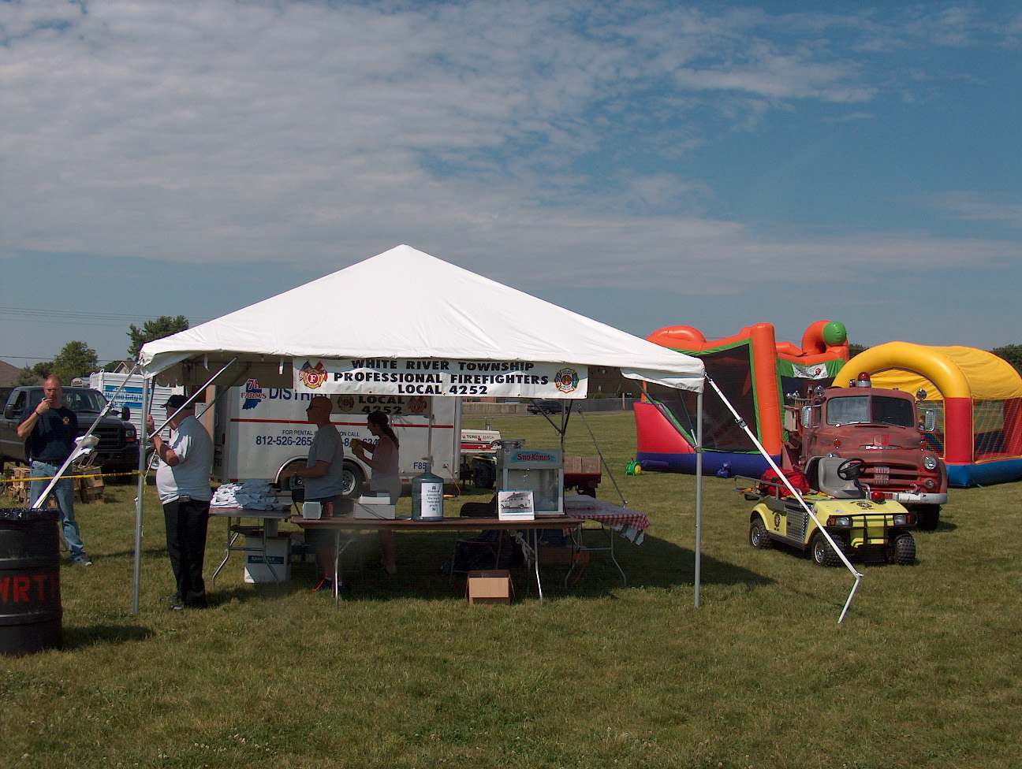 Birthdays (March 9 – March 22)

Dale Saucier – March 11 Steve Rowland - March 20
Jackie Emmons - March 22 Jeff Smith – March 22

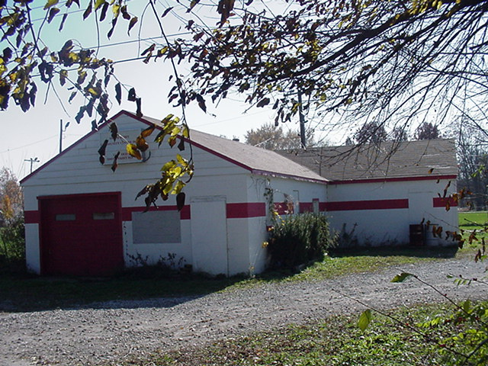 Looking back…..

25 Years ago- March 17, 1982 - Anxious baby starts life in fast lane.
Leslie Ann Williams was born in the fast lane, all 7 pounds and 6 ounces of her, rushed to join the world about 10 miles and at least 10 minutes sooner than her mom and dad, James and Sharon Williams, expected. Leslie Ann was born about 12:30 a.m. in the family car on State Road 37. State Trooper Rick Kauffman pulled her father over after clocking him at 94 mph and assisted with the birth. Very soon after that the White River Township volunteer firefighters, County Sheriff’s Deputies, and a Myers ambulance arrived-a pretty impressive welcoming committee for the young Miss Williams.

30 Years Ago - March 16, 1977 - Father makes special delivery. When Ernie and Nikki Arney made plans to use natural childbirth for the birth of their second child, they had no idea just how natural it would be. Kenda was born March 14 at the couple’s home when the impatient infant made her debut three days early just 55 minutes after the 23-year-old Mrs. Arney felt her first labor pain. Her daddy was the attending “physician” and her big brother Jason, age 3, watched wide-eyed as his new baby sister was born with no complications. Shortly after Kenda’s birth, members of the White River Township Volunteer Fire Department rescue squad arrived to help mother and baby.

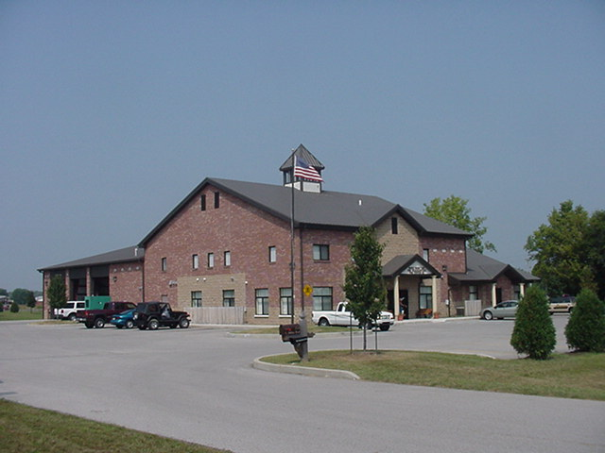 Upcoming events (March - April)

April 3 - Fire Protection District Board Meeting – 7pm. Station 53

March 14 - Community Paramedic Graduation – 6:30pm at Marriott Convention Center on East 21st Street.
March 2007
S | M | T | W | T | F | S
 |  |  |  | 1 | 2 | 3
4 | 5 | 6 | 7 | 8 | 9 | 10
11 | 12 | 13 | 14 | 15 | 16 | 17
18 | 19 | 20 | 21 | 22 | 23 | 24
25 | 26 | 27 | 28 | 29 | 30 | 31
APRIL 2007
S | M | T | W | T | F | S
1 | 2 | 3 | 4 | 5 | 6 | 7
8 | 9 | 10 | 11 | 12 | 13 | 14
15 | 16 | 17 | 18 | 19 | 20 | 21
22 | 23 | 24 | 25 | 26 | 27 | 28
29 | 30

