
Volume 17 Issue 3

February 23, 2007

Inside this Issue

1 Administration
2 Operations
2 Prevention
2 Training
3 EMS
3 Did You Know?
4 Birthdays
4 Looking Back
4 Upcoming Events

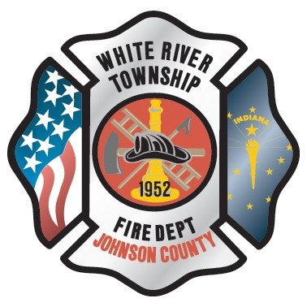 Administration News

As you now know, Chief Tibbetts will be serving his last day on Friday, March 2nd. After a 10 year career at White River, he is moving on to spend more time with his wife. There will be an open house on Friday, March 2nd from noon to 2pm at HQ to bid farewell and is open to everyone.

The scope and purpose of the department’s Special Operations Division has been officially ratified by the Chief Officers. All of the details of the program are outlined in writing and available for viewing via the department’s web site. You can access the document by logging into the employee page of the site and selecting ‘Programs’ from the list of employee resources. From there simply select the ‘Special Operations’ program. If you have any questions, see Captain Settles.

Because of the recent cold and snowy weather, progress at the new fire station has been extremely slow. It needs to dry up a bit (a lot) in order to move dirt around the building. Once this is done, permanent water drainage can be put in place. This, coupled with permanent sump equipment, will assure that the basement will be dry. Until then, drywall and utility hook-up is on hold.

“To effectively and efficiently provide professional services to our community”

Special thanks to all the crews who helped clear the snow and ice from the sidewalks and our parking lots.

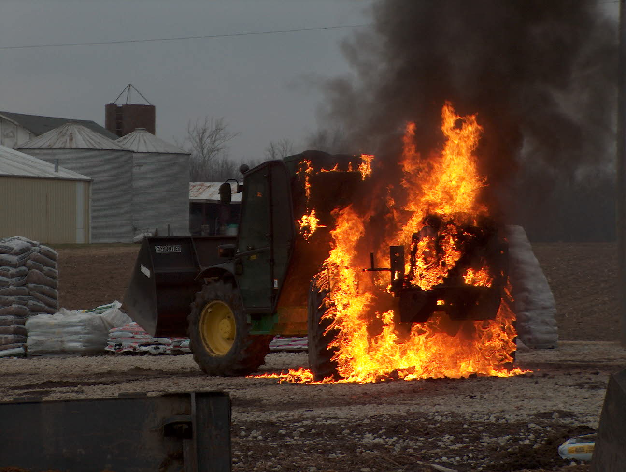 Operations News

I would like to thank all who attended the Hazmat Technician class. I heard several comments from the instructors regarding the quality and professionalism of our organization, our top of the line equipment and apparatus, and the participation and commitment of our personnel to make the class successful. Also, I would like to thank all who filled in open shifts to keep staffing levels appropriate. Lastly, I would like thank Chief Thacker and Captain Hart for making the class possible.

Vehicle lock out kits have been placed on Engine 51 and Ladder 53. Also, elevator key sets have been added to Engine 52 and Engine 53.

The company that makes the Chimfex chimney extinguishers burned down a couple of years ago and there are no companies that make this product. We are down to only a couple of Chimfexes left on the apparatus. From now on, we will be keeping “chimney bags” on the apparatus. These are zip lock bags filled with ABC multipurpose chemical. During a chimney fire, a crew will need to dump the chemical down the flue. Please make sure the damper is closed and the flue is covered on the roof. This will work the same as the Chimfex. There will be a 5 gallon bucket of ABC multipurpose chemical at HQ in the upstairs equipment lock up if refills are needed. If you have any questions, please see Battalion Chief Slauter.

Thank you for all that each of you do everyday to make our department great.

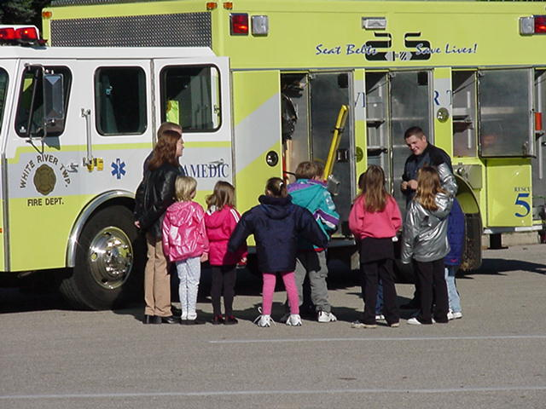 Fire Prevention News

No new news to report this week.

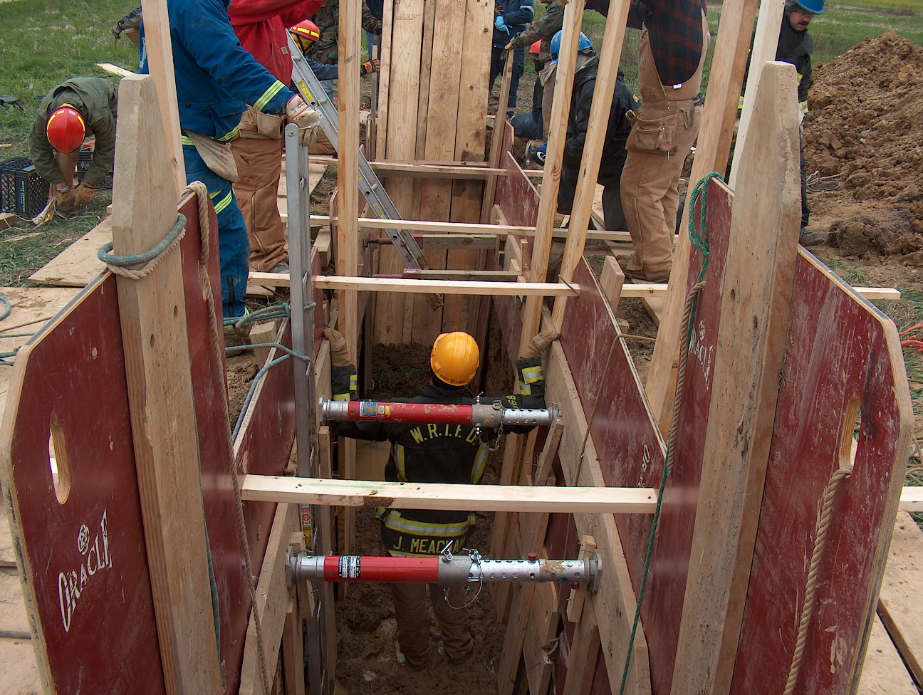 Training News

No new news to report this week.

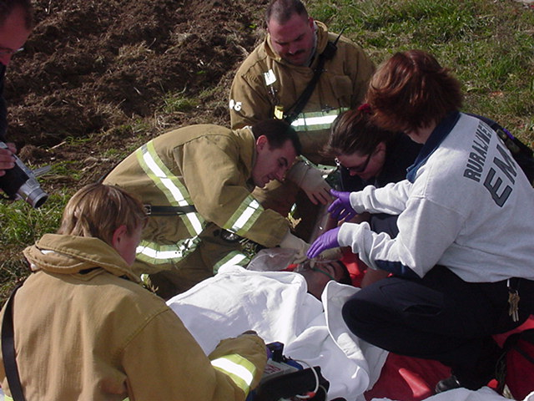 EMS News

Reminder that the protocols are changing slightly starting 3-1-07. Here are the highlights:

SOR: A call is required for age <1. This was previously age <3.

Allergic reaction amended to allow treatment for itchy rash only. In the past there was no treatment offered for this. The rationale is to improve patient comfort.

Pain management amended to allow treatment for any painful condition. This DOES NOT require the medics to give pain meds if they think the patient is drug seeking. This should allow for more medic judgment than the previous protocol. Also, the initial Fentanyl dose has been increased.

Vomiting. The med has been changed to Metaclopramide. (Reglan) This was changed due to some medics complaining the phenergan is too sedating. Reglan is less sedating than phenergan and has less incidence of dystonic reactions. You may use up all of your phenergan before changing if you wish.

C-spine amended to give medics more judgment.

The crichothryotomy protocol has been simplified, and is more consistent with how we have been teaching it.

Anybody that has any questions let me know.

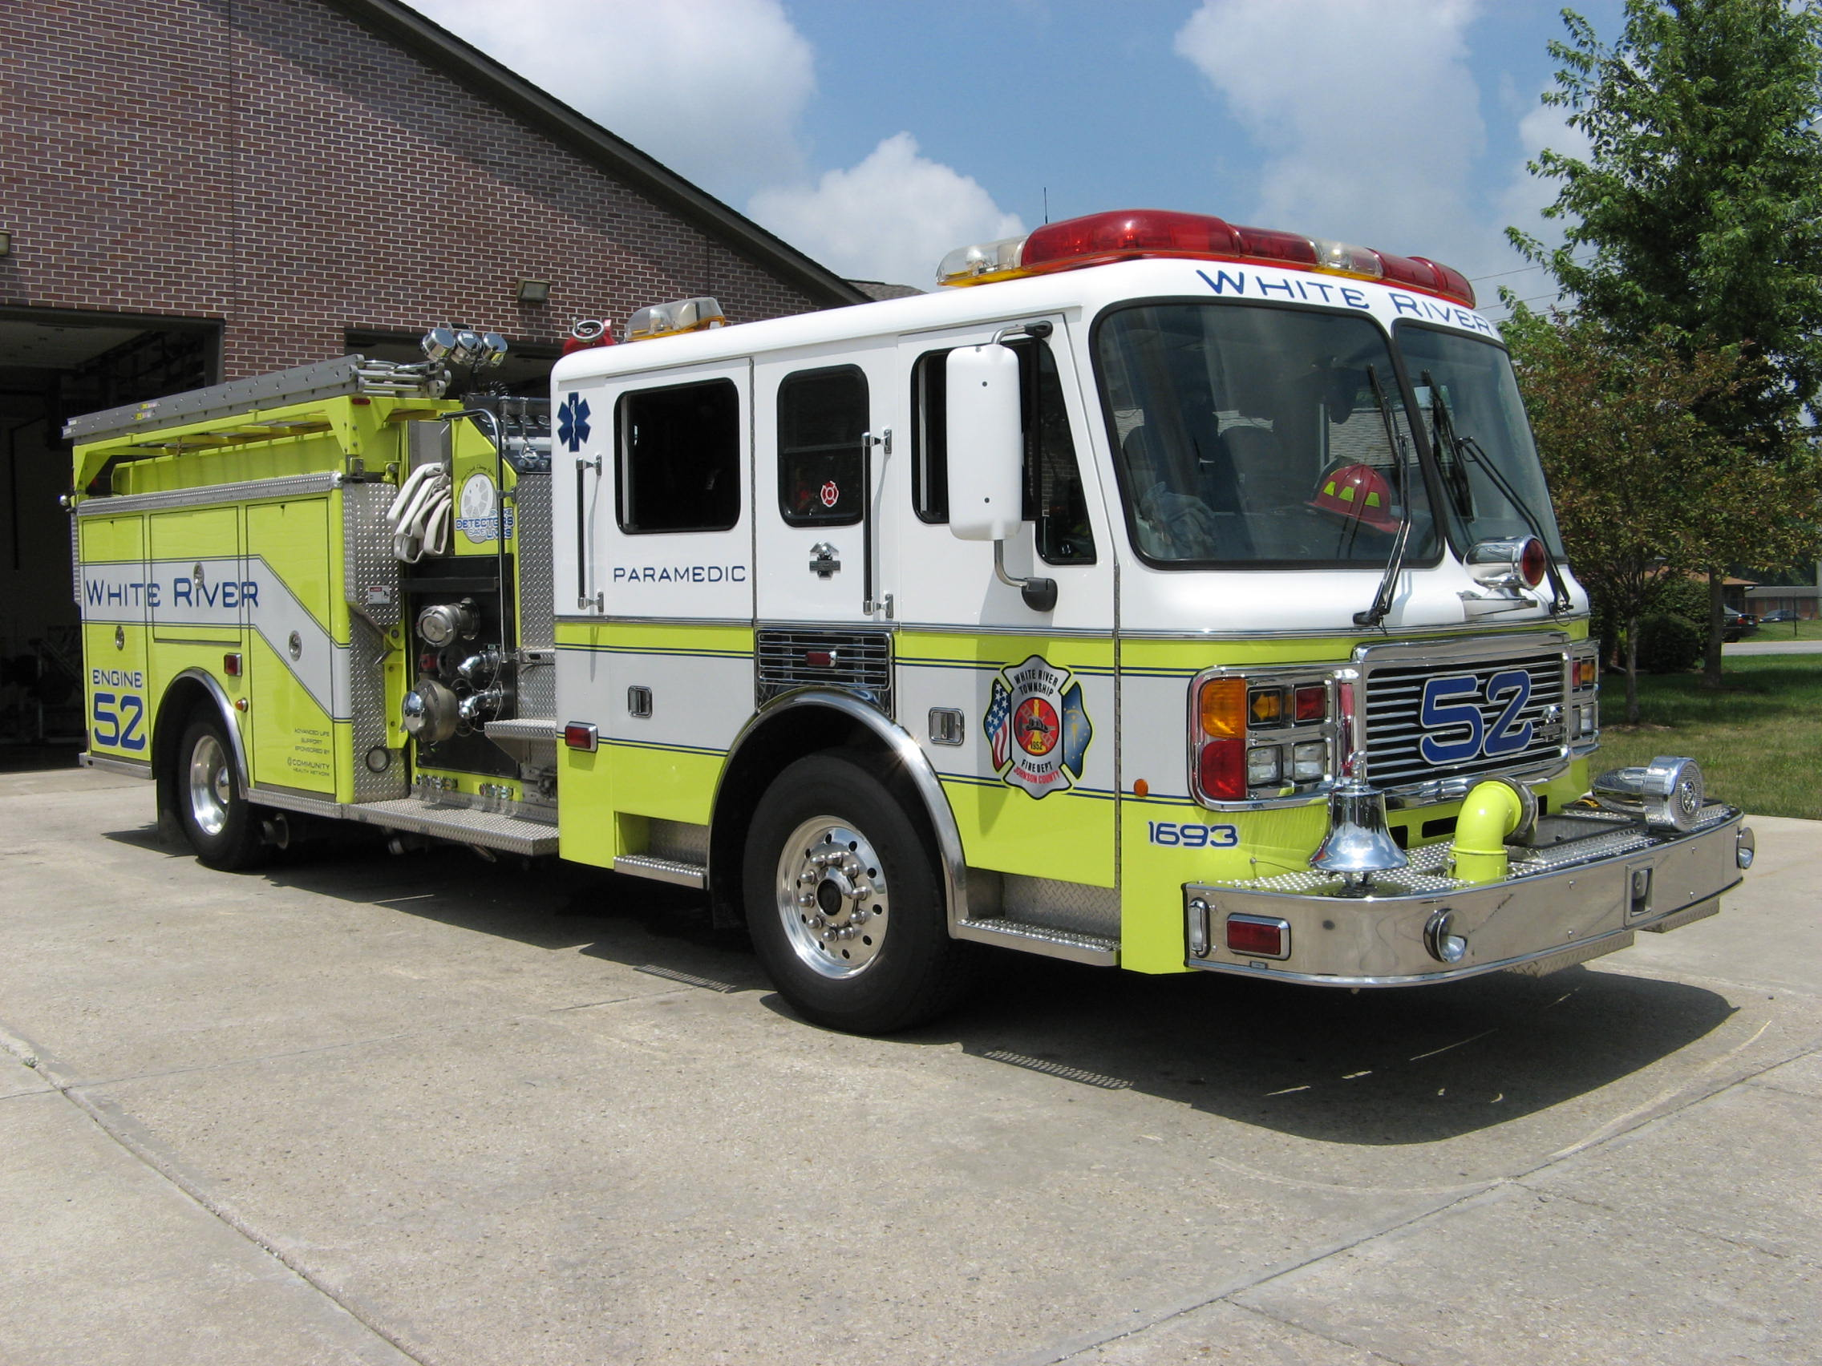 Did you know?

Did you know that Fire Prevention Day was begun by the Fire Marshals Association of North America, now part of the National Fire Protection Association (NFPA)? The day was first proclaimed by President Woodrow Wilson on the 40th anniversary of the Chicago blaze.

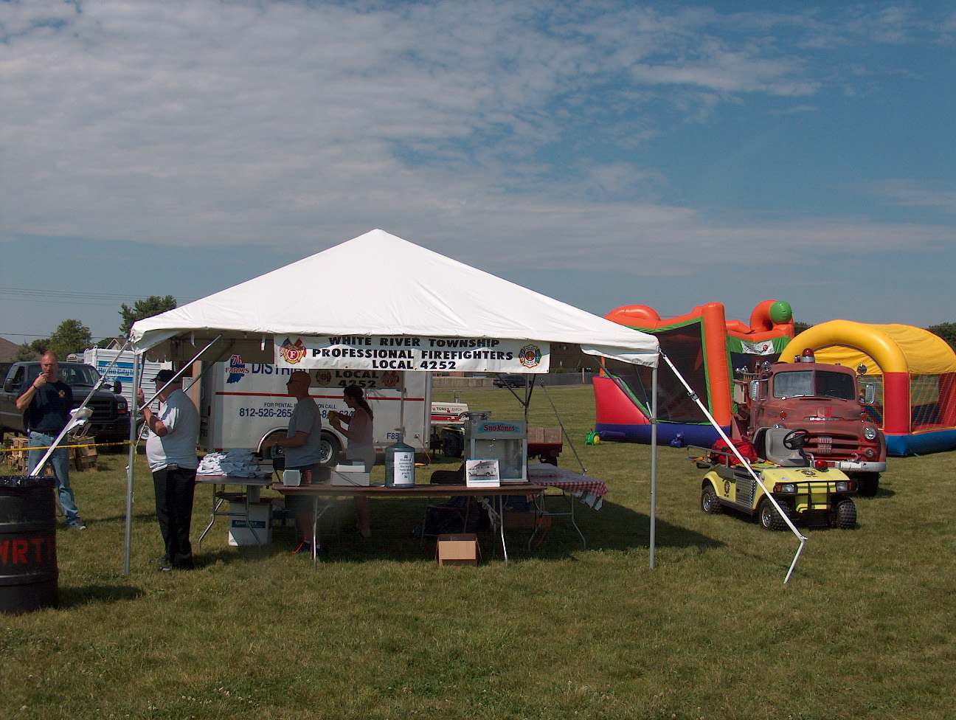 Birthdays (February 23 – March 8)

Ronald Metcalf – February 23
Richard Woehlecke – February 24
Jeffrey Wilson – February 26
Scott Tichenor – March 5

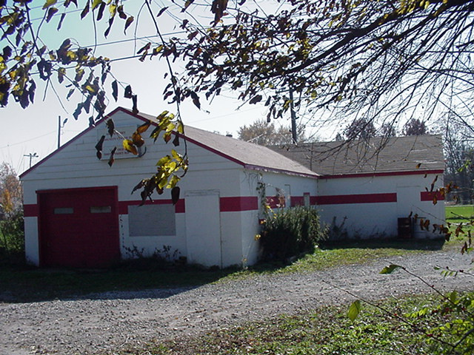 Looking back…..

5 Years ago…. 03/08/2002 – A large brush fire consumed a field and threatened nearby homes near the Glendale Trailer Park. The fire required all hands as well as mutual-aid companies.
30 Years ago…. 02/27/1977 - A kitchen fire broke out in a trailer home in the Oak Meadows trailer park. The stove was totaled and caused $95 in damage.

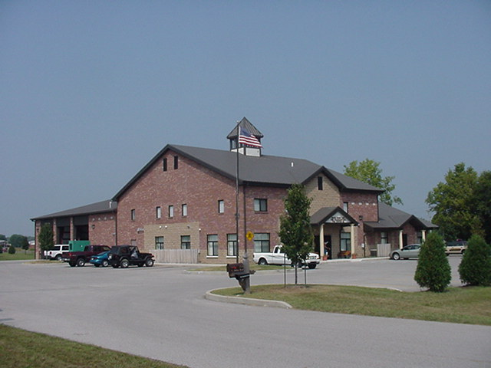 Upcoming events (March)

March 2 – Open House to Honor and bid farewell to Chief Michael Tibbetts Friday, March 2 from Noon to 2 pm. Station 53

March 6 – Fire Protection District Board Meeting – 7pm. Station 53
March 2007
S | M | T | W | T | F | S
 |  |  |  | 1 | 2 | 3
4 | 5 | 6 | 7 | 8 | 9 | 10
11 | 12 | 13 | 14 | 15 | 16 | 17
18 | 19 | 20 | 21 | 22 | 23 | 24
25 | 26 | 27 | 28 | 29 | 30 | 31
APRIL 2007
S | M | T | W | T | F | S
1 | 2 | 3 | 4 | 5 | 6 | 7
8 | 9 | 10 | 11 | 12 | 13 | 14
15 | 16 | 17 | 18 | 19 | 20 | 21
22 | 23 | 24 | 25 | 26 | 27 | 28
29 | 30

