
Volume 17 Issue 3

February 9, 2007

Inside this Issue

1 Administration
2 Operations
3 Prevention
3 Training
3 EMS
3 Did You Know?
4 Birthdays
4 Looking Back
4 Upcoming Events

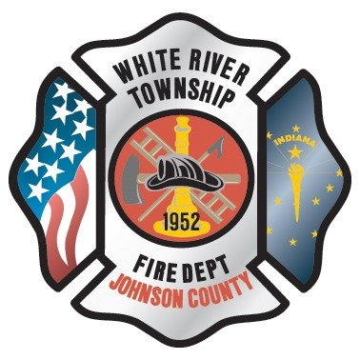 Administration News

As you know Chief Tibbetts will be leaving March 2, 2007. The hiring committee is now being formed by the District Board and the firefighters to proceed with a process for a new Fire Chief.

The White River Township Fire Department’s 55th annual Awards Banquet was great and congratulations to the recipients of the awards. We look forward to the banquet next year.
Station 51 is still on schedule.

“To effectively and efficiently provide professional services to our community”

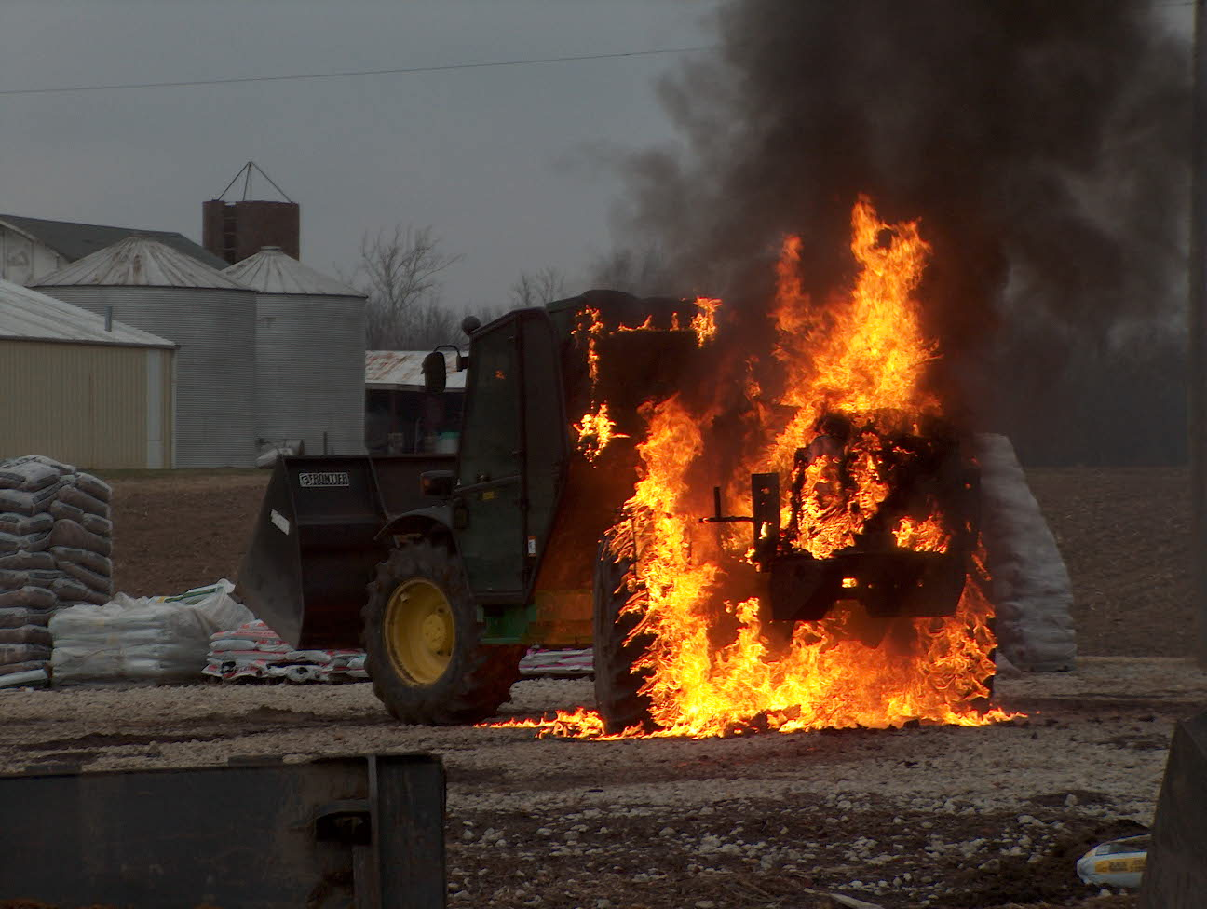 Operations News

The dispatch change to Greenwood is complete and seems to be running smoothly. One item we discovered was that GFD assigns incident numbers for mutual aid responses by the Rural Metro ambulances. So, when Medic 52 responds to Greenwood, Bargersville, and other agencies, Fire Control will assign them an incident number. For now, the company officers at Station 52 will be responsible for the recording the incident in Firehouse. We will wait for Chief Cassin to return from vacation and get his input before making a final decision. Please see Captain Hart with any questions.

The White River Fire Department Special Operations Proposal from Captain Settles has been approved by the Chief Officers. This plan will be explained in greater depth by Captain Settles in the near future. Basically, it defines what levels of service WRTFD will provide, personnel training, and mutual aid response.

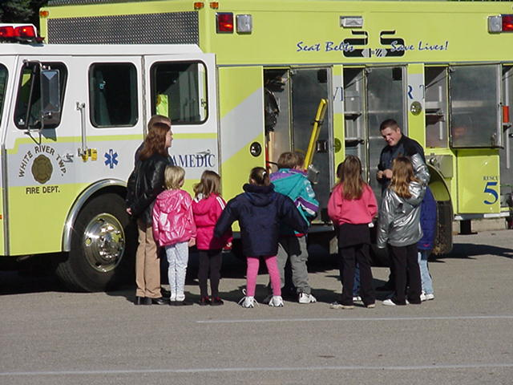 Fire Prevention News

It’s hard to believe, but it’s time to start working on this year’s Strawberry Festival scheduled for June 8th and 9th. If you are interested in helping plan this year’s event, see Captain Skipper.

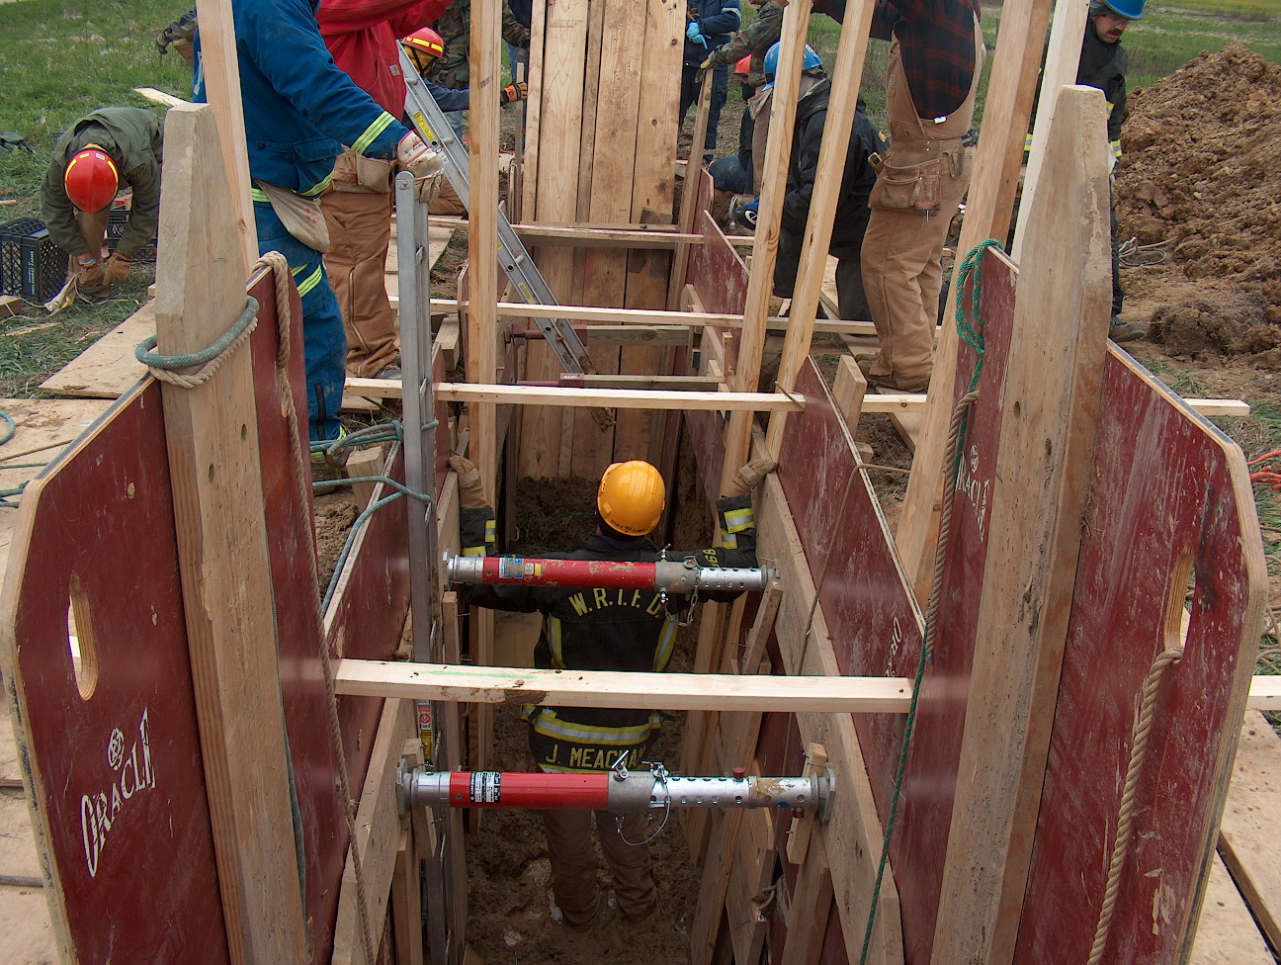 Training News

As of this newsletter The Hazardous materials technician course is under way. It will finish up February 16, 2007 with all students taking the State of Indiana Hazardous Materials test.

Upcoming training for March 2007:
- The first 2 weekends in March are Jasper Fire School.
- The last 2 weekends in March are Duneland Fire School.
- Anyone interested in taking any classes should see Chief Thacker as soon as possible to get registered.

FDIC is just around the corner April 16 through the 21st, anyone interested in taking classes should see me as soon as possible because the classes will fill up fast.

Please don’t forget April 19, 2007 Chief Rick Lasky will be coming here to give his presentation of Pride in Ownership. I would like to have 100% participation from this organization. Until next time stay safe!

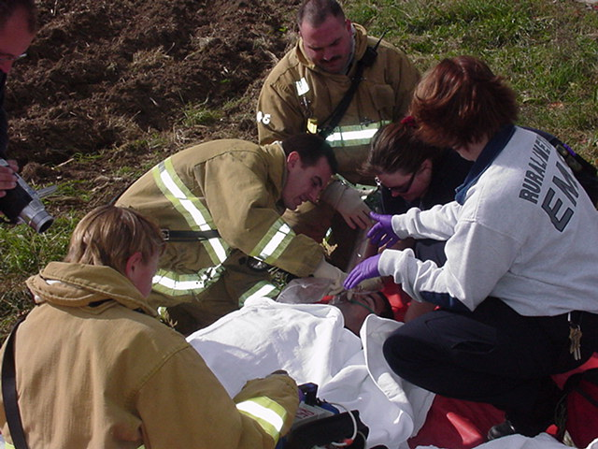 EMS News

Please look forward to new EMS News in our next edition!!!!

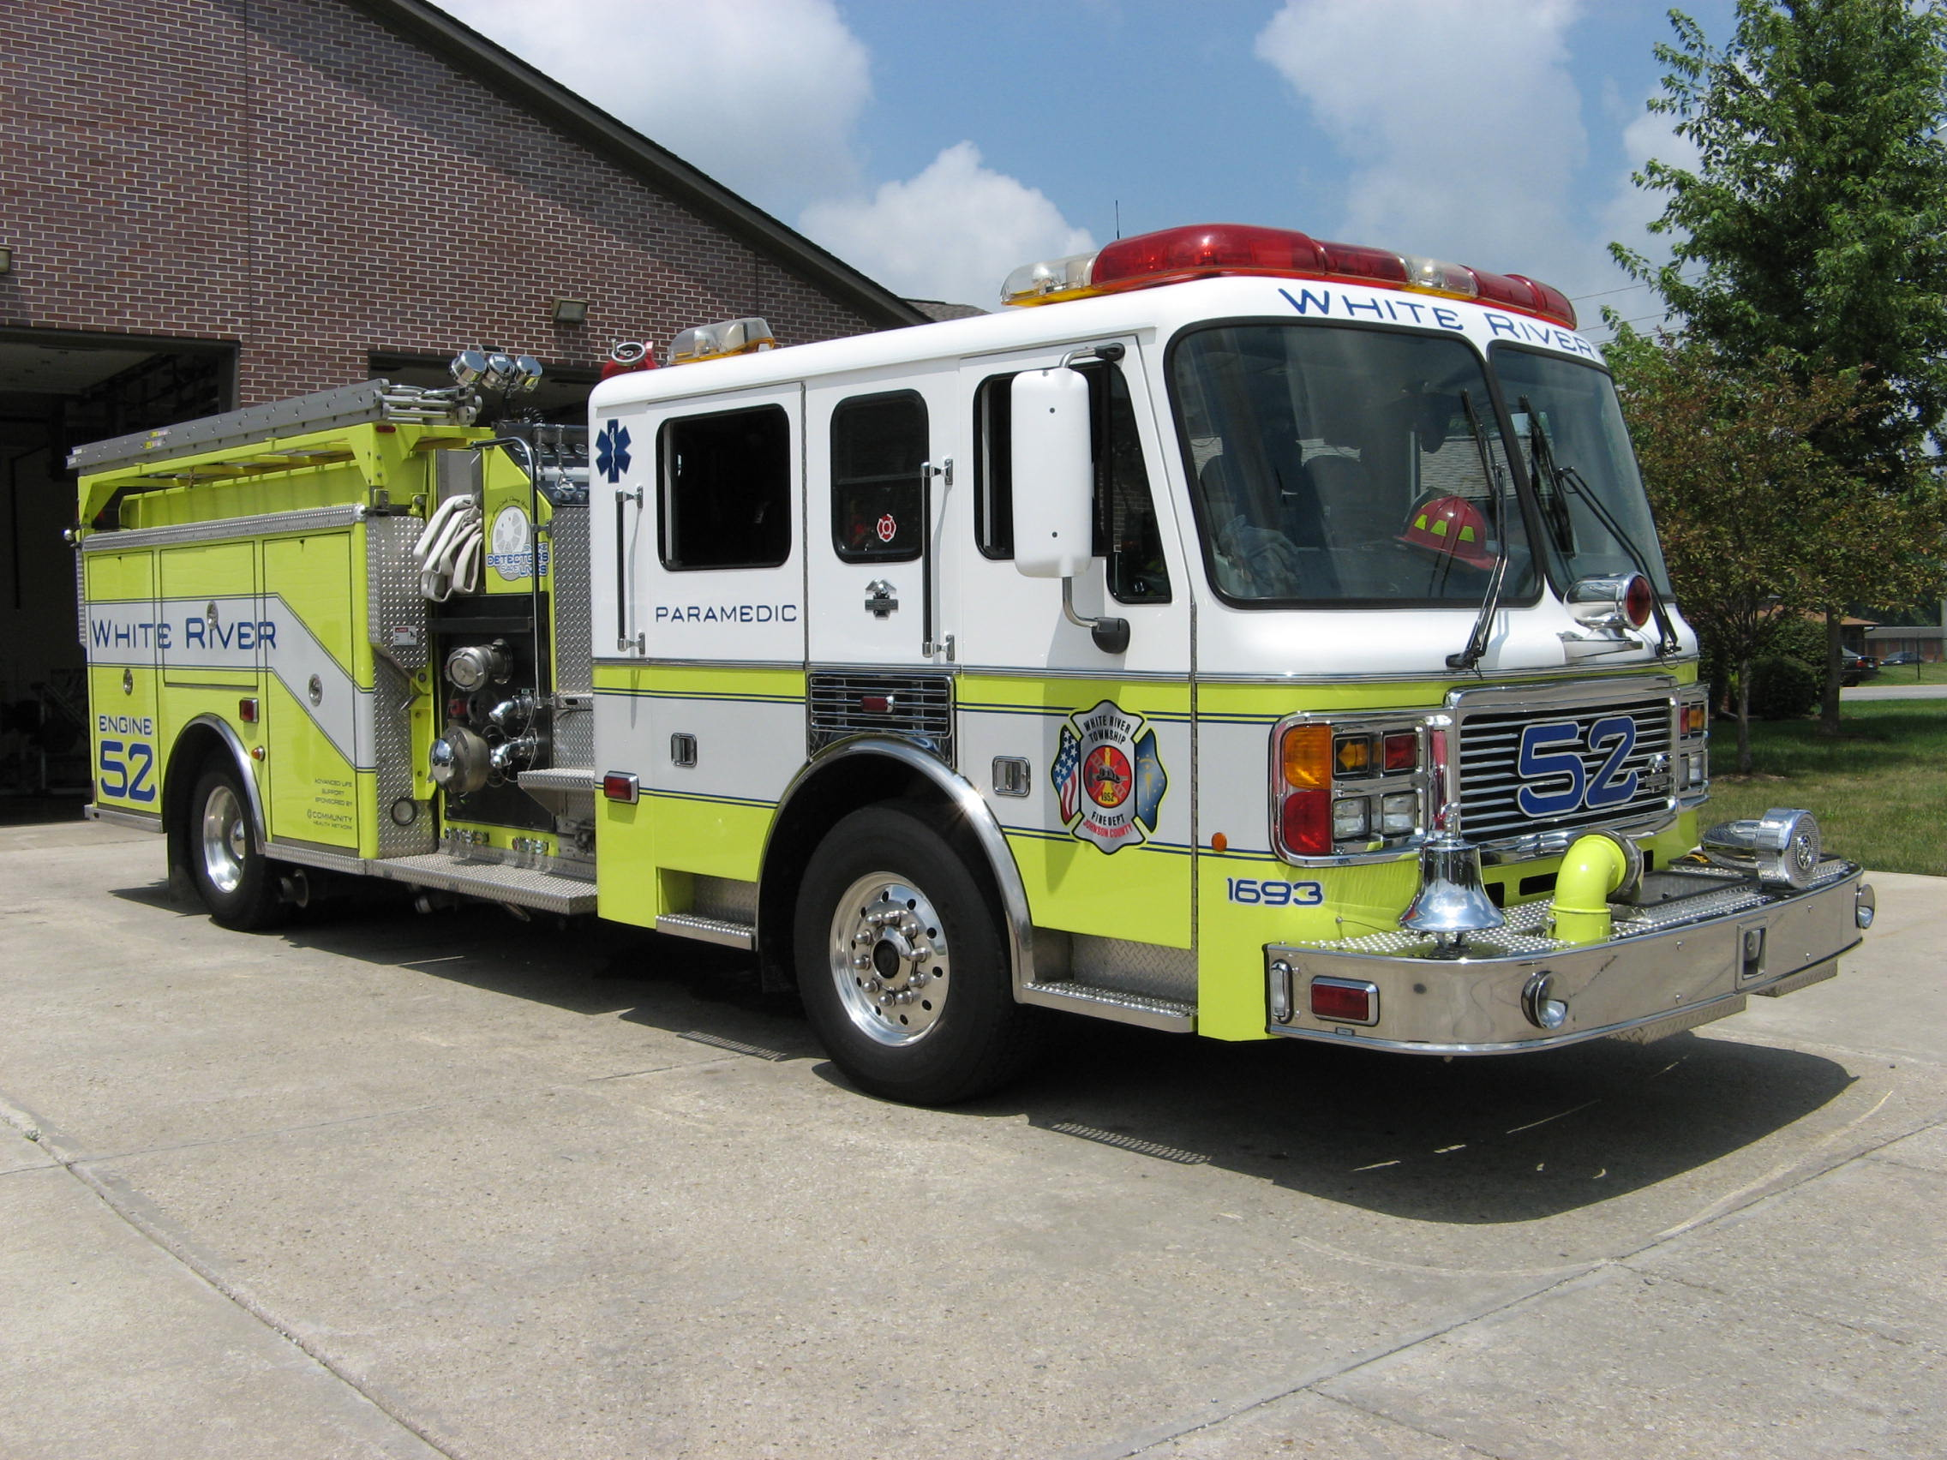 Did you know?

Esther Howland, the woman who produced the first commercial American Valentines in the 1840s, sold a then mind-boggling $5,000 in cards her first year of business. Today, over 1 billion valentine cards are sent in the US - second in number only to Christmas cards.
Happy Valentine's!

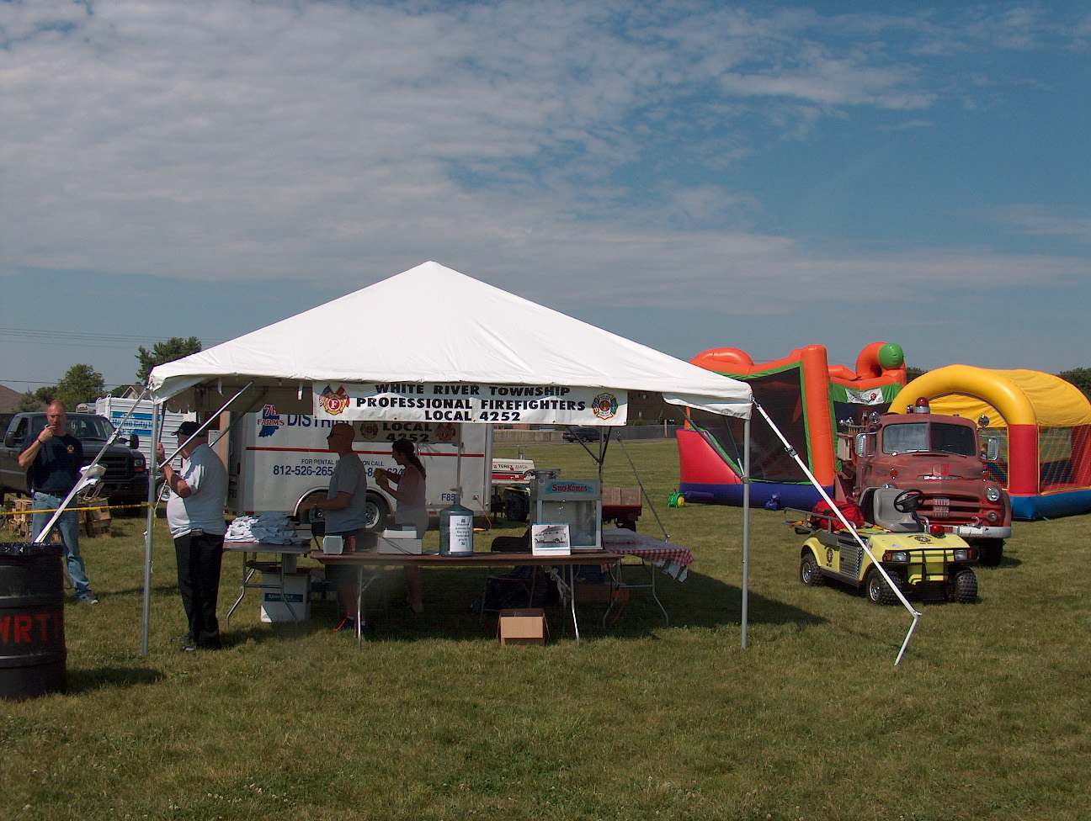 Birthdays (January 26 – February 8)

February 10 - Jason Tibbetts February 12 - Mike Rude
February 13 - Eric Brown February 16 - Eric Wiseman
February 23 - Ron Metcalf February 24 - Richard Woehlecke

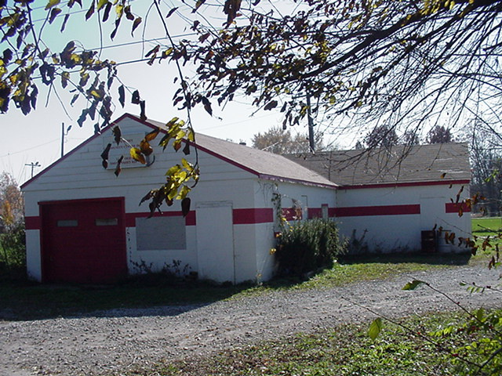 Looking back…..

This Month last year February 2, 2006 our Great Nations Groundhog (aka Phil) saw his shadow and we had six more weeks of winter.
However, February 2007 Phil did not see his shadow and we can look forward to spring early this year. Phil is the Hog!

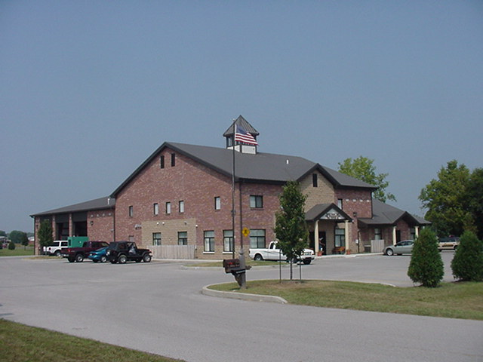 Upcoming events (March)

March 6 – Fire Protection District Board Meeting – 7pm. Station 53
March 2007
S | M | T | W | T | F | S
 |  |  |  | 1 | 2 | 3
4 | 5 | 6 | 7 | 8 | 9 | 10
11 | 12 | 13 | 14 | 15 | 16 | 17
18 | 19 | 20 | 21 | 22 | 23 | 24
25 | 26 | 27 | 28 | 29 | 30 | 31

