
Volume 16 Issue 2

January 26, 2007

Inside this Issue

1 Administration
2 Operations
3 Prevention
3 Training
3 EMS
3 Did You Know?
4 Birthdays
4 Looking Back
4 Upcoming Events

 Administration News

As you are now aware, the department’s newsletter is making its official comeback beginning with this issue. The newsletter will be issued every two weeks on Friday morning and in conjunction with payroll. Because of this newly-revived method of information transmission, we will be reducing the number of meetings that take place, as well as re-organizing the others. In addition to the normal chain of command methods, the newsletter is intended to become a primary source of continued and updated information. These newsletters will be both e-mailed and posted at each station on the assigned delivery date. Additionally, each newsletter will be archived and available at any time via the department’s web site.
On the topic of meetings, we are discontinuing the ‘Staff’ meetings that took place every four weeks. These meetings were never productive and did not serve a specific purpose. Additionally, the former ‘Senior Staff’ meeting has been replaced by a bi-weekly ‘Strategy’ meeting that will be attended by 501 through 505. These meetings will now be focused on department-wide issues and designed to be more efficient. There will also be a five-minute briefing between all office staff and the on-duty Battalion Chief each morning to discuss the day’s events. All of these changes are intended to improve the communications flow throughout all levels of the department.

“To effectively and efficiently provide professional services to our community”

The department’s Chief Officers just completed the first of two bi-annual Strategic Planning sessions scheduled for the year. The meeting was held off site in Nashville, Indiana, and spanned two full days. After a very productive session, several key strategies for 2007 and beyond were identified, several of which are mentioned throughout this newsletter. One of the main topics however, concerned future alternative funding and developing a strategy to achieve a method to grow the fire department. As it stands now, the department is unable to grow and keep up with the growth of the community. This is an unfortunate byproduct of how the department is organized as a district. In order to change this, it will most likely take some form of legislative action. In order to do this, it will take a grass-roots campaign spanning a couple of years to achieve. It is a goal of the department to begin this process in 2007. This is a very complex, time-consuming, and challenging project that will take everyone’s support and input. We will keep everyone posted as the project evolves. Note: When we say ‘grow’ that primarily means the adding of additional personnel. Don’t confuse this with having to downsize or make personnel changes in the future. We currently have a very stable fiscal and strategic plan locked in place that allows the department to operate AS IS for an indefinite time period.
There are several policy updates that have been approved. In a nutshell, they involved the updating of the department’s mission statement (page 8), specifying the Christmas Eve holiday as the actual holiday observed (page 20), the addition of a Code of Ethics policy (page 31), and the addition of an EMT and Paramedic of the Year award pin (page 58). Be sure to read these updates at your convenience and sign an acknowledgement form that will be distributed via your Battalion Chief.

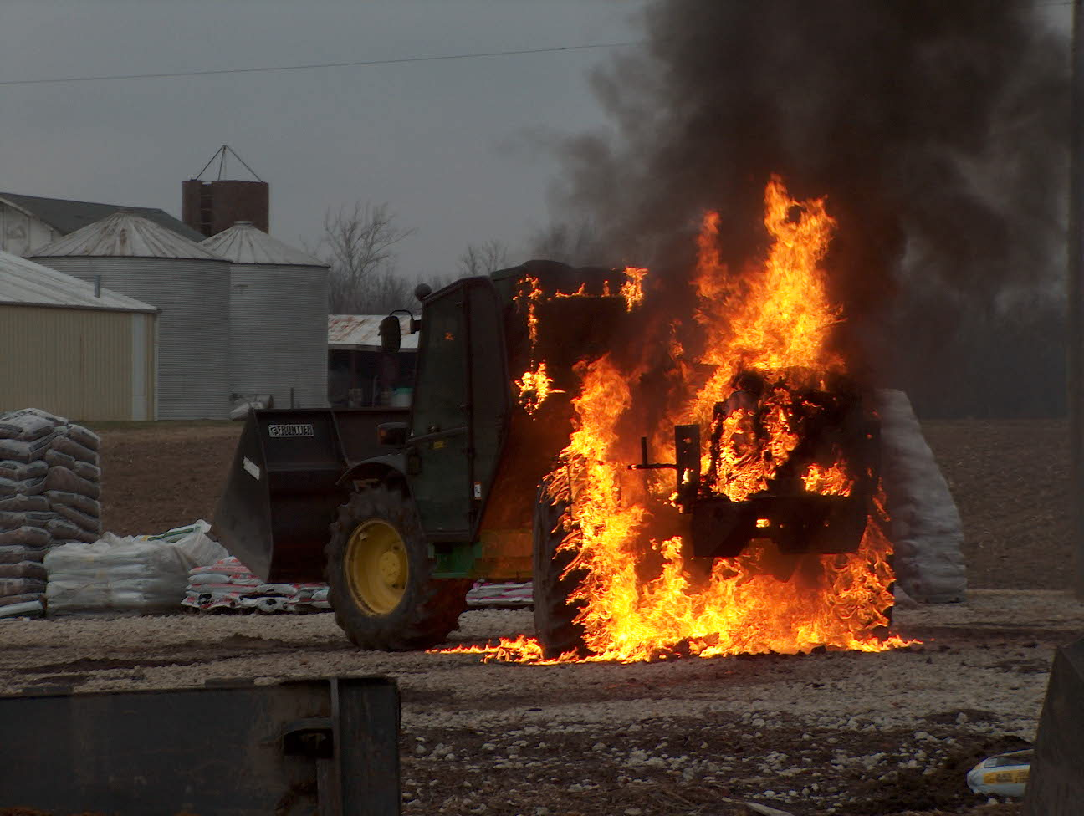 Operations News

The plans for the occupation of the new fire station have been finalized. In order to better serve the needs of the community, the department has elected to move the ladder company out to the new station. This is in addition to Rescue and Engine 51 and the Battalion Chief. These changes are slated to take place on or around July 1st of this year, depending on the final completion date of the building. The re-districting has also been finalized and maps of the new districts (effective after the July 1st move) have been posted at each station.

In an effort to improve our daily staffing levels, the department is raising the minimum total staffing level to sixteen. Additionally, we are increasing the total number of personnel scheduled per day to twenty. This is an attempt to fill as many seats as possible (up to the budgeted total of eighteen) after the usual call-offs, vacations, etc, have taken place. This will take effect February 1st. In the event there is no one off, the extras will be placed on the Ladder and/or Rescue as needed.

The date for moving dispatch services to GFD is set for Feb 5th. Battalion Chief Engmark will be conducting with all shifts prior to this date. We will meet with the GFD dispatch supervisors and staff on Jan. 30 to discuss the transition. See Battalion Chief Engmark with any questions.

No new information on the new engine being built by Crimson Fire. This engine will replace Engine 53 and Engine 53 will be placed in reserve status (Engine 55). The completion date should be this summer. See Captain Arkins with any questions.

We are ready to put the new NIMS SOG in service. Battalion Chief Wilson has completed this SOG and training will take place in the next couple of weeks.

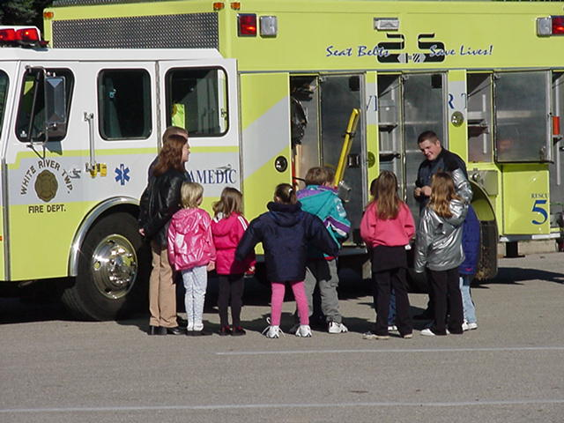 Fire Prevention News

It’s hard to believe, but it’s time to start working on this year’s Strawberry Festival scheduled for June 8th and 9th. If you are interested in helping plan this year’s event, see Captain Skipper.

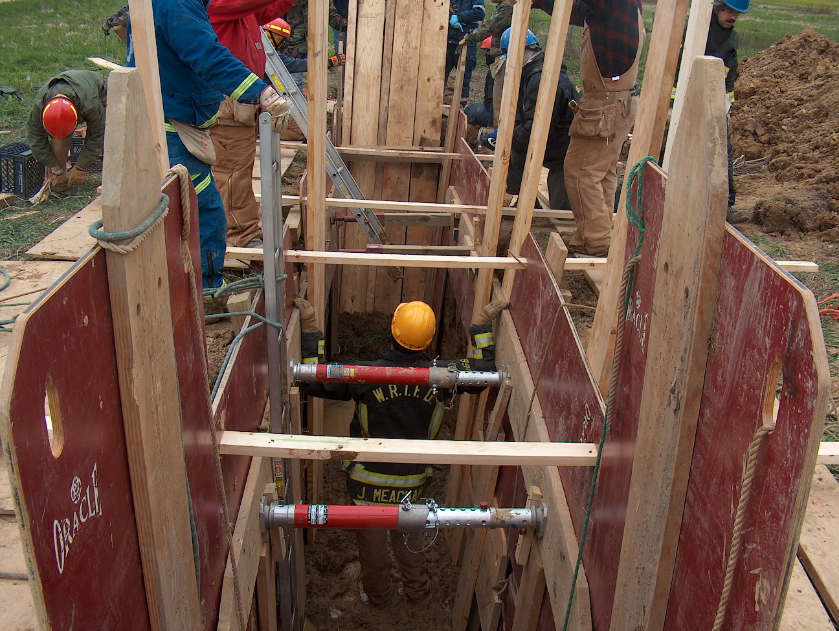 Training News

The department is putting together a Training Facility Assessment Team to discuss the options available regarding a future permanent training facility. The slate is currently wide-open and all ideas are being looked at. If you are interested in serving on this committee, please see Chief Thacker.

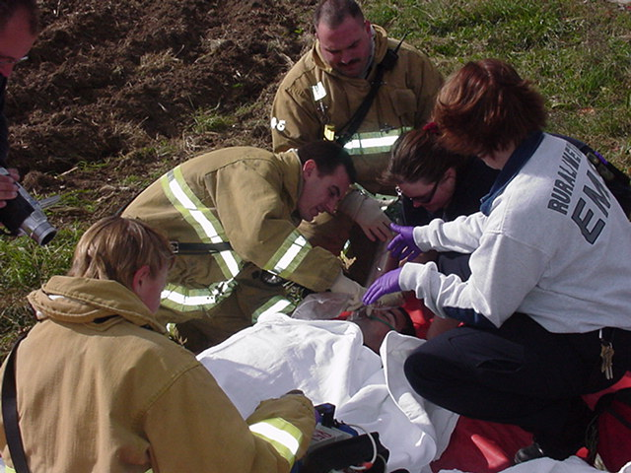 EMS News

One of the major goals for the upcoming year, as identified in the recent retreat, was the establishment of an ambulance service feasibility assessment. This will include investigating all potential sources of revenue from straight-forward billing to property taxes. Anyone interested in this project should see Captain Hart.

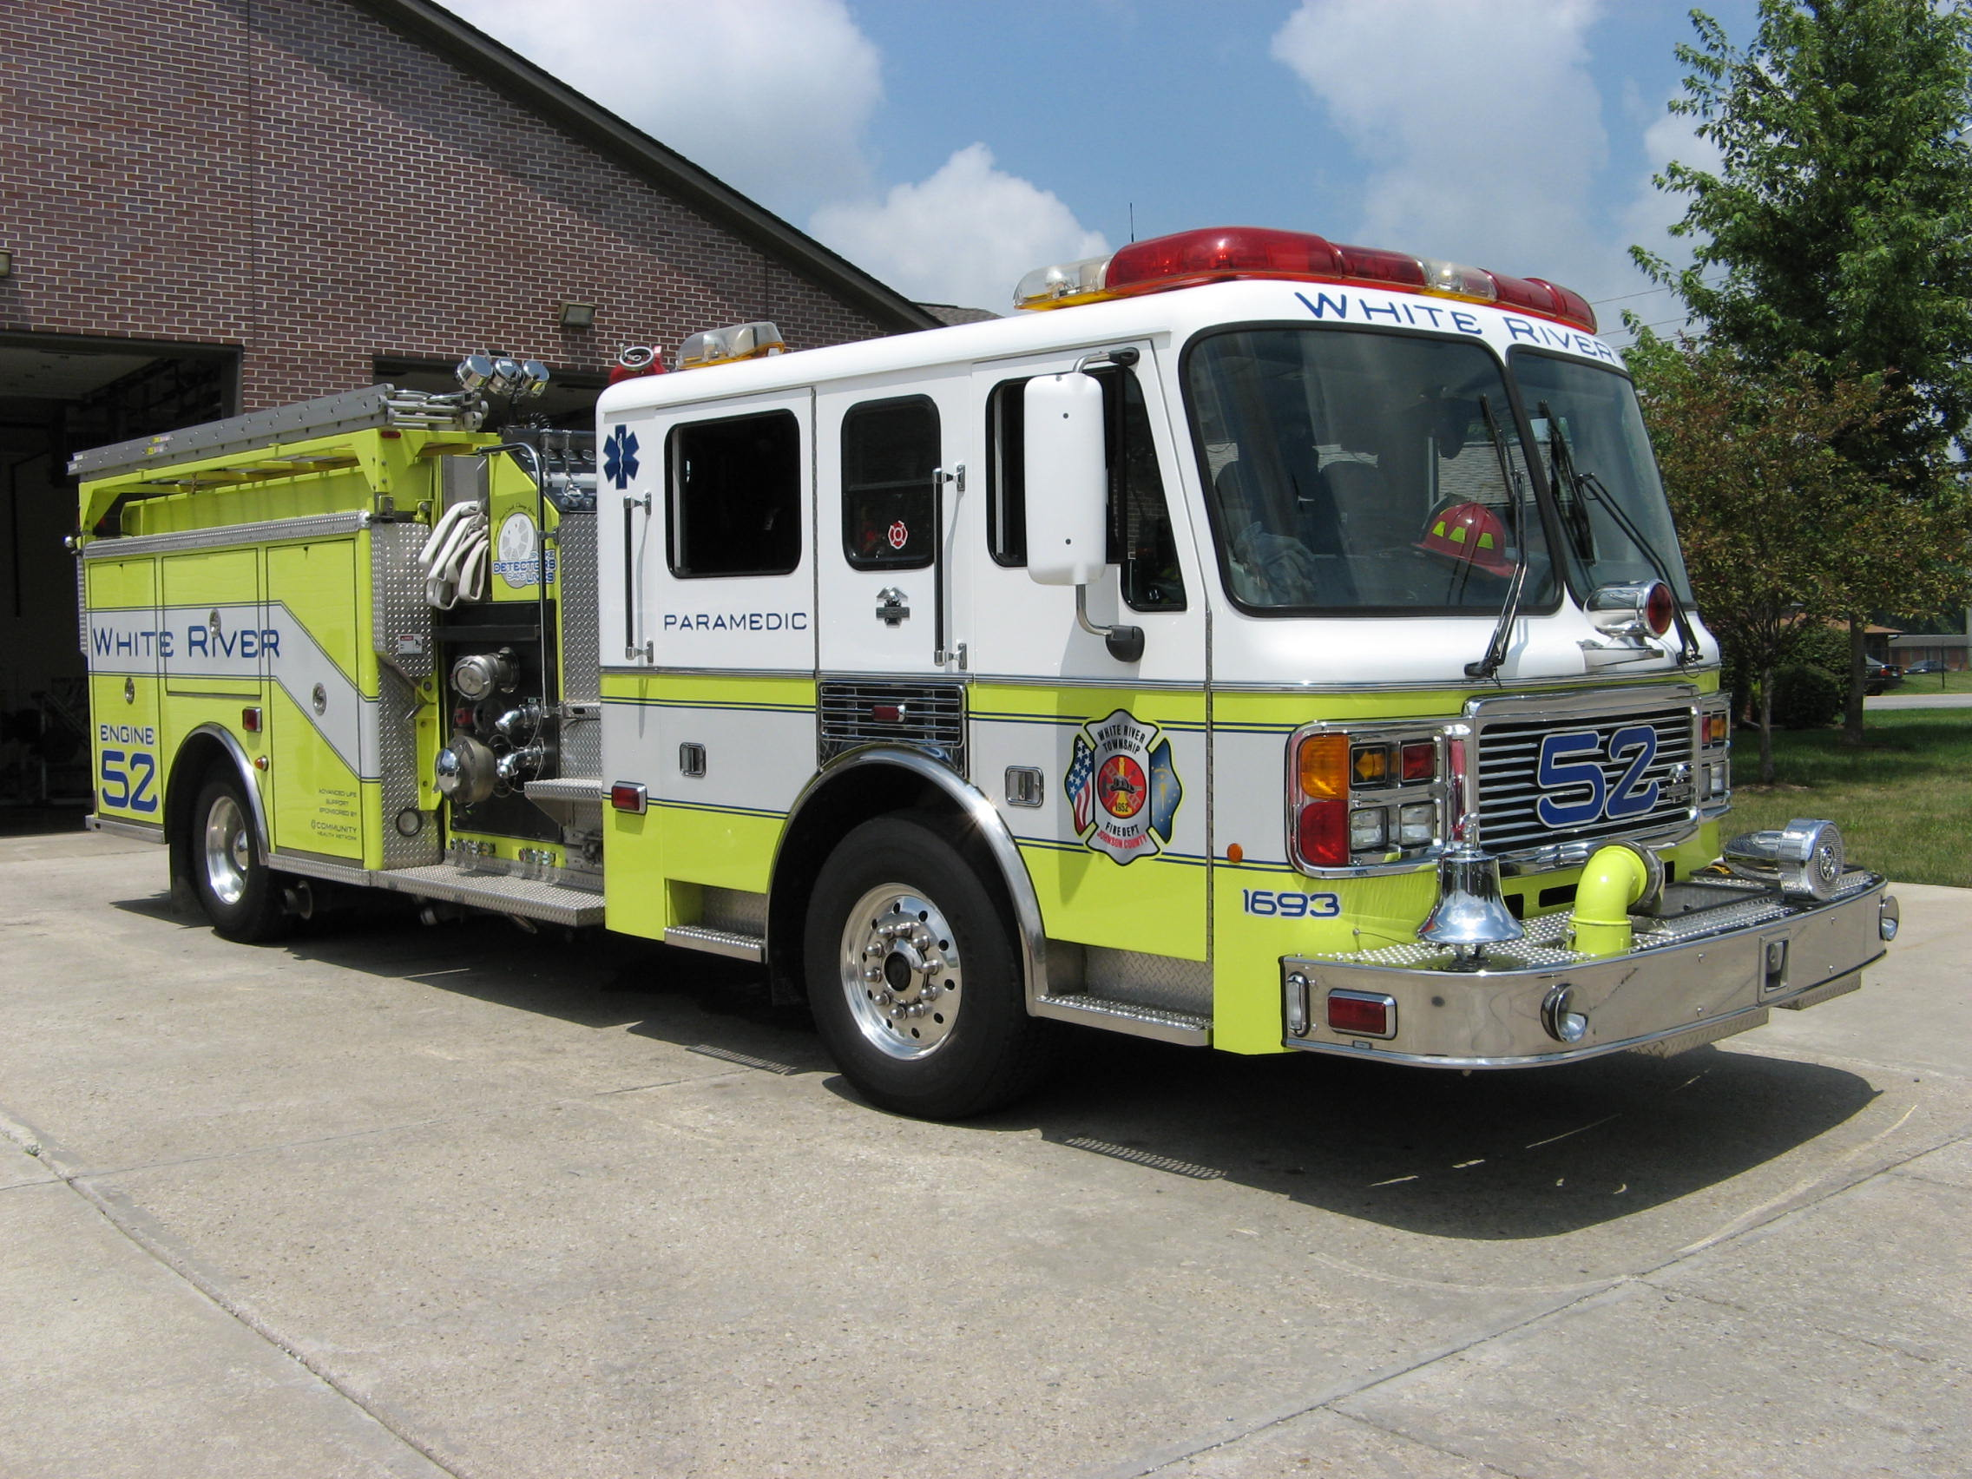 Did you know?

That if you started spelling out numbers beginning with one and counting up, i.e. o-n-e, t-w-o, t-h-r-e-e, etc, that you would have to count and spell all the way to one-thousand before you reached the first letter ‘A’?

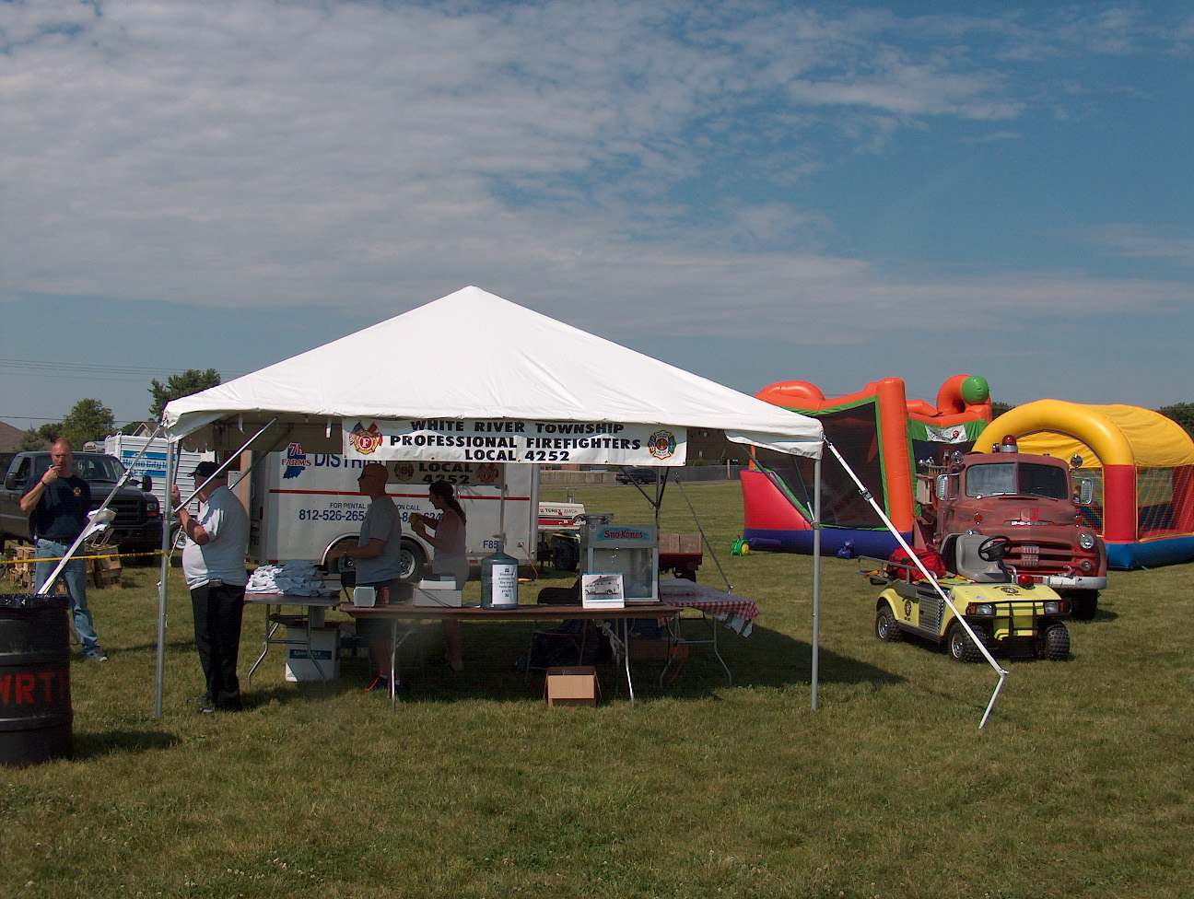 Birthdays (January 26 – February 8)

January 28 – Brian McRoberts  January 28 – Josh Abraham  January 29 – Jeff Campbell  January 30 – Aaron Bryant  February 1 – Rob Lewis | February 1 – Andrew Carman  February 2 – Ron Niebel  February 3 – Ray Denson  February 4 – Andrew Tames  February 7 – Derrick Watkins

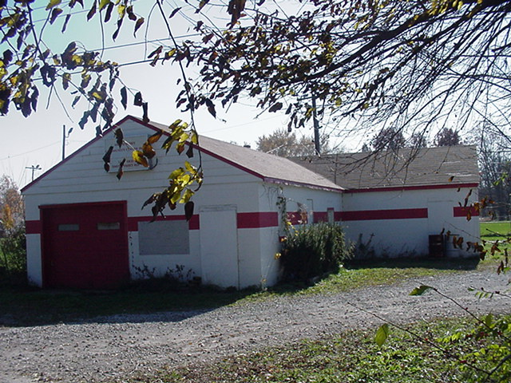 Looking back…..

Five years ago this month (January, 2002):

- Station 51 crews were busy painting the entire upper level of the building. All three shifts participated in the month-long project.

- Station 51 was using a 1977 Pierce loaner engine in place of the 1992 Smeal engine that was totaled in an accident six months earlier.

- The department had 102 runs in the books as of January 26, 2002.

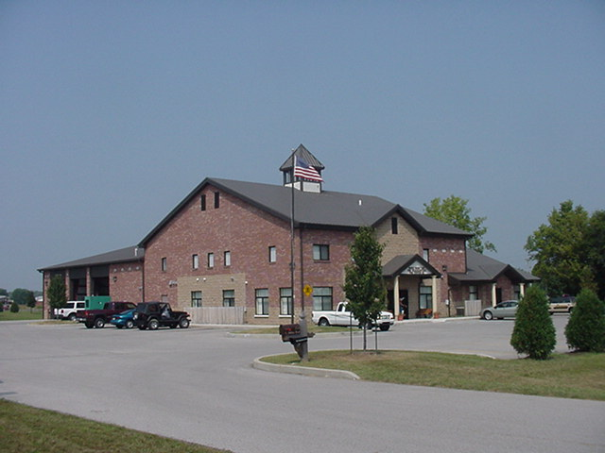 Upcoming events (January – February)

January 27 – Award’s Banquet – 7pm. Hickory Stick Golf Club
February 6 – Fire Protection District Board Meeting – 7pm. Station 53

February 2007
S | M | T | W | T | F | S
 |  |  |  | 1 | 2 | 3
4 | 5 | 6 | 7 | 8 | 9 | 10
11 | 12 | 13 | 14 | 15 | 16 | 17
18 | 19 | 20 | 21 | 22 | 23 | 24
25 | 26 | 27 | 28
January 2007
S | M | T | W | T | F | S
 | 1 | 2 | 3 | 4 | 5 | 6
7 | 8 | 9 | 10 | 11 | 12 | 13
14 | 15 | 16 | 17 | 18 | 19 | 20
21 | 22 | 23 | 24 | 25 | 26 | 27
28 | 29 | 30 | 31

