NEWSLETTER

WHITE RIVER TOWNSHIP FIRE DEPARTMENT

VOLUME 15, ISSUE 6 June 1, 2006

The newsletter editors are taking a break …
The last few months have some of the most hectic for many of us and unfortunately the department’s newsletter has fallen victim. Because the flow of e-mail and direct reporting has been so good, the decision was made to skip this month’s newsletter. Sorry for the inconvenience and see you next month.

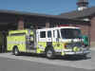

Apparatus Issues


Station Issues



Training Issues

REMEMBER: LET NO FIREFIGHTER SAY THEIR TRAINING FAILED THEM!


General Operations

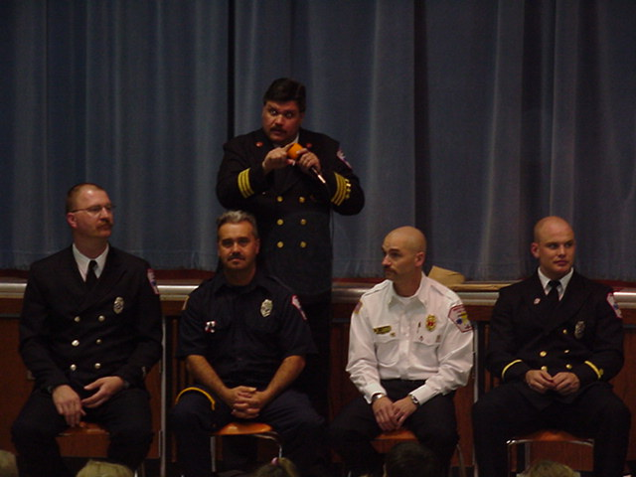

Health & Safety


Notes from Crystal ☺



Strawberry Festival

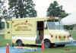

Auxiliary Corner


Did you know……..



Did you Notice?

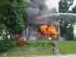

Birthdays



Looking Back…….

5 Years Ago……

- That’s it for this month – Be safe, Scott

