NEWSLETTER

WHITE RIVER TOWNSHIP FIRE DEPARTMENT

VOLUME 13, ISSUE 3 March 12, 2004

Spring!?
The calendar says it’s almost Spring, but today it will barely reach the freezing mark, reminding us that winter is still upon us. With this in mind, and with the crazy Indiana weather ahead, we must remember to keep bay doors down when the temperature is below that of the heater settings. Even though a sunny 55 degree day is a welcome change after a cold winter, the bay heaters will still run and try to warm it to 65 or what ever they are set at. Some of our biggest heating bills come in March, probably for this reason. Just remain cognizant of the temperature and we’ll keep our heating bill as low as can be.

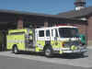

Apparatus Issues

I think this story is in the hunt for the longest running story in the newsletter, but the new Engine 51 is almost a reality! Final inspection is March 23 & 24. We anticipate having it in service mid-April.

Construction on the chassis for the new tactical has begun with a scheduled build time of about six months. Once completed, the chassis will go to the plant in New York for construction of the box. Delivery is still expected about a year from now.

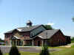
Station Issues
The Land at Olive Branch and 135 is still a work in progress. As you recall, the Fire Protection District Board agreed to make the purchase at the January meeting. We are currently still in negotiations with the land owner working on some of the details. Right now, planning and eventual construction will hopefully get under way later this year. However, we also have to re-plat the land which could take up to six months to complete, pushing the project back by that period of time.



Training Issues

We are looking for volunteers to help with this year’s FDIC to function in support roles. If you are interested, see Chief Thacker for more information.

REMEMBER: LET NO FIREFIGHTER SAY THEIR TRAINING FAILED THEM!

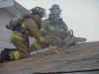

General Operations
Here is the status of the 2003 fire loan projects that are already under way. Here is a breakdown:

Hurst System: All in, training under way
AED’s: All in, training nearly complete
Computer system: Items arriving
Copier buyout: Buying print board instead

The receptionist applications are available March 22 – 26 and are due back by 4/2. Please see our website hiring page for more information and requirements. The receptionist is scheduled to start late May with the rest of the new staff starting in October (street-ready by December).

Speaking of receptionists, Amy Brown will be working in the office to help pick up our extra workload until the new receptionist is able to start work.

Here is this month’s House Fund account summary: The breakdown is as follows:

Station 51: $2,467.16
Station 52: $1,997.22
Station 53: $1,487.10

- There was $569.42 in staple supplies for the month.

Jason Coffey has been awarded the shift position at station 53 on the A-shift during the day. Justin Walls has been awarded the shift position at station 53 on the C-shift during the day. Congratulations to both!

No update on the new thermal imaging camera other than it is still on order along with a new 4-gas detector.

The new computer system has begun to arrive in stages and installation will begin in the coming weeks. The existing equipment will be sold off (hopefully as individual units – we’re waiting on legal council to render an opinion on what we have to do). If all goes as planned, we will post the list of equipment to be sold at a pre-determined time and place offering everyone a similar opportunity to make a purchase. Sales will be cash or check only.

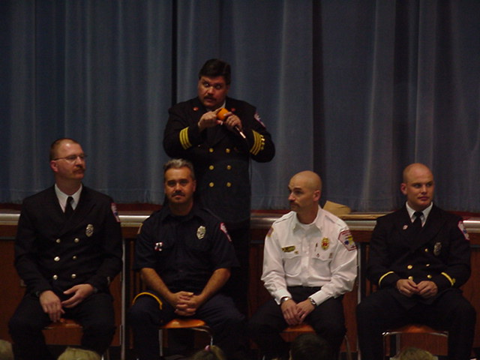

Health & Safety

No news this month.


Notes From Kim ☺

The Fire Protection District Board has finalized their meetings for the rest of this year and are as follows:
April 5, May 4, June 1, August 3, September (TBA), October 5, November 4 and December 7. All meetings are at 1900 hours and at Fire Headquarters.



Strawberry Festival

Meetings are now being held every two weeks at 6pm and still at Headquarters. The next one is March 11, then March 25, etc. All of those interested in helping plan the event are encouraged to attend. PLEASE!!! WE NEED HELP!

Be sure to check the Strawberry Festival web page in the employee section for planning information. This page is updated as the festival planning process continues.

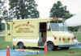

Auxiliary Corner

The Auxiliary’s next meeting is March 14th at 5pm and will be held at Smokey Joe’s BBQ at County Line & SR 135. The April meeting is the 4th and will be at Fire Headquarters at 5pm with training to follow.

Our web page will be changing soon. Please keep an eye on it and let us know what you think!

Our web page still has a schedule for a list of meeting dates, upcoming events, recent photos, and information on the Auxiliary Program. www.wrtfd.org/auxiliary.htm. Our meetings are open to everyone so please feel free to attend and get an idea of the things we do!


Did you know……..

- A shark is the only fish that blink both its eyes at the same time?

- A snail can sleep for three years. (Kim tells me she wants to be a snail in her next life!)

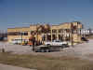

Did you Notice?

- Crews getting ready to close the intersection of Berry and Smith Valley for the summer’s realignment project?

- That McCarty Mulch is moving from Olive Branch and 37 to Bluffdale and 37?

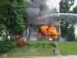

Birthday

March, 2004

March 22 – Jeff Smith

HAPPY BIRTHDAY JEFF!



Looking Back…….

5 Years Ago……

Mar 8, 1999 | Station 52 reports heavy snow falling today.
Mar 13, 1999 | The fire department installed its first true file server today. It was named “Zues”.
Mar 15, 1999 | Engine 52 buried up to its axels in mud at a training site at 135 and Stones Crossing. The truck had to be towed out by Hix Wrecker Service.
Mar 27, 1999 | Assisted Bargersville in the 4800 Block of West State Road 144 on a working residence fire.
FYI ONLY | As of March 1, 1999, the department had 172 runs. This is compared to 256 runs in 2003 and 251 in 2004.

- That’s it for this month – Be safe, Scott

