NEWSLETTER

WHITE RIVER TOWNSHIP FIRE DEPARTMENT

VOLUME 13, ISSUE 6 June 4, 2004

Good ol’ summertime!
Finally it’s here…summer! And Scott’s back at the newsletter helm, well, at least sort of anyway. Kim has done most of the work with Scott filling in the gaps.

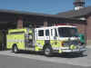

Apparatus Issues

The new Engine 51 is currently at TKO Graphics in Avon getting its graphics package applied. Once completed, it will return for final tool installation and placed in service shortly thereafter. The current Engine 51 will then go to reserve status as Engine 54.

No new news to report on the tactical unit under construction.

We will be ordering two new Expeditions to replace our two oldest Tahoes later this month. This will be via our budget plan that calls for a 4-year rotation of all staff vehicles.


Station Issues
The contract issues regarding the land at Olive Branch and 135 (Heron Ridge) for our next station have been resolved. We are now waiting on a few final inspections and we’ll be ready to sign on the line and make payment.

Speaking of the land, the new Station 51 building team has met a few times already and is progressing on a new station design. The underlying goal of the group is to produce a well-designed and functional facility that meets are needs both now and well into the future. It will undoubtedly be a building we will all be proud of. Minutes of each meeting are available on the employee page of the web site and will be e-mailed to everyone following each meeting.

The Station 52 weight room addition team has also met and begun the design process. We meet with the architect later next week to discuss the next phase of the design process.

Please do not turn the air conditioners down below 65. This causes the compressors to run non-stop, freeze-up, and then lock-up causing the motor to burn out. We’ve already replaced two motors this year in units that are less than 5 years old! We need to be more RESPONSIBLE!



Training Issues

Congratulations to Lieutenant Wilson and Firefighter Tony Slusher for graduating from Paramedic School under the Class of 2004. This was a huge accomplishment for both of them. We wish Lieutenants Engmark and Arkins the same success as well.

REMEMBER: LET NO FIREFIGHTER SAY THEIR TRAINING FAILED THEM!


General Operations
The “Quick and Dirty” hiring process for part-time employees is now complete. We are hiring 6 people, all of which will be placed immediately into a 12hr shift position upon completion of their basic orientation and training. The six names are as follows:
- Ryan Slevin
- Ken Grady
- Ricky Mullis
- Devon Bancroft
- Erin Hensley
- Scott Hendershot
Their shifts however have yet to be determined. Chief Slauter will handle this when he returns from out of town. This is the first time we’ve hired directly into shift positions, so please be patient with them and provide any education necessary to make them a contributing member of our team.

The next part-time process will begin sometime in August after the full-time positions have been named. So, if you know of anyone who may be interested in a part-time shift position, give them a heads up.

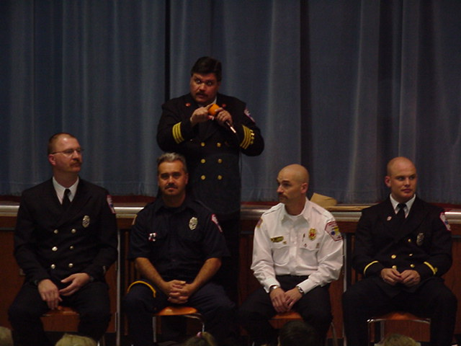

Health & Safety

Nothing to report this month.


Notes from Kim ☺

We are glad to announce that the receptionist hiring process is over and we happily welcome Jacqueline “Jackie” Emmons to our group. If you haven’t already done so, please stop by to introduce yourself and say hi. Remember how it was when you first started and there were so many names to remember and try to put with faces?

On that note, what has always been to us “just” the receptionist area or copier area of the station is now Jackie’s “office” space. Please be considerate and if you’re using that space be sure to clean up after yourself. It’s especially important if you are using the 2nd computer to put the chair back under the counter. It sounds like such a tedious point but if it’s left out in just the right spot, it causes problems for the sorter on the copier when it’s running. This could potentially be an expensive problem when the sorter breaks off and falls in the floor! ☺

On a separate note, there had been some discussion recently (and even brought up at a staff meeting) that Chief Cassin & I would be teaching a Windows/MS Office class just to get everyone caught up on the basics. We had planned on doing this on July 22nd, however, with the numerous projects that have been going on lately and with the upcoming hiring of new employees, we have opted to put this off until the new full time personnel are in their shifts and “settled”. So, in all likelihood, this class would not occur until late this year or early next year. If you are still interested but don’t want to wait that long, I do have some training CDs on most of the MS Office 2000 products. While it’s “old”, it should still cover the basics. Copies of these CDs cannot be made, nor can they be placed on the server for people to learn there. So, if you want one, please see me for more info.



Strawberry Festival
Dear God, is it over yet? That seems to be the motto for this year’s event. But, the good news is we’re about ready to wrap for another year. WE STILL NEED HELP!! Stop by Station 53 to sign up for a 3 hour shift or two. This is an all-hands event!
The wrap-up meeting for this year’s Strawberry Festival is slated for Wednesday, July 7th (B-Shift) at 7pm at Pauly’s Italian Restaurant at Southport and 37.

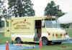

Auxiliary Corner
It’s summer and it’s hot outside. Please make sure you stay hydrated during your shift, and if you have coolers on the trucks, fill them up with water each morning. This is very important but sometimes forgotten. We will do our best, as always, to respond on working incidents. However, day time responses are usually difficult for us. Anyway, stay hydrated and stay safe!

Congratulations to members Jackie Boone, Anna Marsh, and Kim Clawson on successful completion of United States Fire Administration CERT course.


Did you know……..
- That the highest point in Pennsylvania is lower than the lowest point in Colorado?

- No NFL team which plays its home games in a domed stadium has ever won a Superbowl?



Did you Notice?

- Appleebee’s is finished and NOW OPEN!

- The new subdivision now open off of Curry Road?



Birthdays

Happy June Birthday To:
6/1 – Brad Jewell
6/2 – Mike Hoffman
6/6 – Maria VanHart
6/7 – Chris Kindred
6/9 – Kevin Skipper
6/9 – Brent Shepherd
6/14 – Brandon Melady
6/17 – Pat Carmean
6/28 – Carlos Sanchez



Looking Back…….

5 Years Ago……

June 1st, 1999 – Crews attended the wake of Sheriff Deputy Tracy Miles who was struck and killed by a motorist on the Interstate while in the line of duty.

June 2nd, 1999 – Working attic fire from a lighting strike at 4460 Willow Wind Drive.

June 15th, 1999 – All computers were upgraded to Windows 98 from Windows 95.

June 25th – 7th Annual Strawberry Festival held at Sugar Grove Elementary (25th and 26th)

- That’s it for this month – Be safe, Scott

