NEWSLETTER

WHITE RIVER TOWNSHIP FIRE DEPARTMENT

VOLUME 13, ISSUE 2 February 13, 2004

Brr… It’s cold!
Well, here we are right in the middle of winter and with snow on the ground and temperatures below zero, it seems as though spring is a ways off. Even if we are blessed with an early spring, we must still remember to keep the bay doors closed when the temperature is below that of our heater settings (67 degrees in the bay). County highway has agreed to sand our lots for us on the bad snow days but we still have to shovel and salt the sidewalks. Thanks to all those who have been keeping up on the plowing and salting this year.

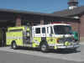

Apparatus Issues

I think this story is in the hunt for the longest running story in the newsletter, but the new Engine 51 is still under construction and delivery is still expected by April. The pre-paint inspection is finally a reality and will be completed on March 3rd.

The new tactical unit has been officially ordered from Saulsbury. The committee is still ironing out some last minute details but is pretty much ready to go. The truck should be delivered in a little less than a year from now.


Station Issues
Most of the projects slated for this year involving the remodel of Stations 52 and 53 will be getting going in the next month or so. We are currently in the process of getting a reputable architect. Lieutenant Smith has agreed to serve as project coordinator and as the committee chair once the ball starts to roll.

Land at Olive Branch and 135 is almost a done deal. The Fire Protection District Board agreed to make the purchase at the January meeting. Planning and eventual construction will hopefully get under way later this year. More on this as our strategic plan develops.

The sign repair at Station 53 is dependent on good weather. As soon as we get a good stretch, it will be repaired.



Training Issues

Community Church of Greenwood and Mount Pleasant Christian Church both now have (or soon to have) Zoll AED’s in their buildings. Be aware that in a cardiac arrest situation they may have these devices attached. The pads they will be using are 100% compatible with our system!
We are in the process of securing a couple of old homes to do some training in. Both houses are to be torn down, so we will be able to do full training evolutions. More on this as we secure the structures.
We are looking for volunteers to help with this year’s FDIC to function in support roles. If you are interested, see Chief Thacker for more information.

REMEMBER: LET NO FIREFIGHTER SAY THEIR TRAINING FAILED THEM!

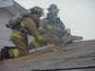

General Operations
Some of the 2003 fire loan projects are under way. Here is a breakdown:

Hurst System: on order
AED’s: on order
Computer system: Bidding out
Copier buyout: In process

The 2004 hiring process for full-time career personnel is under way. We are hiring 3 Lieutenants, 15 Firefighter/Engineers, a M-F prevention Lieutenant, promoting 4 Captains, and a full-time receptionist. See the department’s web site for more information on minimum requirements and procedures. We will also be conducting a part-time process also sometime this year. This time-line has yet to be determined. The receptionist is scheduled to start sometime in April with the rest of the new staff starting in October (street-ready by December).

Speaking of receptionists, Amy Brown will be working in the office to help pick up our extra work load until the new receptionist is able to start work.

Here is this month’s House Fund account summary: The breakdown is as follows:

Station 51: $2,437.00
Station 52: $1,967.06
Station 53: $1,456.92

- There was $569.42 in staple supplies for the month.

Mike Phillips and Mike Vanderploeg are no longer associated with our agency. We wish them luck in their future endeavors and think them for their time and commitment here at White River.

Ed Carlson, Lori White, and Eric Wiseman have all returned from leave.

Please pay attention to the pop-ups on the computer. If quickly dismiss them, you may be inadvertently installing spy-ware on your computer. The ads have gotten very clever and just hitting “cancel” may no longer work. DO NOT install any programs onto the department’s computers. This includes tool bars, helper menus, or any other cutsie items. We do not have the staff available to maintain the computer system with all the problems we have been having lately. Further abuse of the system will result in tighter Internet controls or revocation altogether. Remember, the computers are BUSINESS TOOLS and not personal PC’s.

Josh Meadows has been moved to C-shift at Station 51 days and Brad Jewell has been moved to A-shift at Station 53 nights.

No update on the new thermal imaging camera other than it is still on order along with a new 4-gas detector.

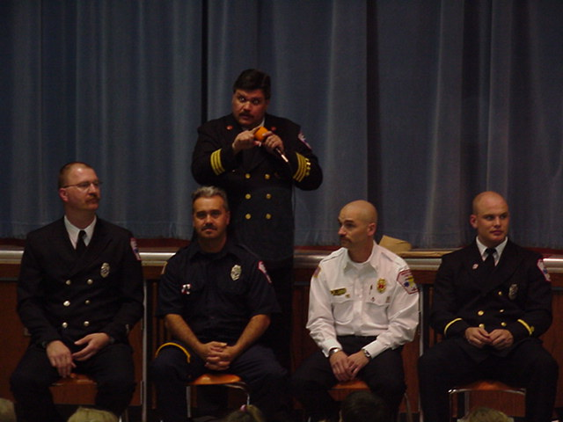

Health & Safety

Gear inspections are being issued and will be completed by the 1st week of March. Company officers will inspect line personnel, Battalion Chiefs will inspect the Lieutenants and Chief Young will inspect all Chiefs. The purpose of the inspection is to make sure everyone’s gear is as safe as possible, as well as to establish a baseline for when we take delivery of our new fire gear. This will determine who has the greatest need of fire gear. The gear inspection process is in no way a punitive measure but rather a proactive safety measure.

Following the fire gear inspections, mask fit testing will commence.

Special thanks to Lt. Settles in this year’s ice rescue training. We’ve seen recent events showing where this type of training has been put to the test in real incidents. Our members are better prepared to do this type of rescue as safely as possible.

A reminder to all personnel, company officers are responsible for making sure your duty uniforms are presentable. If you are starting to have fading, cracking or other problems with your uniforms let’s get them replaced!!

With this thinking, the Chief officers have approved all members for wearing golf shirts for duty wear. A golf shirt purchase request is coming out soon regarding the purchase these golf shirts. Check your email. The order will be placed March 1st. The department’s uniform policy will be amended to allow for the wearing of these shirts on duty.

Until next time…be careful out there!
-Don


Notes From Kim ☺

Hey everyone! I’m finally back! Well, at least for ½ days anyway. I should be released back to full duty in mid-March. Thanks to everyone who sent get well wishes! ☺

If anyone needs anything from me prior to my full return, and you can’t get in touch with my by phone, I am checking my emails frequently so feel free to get in touch with me that way.



Strawberry Festival

The meeting that was scheduled for 2/19 has been postponed until February 25. Still at 6pm and still at Headquarters. All of those interested in helping plan the event are encouraged to attend.

Be sure to check the Strawberry Festival web page for planning information. This page is updated as the festival planning process continues.

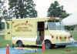

Auxiliary Corner

The Auxiliary would like to thank those who purchased Valentine’s Day gift bags for their sweeties! Be sure to look for this next year!

The Auxiliary’s next meeting is March 14th at 5pm and will be held at a local restaurant. As of the printing of this newsletter, a location has not been determined. If you plan on attending, contact Andrea, Kim or Marian to find out where it’s going to be.

Please visit our web page for a list of meeting dates, upcoming events, recent photos, and information on the Auxiliary Program. www.wrtfd.org/auxiliary.htm. Our meetings are open to everyone so please feel free to attend and get an idea of the things we do!


Did you know……..

- That a dragonfly only lives for 24 hours? What would you do with your day?

- A “jiffy” is an actual unit of time? It is 1/100th of a second.



Did you Notice?

- Crews getting ready to close the intersection of Berry and Smith Valley for the summer’s realignment project?

- That McCarty Mulch is moving from Olive Branch and 37 to Bluffdale and 37?

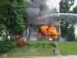

Birthdays

February, 2004

February 3 – Ray Denson

February 4 – Andrew Tames

February 9 – Kim Clawson

February 10 – Jason Tibbetts

February 16 – Eric Wiseman

February 23 – Ron Metcalf

February 26 – Jeff Wilson
HAPPY BIRTHDAY!



Looking Back…….

5 Years Ago……

Feb 11, 1999 | Shorts and T-shirts were pulled from the mothballs as the temperature reached 75 degrees under a sunny sky.
Feb 13, 1999 | White River Fire Department has its first official Strategic Planning Meeting at the Community Church of Greenwood.
Feb 24, 1999 | Working building fire at 1701 Library Boulevard. Call came in as smoke in the area with a single engine response. Call was upgraded to a Box with
FYI ONLY | January 1999 was a pretty uneventful month finishing with 97 runs. This is compared to 131 runs completed in 2004.

- That’s it for this month – Be safe, Scott

